Mathematics

- Compare and order numbers up to 100 and use < > =.
- Read and write all numbers to 100 in digits and words.
- Say 10 more/less than any number to 100.
- Count in steps of 2, 3 and 5 from zero and in 10s from any number (forwards and backwards).
- Recall and use multiplication and division facts for 2, 5 and 10 tables.
- Recall and use +/- facts to 20.
- Derive and use related facts to 100.
- Recognise place value of any 2-digit number.
- Add and subtract:
  - 2-digit nos and ones.
  - 2-digit nos and tens.
  - Two 2-digit nos.
  - Three 1-digit nos.
- Recognise and use inverse (+/-).
- Calculate and write multiplication and division calculations using multiplication tables.
- Recognise, find, name and write 1/3; 1/4; 2/4; 3/4.
- Write and recognise equivalence of simple fractions.
- Tell time to five minutes, including quarter past/to.

These are our recommended websites:
http://www.swingate.medway.sch.uk/ (curriculum hyperlink then maths option)
http://www.conkermaths.org/cmweb.nsf/pages/kirfs.html
http://resources.woodlands.kent.sch.uk/maths/index.html
http://www.topmarks.co.uk/maths-games/7-11-years/ordering-and-sequencing-numbers
http://www.bbc.co.uk/bitesize/ks1/maths/multiplication/play/​
http://www.transum.org/Tables/Times_Tables.asp

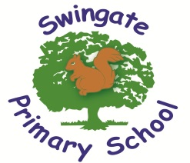

Believe, Learn and Achieve

End of Year Expectations for
Year 2
This booklet provides a summary of the most significant end of year expectations for children in Year 2 for reading, writing and mathematics.
All of the end of year expectation objectives will be
worked on throughout the year and will be the focus of direct teaching. Any extra support you can provide in helping your children to achieve these is greatly valued.

If you have any queries regarding the content of this booklet or want support in knowing how best to help your child, please talk to your child’s teacher.

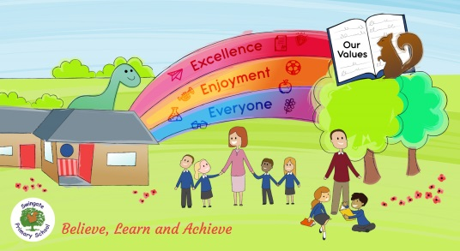

Reading

- Secure with year group phonic expectations.
- Recognise simple recurring literary language.
- Read ahead to help with fluency and expression.
- Comment on plot, setting and characters in familiar and unfamiliar stories.
- Recount main themes and events.
- Comment on structure of the text.
- Use commas, question marks and exclamation marks to vary expression.
- Read aloud with expression and intonation.
- Recognise:
- commas in lists
- apostrophe of omission and possession (singular noun)
- Identify past / present tense and why the writer has used a tense.
- Use content and index to locate information.

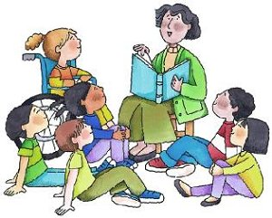

Writing
- Write different kinds of sentence: statement, question, exclamation, command.
- Use expanded noun phrases to add description and specification.
- Write using subordination (when, if, that, because) and co-ordination (or, and but).
- Correct and consistent use of present tense and past tense.
- Correct use of verb tenses.
- Write with correct and consistent use of:
- capital letters
- full stops
- question marks
- exclamation marks

- Use commas in a list.
- Use apostrophe to mark omission and singular possession in nouns.
- Write under headings.
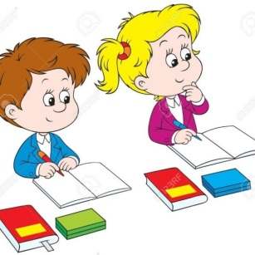
- Write lower case letters correct size relative to one another.
- Show evidence of diagonal and horizontal strokes to join handwriting.

