Mathematics
Numbers:
- Children count reliably with numbers from 1 to 20.
- They place numbers 1-20 in order
- They say which number is one more or one less than a given number.
- Using quantities and objects, they add and subtract two single-digit numbers and count on or back to find the answer.
- They solve problems, including doubling, halving and sharing.

Shape, Space and Measures:
- Children use everyday language to talk about size, weight, capacity, position, distance, time and money to compare quantities and objects to solve problems.
- They recognise, create and describe patterns.
- They explore characteristics of everyday objects and shapes and use mathematical language to describe them.

These are our recommended websites:
http://www.swingate.medway.sch.uk/ (curriculum hyperlink then maths option)
http://www.conkermaths.org/cmweb.nsf/pages/kirfs.html
http://resources.woodlands.kent.sch.uk/maths/index.html
http://www.topmarks.co.uk/maths-games/7-11-years/ordering-and-sequencing-numbers
http://www.bbc.co.uk/bitesize/ks1/maths/multiplication/play/​
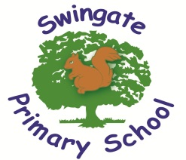
http://www.transum.org/Tables/Times_Tables.asp

Believe, Learn and Achieve

End of Year Expectations for FS2

This booklet provides a summary of the end of year expectations (Early Learning Goals) for children for reading, writing and mathematics.

All of the Early Learning Goals will be worked on throughout the year and will be the focus of adult-led and child-initiated activities. Any extra support you can provide in helping your children to achieve these is greatly valued.

If you have any queries regarding the content of this booklet or want support in knowing how best to help your child, please talk to your child’s teacher.

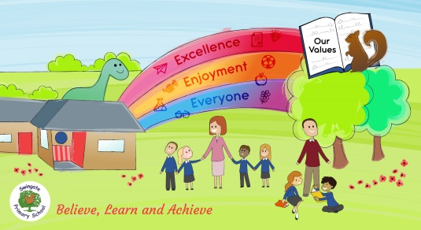
Reading
- Children read and understand simple sentences.
- They use phonic knowledge to decode regular words and read them aloud accurately.
- They also read some common irregular words, e.g. was, said, you, like.
- They demonstrate understanding when talking with others other about what they have read.

Writing
- Children use their phonic knowledge to write words in ways which match their spoken sounds.
- They also write some irregular common words, e.g. the, my, he, she.
- They write simple sentences which can be ready by themselves and others.
- Some words are spelt correctly and others ae phonetically plausible, e.g. ‘wosht’ instead of ‘washed’ and ‘shi’ instead of ‘shy’.

Personal, Social and Emotional Development
Self-Confidence and Self-Awareness
- Children are confident to try new activities and speak in a familiar group. They will choose the resources they need for their chosen activities. They say when they do or don’t need help.

Managing Feelings and Behaviour
- Children talk about how they and others show feelings, talk about their own and others’ behaviour, and its consequences, and know that some behaviour is unacceptable. They work as part of a group or class, and understand and follow rules. They adjust their behaviour to different situations, and take changes of routine in their stride.

Making Relationships
- Children play cooperatively, taking turns with others. They take account of one another’s ideas about how to organise their activity. They show sensitivity to others’ needs and feelings, and form positive relationships with adults and other children.

Physical Development
Moving and Handling
- Children show good control and coordination in large and small movements. They move confidently in a range of ways, safely negotiating space. They handle equipment and tools effectively, including pencils for writing.

Health and Self-Care
- Children know the importance for good health of physical exercise and a healthy diet, and talk about ways to keep healthy and safe. They manage their own basic hygiene and personal needs successfully, including dressing and going to the toilet independently.

