This term our topic is the Normans.

Monday (01/06/2020):

Answer the following question: Edward the confessor was the last Anglo-Saxon king of England. He did not have any children. Why do you think this might have been a problem?

There were three people who thought they had a right to the throne after Edward dies. These were Harold Godwinson (Earl of Wessex), Harald Hardrada (King of Norway) and William (Duke of Normandy).

Harold Godwinson, Earl of Wessex
Harold was a powerful and rich English nobleman. According to the Anglo-Saxon Chronicle, Edward named Godwinson as his successor on his deathbed. The next day, the royal council, known as the Witan, met and declared Godwinson king. An English king was proclaimed by the Witan - this gave Harold Godwinson the only claim to the throne by right.

William, Duke of Normandy
The Norman chroniclers reported that Edward had promised his distant relative, William, the throne in 1051. William was the only blood relative of Edward, but the English throne was not hereditary anyway. Claims that Edward promised the throne were probably made up by the rival sides after the event. The Bayeux Tapestry, which was made after the Conquest, shows Godwinson swearing an oath of support to William in a visit to Normandy in 1064. William was supported by the Pope.

Harald Hardrada, King of Norway, Viking warrior
Hardrada based his claim on the fact that his ancestor, King Cnut, had once ruled England (1016‒1035). He was helped by Godwinson's half-brother, Tostig.

Below is a family tree to show how William and Harold are related to Edward:
Harold Godwinson was related to Edward the Confessor by marriage. William was Edward's distant cousin.

From the information you now know. Write in your red book who you think had more right to be king and why.

Tuesday (02/06/2020): Research Harold Godwinson, William the conqueror and Harold Hardrada – Why did they each think they had a right to the throne? What facts can you discover about them? Make notes on your findings. Then write these notes up into paragraphs about each person. These paragraphs will them be written up to form a booklet.

Wednesday (03/06/2020): Edit your writing from yesterday and write up your paragraphs into your booklet. One page for each person, try and include an illustration too. There is a booklet template available alternatively, create your own by folding pieces of paper, you will need to create a booklet with 8 pages.

Thursday (04/06/2020): Carry out research on the battle of Stamford Bridge, which occurred in 1066. Make notes on your finding. Then write these notes up into paragraphs ready to be written up into your booklet tomorrow.

Friday (05/06/2020): Edit your writing from yesterday and write up your paragraphs into your booklet. Try and include an illustration if you can. We will continue with our booklet next week. Remember to use appropriate punctuation, capital letters in the correct place and try and include some fronted adverbials if you can.

Monday (08/06/2020): Research the Battle of Hastings which occurred in 1066. Make notes on your findings. Then write at least 2 paragraphs about the Battle of Hastings using the notes you have made.

Tuesday (09/06/2020): Edit your writing from yesterday and write up your paragraphs about the Battle of Hastings into your booklet. Try to include an illustration if there is enough space. Remember to present your learning clearly and to use appropriate punctuation.

Wednesday (10/06/2020): Research the Bayeux Tapestry. Write notes while carrying out your research. Then write 2 paragraphs based on your findings.

Thursday (11/06/2020): Edit your writing from yesterday and write it up into your booklet. Once you have finished this, design a front cover for your booklet. Remember to make it eye catching, using bold colours and pictures. Write an introductory paragraph on the front of the booklet that tells people what the booklet is about and makes them want to read it. Don’t forget to include a title.

Friday (12/06/2020): GPaS Quiz – On the next page.

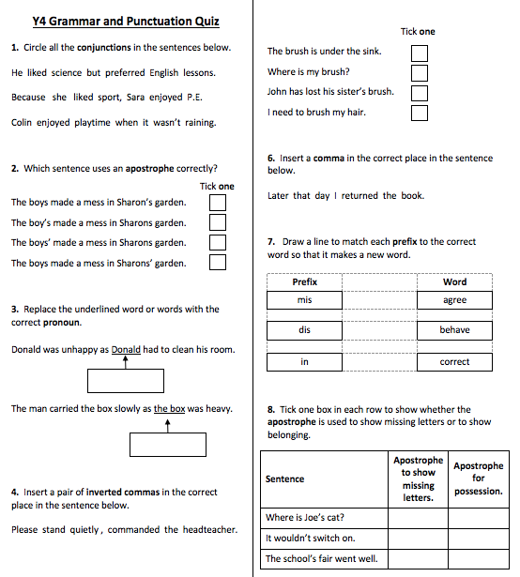

Qu. | Quiz Answers | Notes
1 | but, Because, when | Also accept answers that have been underlined.
2 | The boys made a mess in Sharon’s garden. (Option 1)
3 | he, it
4 | “Please stand quietly,” commanded the headteacher. | Accept single or double inverted commas, as long as the choice is consistent.
5 | I need to brush my hair. (Option 4)
6 | Later that day, I returned the book. | Commas must be the correct size and must be curved to the left.
7 | Prefix Word  mis agree  dis behave  in correct
8 | Sentence Apostrophe to show missing letters Apostrophe to show belonging  Where is Joe’s cat?  It wouldn’t switch on.  The school’s fair went well.

