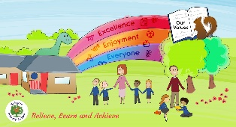
Learning Activities
Year 2019-20

self-isolation learning Week 5
 | Lessons set  This terms topic: Landscapes Across the UK  This weeks maths topic: number and place value | Additional comments
Monday | Maths: Please find all maths sheets in the document named ‘Maths week 5-6’.  Complete at least 5 sessions of TT Rockstars.  - Create a song to help you remember your 12 times table.  - Find 1000 more and 1000 less.  SLOR: All reading extracts can be found in the document names ‘SLoR WEEK 5’. This week’s activities are designed to be worked on with the children. If this is not possible please feel free to adapt the task so it can be done independently.  Understanding poetry: Share the poem ‘My Best Friend’. Read each line and ask children to read/say it back to you. Identify key features such as rhyme, verses, repetition etc. Explore the hidden meaning of the poem (the friend is actually very unkind). What makes a good friend? Sort the actions from the poem into ‘kind/unkind’ and add your own ideas.  English: English weeks 3-4 document contains resources needed for the next two weeks. It also contains further explanations for each task as well as answer sheets to some of the activities.  Look at the picture. Discuss what you can see. Think of different adjectives to describe the scene, imagining you are there. Then write a descriptive paragraph. Use your senses to help you describe. Remember to use adjectives, similes and metaphors to make your descriptions interesting to the reader.  Science: Create a bug hotel using things you can find in your house, garden or on your daily walk. Then record what insects/ wildlife you see in your garden during the next week. There is a science document that contains some example bug hotel photos. | Take part in the Joe Wicks daily P.E lessons at 9am each morning https://www.youtube.com/user/thebodycoach1/featured  Art for Kids Hub on You Tube has some good tutorials for different drawings. Alternatively you could join in with Miss Dent’s daily drawing challenge on Twitter.  SLOR  All reading extracts can be found in the document names ‘SLoR WEEK 5’. This week’s activities are designed to be worked on with the children. If this is not possible please feel free to adapt the task so it can be done independently.  English  Please find all English sheets in the document named ‘English week 5-6’.  Science: Bug hotel examples can be found in Science week 5-6  Reading Bingo!  Complete one of the tasks from the reading bingo sheet and tick them off as you go. Feel free to share with us what you get up to!
Tuesday | Maths: Complete at least 5 sessions of TT Rockstars.  Comparing sums of money.  SLOR: Identify how a character feels: Share the story ‘The Kite’. Have you ever flown a kite before? Discuss how Tyler behaved when he was given the kite. Explore how his feelings had changed by the end of the story. How do you know? Collect words that demonstrate how he felt before/after flying the kite  English: Looking again at the image from yesterday you need to:  - Using the picture as a stimulus, write brief notes about three different ideas for a story.  - Choose your favourite idea, then write more notes to suggest how you could develop it in more detail.  PSHE/ Jigsaw: How kindness makes us feel Discuss how kindness makes us feel cared for and that we get those same feelings when we show kindness. Through kindness we can make ourselves and someone else feel good. Explain how easy it will be to start making our world more caring with simple acts of kindness. Cut out some heart chains and fill the hearts with drawings of acts of kindness they have received or given. Around the pictures write words about how it made them feel. | Maths  Please find all maths sheets in the document named ‘Maths week 5-6’.  SLOR  All reading extracts can be found in the document names ‘SLoR WEEK 5’. This week’s activities are designed to be worked on with the children. If this is not possible please feel free to adapt the task so it can be done independently.  English  Please find all English sheets in the document named ‘English week 5-6’.  Reading Bingo!  Complete one of the tasks from the reading bingo sheet and tick them off as you go. Feel free to share with us what you get up to!
Wednesday | Maths: Complete at least 5 sessions of TT Rockstars.  Comparing and reasoning about amounts of money  SLOR: Vocabulary in context: Read the text ‘Forces’ with your children. Highlight any words that are unfamiliar and discuss their meanings. Create your own glossary to explain the meaning of any words that they are unsure of.  English: Using your ideas from yesterday, choose your favourite idea and plan a story. The English document contains things you might want to consider when planning as well as a story mountain to help you remember each part of the story you need to plan.  Art: Using a birds-eye view perspective create a drawing of a room in your house. (a birds-eye perspective is a view from above, as though you are in the sky.)  e.g: 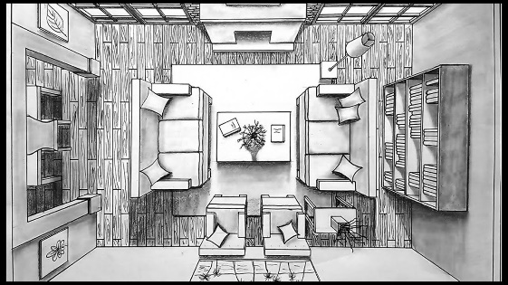 | Maths  Please find all maths sheets in the document named ‘Maths week 5-6’.  SLOR  All reading extracts can be found in the document names ‘SLoR WEEK 5’. This week’s activities are designed to be worked on with the children. If this is not possible please feel free to adapt the task so it can be done independently.  English  Please find all English sheets in the document named ‘English week 5-6’.  Reading Bingo!  Complete one of the tasks from the reading bingo sheet and tick them off as you go. Feel free to share with us what you get up to!
Thursday | Maths: Complete at least 5 sessions of TT Rockstars.  Temperature challenge including negative numbers.  https://www.bbc.co.uk/bitesize/articles/zkmv382 watch the link to remind yourself what negative numbers are.  SLOR: Asking questions Read the text ‘Deciduous and Evergreen Trees’. One person will become the quiz master on evergreen trees and the other person to become the quiz master on deciduous trees. Children should use the text to come up with five or more questions about their type of trees. Give each person a chance to ask and answer their questions. Who won?  English: Using your plan from yesterday, write your story. Remember to proof read your story and make any changes you need to make to improve the story.  Topic: During your daily exercise, take a walk around your local area (if you are self-isolating then you can use google maps to take a virtual tour). As you walk around make a note of any human and physical features. Which one did you notice more of?  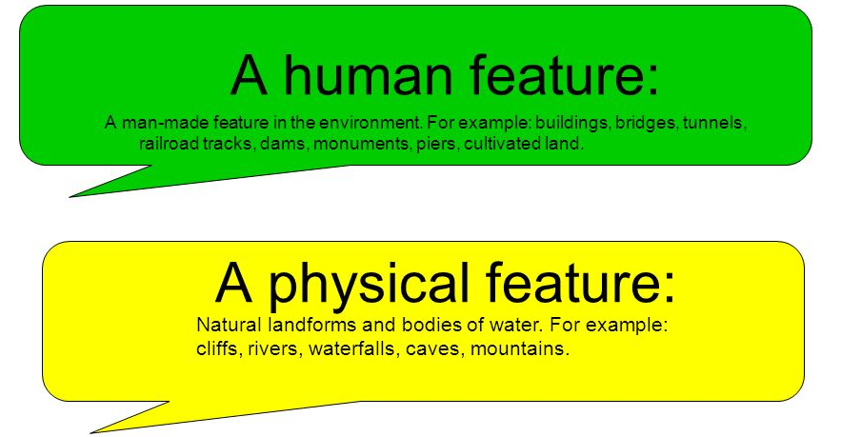 | Maths  Please find all maths sheets in the document named ‘Maths week 5-6’. Todays task has an answer sheet.  SLOR  All reading extracts can be found in the document names ‘SLoR WEEK 5’. This week’s activities are designed to be worked on with the children. If this is not possible please feel free to adapt the task so it can be done independently.  English  Please find all English sheets in the document named ‘English week 5-6’.  Reading Bingo!  Complete one of the tasks from the reading bingo sheet and tick them off as you go. Feel free to share with us what you get up to!
Friday | Maths: Complete at least 5 sessions of TT Rockstars.  Complete the week 5 10 in 10 arithmetic.  Rounding to the nearest 10, 100 and 1000.  Watch the link to remind yourself how to round numbers then have a go at the interactive activities below the video.  https://www.bbc.co.uk/bitesize/articles/zjf492p  Don’t forget: 5 or more raise the score, 4 or less let it rest!  SLOR: Performance poetry Read the ‘Left and Right’ poem aloud. Have you ever forgotten something or been late? Read the poem again, verse by verse. Act out each part of the poem. Discuss facial expressions, movement and tone of voice. (This is a good opportunity to check children’s knowledge of left/right, personal organisation and road safety!).  English: Editing for meaning activities. Complete the activities on the sheet. Adults, there is an answer sheet in the English document if you require it.  Topic: Complete one activity from the home learning grid | SLOR  All reading extracts can be found in the document names ‘SLoR WEEK 5’. This week’s activities are designed to be worked on with the children. If this is not possible please feel free to adapt the task so it can be done independently.  English  Please find all English sheets in the document named ‘English week 5-6’.  Reading Bingo!  Complete one of the tasks from the reading bingo sheet and tick them off as you go. Feel free to share with us what you get up to!

Learning Activities
Year 2019-20

self-isolation learning Week 6
 | Lessons set  Maths topic: Addition, Subtraction and Inverse  English topic: Poetry | Additional comments
Monday | Maths: Complete at least 5 sessions of TT Rockstars.  Practice addition and subtract of 4-digit numbers and money using the column method  SLOR: The resources for this week can be found in the document named ‘SLoR WEEK 6’.  Read the text ‘Five Children and It’. Discuss and research the meaning of any words you are unsure of. Write a short summary (3 sentences) to sum up what has happened in the text.  English: Think about and discuss what a good friendship is. Think about the relationship you have with your friend rather than just being a friend. Explore ideas such as fairness, equity, trust and kindness. Write a list of ingredients for a good friendship and then explain how it feels to have a good friendship with someone.  Science: Looking back at the wildlife/insect dairy you have been keeping, select an animal to research and create a fact file. There is an example fact file on the Science document. | Take part in the Joe Wicks daily P.E lessons at 9am each morning https://www.youtube.com/user/thebodycoach1/featured  Please find all maths sheets in the document named ‘Maths week 5-6’.  SLoR  The reading extract and questions can be found in the document named ‘SLoR WEEK 6’.  English  Please find all English sheets in the document named ‘English week 5-6’.  Science: Example fact file can be found in the document named science week 5-6.  Reading Bingo!  Complete one of the tasks from the reading bingo sheet and tick them off as you go. Feel free to share with us what you get up to!
Tuesday | Maths: Complete at least 5 sessions of TT Rockstars.  Use the word problems to put the correct values in the bar model.  SLOR: Re-read the text ‘Five Children and It’. Answer questions 1-3 labelled vocabulary. Use the answer page at the bottom of the document to mark your answers. If your answer is incorrect think about what went wrong and make your corrections.  English: Think about who your best friend is. Why are you best friends? What do you like doing together? What is a fond memory you have? What would you like to do together once we are able to see each other again? Use these ideas to write a draft of a postcard to a friend. You will be able to give these to your friends at a later date. Once you have written your message edit and improve it ready to write up tomorrow.  PSHE/ Jigsaw: Patience  Discuss what it means to be patient. Can you remember any times you have had to show patience? Was it easy? Explain that for most of our day we are with other people and whether we are playing or working, we need to show patience. Patience can be shown by waiting our turn, letting others have time to think about their answer or making sure someone has finished talking before you start to talk. Can you list five synonyms (words that mean the same) and five antonyms (words that mean the opposite) for patience? | Maths  Please find all maths sheets in the document named ‘Maths week 5-6’.  SLoR  The reading extract and questions can be found in the document named ‘SLoR WEEK 6’.  English  Please find all English sheets in the document named ‘English week 5-6’.  Reading Bingo!  Complete one of the tasks from the reading bingo sheet and tick them off as you go. Feel free to share with us what you get up to!
Wednesday | Maths: Complete at least 5 sessions of TT Rockstars.  Find fact families using the bar model.  SLOR: Re-read the text ‘Five Children and It’. Answer questions 4-6 labelled retrieval. Use the answer page at the bottom of the document to mark your answers. If your answer is incorrect think about what went wrong and make your corrections.  English: Write up your message on to the postcard template. Remember to use your best handwriting. Once this is finished, draw an illustration on the front of your postcard.  Topic: Take a look on google maps and type in your local area (Lordswood). Use the Zoom in/out buttons to take a closer look. As you zoom you will notice lots of different keys e.g:  Draw the keys you find and write down what they symbolise. For Example:  This symbols represents food providers such as restaurants and takeaways.  Extension: You can always move the map around, zoom out and look at other areas around Lordswood. Are there any other different symbols? Can you find the symbol for a Hospital? Can you find the symbol for a railway station? Can you find the symbol for an airport? | Maths  Please find all maths sheets in the document named ‘Maths week 5-6’.  SLoR  The reading extract and questions can be found in the document named ‘SLoR WEEK 6’.  English  Please find all English sheets in the document named ‘English week 5-6’.  Reading Bingo!  Complete one of the tasks from the reading bingo sheet and tick them off as you go. Feel free to share with us what you get up to!
Thursday | Maths: Complete at least 5 sessions of TT Rockstars.  Use the inverse to find the missing number in the calculations.  SLOR: Re-read the text ‘Five Children and It’. Answer questions 7-9 labelled inference. Use the answer page at the bottom of the document to mark your answers. If your answer is incorrect think about what went wrong and make your corrections.  English: GPaS activities. Complete the homophones and editing sheets. Adults there are answer sheets attached. Homophones are two or more words having the same pronunciation but different meanings, origins, or spelling.  Art: Using sketching skills, draw a picture of an animal that inhabits the United Kingdom. | Maths  Please find all maths sheets in the document named ‘Maths week 5-6’.  SLoR  The reading extract and questions can be found in the document named ‘SLoR WEEK 6’.  English  Please find all English sheets in the document named ‘English week 5-6’.  Art for Kids Hub on You Tube has some good tutorials for different drawings.  Reading Bingo!  Complete one of the tasks from the reading bingo sheet and tick them off as you go. Feel free to share with us what you get up to!
Friday | Maths: Complete at least 5 sessions of TT Rockstars.  Complete the week 6 10 in 10 arithmetic. Has your score improved from last week?  Miss Sahota, Miss Harpum and Mrs Hopcraft wanted to make sure we haven’t forgotten to add and subtract. Can you use the inverse to check our answers and mark it? We would be very grateful!  SLOR: Re-read the text ‘Five Children and It’. Answer questions 10-12. Use the answer page at the bottom of the document to mark your answers. If your answer is incorrect think about what went wrong and make your corrections.  English: Complete the GPaS quiz. Adults the answers are attached.  Topic: complete one activity from the home learning grid | Maths  Please find all maths sheets in the document named ‘Maths week 5-6’.  SLoR  The reading extract and questions can be found in the document named ‘SLoR WEEK 6’.  English  Please find all English sheets in the document named ‘English week 5-6’.  Reading Bingo!  Complete one of the tasks from the reading bingo sheet and tick them off as you go. Feel free to share with us what you get up to!

