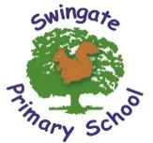

“We all flourish from a wealth of learning experiences that positively impact on academic, physical and emotional success.”

What is expected in Year 3?

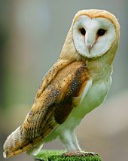
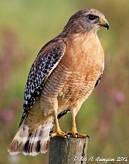

As a school, we feel it is important to work alongside you and share with you the end of year expectations for children in Year 3 for Reading, Writing and Mathematics.

Any extra support you can provide in helping your children to achieve these will be extremely beneficial and greatly valued.

The year 3 team are often available after school for a quick chat if you have any worries or queries. Alternatively, you can email or call the school office and any important information will be passed on.


Reading

- Comment on the way characters relate to one another.
- Know which words are essential in a sentence to retain meaning.
- Draw inferences such as inferring characters’ feelings, thoughts and motives from their actions.
- Recognise how commas are used to give more meaning.
- Draw inferences such as inferring characters’ feelings, thoughts and motives from their actions.
- Recognise how commas are used to give more meaning.
- Recognise inverted commas.
- Recognise:
  - plurals
  - pronouns and how used
  - collective nouns
  - adverbs
- Explain the difference that the precise choice of adjectives and verbs make.

Daily reading really does make a difference. The assessments we now do in school rely on the children being able to read with fluency, accuracy and understanding. They have a substantial piece to read and answer questions within a time scale of an hour. In order to prepare for this, the children need to read and answer questions.

What happens in the story? Why? (making connections)
What might happen next? (predicting/inferring)
What can you remember about the story (summarising)
What did the author mean when they said….? (evaluating)

Writing

- Use conjunctions (when, so, before, after, while, because).
- Use adverbs (e.g. then, next, soon).
- Use prepositions (e.g. before, after, during, in, because of).
- Experiment with adjectives to create impact.
- Correctly use verbs in 1st, 2nd and 3rd person.
- Use perfect form of verbs to mark relationships of time and cause.
- Use inverted commas to punctuate direct speech.
- Group ideas into basic paragraphs.
- Write under headings and sub-headings.
- Write with increasing legibility, consistency and fluency.

If you write anything at home…don’t forget to share it with us!
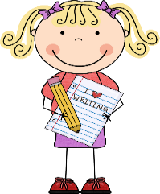


Year 3 spelling patterns:
- Words ending –tch and –ch
- Plurals –s and –es
- Suffixes: -ed, -er, -est, -ing -ment, -ess, -ful, -less, -ly
- Contractions didn’t, haven’t
- Sion/tion endings
- Prefixes
- Sure/ture endings
- Ous/ious endings
- -cian/ssion endings

Example words:
Stack, jumper, batch, punch, foxes, stone, dummy, nappy, boil, royal, poked, ripped, sadder, widest, feeling, tipping, barge, edge, saddle, able, haven’t, they’ll, enjoyed, dustier, payment, goodness, slowly, badly, vision, section, mistrust, remove, fixture, treasure, nervous, obvious, forgetting, happened, mission, musician

Y3 recommended reads:

The Diary of a Killer Cat series by Anne Fine
The Worst Witch by Jill Murphy
The 100 Mile an Hour Dog by Jeremy Strong
The Queen’s Nose by Dick King Smith
The Faraway Tree by Enid Blyton
Fantastic Mr Fox by Roald Dahl
Just So Stories by Rudyard Kipling
Flat Stanley by Jeff Brown
The Lion, the Witch and the Wardrobe by CS Lewis
Mr Majeika by Frank Roders
Mr Magnorlia by Quentin Blake

Why not let your teachers know what your recommended reads are?
Please do fill in the reading records daily with all texts you are reading.

Maths Strategies
Videos of these can be found on the school website:

Under Curriculum/Maths/calculation videos.
Addition:
Stage 2
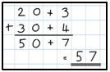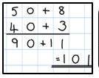
Stage 3
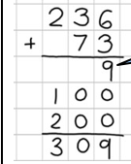
Subtraction
Stage 2
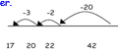

Stage 3
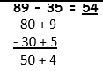
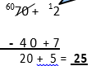

Multiplication
Stage 2
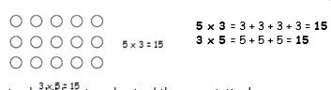

Stage 3
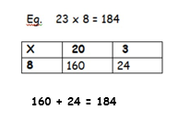
Division
Stage 2
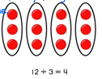
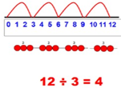

Stage 3
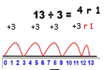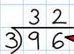

Mathematics

- Compare and order numbers up to 1000.
- Read and write all numbers to 1000 in digits and words.
- Find 10 or 100 more/less than a given number.
- Count from 0 in multiples of 4, 8, 50 and 100.
- Recall and use multiplication and division facts for 3, 4, 8 tables.
- Recognise place value of any 3-digit number.
- Add and subtract:
  - 3-digit nos and ones
  - 3-digit nos and tens
  - 3-digit nos and hundreds
- Add and subtract:
  - Numbers with up to 3-digits using written column method.
- Estimate and user inverse to check.
- Multiply:
  - 2-digit by 1-digit
- Count up/down in tenths.
- Compare and order fractions with same denominator.
- Add and subtract fractions with same denominator with whole.
- Tell time using 12 and 24 hour clocks; and using Roman numerals.
- Tell time to nearest minute.
- Know number of days in each month and number of seconds in a minute.

These are our recommended websites:
http://www.swingate.medway.sch.uk/ (curriculum hyperlink then maths option)
http://www.conkermaths.org/cmweb.nsf/pages/kirfs.html
http://resources.woodlands.kent.sch.uk/maths/index.html
http://www.topmarks.co.uk/maths-games/7-11-years/ordering-and-sequencing-numbers
http://www.bbc.co.uk/bitesize/ks1/maths/multiplication/play/​
http://www.transum.org/Tables/Times_Tables.asp



