
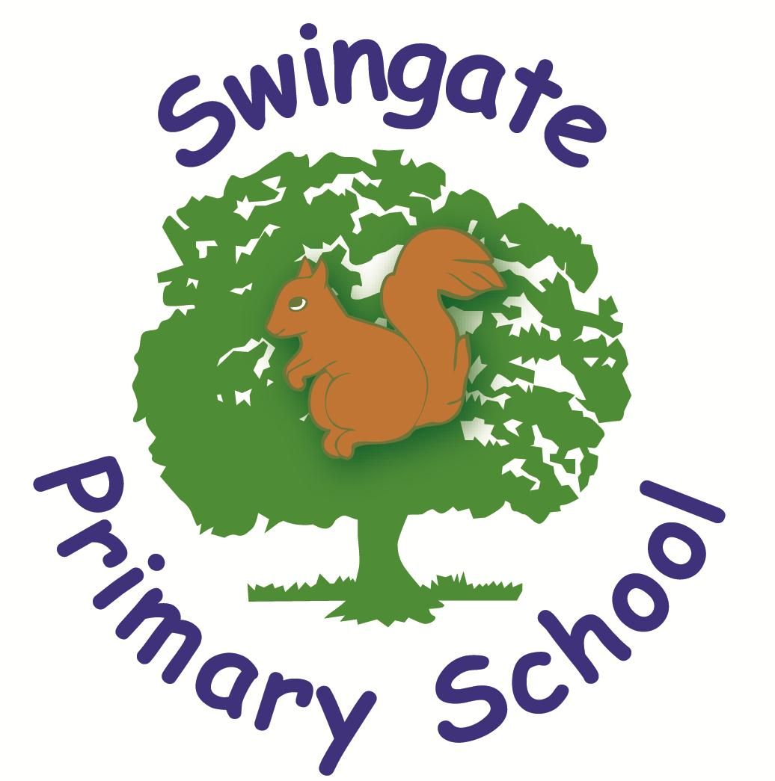
In-year (casual) admission application form
Please fill in all the details and return this form directly to the school you are applying to. Please ensure you complete all sections.

Please read the information about in-year admissions at medway.gov.uk/inyearadmissions before completing this form.

To apply for in-year places, complete this form and return it directly to each school you wish to apply for. Each school you apply for must give you an application outcome in writing within 15 school days.

If you have been refused a place at a school and would like to know which schools have vacancies, please contact School Admissions & Transport at Medway Council. Email: casualadmissions@medway.gov.uk Phone: 01634 331110

School being applied for:

Child’s details

Child’s forename(s): Child’s date of birth: School year group: Full address:
Child’s surname: Child’s gender: Male



Female


Child’s current school:

Postcode: Postcode:

Does your child have an Education, Health and Care Plan (EHCP): Yes No If yes, please do not complete this application. Instead, contact the SEN Team: seneducationteam@medway.gov.uk

Has your child been in public care or adopted, i.e. has your child been looked after by a local authority/subject to an adoption, child arrangements or special guardianship order /in state care or adopted outside of England? Yes  No 
If yes, by which local authority?

Parent’s/carer’s details

Parent/carer title: Relationship to child: Mother Phone number: Home
Email address:

Full address, if different from child’s address above, (leave blank if the same):
Postcode:
Forename:
Father Other (please state) Work
Surname:

Mobile



Are you a crown servant? Yes No

Fair Access Questions

Each local authority must have a Fair Access Protocol. Information about Medway Council’s Fair Access Protocol can be found at
medway.gov.uk/inyearadmissions

The questions below will help identify whether your child is eligible to be referred to the Fair Access Panel if the school you are applying for cannot offer a place.

You must answer these questions accurately.


Has your child been subject to a Child in Need Plan or Child Protection Plan in the last 12 months? Yes No  Is your child living in a refuge? Yes No

Is your child in the criminal justice system? Yes No
No
Has your child been permanently excluded in the last two academic years? Yes


Has your child had fixed term exclusions in the last two academic years? Yes No If yes, how many days? Is your child currently attending alternative provision? Yes No 
Does your child have special educational needs, a disability or medical conditions? Yes
No
If yes, please specify:
Is your child a carer? Yes
No
Is your child homeless? Yes
No

Are you or your child Gypsy, Roma, Traveller, a refugee or asylum seeker? Yes No Has your child been out of education for four or more weeks? Yes No

Declaration and parent/carer signature

I have parental responsibility for this child.

The information I have provided on this form is correct and true to the best of my knowledge. I understand that if, at a later date, any of the information is found to be incorrect I may lose any place allocated to my child.

I give permission for the school to process all the information given in accordance with the admissions criteria and processes and to share this information with the local authority.

Signed: Date:

Print name:

Once you have completed this form, you must return it to the school you want to apply for. The school will contact you directly with the outcome within 15 school days.





To be completed by the school applied for

Name of school applied for:

Date application received:

The statutory deadline for providing an application outcome to the applicant is 15 school days.

The school must complete this section and return the whole form to School Admissions & Transport within two school days of the application outcome being determined.

If a place is offered

Date offered:

Start date:

Withdrawn date:

Reason for withdrawal:

If a place is not offered

Was a place available? Yes No If yes, why was a place not offered?

Have you provided a refusal letter to the applicant giving the reason for refusal and right of appeal? Yes No Does the pupil meet the criteria to be referred to the Fair Access Panel? Yes No
If yes, please consider whether you can offer under the Protocol. If you can offer, update this page accordingly and submit the form to School Admissions & Transport. If you cannot offer under FAP, return this form along with a completed FAP referral form and any relevant documents.

Once this form is completed, please return it to casualadmissions@medway.gov.uk Alternatively, post it to: School Admissions & Transport,
Medway Council, Gun Wharf,
Dock Road, Chatham, ME4 4TR

