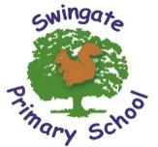

“We all flourish from a wealth of learning experiences that positively impact on academic, physical and emotional success.”

What is expected in Year 2?
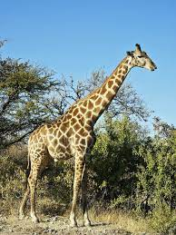



As a school, we feel it is important to work alongside you and share with you the end of year expectations for children in Year 2 for Reading, Writing and Mathematics.

Any extra support you can provide in helping your children to achieve these will be extremely beneficial and greatly valued.

The year 2 team are often available after school for a quick chat if you have any worries or queries. Alternatively, you can email or call the school office and any important information will be passed on.

Reading

- Secure with year group phonic expectations.
- Recognise simple recurring literary language.
- Read ahead to help with fluency and expression.
- Comment on plot, setting and characters in familiar and unfamiliar stories.
- Recount main themes and events.
- Comment on structure of the text.
- Use commas, question marks and exclamation marks to vary expression.
- Read aloud with expression and intonation.
- Recognise:
- commas in lists
- apostrophe of omission and possession (singular noun)
- Identify past / present tense and why the writer has used a tense.
- Use content and index to locate information.

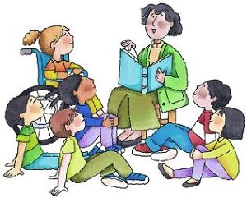

Writing
- Write different kinds of sentence: statement, question, exclamation, command.
- Use expanded noun phrases to add description and specification.
- Write using subordination (when, if, that, because) and co-ordination (or, and but).
- Correct and consistent use of present tense and past tense.
- Correct use of verb tenses.
- Write with correct and consistent use of:
- capital letters
- full stops
- question marks
- exclamation marks

- Use commas in a list.
- Use apostrophe to mark omission and singular possession in nouns.
- Write under headings.

- Write lower case letters correct size relative to one another.
- Show evidence of diagonal and horizontal strokes to join handwriting.

Mathematics

- Compare and order numbers up to 100 and use < > =.
- Read and write all numbers to 100 in digits and words.
- Say 10 more/less than any number to 100.
- Count in steps of 2, 3 and 5 from zero and in 10s from any number (forwards and backwards).
- Recall and use multiplication and division facts for 2, 5 and 10 tables.
- Recall and use +/- facts to 20.
- Derive and use related facts to 100.
- Recognise place value of any 2-digit number.
- Add and subtract:
  - 2-digit nos and ones.
  - 2-digit nos and tens.
  - Two 2-digit nos.
  - Three 1-digit nos.
- Recognise and use inverse (+/-).
- Calculate and write multiplication and division calculations using multiplication tables.
- Recognise, find, name and write 1/3; 1/4; 2/4; 3/4.
- Write and recognise equivalence of simple fractions.
- Tell time to five minutes, including quarter past/to.

These are our recommended websites:
http://www.swingate.medway.sch.uk/ (curriculum hyperlink then maths option)
http://www.conkermaths.org/cmweb.nsf/pages/kirfs.html
http://resources.woodlands.kent.sch.uk/maths/index.html
http://www.topmarks.co.uk/maths-games/7-11-years/ordering-and-sequencing-numbers
http://www.bbc.co.uk/bitesize/ks1/maths/multiplication/play/​
http://www.transum.org/Tables/Times_Tables.asp


