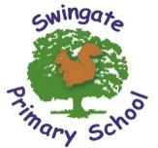

“We all flourish from a wealth of learning experiences that positively impact on academic, physical and emotional success.”

What is expected in Year 1?




As a school, we feel it is important to work alongside you and share with you the end of year expectations for children in Year 1 for Reading, Writing and Mathematics.

Any extra support you can provide in helping your children to achieve these will be extremely beneficial and greatly valued.

The year 1 team are often available after school for a quick chat if you have any worries or queries. Alternatively, you can email or call the school office and any important information will be passed on.

Reading
- Identify which words appear again and again.
- Recognise which words appear again and again.
- Recognise and join in with predictable phrases.
- Relate reading to own experiences.
- Re-read if reading does not make sense.
- Re-tell with considerable accuracy.
- Discuss significance of title and events.
- Make predictions on basis of what has been read.
- Make inferences on basis of what is being said and done.
- Read aloud with pace and expression, i.e.
- Recognise:
  - capital letters
  - full stops
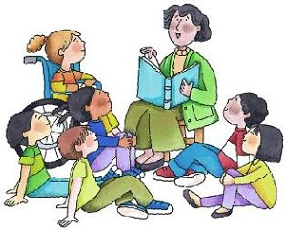
  - question marks
  - exclamation marks
  - ellipsis
- Know why the writer has used the above punctuation in a text.
- Know difference between fiction and non-fiction texts.

Writing
- Write clearly demarcated sentences.
- Use ‘and’ to join ideas.
- Use conjunctions to join sentences (e.g. so, but)
- Use standard forms of verbs, e.g. go/went.
- Introduce use of:
    - capital letters
    - full stops
    - question marks
    - exclamation marks
- Use capital letters for names and personal pronoun ‘I’.
- Write a sequence of sentences to form a short narrative (as introduction to paragraphs).
- Use correct formation of lower case – finishing in right place.
- Use correct formation of capital letters.
- Use correct formation of digits.



Mathematics

- Count to and across 100, forwards and backwards from any number.
- Read and write numbers to 20 in numerals and words.
- Read and write numbers to 100 in numerals.
- Say 1 more/1 less to 100.
- Count in multiples of 2, 5 and 10.
- Use bonds and subtraction facts to 20.
- Add and subtract 1 digit and 2 digit numbers to 20, including zero.
- Solve one-step multiplication and division using objects, pictorial representation and arrays.
- Recognise half and quarter of object, shape or quantity.
- Sequence events in chronological order.
- Use language of day, week, month and year.
- Tell time to hour and half past.

These are our recommended websites:
http://www.swingate.medway.sch.uk/ (curriculum hyperlink then maths option)
http://www.conkermaths.org/cmweb.nsf/pages/kirfs.html
http://resources.woodlands.kent.sch.uk/maths/index.html
http://www.topmarks.co.uk/maths-games/7-11-years/ordering-and-sequencing-numbers
http://www.bbc.co.uk/bitesize/ks1/maths/multiplication/play/​
http://www.transum.org/Tables/Times_Tables.asp


