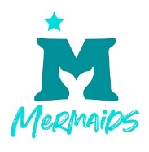
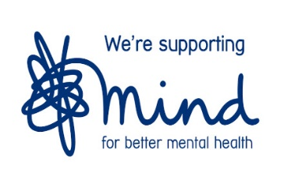

https://mermaidsuk.org.uk/

Text: MERMAIDS to 85258

Telephone: 0808 801 0400

Mermaids supports transgender, non-binary and gender-diverse children, young people and their families.

https://www.mind.org.uk/

Infoline: 0300 123 3393
Email: info@mind.org.uk
Text: 86463

Mind provides advice and support to empower anyone experiencing a mental health problem.

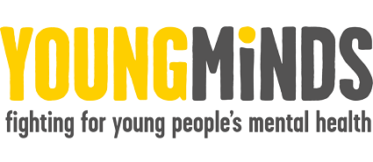
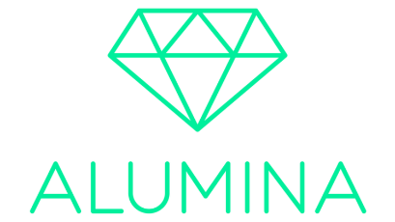

youngminds.org.uk
For young people in crisis text: YM to 85258
Telephone: 08088025544

Young Minds aims to stop young people’s mental health reaching crisis point, supporting them no matter what.

selfharm.co.uk

https://www.beheadstrong.uk/

Email: helloalumina@youthscape.co.uk

Alumina is a ground-breaking online support programme for young people who are struggling with self-harming behaviour.

www.kooth.com

Please SEE LETTER BELOW

It provides a safe, secure means of accessing online emotional health support from a professional team of qualified counsellors and emotional wellbeing practitioners.

Telephone: 116 123

Email: jo@samaritans.org

Write a letter to:

Chris Freepost

RSRB-KKBY-CYJK

PO Box 9090

Stirling FK8 2SA

Samaritans works to make sure there's always someone there for anyone who needs someone.

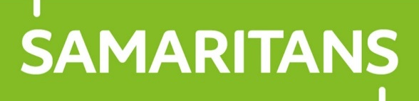


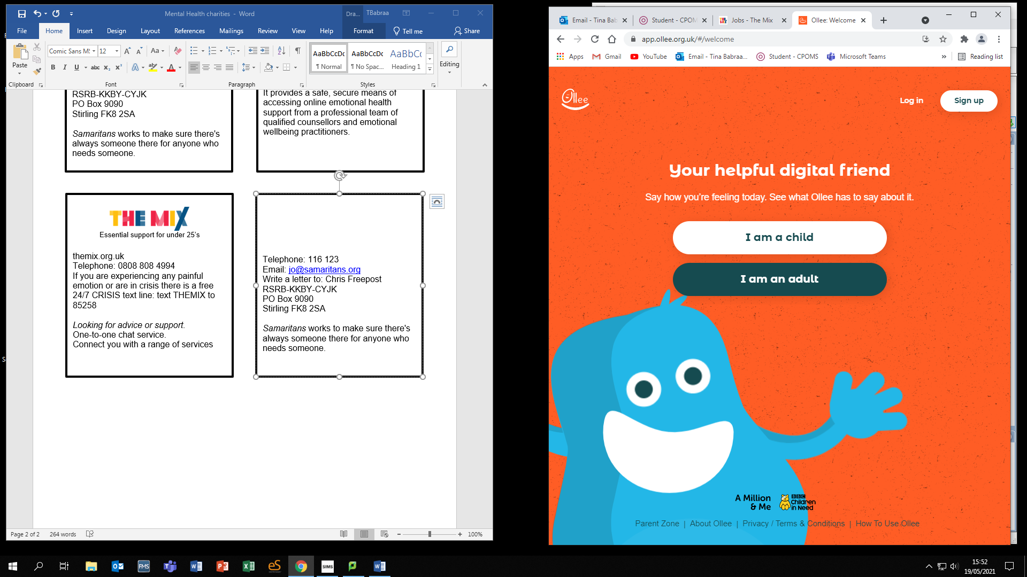

http://app.ollee.org.uk

Ollee is a digital friend for children aged 8-11, created by Parent Zone and funded by BBC Children in Need, which aims to make a difference to children’s emotional wellbeing.



Essential support for under 25’s

themix.org.uk

Telephone: 0808 808 4994

If you are experiencing any painful emotion or are in crisis there is a free 24/7 CRISIS text line: text THEMIX to 85258

Looking for advice or support.

One-to-one chat service.

Connect you with a range of services

