
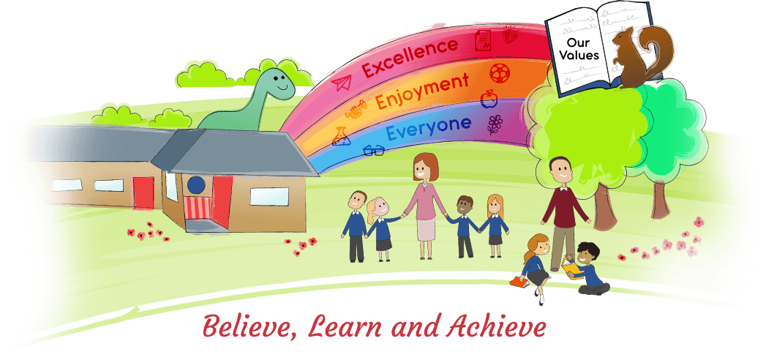


11 March 2019
Dear Parents/Carers,
We are rebranding KIRFS to Rocking Recall!
What was a KIRF I hear you ask?
KIRF
KIRF stands for Key Instant Recall of Facts. These are key skills each children should know in order to develop arithmetic skills such as times tables and number bonds. Each term, these are sent home to be learnt as well as covered during STDTMW. Children are then assessed on their KIRF each term.
Why are we rebranding?
As you know the children love TTRockstars and many of the KIRFs are linked to timetable facts so we going to make the connection between the two to emphasise to the children the importance of practising their timetables. TTRockstars is an awesome website created by teachers to help children learn their timetables facts though games and challenges. They create an avatar and are given rock statuses depending on the time they answer questions in; the highest being a Rock Hero who can answer questions in under a second (WOW!) So far we have 17 Rock Heroes in the school (4 of them are in Year 3!)
Why is learning Rocking Recall facts important?
Learning these facts can significantly help children when learning about fractions, decimals, percentages, area, volume, perimeter multiples, division, multiplication, ratio, proportion, algebra, problem solving, angels, statistics… the list goes on. There has also been a noticeable improvement in class in the children who regularly play TTRockstars not only in academic progress but in their attitude towards maths and their confidence within it.
How can I help?
Attached to this letter is the Rocking Recall facts for each year group this term with suggestions about what can be done at home to support the children in learning them. Also, encouraging them to play TTRockstars regularly will be hugely beneficial too.
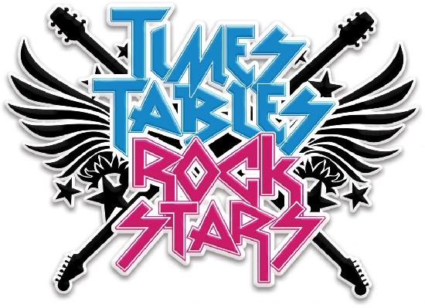
Thanks you for your continuing support and keep on rocking!!!
Mrs Clarke, Miss Wilde and Miss Summerfield.



