
Learning Activities
Nursery 2019-20
Self-isolation learning Week 8
 | Lessons set Plant the Tiny Seed | Additional comments
Monday | Watch the video of the story Plant the Tiny Seed.  https://www.youtube.com/watch?v=MHRDM5nb8Ks  Have you planted a seed before? Do you remember what happened?  What do we already know about plants?  Sequence the pictures in order of how to grow a plant.  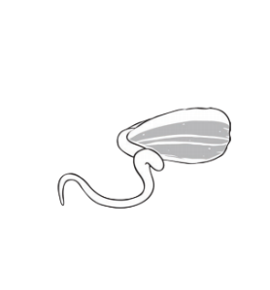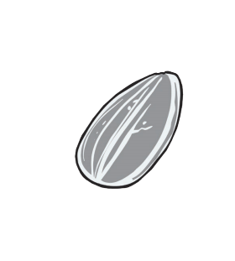  Do you know the different parts of the plants? | Jolly phonics letter s  Take the time with your child to learn the song for the letter s  https://www.youtube.com/watch?v=RrIC8M38DNE
Tuesday | On your daily walk, today look around you at all the beautiful plants and flowers that are out.  Can you spot the flowers and plants on the list?  Have a look at apps online that you can use when on your walk if you have a smart phone.  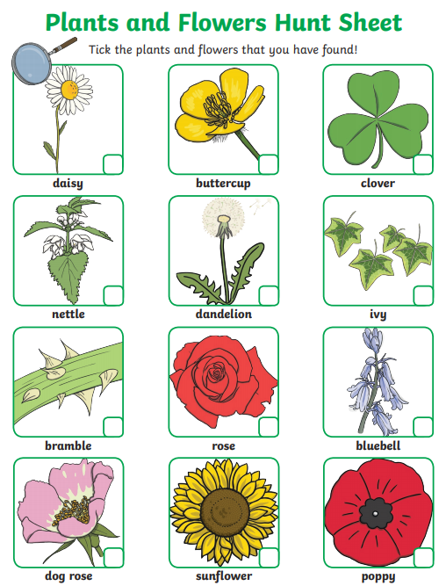  Did you spot any of the flowers from our story Plant the Tiny Seed? Red ones or Purple ones?  Draw a picture of the flowers that you saw on our journey. Which one was your favourite?  Use technology and take a photograph of the flowers that you take. Which ones grow taller? Are there are that are as big as your hand? Finger? Whole body?  Can you find flowers of all different colours? | Jolly phonics letter a  Take the time with your child to learn the song for the letter a  https://www.youtube.com/watch?v=wdG4_FB0A0A
Wednesday | Let's plant a number line. Have a hunt in your garden for 5 sticks. Using cake cases and a kitchen roll, help the children to make flowers.  If you don’t have these things at home what else could you use? Get creative and share your ideas with us.  In each case, put dots inside to represent the numbers 1-5.  Order the number of dots from 1-5 in the correct order. Once they have ordered the dots, can they tell you how many they are? Write the numbers on holes, can they recognise the numerals and match them to the number of dots?  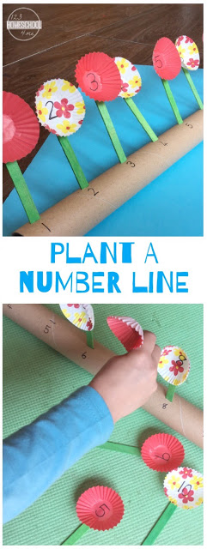  Remember we love seeing pictures - Draw the flowers as a number line include the number if you can. | Jolly phonics letter t  Take the time with your child to learn the song for the letter t  https://www.youtube.com/watch?v=7r2pT-8cOA0
Thursday | Listen to the story, Jack and the Beanstalk.  https://www.youtube.com/watch?v=9q1dfTOoSrA  Learn the poem and the actions as a team at home.  This is my garden (Extend one hand forward, palm up)  I’ll rake it with care, (Make raking motion on palm with 3 fingers of other hand)  I’ve got some small seeds (Use thumb and finger to show small)  To plant right in there. (Plant motion)  The sun will shine (Make circle with hands)  And the rain will fall, (Let fingers flutter down to lap)  My seeds will sprout (Cup hands together; extend upward slowly)  And grow really tall. (Stand on tiptoes and indicate tall)  Can you use technology to perform and record your poem?  Can you come up with any of your own actions? | Jolly phonics letter p  Take the time with your child to learn the song for the letter p  https://www.youtube.com/watch?v=eTEmtADqMFg
Friday | Nature self-portraits.  Look around your garden and on your daily exercise.  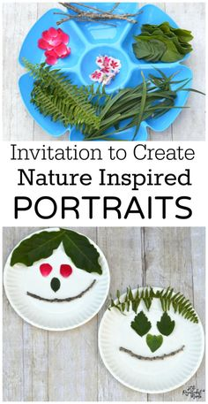  Think about the things that you can collect on your walk. What do you need to make a self-portrait? Look at yourself in the mirror before you start your hunt. Do you have long hair or short hair? Do you have light eyes or dark eyes? Think about how you can use nature to create a picture? Can you make a family portrait? Give each picture a name.  Maybe try using leaves to create different animals.  Can you turn a leaf into a hedgehog?  Could you freeze any leftover create Frozen flowers? | Jolly phonics letter i  Take the time with your child to learn the song for the letter i  https://www.youtube.com/watch?v=RUODVQZfUK0

Learning Activities
Nursery 2019-20

Self-isolation learning Week 9
 | Lessons set The Tiny Seed | Additional comments
Monday | Listen to The Tiny Seed https://www.youtube.com/watch?v=ls6wTeT2cKA  Draw a picture of the flower that grew from The Tiny Seed. Can you remember how the flower grew.  Sequence these pictures in order to what happens during the life cycle of a plant.  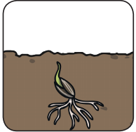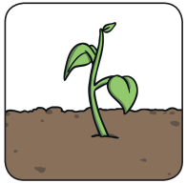  Could you create a flower with toys you have at home or even draw a picture.  What do flowers and plant feel like? Sensory walk? What words would you use to describe them? Rough, smooth? | Jolly phonics letter n  Take the time with your child to learn the song for the letter n  https://www.youtube.com/watch?v=ShOLkFMTU4s
Tuesday | For your snack today, of course, you have to make a beautiful flower that the tiny seed grows into.  Ingredients  1 small orange  A small amount of sunflower seeds  1 small celery piece cut in half  2 spinach or salad leaves from a bag  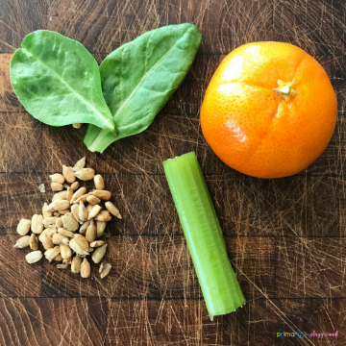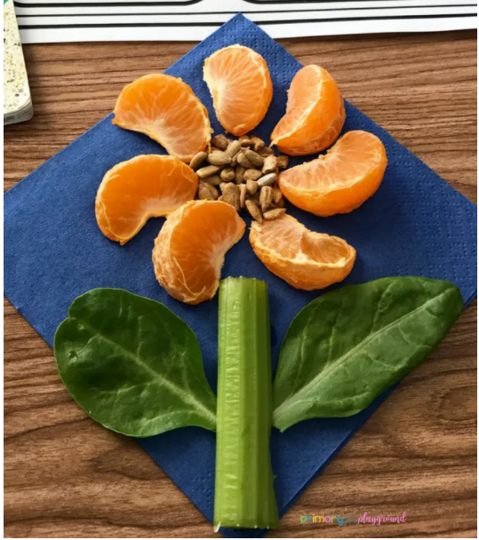  Can you name the parts of the flower? | Jolly phonics letter m  Take the time with your child to learn the song for the letter m  https://www.youtube.com/watch?v=JgHidP5ioJo
Wednesday | Letters and sounds – There’s a fantastic game that is available online to help children with their phonics.  https://www.teachyourmonstertoread.com/  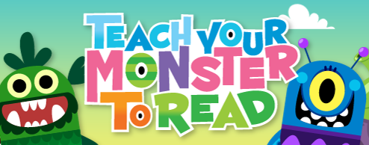  Set your child up an account; it is entirely free on a computer. Help your child work their way through the letters and the levels. | Jolly phonics letter d  Take the time with your child to learn the song for the letter d  https://www.youtube.com/watch?v=boXUMOlw5Ow
Thursday | Listen to Eddie’s Garden and how to make it grow.  https://www.youtube.com/watch?v=OC0V3k_8F_U  Do you remember what was needed to make it grow?  Could you you draw instructions for Eddies to help him to remember?  Go out into the garden and find a flower, can you take it appart and match it with the parts of a flower?  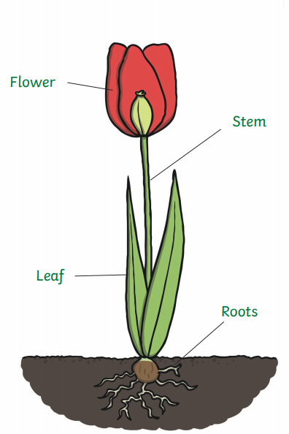 | Jolly phonics letter g  Take the time with your child to learn the song for the letter g  https://www.youtube.com/watch?v=EJlqibssexg
Friday | Have a go at measuring flowers. Count the squares to find out how tall each flower is. What else can you use to measure items in the garden? What else can you measure around the house?  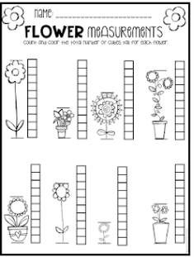  Draw a picture of what you have measured tell big it is. | Jolly phonics letter o  Take the time with your child to learn the song for the letter o  https://www.youtube.com/watch?v=a5npjY6shlI

