
Learning Activities
Nursery 2019-20

Self-isolation learning Week 7
 | Lessons set | Additional comments
Monday | Did you know, you can make honey from dandelion petals? I didn’t know either and we would definitely be trying this if we were at nursery. Why don’t you have a go at home?  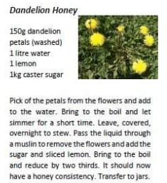
Tuesday | Let’s do a science investigation. In nursery we love finding things to roll balls or cars down. Can you make your own car ramp? (a piece of tubing, a piece of cardboard) How far does the car/ball travel. Can you make it travel further or faster?
Wednesday | Are you missing your friends? Why not make spoon versions of them to play with?  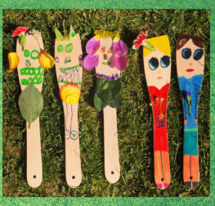  Practise your balancing today. Pretend the floor is lava. Place cushions, towels and tea towels on the floor and navigate your way around without touching the flooring.
Thursday | Fill up some different sized jars with different amounts of water. Add food colouring to make it more interesting.  Now get a metal spoon and make music. Listen really hard to the sounds each jar makes, are they different? Now have fun making and pouring your own potions.  Make a pictogram of your families favourite things.  You could choose colours, fruit, vegetables. Ask each family member what their favourite thing is and add a cube to your chart. What did people like most/least. How many cubes altogether? Call other family members and ask them too.  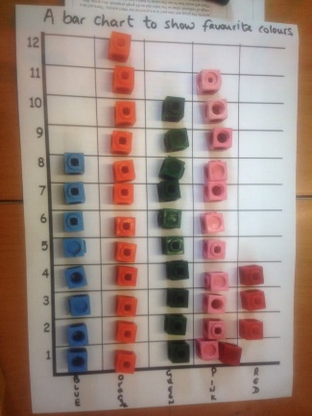
Friday | Build a good old fashioned den in your house or garden.  Read your favourite book with an adult in your den then draw a picture of the story. Post it onto the Twitter page to see if we can guess what you read.  You could even make your own ice cream in 5 minutes to enjoy in your den with some tasty fruit.  https://www.food.com/recipe/5-min-ice-cream-192039

