
Learning Activities
Nursery 2019-20

Self-isolation learning Week 5
 | Lessons set | Additional comments
Monday | Make your own set of pick up sticks.  Use spaghetti or collect twigs. Paint each end in the same colour. Then drop them from a height and try to pick them up without moving others.  Can you compare the sizes of the sticks?  How many sticks have you got?  What would happen to the number if you found two more sticks?
Tuesday | Take a piece of paper and some crayons around the house and create different rubbings of different textures. Cut them out in basic shapes to create a picture. What is your favourite texture? How did the different textures feel?  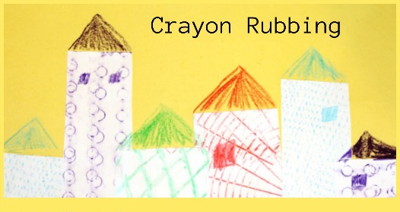
Wednesday | Number a piece of paper 1-5.  Go around the garden or when out on your walk ask your child to collect a certain amount of an object. E.g. 5 twigs, 4 leaves, 3 stones, 2 flowers, 1 feather.  Then see if they can match the quantity to the correct numeral on the piece of paper.  Use the items you collected to create a natural art picture.
Thursday | Bubble blowing.  Cut the bottom off of a plastic bottle and cover it with a sock. Dip the sock into some water with washing up liquid in and blow through the top. Look what happens. How big can you get your bubble stream?  What happens to your bubble stream the longer you blow?
Friday | Adult: Cut some long strips of paper and draw different shape lines on each; straight, zig zag, curved, random. Then stick them to the edge of a table. Get your child to practise cuttting along the lines. Encourage them to hold the sheet of paper with one hand and cut with the other.  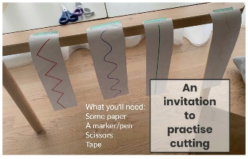  Now put some different textures into trays e.g. flour, sugar, sand and encourage your child to make the patterns they just cut with their finger or using a pencil.

Learning Activities
Nursery 2019-20

Self-isolation learning Week 6
 | Lessons set | Additional comments
Monday | There are lots of bugs out at the moment, see what you can find hiding around your garden.  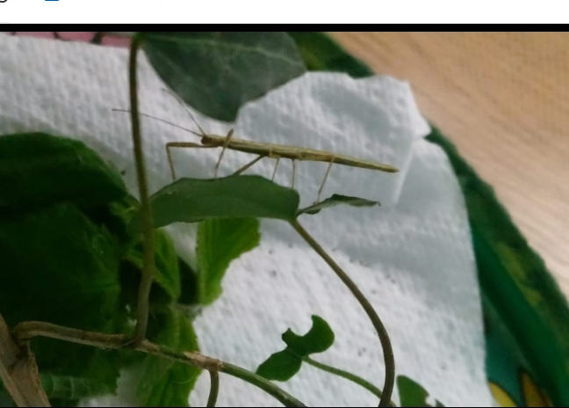  Have a go at building a mini beast hotel outside. There are lots of ideas on the internet. Think about what we have learnt that animals need. Here is a picture of our stick insects happy in their home.  Listen to the ugly bug ball song, can you sing along?
Tuesday | Make a playdough bug and see if you can explore patterns on your bug. Use coloured beads to create patterns along your bug.  Can you draw our school stick insects and think of names for them?
Wednesday | Sing and add the actions to head, shoulders, knees and toes.  Now draw around a family member’s body in chalk outside. Can you name some different parts of the body; head, ears, neck, shoulders, arms, legs, hands, feet, knee, elbow, fingers, toes. What else can you name?  Can you hear any sounds in the words? Have a go at writing these letters.
Thursday | Have a go at making an alphabet museum. Choose some sounds you have learnt and write it nice and big inside a box. Now go on a hunt around the house to see what you can find beginning with that sound. I can’t wait to see your museums on Twitter.  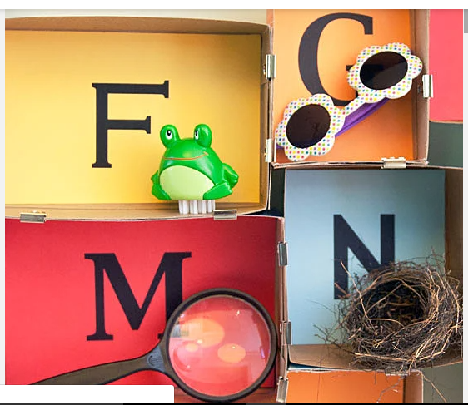  Once your museum is complete ask an adult to hide some of the objects around the room. You then need to find the object starting with the letter your adult says, e.g. “Find me a p.”
Friday | Below are some pictures from the Hungry Caterpillar story. Read this story with an adult then have a go at putting the pictures in the correct order.  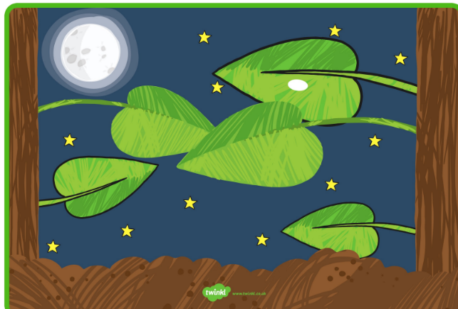  Can you create your own pictures to order for your favourite story book?  

