
Learning Activities
Year 6 2019-20

Hello Year 6,
We hope everyone is well and enjoying their new school experience.
Please follow the links to complete the assigned work below.
If there are any issues, or you would like to send us any of your fantastic learning, just email us using the email address on the website.

Self-isolation learning Week 14
 | Lesson set |  | Additional comments
Monday | GPAS  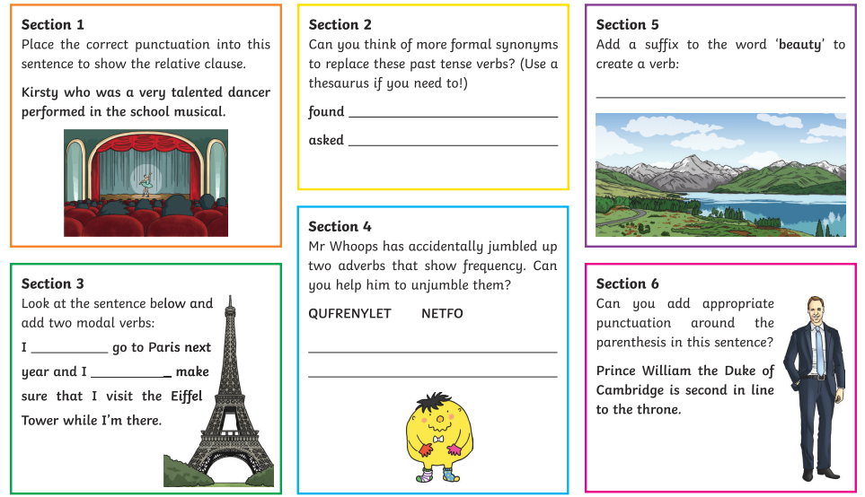  English  This week you are going to create a comic strip about a squirrel who lives in the Forest school. Today you will need to develop your character… the squirrel. What kind of character will you develop? A good guy? A bad guy? A superhero? A spy? Do they have magical powers? Or are they a regular squirrel?  Write a description using interesting adjectives (use a thesaurus) and draw a picture  Reading  Read Chapter 8 of The Boy in the Tower and write a summary of the chapter  Maths  Find maths lesson for today’s date https://www.bbc.co.uk/bitesize/tags/zncsscw/year-6-and-p7-lessons  Swingate Olympic Project  See separate sheet |  | Daily Reading  TT Rockstars
Tuesday | GPAS  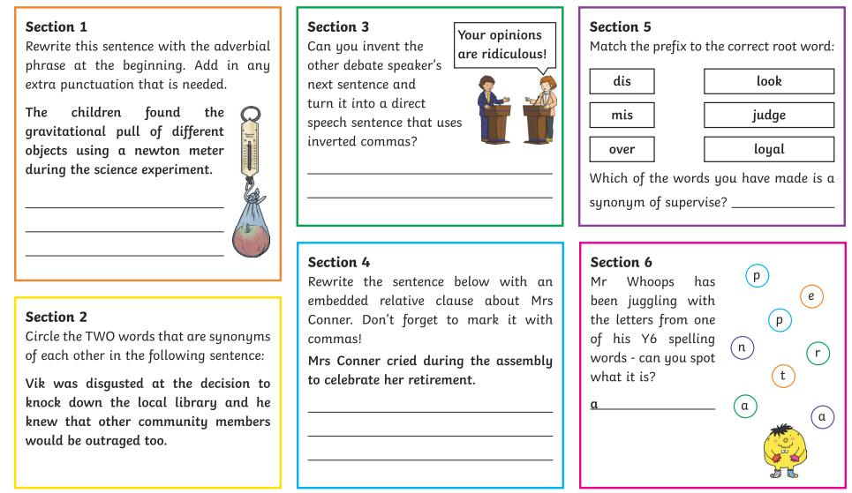  English  Today you are going to plan a short story for your squirrel character. What adventure are they going to go on? Will they discover an evil plan from a fiendish fox? Will they go through a magical fairy door? Will they meet a child from Swingate? Are they plotting to kidnap Mrs Webb??? Use your imagination and go wild!  Reading  Read Chapter 9 of The Boy in the Tower and write a summary of the chapter  Maths  Find maths lesson for today’s date https://www.bbc.co.uk/bitesize/tags/zncsscw/year-6-and-p7-lessons  Swingate Olympic Project  See separate sheet |  | Daily Reading  TT Rockstars
Wednesday |  | GPAS  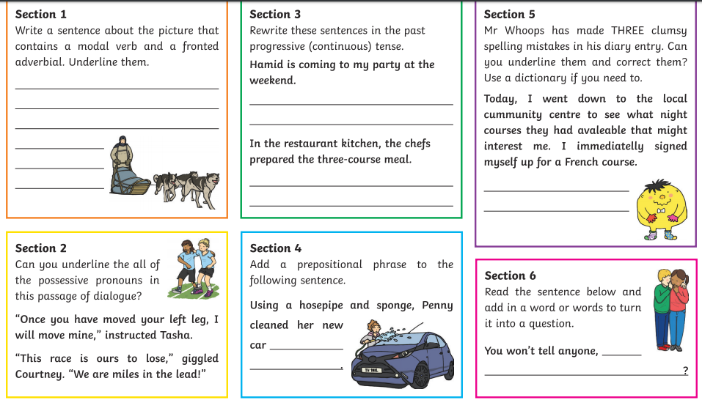  English  Look at the Powerpoint about the features of a comic strip and use this to start writing up your comic. Use as many of these features as possible. Print or copy the template onto plain paper and begin!  Reading  Complete Activity 5 from The Boy in the Tower PowerPoint  Maths  Find maths lesson for today’s date https://www.bbc.co.uk/bitesize/tags/zncsscw/year-6-and-p7-lessons  Swingate Olympic Project  See separate sheet | Daily Reading  TT Rockstars
Thursday | GPAS  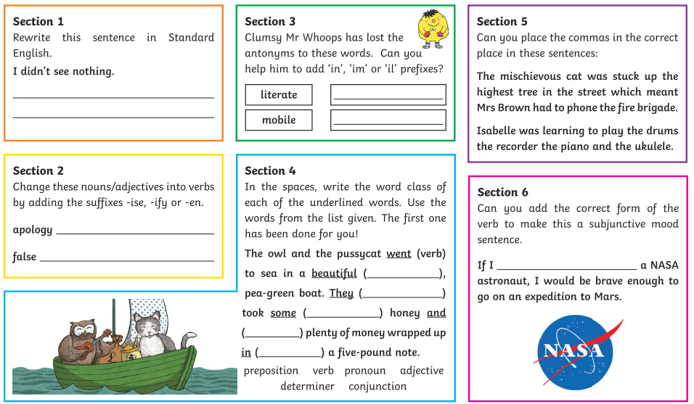  English  Finish your comic strip. Don’t forget to edit it!  Reading  Write a review for what you have read so far  Use this structure  1. Start with a couple of sentences describing what the book is about  But without giving any spoilers or revealing plot twists! As a general rule, try to avoid writing in detail about anything that happens from about the middle of the book onwards. If the book is part of a series, it can be useful to mention this, and whether you think you'd need to have read other books in the series to enjoy this one.  2. Discuss what you particularly liked about the book  Focus on your thoughts and feelings about the story and the way it was told. You could try answering a couple of the following questions:  - Who was your favourite character, and why?  - Did the characters feel real to you?  - Did the story keep you guessing?  - What was your favourite part of the book, and why?  - Were certain types of scene written particularly well - for example sad scenes, tense scenes, mysterious ones...?  - Did the book make you laugh or cry?  - Did the story grip you and keep you turning the pages?  3. Mention anything you disliked about the book  Talk about why you think it didn't work for you.  - Did you wish the ending hadn't been a cliffhanger because you found it frustrating?  - Did you find it difficult to care about a main character, and could you work out why?  - Was the story too scary for your liking, or did it focus on a theme you didn't find interesting?  4. Round up your review  Summarise some of your thoughts on the book by suggesting the type of reader you'd recommend the book to. For example: younger readers, older readers, fans of relationship drama/mystery stories/comedy. Are there any books or series you would compare it to?  5. You can give the book a rating, for example a mark out of five or ten, if you like!  Maths  Find maths lesson for today’s date https://www.bbc.co.uk/bitesize/tags/zncsscw/year-6-and-p7-lessons  Swingate Olympic Project  See separate sheet |  | Daily Reading  TT Rockstars
Friday | GPAS  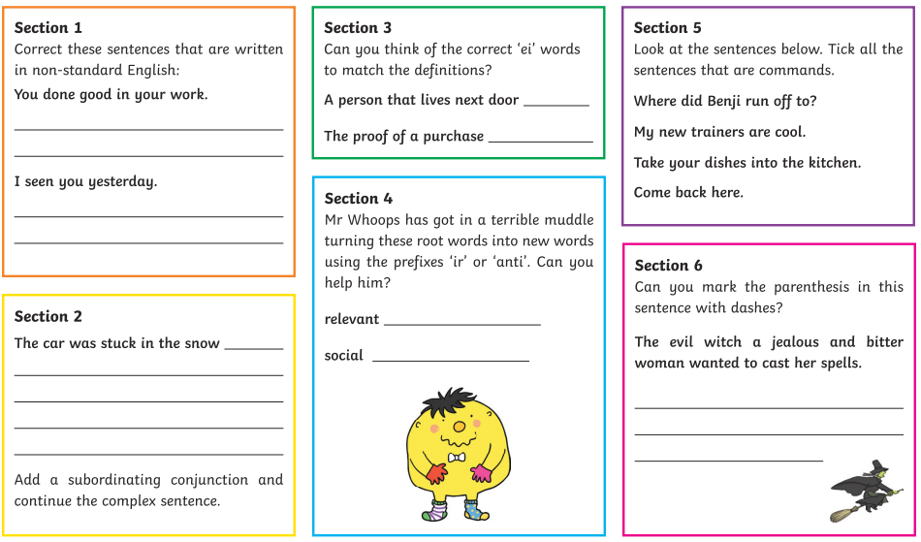  English  Write a letter to Miss Boon with all your favourite memories of Swingate. She would love to hear them! Post it or drop it off at the school office when it is safe to do so.  Reading  Research and write a list of books you would like to read over the summer holiday. Read their blurbs (on amazon or Waterstone website) and see if they take your fancy. Here are some ones to start researching.  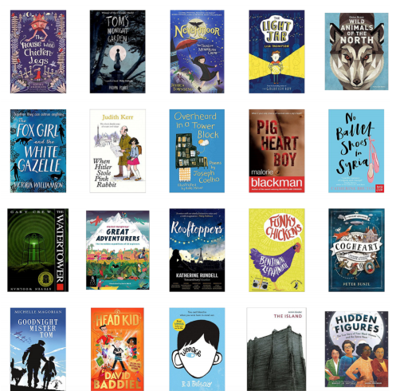  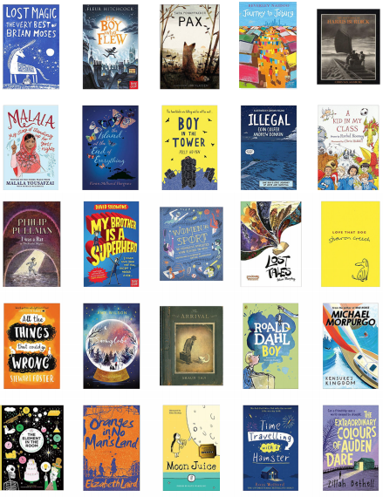  Maths  Find maths lesson for today’s date https://www.bbc.co.uk/bitesize/tags/zncsscw/year-6-and-p7-lessons  Swingate Olympic Project  See separate sheet |  | Daily Reading  TT Rockstars

Extra learning over summer.
If you would like to do any extra learning over the summer to boost your brains ready for secondary school use these websites:
https://www.bbc.co.uk/bitesize/tags/zncsscw/year-6-and-p7-lessons
https://classroom.thenational.academy/subjects-by-year/year-6
https://play.ttrockstars.com/
https://home.oxfordowl.co.uk/

Summer Holiday Homework!

- Make tie dye shirts
- Run through sprinklers
- Build a sandcastle
- Make fresh lemonade
- Make homemade ice cream
- Have a water balloon fight
- Go on a nature walk
- Make friendship bracelets
- Read a library of books
- Make a blanket fort
- PJ movie day
- Start a gratitude jar
- Stargaze
- Have a picnic
- Fly a kite
- Dance in the rain
- Play Frisbee
- Watch the sunset/sunrise
- Eat breakfast for dinner
- Make s’mores
- Play hide and seek
- Climb a tree
- Help cook dinner
- Host a scavenger hunt
- Family game night
- Write a letter to a family member/friend far away
- Make homemade pizza
- Make handprint art
- Go cloud watching
- Plant flowers
- Play tennis
- Watch a thunderstorm
- Do a science project
- Random act of kindness
- Learn origami
- Bake cookies for neighbours
- Make a bird feeder
- Write a story and illustrate it
- Bury a time capsule
- Play bingo
- Start a summer journal

