
Learning Activities
Year 6 2019-20

Hello Year 6,
We hope everyone is well and enjoying their new school experience.
Please follow the links to complete the assigned work below.
If there are any issues, or you would like to send us any of your fantastic learning, just email us using the email address on the website.

Self-isolation learning Week 12
 | Lesson set | Additional comments
Monday | GPAS Using semi colons  https://www.bbc.co.uk/bitesize/articles/zdtny9q  Complete activities 1 & 2 only  English  This week, you are going to be writing an autobiography. What is that?  https://www.theschoolrun.com/what-are-biography-and-autobiography  Have a look at some examples of autobiographies. Do you have any at home?  What are the features of them? What should they contain? How should they be written?  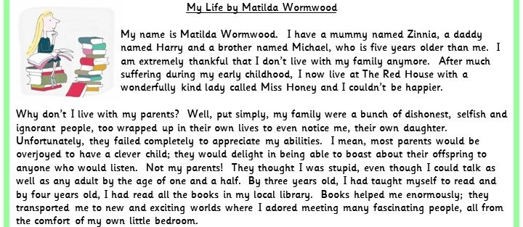  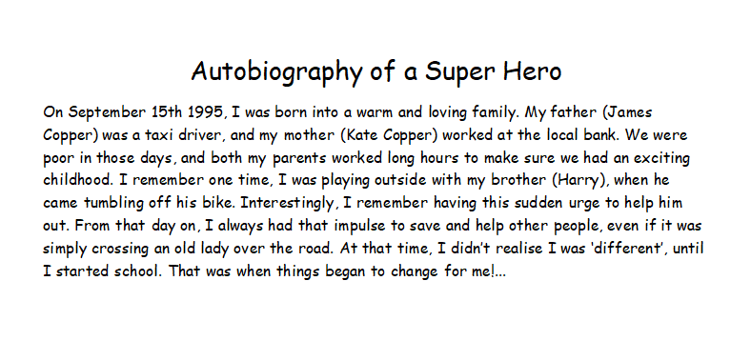  July 9th 1942: “Here’s a description of the building… A wooden staircase leads from the downstairs hallway to the third floor. At the top of the stairs is a landing, with doors on either side. The door on the left takes you up to the spice storage area, attic and loft in the front part of the house. A typically Dutch, very steep, ankle-twisting flight of stairs also runs from the front part of the house to another door opening onto the street. The door to the right of the landing leads to the Secret Annex at the back of the house. No one would ever suspect there were so many rooms behind that plain grey door. There’s just one small step in front of the door, and then you’re inside. Straight ahead of you is a steep flight of stairs. To the left is a narrow hallway opening onto a room that serves as the Frank family’s living room and bedroom. Next door is a smaller room, the bedroom and study of the two young ladies of the family. To the right of the stairs is a windowless washroom with a sink. The door in the corner leads to the toilet and another one to Margot’s and my room… Now I’ve introduced you to the whole of our lovely Annex!”- The Diary of Anne Frank  Create a checklist of the key features.  Reading  Read Chapter 1 of The Boy in the Tower, write a summary of the chapter and complete Monday’s Activity on the Powerpoint  Maths  Find maths lesson for today’s date https://www.bbc.co.uk/bitesize/tags/zncsscw/year-6-and-p7-lessons  Local Area Project  See separate pack | Daily Reading  TT Rockstars
Tuesday | GPAS  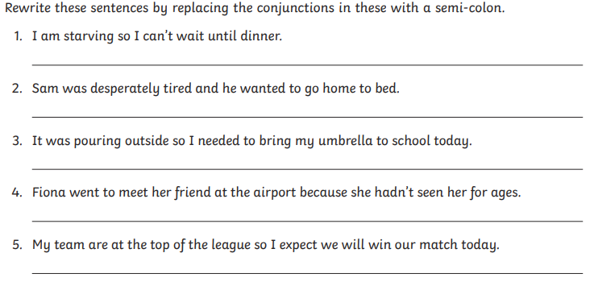  Answers:  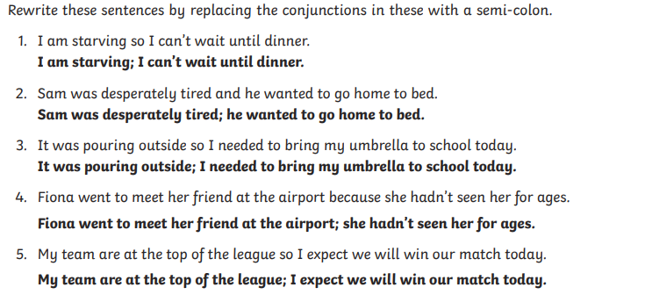  English  Check your checklist of features from yesterday using this:  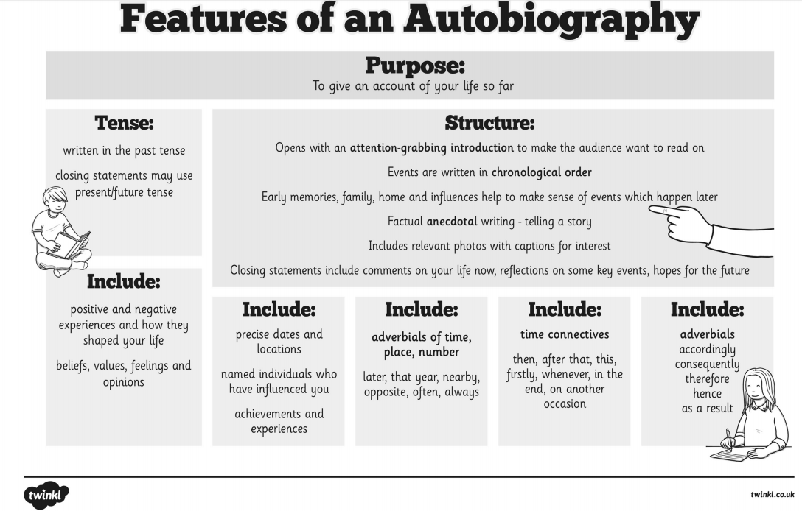  If you missed any, add them to your checklist.  You are going to imagine that you are 30 years old and you are going to write an autobiography of your life so far.  Use the planning format- ‘Writing my Future’ to think about what you could include in it. You can choose how to plan your writing.  Reading  Complete Activity 2 from The Boy in the Tower PowerPoint  Maths  Find maths lesson for today’s date https://www.bbc.co.uk/bitesize/tags/zncsscw/year-6-and-p7-lessons  Local Area Project  See separate pack | Daily Reading  TT Rockstars
Wednesday | GPAS-Using commas, brackets and dashes  https://www.bbc.co.uk/bitesize/articles/zrdyvk7  Complete Activities 1 and 2 only  English  Today, use your plan to write the first half of your autobiography. Concentrate today on your childhood and school life.  Reading  Read Chapter 2 of The Boy in the Tower and write a summary of the chapter  Maths  Find maths lesson for today’s date https://www.bbc.co.uk/bitesize/tags/zncsscw/year-6-and-p7-lessons  Local Area Project  See separate pack | Daily Reading  TT Rockstars
Thursday | GPAS  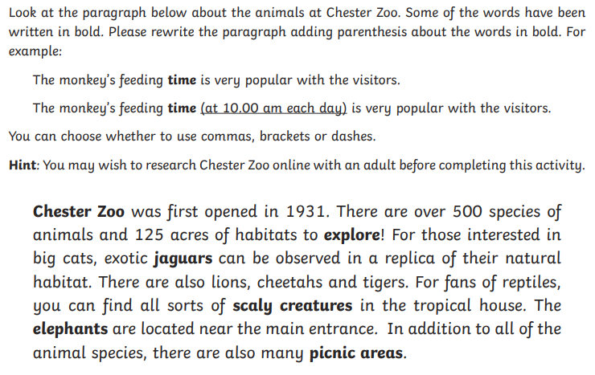  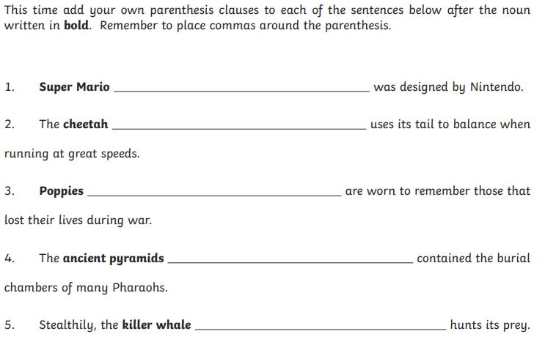  English  Today, use your plan to write the second half of your autobiography. Concentrate today on jobs and your adult life.  Reading  Complete Activity 3 from The Boy in the Tower PowerPoint  Maths  Find maths lesson for today’s date https://www.bbc.co.uk/bitesize/tags/zncsscw/year-6-and-p7-lessons  Local Area Project  See separate pack | Daily Reading  TT Rockstars
Friday | Spellings  https://www.bbc.co.uk/bitesize/articles/zmbsy9q  Creative writing  Write the beginning of this story. How did the children end up like this? You have 10 minutes to plan and 20 minutes to write.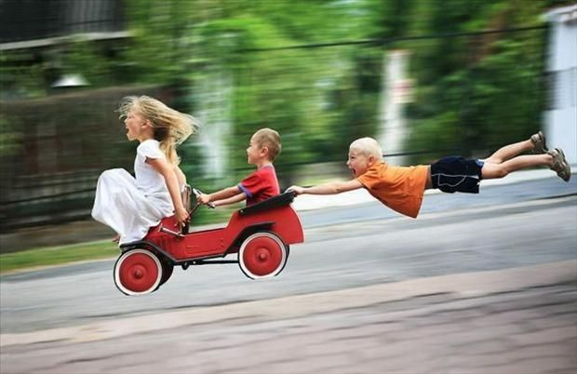  Reading  Read Chapter 3/4 of The Boy in the Tower and write a summary of the chapters  Maths  Find maths lesson for today’s date https://www.bbc.co.uk/bitesize/tags/zncsscw/year-6-and-p7-lessons  Local Area Project  See separate pack | Daily Reading  TT Rockstars

Learning Activities
Year 6 2019-20

Self-isolation learning Week 13

 | Lesson Set | Additional Comments
Monday | GPAS- direct and indirect speech  https://www.bbc.co.uk/bitesize/articles/zmy8qnb  Complete activities 1 & 2 only  English  For the next two days, you are going to create an information leaflet for parents of children joining Swingate in September.  Have a look at lesson 3&4 of the Information leaflet lessons on Oak National Academy:  https://classroom.thenational.academy/subjects-by-year/year-6/subjects/english/  Today, plan what information you are going to put into your leaflet. What do parents need to know for their children?  Reading  Read Chapter 5 of The Boy in the Tower and write a summary of the chapter  Maths  Find maths lesson for today’s date https://www.bbc.co.uk/bitesize/tags/zncsscw/year-6-and-p7-lessons  Spanish Project  See separate pack | Daily Reading  TT Rockstars
Tuesday | GPAS- Using relative clauses  https://www.bbc.co.uk/bitesize/articles/z6g98xs  Complete activities 1 & 2 only  English  Today, create your information leaflet for new parents at Swingate Primary. You may choose how to present the information.  Reading  Read Chapter 6 of The Boy in the Tower and write a summary of the chapter  Maths  Find maths lesson for today’s date https://www.bbc.co.uk/bitesize/tags/zncsscw/year-6-and-p7-lessons  Spanish Project  See separate pack | Daily Reading  TT Rockstars
Wednesday | GPAS-Using verbs and modal verbs  https://www.bbc.co.uk/bitesize/articles/z4y492p  Complete activities 1 & 2 only  English  For the next two days you are going to be writing a letter to your new form tutor.  https://www.bbc.co.uk/bitesize/articles/zmbr47h  Today, plan your letter. Think about what it is you want them to know about you. What do you want to find out from them? You can use the planning format to help you with your ideas.  Reading  Read Chapter 7 of The Boy in the Tower and write a summary of the chapter  Maths  Find maths lesson for today’s date https://www.bbc.co.uk/bitesize/tags/zncsscw/year-6-and-p7-lessons  Spanish Project  See separate pack | Daily Reading  TT Rockstars
Thursday | GPAS- Using hyperbole and metaphors  https://www.bbc.co.uk/bitesize/articles/zhcc92p  Complete activities 1 & 2 only  English  Write your letter to your new form tutor. Remember to use neat handwriting and a dictionary to check spellings – you want to create a good first impression. When you find you who your tutor is going to be – post it to your new school  Reading  Complete Activity 4 from The Boy in the Tower PowerPoint  Maths  Find maths lesson for today’s date https://www.bbc.co.uk/bitesize/tags/zncsscw/year-6-and-p7-lessons  Spanish Project  See separate pack | Daily Reading  TT Rockstars
Friday | Creative Writing  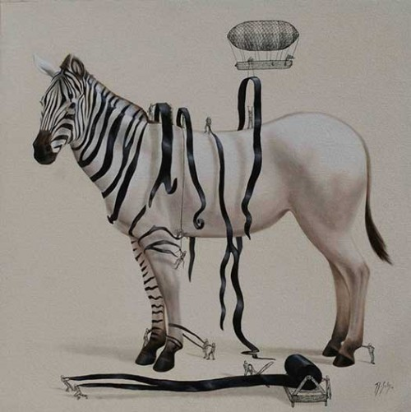  How did the zebra lose his stripes? Who are the people? What are they doing? What do they need the stripes for?  Create a story. You have 10 minutes to plan what you are going to write.  Reading  Complete Activity 5 from The Boy in the Tower PowerPoint  Maths  Find maths lesson for today’s date https://www.bbc.co.uk/bitesize/tags/zncsscw/year-6-and-p7-lessons  Spanish Project  See separate pack | Daily Reading  TT Rockstars

Creative curriculum



