Local Area Project – Rochester
Monday
This week we will be learning about the city of Rochester. Today, you will need to research where Rochester is on a map and list the Geographical features on a table split into physical and human.
(Remember Physical geography looks at the natural processes of the Earth, such as climate and plate tectonics. Human geography looks at the impact and behaviour of people and how they relate to the physical world.)
Physical | Human
River | Castle

Now answer the question: Why is Rochester an important city?

Tuesday
Rochester has such a rich history. Today you will need to create a timeline of Rochester including when the castle and cathedral were built. How far back does its history go?
Here are some examples of layouts. (Note these are NOT Rochester timelines)
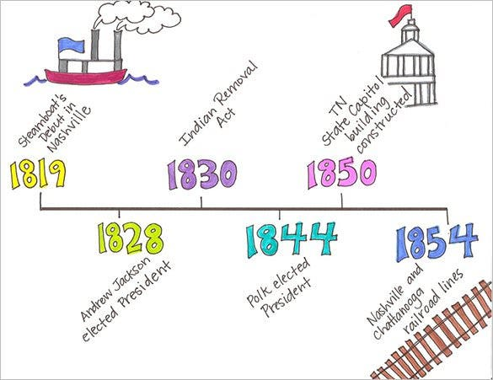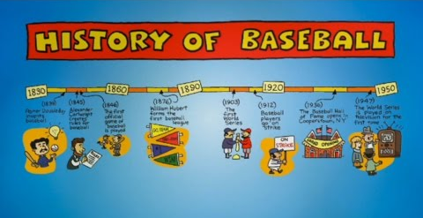
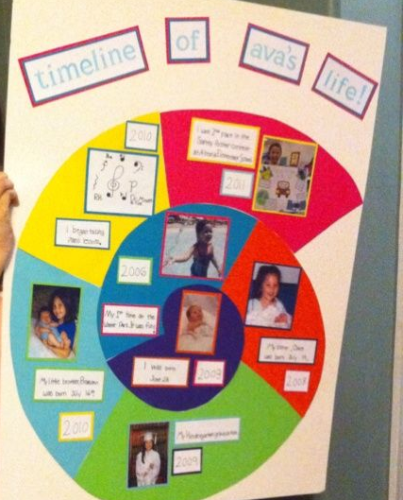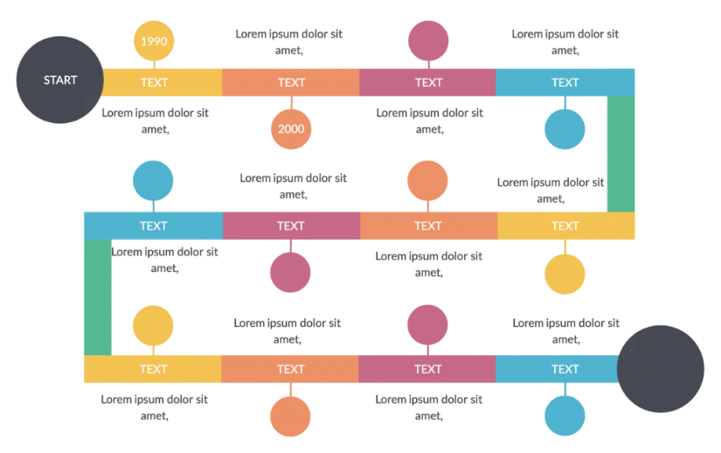

Wednesday
Charles Dickens is the most famous person linked to Rochester but why? Who is he? Why is he famous? What is his history with Rochester? What are the famous buildings/places in Rochester associated with him? Locate these on a map of Rochester.

Thursday
Rochester is situated on the banks of the River Medway. Why do you think settlers chose to build a city here? The castle is built right next to the river – why? The River Medway had many castles and forts built along its banks. Draw a map of the River Medway and locate the castles and forts built along it.

Friday


