
Learning Activities
Year 6 2019-20

Hello Year 6,
We hope everyone is well and enjoying their new school experience.
Please follow the links to complete the assigned work below.
If there are any issues, or you would like to send us any of your fantastic learning, just email us using the email address on the website.

Self-isolation learning Week 8
 | Lesson set | Additional comments
Monday | GPAS- https://www.youtube.com/watch?v=kSGMWCq-UHQ  Phrases, clauses and sentences  English  Watch ‘Catch-a-lot’  https://www.literacyshed.com/catch-a-lot.html  This week, the story has no dialogue. You are going to rewrite the story, including conversations between the two characters and descriptions of the events. Today, watch the video a few times, looking closely at their facial expressions and body language. What can you infer about the characters and their feelings from their actions? What might they be saying?  Reading  Listen to the extract To be a Cat and choose at least one of the activities to answer  https://www.bbc.co.uk/bitesize/articles/zbkbgwx  Maths  Find maths lesson for today’s date https://www.bbc.co.uk/bitesize/tags/zncsscw/year-6-and-p7-lessons  PSHE  Starting Secondary School  Follow lesson on https://www.bbc.co.uk/bitesize/articles/zj2grj6 | Daily Reading  TT Rockstars
Tuesday | GPAS- http://www.ictgames.com/mobilePage/lcwc/index.html  -ible and –able patterns. These can be found under Y5/6 patterns.  English  Watch ‘Catch-a-lot’  https://www.literacyshed.com/catch-a-lot.html  Remind yourself of how to write direct speech.  https://www.bbc.co.uk/bitesize/topics/zvwwxnb/articles/ztcp97h  Choose a section of the video and practise writing part of the conversation.  Double check using the checklist, if you have accurately punctuated your sentences:  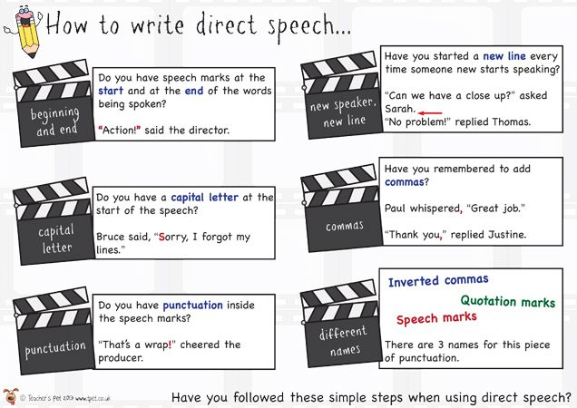  Go back and edit, making any improvements.  https://www.lexico.com/grammar/punctuation-in-direct-speech  Use the video to plan your story in a style you prefer.  Reading  Listen to the extract and choose at least one of the activities to answer  https://www.bbc.co.uk/bitesize/articles/zfx6t39  Maths  Find maths lesson for today’s date https://www.bbc.co.uk/bitesize/tags/zncsscw/year-6-and-p7-lessons  Science  https://www.bbc.co.uk/bitesize/articles/z7ww7nb  Life cycles – watch the videos and complete online activities. Then complete worksheet titled ‘The Mammal Life Cycle’ | Daily Reading  TT Rockstars
Wednesday | GPAS- https://www.youtube.com/watch?v=CQBcWXO_oVQ  English  Watch ‘Catch-a-lot’  https://www.literacyshed.com/catch-a-lot.html  Today, you are going to write the first half of your story. Remember to punctuate any speech correctly. Refer back to your learning and the checklist yesterday as a reminder.  Reading  Listen to the extract and choose at least one of the activities to answer  https://www.bbc.co.uk/bitesize/articles/zdnkd6f  Maths  Find maths lesson for today’s date https://www.bbc.co.uk/bitesize/tags/zncsscw/year-6-and-p7-lessons  History  Research a famous scientist and create a timeline of their life. Why are they significant in our history?  Here are some ideas for scientists:  - Stephen Hawking  - Alexander Fleming  - Mary Leakey  - Daniel Hale Williams  - Marie Curie  - Katherine Johnson  Don’t forget to include: when they were born, events in childhood, when they went to school, events in adulthood. It can be created using pen and paper or on a computer. | Daily Reading  TT Rockstars
Thursday | GPAS- http://www.ictgames.com/mobilePage/lcwc/index.html  -ibly and –ably patterns. These can be found under Y5/6 patterns.  English  Watch ‘Catch-a-lot’  https://www.literacyshed.com/catch-a-lot.html  Today, you are going to write the second half of your story. Remember to punctuate any speech correctly. Refer back to your learning and the checklist yesterday as a reminder.  Reading  Listen to the extract and choose at least one of the activities to answer  https://www.bbc.co.uk/bitesize/articles/zj74kmn  Maths  Find maths lesson for today’s date https://www.bbc.co.uk/bitesize/tags/zncsscw/year-6-and-p7-lessons  Geography  Today you will be looking at two different countries and comparing the similarities and differences between their physical and human geographical features. Remember Physical geography looks at the natural processes of the Earth, such as climate and plate tectonics. Human geography looks at the impact and behaviour of people and how they relate to the physical world.  There are 4 different areas to from (Haiti, Japan, Sicily, South West England – see separate sheets week 10 geography fact sheets). Record your answers on the worksheet (see separate sheet week 10 Geography comparing places sheet) OR draw the table in your workbooks. | Daily Reading  TT Rockstars
Friday | GPAS- https://resources.hwb.wales.gov.uk/VTC/sentence_detectives/eng/Introduction/MainSession.htm  English- Creative writing    Write a description of where the stairs lead to.  Reading  Listen to the extract and choose at least one of the activities to answer  https://www.bbc.co.uk/bitesize/articles/zvhhnrd  Maths  Find maths lesson for today’s date https://www.bbc.co.uk/bitesize/tags/zncsscw/year-6-and-p7-lessons  Art  Zentangle - “ZEN” means calm and “TANGLE” means a collection of overlapping patterns. ZENTANGLE is the bringing together of the calm and the pattern. Today we would like you to create a Zentangle picture of your own. Here are some ideas:  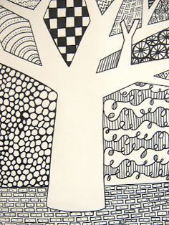  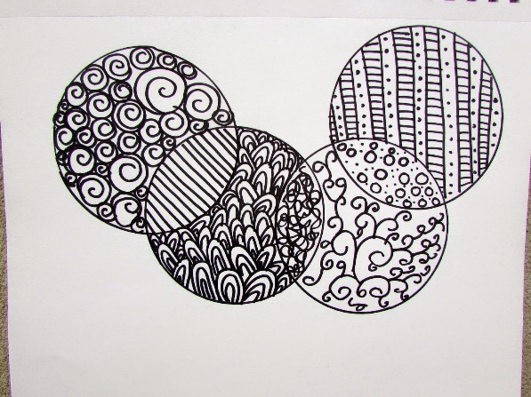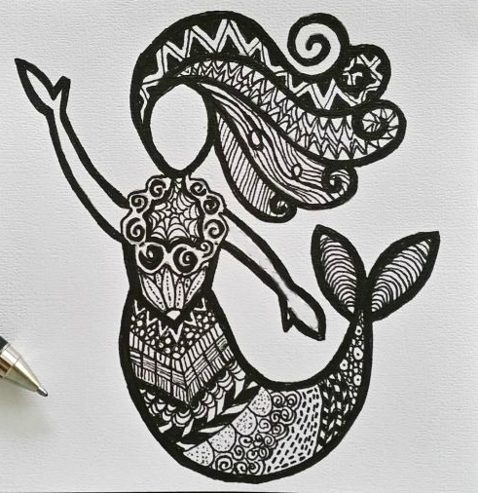  Here is a how to guide https://kinderart.com/blog/zentangles-101/  Watch this video to learn more https://www.youtube.com/watch?v=qBwHUKHUdD8 | Daily Reading  TT Rockstars

Learning Activities
Year 6 2019-20

Self-isolation learning Week 4

 | Lesson Set | Additional Comments
Monday | GPAS- https://www.youtube.com/watch?v=sueh1OKXp78&list=PLB5TN0ac12P8J5P-tZMMY84pmEIQY6Pep&index=11  Try to use apostrophes accurately in your writing this week.  English  Watch ‘3 Little Pigs’  https://www.literacyshed.com/3littlepigs.html  This week, you have a choice. You are going to be a lawyer either defending the 3 little pigs or trying to prove that they are guilty of murder. Whichever side you take, you will be writing a speech to persuade the judge to find the pigs either innocent or guilty.  Today, watch the video a few times and make notes about what happened. Think carefully about the events, the reasons and what arguments the opposing side may have.  Reading  Listen to the extract and choose at least one of the activities to answer  https://www.bbc.co.uk/bitesize/articles/zvhq7nb  Maths  Find maths lesson for today’s date https://www.bbc.co.uk/bitesize/tags/zncsscw/year-6-and-p7-lessons  Enterprise Project!  This week you are going to be budding entrepreneurs. You will create an imaginary business with an imaginary £5 budget. Use the booklet to help develop your business plan – can’t wait to see what you come up with! There is an accompany booklet to support this project – it does not need to be printed but can be used as a guide for how to complete each activity.  Think it!  Use the space on page 4 in the booklet to draw or write down all your ideas of the businesses you could start with just £5. For example, you could sell stickers or reusable straws, wash cars or walk dogs! On page 5 and 6 you can think of your business ideas, choose one and then create your business name and create your logo. Use the “Top tips for creating a logo” sheet to make your logo the best it can be! | Daily Reading  TT Rockstars
Tuesday | GPAS- http://www.ictgames.com/mobilePage/lcwc/index.html  -c-ei (I before e, except after c) patterns. These can be found under Y5/6 patterns.  English  Watch ‘3 Little Pigs’  https://www.literacyshed.com/3littlepigs.html  How to persuade a reader or listener:  https://www.bbc.co.uk/bitesize/topics/zv7fqp3/articles/zr8cmfr  Plan your persuasive speech, focusing on the mnemonic  ‘PERSUADE’  Persuade  Emotive language  Rhetorical Questions  Say again (Repeat)  Undermine the opposition  Anecdote (short story from real life)  Direct address  Exaggeration  Use the 3 Little Pigs video to look for events that you could apply these techniques to.  Remember your challenge-Apostrophes  Reading  Listen to the extract and choose at least one of the activities to answer  https://www.bbc.co.uk/bitesize/articles/zbk492p  Maths  Find maths lesson for today’s date https://www.bbc.co.uk/bitesize/tags/zncsscw/year-6-and-p7-lessons  Enterprise Project!  Find out what your customers might want from your product or service by doing Remote Market Research. Use the “Remote Market Research Survey Template”, adding in your questions and asking friends and family what they think about your business. There are examples of questions on page 7 of the workbook too! Please note - this survey is only to be completed at home under parent/career supervision if necessary. You can use the telephone or email to get answers from people not in your house but only if you know the people already. | Daily Reading  TT Rockstars
Wednesday | GPAS-  https://www.bbc.co.uk/bitesize/topics/zcc2gdm/articles/zsn3msg  Use a thesaurus at home or online. Identify 5 words you could use in your writing. Double check the synonym makes sense in the context of the sentence.  English  Watch ‘3 Little Pigs’  https://www.literacyshed.com/3littlepigs.html  Write the first half of your speech. Remember to refer back to your plan to make sure you have the key events and have used the persuasive techniques.  Reading  Listen to the extract and choose at least one of the activities to answer  https://www.bbc.co.uk/bitesize/articles/zvwr47h  Maths  Find maths lesson for today’s date https://www.bbc.co.uk/bitesize/tags/zncsscw/year-6-and-p7-lessons  Enterprise Project  Fill in the business plan to see what the important parts of your business are using pages 8 & 9. Use the space on page 10 to draw your product or create a poster to attract customers. Answering the questions will help you to understand all the details of your imaginary business! | Daily Reading  TT Rockstars
Thursday | GPAS- http://www.ictgames.com/mobilePage/lcwc/index.html  Tricky Words Set 1. These can be found under Y5/6 tricky words tab.  English  Watch ‘3 Little Pigs’  https://www.literacyshed.com/3littlepigs.html  Write the second half of your speech. Remember to refer back to your plan to make sure you have the key events and have used the persuasive techniques.  Reading  Listen to the extract and choose at least one of the activities to answer  https://www.bbc.co.uk/bitesize/articles/zkrc92p  Maths  Find maths lesson for today’s date https://www.bbc.co.uk/bitesize/tags/zncsscw/year-6-and-p7-lessons  Enterprise Project  Write a sales pitch that you think would make investors put money into your business using our template on pages 11&12. Read over your market research, business plan and to practice to make it professional! Use the top tips on page 16 and present your sales pitch to someone in your house! | Daily Reading  TT Rockstars
Friday | GPAS- https://www.bbc.co.uk/bitesize/topics/zwwp8mn/articles/z9wvqhv  Co-ordinating Conjunctions  English- Creative Writing    Explain how the child found themselves inside the bottle.  Reading  Listen to the extract and choose at least one of the activities to answer  https://www.bbc.co.uk/bitesize/articles/zrndjhv  Maths  Find maths lesson for today’s date https://www.bbc.co.uk/bitesize/tags/zncsscw/year-6-and-p7-lessons  Enterprise Project  Create a Dragon Den style video pitching your idea and load them onto Twitter or email it to us.  If you have emailed us examples of your work throughout the week, we will send you a certificate to show the completion of your enterprising skills! | Daily Reading  TT Rockstars

Creative curriculum
Get outdoors!!! – How many outdoor activities can you complete in the next two weeks!


