
Learning Activities
Year 6 2019-20

Hello Year 6,
We hope everyone is well and enjoying their new school experience.
Please follow the links to complete the assigned work below.
If there are any issues, or you would like to send us any of your fantastic learning, just email us using the email address on the website.

Self-isolation learning Term 6 Week 1 01/06/20
 | Lessons set | Additional comments
Monday | Maths  Get your brain in gear – play a couple of games of hit the button.  https://www.topmarks.co.uk/maths-games/hit-the-button  Investigation – Ice Cream Maths – see separate document  GPaS  GPAS- https://www.youtube.com/watch?v=BT1HhMcB8aw  Try to include subordinate clauses in your writing this week.  Writing  Watch ‘The Alchemist’s Letter’  https://www.literacyshed.com/the-alchemists-letter.html#  This week, you are going to write a reply from Veridian to his father.  Today, watch the video a few times and make notes about what the alchemist wrote. Look back at your notes and start to think about how this would make Veridian feel.  Reading  Read ‘My Shadow, and answer questions Set A – answers at the end of the document  Theme Park Project  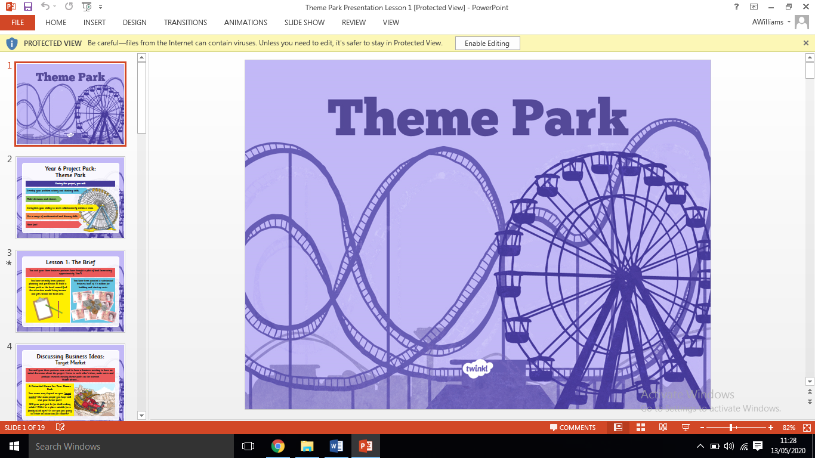  This week, you are going to be completing a new project all about Theme Parks. Each day you will have a new task to complete about your project and you can add any other ideas of your own that you have too!  Task 1:  Research  Your first task is to do some research and find out what make a fantastic theme park. To do this, you need to choose one theme park that you are going to study. Here are some examples you could use:  - Chessington World of Adventures  - Thorpe Park  - Alton Towers  - Disneyland Paris  - Or any other theme park of your choice  Look at the website for these theme parks. What are their themes? How are the parks laid out? What rides do they have? Who are they aimed at? What else is there at the theme park? Do they have shops/restaurants?  Create a fact file/poster/powerpoint of your chosen theme park including all of the key information. You can lay this out how you choose. | Daily reading  TTRockstars
Tuesday | Maths  Get your brain in gear – play a couple of games of hit the button.  https://www.topmarks.co.uk/maths-games/hit-the-button  Investigation – Hexagons – see separate document  GPaS  GPAS- http://www.ictgames.com/mobilePage/lcwc/index.html  -cious and –tious patterns. These can be found under Y5/6 patterns.  Writing  Watch ‘The Alchemist’s Letter’  https://www.literacyshed.com/the-alchemists-letter.html#  Check your understanding of letter writing with this quiz:  https://www.educationquizzes.com/ks2/english/writing-letters/  Will you be writing a formal or informal letter? Make yourself a checklist of what the key features should be.  Try this website to help you:  https://www.literacyideas.com/how-to-write-a-great-letter  Plan the contents of your letter. What will Veridian write back? You can choose the format of your plan (box up, mind map, text map etc).  Reading  Read ‘My Shadow’ and answer questions Set B – answers at the end of the document  Theme Park Project  Task 2:  Plan  Now you have completed your research and have a better understanding of what a theme park looks like and how it works, you are going to get a bit creative and start thinking about your own theme park. Today you need to plan what type of theme park you are going to create. You must include the following information:  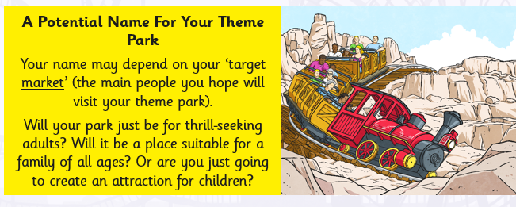  1.  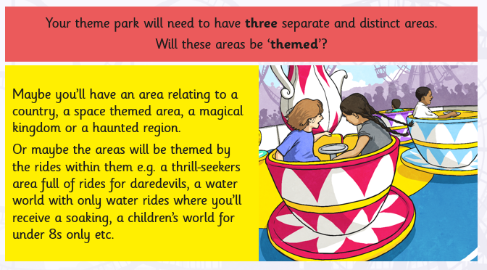  2.  3. You need to design a logo for your theme park. Here are some famous examples:  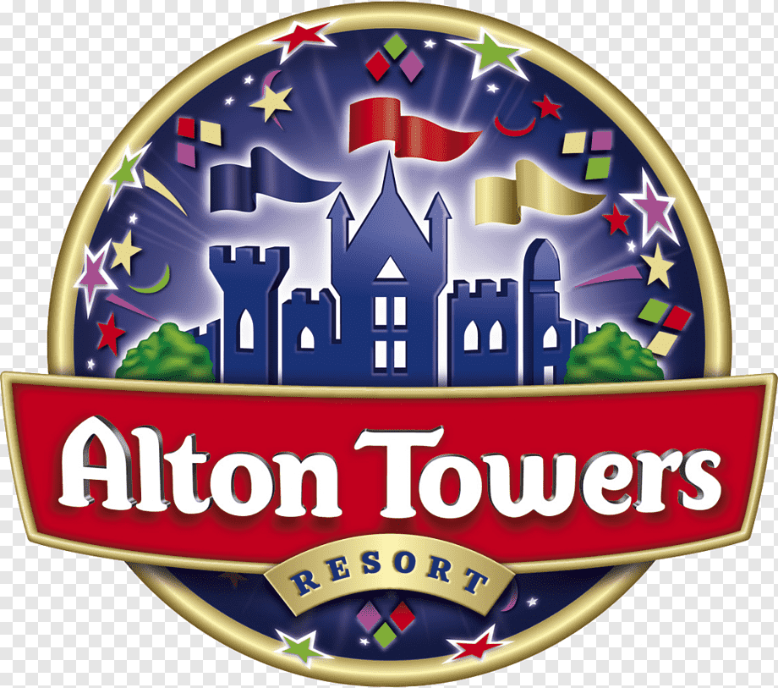  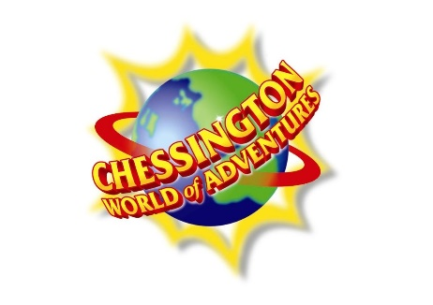      4. Think about prices. What will an adult/child/family ticket cost? | Daily reading  TTRockstars
Wednesday | Maths  Get your brain in gear – play a couple of games of hit the button.  https://www.topmarks.co.uk/maths-games/hit-the-button  Investigation – Consecutive Numbers Addition – see separate document  GPaS  GPAS- https://www.bbc.co.uk/teach/skillswise/past-present-or-future/z67bt39  Then try the worksheet- ‘Choosing the right tense’. Answers can be found on the website.  Writing  Watch ‘The Alchemist’s Letter’  https://www.literacyshed.com/the-alchemists-letter.html#  Write the first half of your letter today. Remember to refer back to your checklist.  Reading  Read ‘The Alps’ and answer questions Set A – answers at the end of the document  Theme Park Project  Task 3:  Budget  Using your plan, you now need to budget what you can afford to build in your theme park. You have a budget of £3 million pounds to build your park and everything in it. Complete the budget sheet to decide what you will build. The following sheet tells you how much different things will cost.  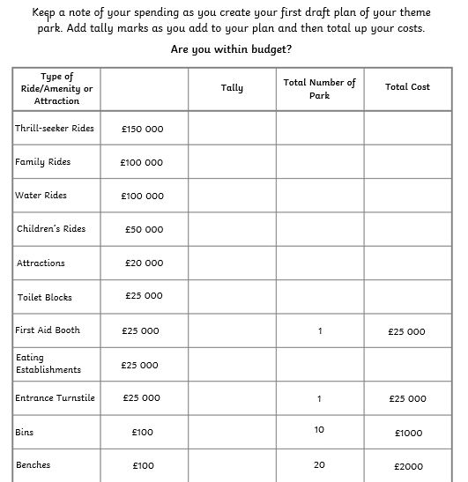  Think about where in your park each of these will go so that you can share them out evenly. You don’t want all your rides in one area and nothing in another. The areas filled in already are what you must include (first aid, bins and benches). Attractions means other things that are not rides like amusement arcades or fun fair games that can be payed to win prizes or gift shops.  What have you spent in total? Are you in budget? | Daily reading  TTRockstars
Thursday | Maths  Get your brain in gear – play a couple of games of hit the button.  https://www.topmarks.co.uk/maths-games/hit-the-button  Investigation – Routes – see separate document  GPaS  GPAS- http://www.ictgames.com/mobilePage/lcwc/index.html  -cial and –tial patterns. These can be found under Y5/6 patterns.  Writing  Watch ‘The Alchemist’s Letter’  https://www.literacyshed.com/the-alchemists-letter.html#  Write the second half of your letter today. Remember to refer back to your checklist.  Reading  Read ‘The Alps’ and answer questions Set B – answers at the end of the document  Theme Park Project  Task 4:  Theme park map  You should now know from your budget task what you are building in your park, so it’s time to design it. Your task today is to create a map for your theme park. Your map should show the different areas of the park and what rides, attractions or food stalls are in them. You might want to use a key to label the names of the rides or attractions.  Here are some examples:  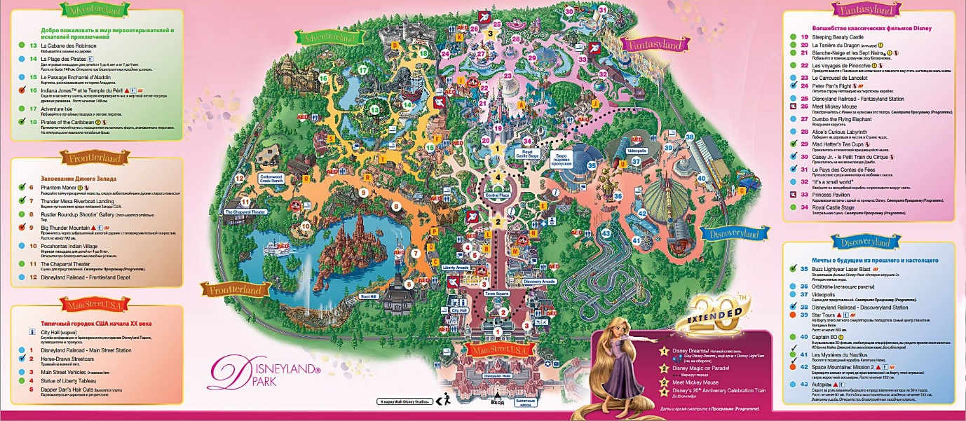  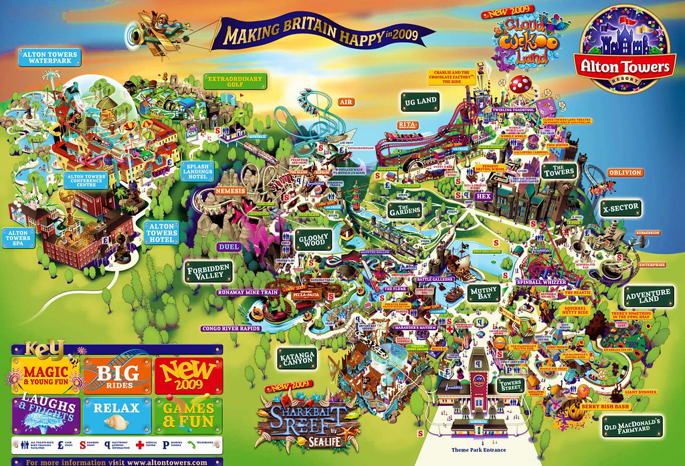  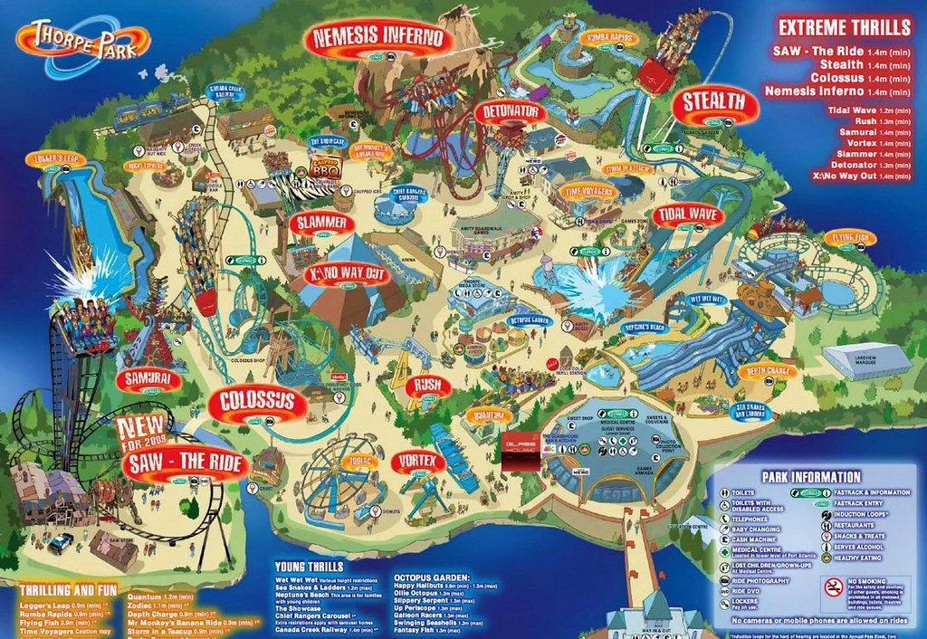  You could research other theme park maps on the internet to get some more ideas about how you could lay it out. | Daily reading  TTRockstars
Friday | Maths  Get your brain in gear – play a couple of games of hit the button.  https://www.topmarks.co.uk/maths-games/hit-the-button  Investigation – How Many Marks? – see separate document  GPaS  GPAS- Editing and improving a story  http://www.scootle.edu.au/ec/viewing/L1275/index.html#  Writing  Watch ‘The Alchemist’s Letter’  https://www.literacyshed.com/the-alchemists-letter.html#  Edit spellings and grammar.  Choose one paragraph from your letter to rewrite and improve.  Remember your challenge from Monday-Have you included subordinate clauses?  Reading  Read ‘Wonder’ and answer questions– answers at the end of the document  Theme Park Project  Task 5:  Advertising  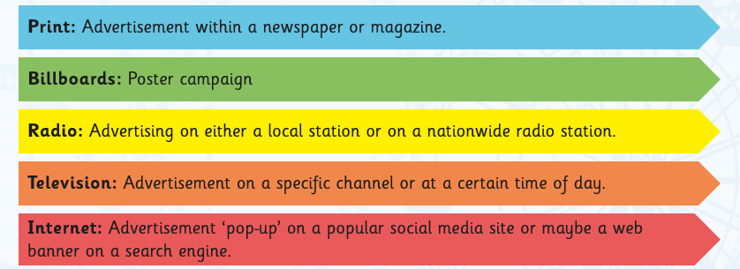  You now need to think about how you are going to advertise your theme park. What type of advertising do you think would be most effective? Here are some examples:  Your task today is to create a form of advertisement that you could use to promote your theme park. Be as creative as you want from writing and recording a radio or TV advert to designing a pop up poster or banner that would appear on social media or a website. Remember, if it is going to successfully advertise your theme park it must capture attention, be memorable and include all of the key information. | Daily reading  TTRockstars

Learning Activities
Year 6 2019-20

Self-isolation learning Term 6 Week 2 08/06/20
 | Lessons set | Additional comments
Monday | Maths  Get your brain in gear with Countdown Numbers  http://happysoft.org.uk/countdown/numgame.php  Investigation – Consecutive Numbers Subtractions – see separate document  GPaS  https://www.youtube.com/watch?v=ZnL689Mpzew  Try to include active and passive sentences in your writing this week.  Writing  Watch ‘Pigeon Impossible’  https://www.literacyshed.com/pigeon-impossible.html  This week, you are going to write a newspaper about the events that resulted from the pigeon getting caught in the briefcase.  Today, watch the video a few times and make notes about what happened. Remember the 5ws:  Who?  What?  Where?  When?  Why?  Reading  Read ‘The Railway Children’ and answer questions Set A – answers at the end of the document  Jigsaw – Healthy ME  Think of all the things for which you are responsible. Is it: getting up and dressed in the morning; doing homework, looking after a pet, helping with some chores? Do you have the same responsibilities through your life or do they change? Why do they change?  One of the big responsibilities is to look after your health and keep yourself safe. You have learnt about healthy diet previously, but what else is necessary in maintaining a healthy living? What responsibilities do you have for your health now? Are there elements of this you can improve? What small changes can you make that might make a big difference? Create a poster to help you be healthy inside out.  Experiment: How alcohol affects protein structure. Ask an adult for help/ permission.  Watch the video that will explain what proteins are:  https://www.youtube.com/watch?v=4u-eZ0HHN_U  You will need: an egg, two cups, some alcohol (the stronger the alcohol the better).  What might happen to the proteins in the egg’s white? Do you think it will the same or different?  Method: First, crack the egg open. Next, separate the egg’s white and drop it into a cup. Then, pour alcohol into the cup to cover the white. Do not stir. Leave for an hour.  Conclusion: What has happened? Are there any other processes you know of that turn egg whites from clear to white? What is it and do you think the same processes are happening?  How does this experiment link to our topic ‘Healthy Me’? | Daily reading  TTRockstars
Tuesday | Maths  Get your brain in gear with Countdown Numbers  http://happysoft.org.uk/countdown/numgame.php  Investigation – Towers 4 – see separate document  GPaS  http://www.ictgames.com/mobilePage/lcwc/index.html  -ant and –ent patterns. These can be found under Y5/6 patterns.  Writing  Watch ‘Pigeon Impossible’  https://www.literacyshed.com/pigeon-impossible.html  Features of a newspaper:  https://www.bbc.co.uk/bitesize/topics/z2yycdm/articles/z2gk9qt  Plan the features of your newspaper. What will your headline be?  Use the 5ws to plan your opening paragraph.  What will the witnesses say?  Remember your challenge-Active and Passive sentences.  Reading  Read ‘The Railway Children’ and answer questions Set B – answers at the end of the document  Science – Humans and other Animals/ DT  Do you know how your respiratory system works? Follow the link below to read the information, discover some fun facts, watch the videos to learn more about it:  https://www.theschoolrun.com/homework-help/human-respiratory-system  Now check how some of the animals breathe:  https://www.bbc.co.uk/bitesize/topics/zv9qhyc/articles/zd7qnrd  Then design your own model of respiratory system using items in your household. Make sure you ask the grown-ups first. Can you name all the parts correctly?  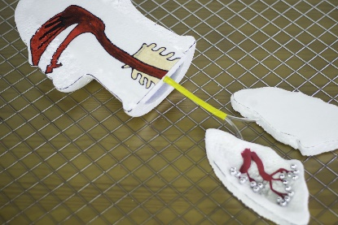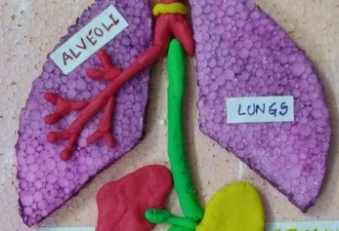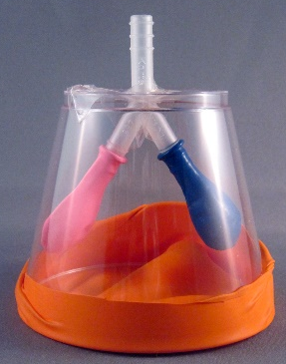  Solve the quiz to check your knowledge:  https://kidshealth.org/en/kids/rsquiz.html | Daily reading  TTRockstars
Wednesday | Maths  Get your brain in gear with Countdown Numbers  http://happysoft.org.uk/countdown/numgame.php  Investigation – Consecutive Numbers Multiplication – see separate document  GPaS  https://www.bbc.co.uk/bitesize/topics/zwwp8mn/articles/zps4pbk  Modal verbs  Writing  Watch ‘Pigeon Impossible’  https://www.literacyshed.com/pigeon-impossible.html  Write the first half of your newspaper. Remember to refer back to your plan to make sure you have the key events and check you have included the features.  Reading  Read ‘The Jungle Book’ and answer questions Set A – answers at the end of the document  Computing – Coding  Create your own Google doodle using scratch. Follow the link, watch the video and have fun with the computer science:  https://csfirst.withgoogle.com/c/cs-first/en/create-your-own-google-logo/create-your-own-google-logo/create-your-own-google-logo.html | Daily reading  TTRockstars
Thursday | Maths  Get your brain in gear with Countdown Numbers  http://happysoft.org.uk/countdown/numgame.php  Investigation – Dots Triangles – see separate document  GPaS  http://www.ictgames.com/mobilePage/lcwc/index.html  -ance and –ence patterns. These can be found under Y5/6 patterns.  Writing  Watch ‘Pigeon Impossible’  https://www.literacyshed.com/pigeon-impossible.html  Write the second half of your newspaper. Remember to refer back to your plan to make sure you have the key events and check you have included the features.  Reading  Read ‘The Jungle Book’ and answer questions Set B – answers at the end of the document  History  Become a historian for a day and use your inference and retrieval skills. Read the letter from the king Henry VIII to Anne Boleyn. Can you prove it is a love letter? Look for words and phrases that can be used as evidence. There are 14 clues to spot and the first two clues are already marked so only 12 to find. Good luck! | Daily reading  TTRockstars
Friday | Maths  Get your brain in gear with Countdown Numbers  http://happysoft.org.uk/countdown/numgame.php  Investigation – Dots Squares – see separate document  GPaS  Points of view in a newspaper  http://www.scootle.edu.au/ec/viewing/L935/index.html  Writing  Watch ‘Pigeon Impossible’  https://www.literacyshed.com/pigeon-impossible.html  Edit spellings and grammar.  Choose one paragraph from your letter to rewrite and improve.  Remember your challenge from Monday-Have you included active and passive sentences?  Reading  Read ‘The Listeners’ and answer questions– answers at the end of the document  Art – Watercolours with a twist  Watch the tutorial and then follow the steps below (if you wish, replace the coffee with tea). Watch from 1:53  https://www.youtube.com/watch?v=rvAaeIXt9kE  You will need: 3 cups, coffee, warm water, brush, paper towel, pencil and a sheet of paper.  Prepare your paint: place different amount of coffee in each cup and pour the SAME amount of water. Stir. Now your paints are ready.  With a pencil, softly draw your picture on the sheet of paper (make it simple/easy, not too many details, large areas to paint).  Use only the three shades to paint your picture.  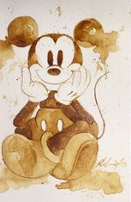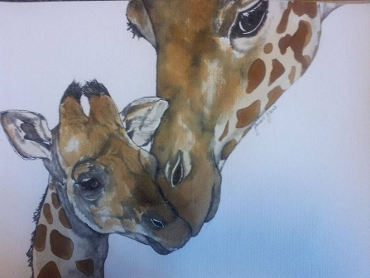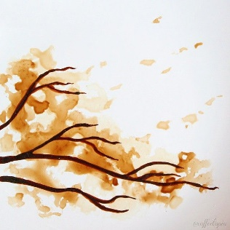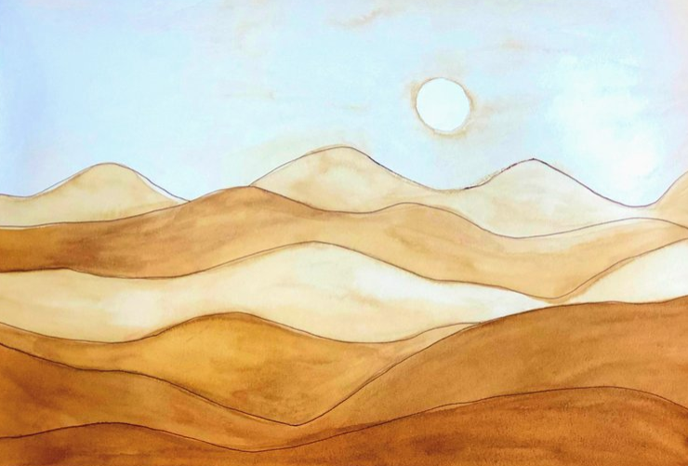 | Daily reading  TTRockstars

Creative curriculum

In addition to these tasks, we would like you to produce something creative! Choose one thing, two things... all the things from the list below if you fancy:

- Try out a new recipe and take a picture of how it turns out
- Learn how to say hello and goodbye and numbers up to 10 in a language you haven’t tried before
- Create a self-portrait using a medium of your choice
- Design and create a model of a ride that could be in your theme park

