

Reading extract and questions:
Year 5/6
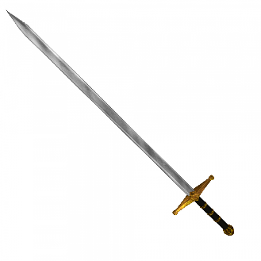
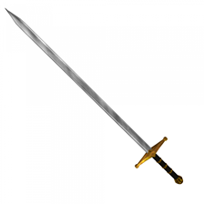
Jabberwocky
by Lewis Carroll

Set A/B

‘Beware the Jabberwock, my son!
The jaws that bite, the claws that catch!
Beware the Jubjub bird, and shun
The frumious Bandersnatch!’

He took his vorpal sword in hand:
Long time the manxome foe he sought—
So rested he by the Tumtum tree,
And stood awhile in thought.

And, as in uffish thought he stood,
The Jabberwock, with eyes of flame,
Came whiffling through the tulgey wood,
And burbled as it came!

One, two! One, two! And through and through
The vorpal blade went snicker-snack!
He left it dead, and with its head
He went galumphing back.

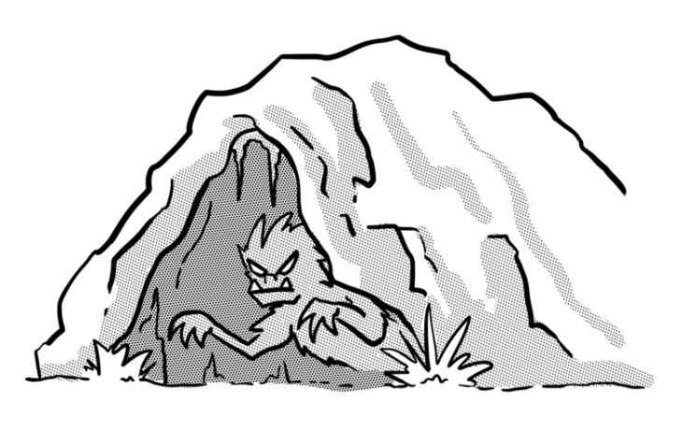

Questions for Jabberwocky Set A

Vocabulary:

1. Look at verse one. Find and copy one word that means the same as ‘Watch out for…’

_________________________________________________________________

2. Which phrase below best matches the meaning of the word sought?
Tick one.
sorted out fought with

searched for worried about

3. Long time the manxome foe he sought…

What does foe mean in this sentence?

_________________________________________________________________

Retrieval
4. Look at verse one. Write down two of the dangers that the son is warned about.

a. _____________________________________________________________

b. _____________________________________________________________

5. Where did the warrior rest on his journey to find the Jabberwock?

_________________________________________________________________

6. What did the warrior take back with him?

_________________________________________________________________

Inference
7. What might the Jabberwock do if it caught you?

_________________________________________________________________

8. What impressions do you get of the warrior in the poem?

Give two impressions, using evidence from the text to support your answer.

Impression | Evidence
_________________________________________ | ________________________________________  ________________________________________  ________________________________________
_________________________________________ | ________________________________________  ________________________________________  ________________________________________

9. Was it difficult for the warrior to kill the Jabberwock?

Circle one: yes no

Explain your answer, referring to the text.

______________________________________________________________________________________

______________________________________________________________________________________

______________________________________________________________________________________

Summarise
10. Which verse describes the warrior’s journey? Circle one.

verse 1 verse 2 verse 3 verse 4

Predict
11. Predict what will happen when the warrior returns home.

_______________________________________________________________________________________

_______________________________________________________________________________________

_______________________________________________________________________________________

_______________________________________________________________________________________

Compare
12. How was the warrior’s journey to find the Jabberwock different to his journey home?

_______________________________________________________________________________________

_______________________________________________________________________________________

_______________________________________________________________________________________

_______________________________________________________________________________________

Questions for Jabberwocky Set B

Vocabulary
1. What class of words are frumious, vorpal and manxome in the poem?
Tick one.
adjectives adverbs

nouns determiners

2. He took his vorpal sword in hand…
Write three English words that you could use instead of vorpal.

____________________ ____________________ ____________________

3.
Beware the Jubjub bird, and shun
The frumious Bandersnatch!

What does the word shun mean in the poem?
Tick two.
fight

feed

hug

avoid

Retrieval
4. What type of eyes does the Jabberwock have?

_________________________________________________________________

5. Which two things does the Jabberwock do as it approaches the warrior?

a. ____________________________________

b. ____________________________________

6. Using information from the poem, tick one box in each row to show whether each statement is true or false.

 | True | False
The Jabberwock has dangerous claws and teeth, and unusual eyes.
The warrior found the Jabberwock quickly.

The Jabberwock found the warrior in the woods.

Inference
7. Did the Jabberwock want to fight the warrior?

Circle one: yes no

Explain your answer, referring to the text.

_______________________________________________________________________________________

_______________________________________________________________________________________

_______________________________________________________________________________________

_______________________________________________________________________________________

8. What impressions do you get of the Jabberwock in the poem?

Give two impressions, using evidence from the text to support your answer.

Impression | Evidence
______________________________ | ______________________________  ______________________________  ______________________________
______________________________ | ______________________________  ______________________________  ______________________________

9. What was the warrior thinking as he galumphed home?
Tick one thought.
I’m so tired.
I’m a hero!

Where is the Jabberwock?
The Jabberwock is terrifying.

Meaning as a whole
10. Retell what happened in the poem in your own words.

_______________________________________________________________________________________

_______________________________________________________________________________________

_______________________________________________________________________________________

_______________________________________________________________________________________

_______________________________________________________________________________________

_______________________________________________________________________________________

_______________________________________________________________________________________

Authorial intent
11. Why do you think the poet, Lewis Carroll, uses made up language in this poem?

_______________________________________________________________________________________

_______________________________________________________________________________________

_______________________________________________________________________________________

Compare
12. Join up the two sets of boxes so that you label the text as either description or action.
The vorpal blade went snicker-snack!

description
The frumious Bandersnatch

So rested he by the Tumtum tree
action
The jaws that bite, the claws that catch!

Answers for Jabberwocky
Set A:

Vocabulary:
1. beware
2. searched for
3. enemy

Retrieval:
4. Pupils should reference any of the dangers in verse one, either by name, by detail or both. E.g. The Jubjub bird; the Jabberwock’s jaws and claws.
5. By the Tumtum tree.
6. The Jabberwock’s head.

Inference:
7. bite you and scratch you
8.
Impression: He was brave. Evidence: He searched for the Jabberwock despite knowing it was dangerous.
Impression: He was determined. Evidence: He searched and searched.
Impression: He was thoughtful. Evidence: He stood thinking by the Tumtum tree.
Impression: He was a good warrior. Evidence: He killed the Jabberwock quickly.
Accept other answers that are evidenced accurately using the text.

9. No. It was not difficult for the warrior to kill the Jabberwock because the poem describes the sword moving quickly and going ‘through and through’ the Jabberwock, there is no mention of it fighting back or of the warrior being in danger.

Summarise:
10. verse 2

Predict:
11. Pupils should express a justifiable prediction for what happens next. For example, he is treated like a hero when he returns with the head; he feels guilty for killing the beast so easily; people are horrified that a magnificent beast has been killed; the warrior goes off looking for the Jubjub bird or the Bandersnatch.

Compare:
12. Pupils should reference the warrior repeatedly searching in verse two and then stopping to rest and think, compared to him ‘galumphing’ home, victorious, with the Jabberwock’s head, at the end of verse four.

Commissioned by The PiXL Club Ltd. July 2019
This resource is strictly for the use of member schools for as long as they remain members of The PiXL Club. It may not be copied, sold nor transferred to a third party or used by the school after membership ceases. Until such time it may be freely used within the member school.
All opinions and contributions are those of the authors. The contents of this resource are not connected with nor endorsed by any other company, organisation or institution.
PiXL Club Ltd endeavour to trace and contact copyright owners. If there are any inadvertent omissions or errors in the acknowledgements or usage, this is unintended and PiXL will remedy these on written notification.

© Copyright The PiXL Club Limited, 2019
Answers for Jabberwocky

Set B:

Vocabulary:
1. adjectives
2. examples include: magic, shiny, silver, mystical, steel, royal. Consider other answers on their merits, perhaps in conversation with the pupil.
3. avoid

Retrieval:
4. flaming eyes / fiery eyes
5. whiffles and burbles
6.
The Jabberwock has dangerous claws and teeth, and unusual eyes – True
The warrior found the Jabberwock quickly – False
The Jabberwock found the warrior in the woods – True

Inference:
7. Pupils should justify their answers using the text, and may define ‘whiffling’ and ‘burbled’ to justify their answer. One reason for stating ‘yes’ could be that the Jabberwock was a fierce beast and it came towards the warrior; a reason for ‘no’ could be that it was just wandering around its habitat and came upon the warrior accidently.

8.
Impression: It was fierce. Evidence: People are told to beware of it; it has jaws that bite and claws that catch; it has fiery eyes.
Impression: It was not good at fighting warriors. Evidence: It was beaten easily.
Impression: It lived in the woods. Evidence: This is where the warrior meets it in the poem.
Accept other answers that are evidenced accurately using the text.
9. I’m a hero!

Meaning as a whole:
10. This should be a retelling that includes a beginning where the Jabberwock is introduced; a middle section where the warrior takes his sword and searches for the Jabberwock; an ending where the two fight, the warrior wins, and returns home with the head.

Authorial intent:
11. To create powerful description; to make us think of things we haven’t thought of before; to make the poem mysterious.
Accept other justifiable explanations.

Compare:
12.
The vorpal blade went snicker-snack! – action
The frumious Bandersnatch – description
So rested he by the Tumtum tree – action
The jaws that bite, the claws that catch! – description

Commissioned by The PiXL Club Ltd. July 2019
This resource is strictly for the use of member schools for as long as they remain members of The PiXL Club. It may not be copied, sold nor transferred to a third party or used by the school after membership ceases. Until such time it may be freely used within the member school.
All opinions and contributions are those of the authors. The contents of this resource are not connected with nor endorsed by any other company, organisation or institution.
PiXL Club Ltd endeavour to trace and contact copyright owners. If there are any inadvertent omissions or errors in the acknowledgements or usage, this is unintended and PiXL will remedy these on written notification.

© Copyright The PiXL Club Limited, 2019

