
Learning Activities
Year 6 2019-20

Hello Year 6,
We hope everyone is well and enjoying their new school experience.
Please follow the links to complete the assigned work below.
If there are any issues, or you would like to send us any of your fantastic learning, just email us using the email address on the website.

Self-isolation learning Week 5
 | Lessons set | Additional comments
Monday | Maths  Complete the starter of the day  https://www.transum.org/Software/SW/Starter_of_the_day/  White Rose Summer Term Week 1- Lesson 1  Watch video, – watch video, complete activity and check answers  https://whiterosemaths.com/homelearning/year-6/  Puzzle of the day –  https://www.mathsisfun.com/chicken_crossing.html  Solution – https://www.mathsisfun.com/chicken_crossing_solution.html  Reading  Read ‘Jabberwocky’ and answer questions Set A – answers at the end of the document  GPaS  Apostrophes- Watch the videos and complete the online activities. There are quizzes you can complete as well.  https://www.bbc.co.uk/bitesize/topics/zvwwxnb/articles/zcyv4qt  https://www.bbc.co.uk/bitesize/topics/zvwwxnb/articles/zx9ydxs  Project- ‘The Island’ (Geography, English)  Whilst out exploring, you are shipwrecked and discover your own island that appears to be uninhabited.  Where in the world is your island?  Use an atlas, globe or Google Maps/Earth to work out where you are.  Are you in the Northern or Southern Hemisphere?  Which sea or ocean are you in?  Which continent are you on?  Which countries are closest to you? How far away are they should you need rescuing?  Watch this video- https://www.bbc.co.uk/bitesize/topics/z849q6f/articles/z7dkhbk  What is the weather like?  What is the climate like on your island?  https://www.bbc.co.uk/bitesize/topics/z849q6f/articles/zvsp92p  What is the biome of your island? Think carefully about where it is in the world.  What are the physical features? Are there mountains, rivers, deserts?  Start creating a fact file of your island. Include a map of where in the world your island is and pictures of the landscape. | Daily reading  TTRockstars
Tuesday | Maths  Complete the starter of the day  https://www.transum.org/Software/SW/Starter_of_the_day/  White Rose Summer Term Week 1- Lesson 2  Watch video, – watch video, complete activity and check answers  https://whiterosemaths.com/homelearning/year-6/  Puzzle of the day –  https://www.mathsisfun.com/games/towerofhanoi.html  Solution – https://www.mathsisfun.com/games/hanoi_solver.html  Reading  Read ‘Jabberwocky’ and answer questions Set B – answers at the end of the document  GPaS  How to use a semi-colon, hyphens and dashes. Watch videos and complete quizzes  https://www.bbc.co.uk/bitesize/topics/zvwwxnb/articles/zshfdxs  https://www.bbc.co.uk/bitesize/topics/zvwwxnb/articles/zg8gbk7  Project- ‘The Island’ (English,Computing)  Whilst exploring your island further, you find a space that looks like it once had somebody living in it. There are objects lying around that have been left for what appears to be a very long time.  Write a story or a diary about the shelter.  Where is the shelter? What was it made from? (palm leaves, cave, twigs, ice)  What are the objects lying around? What do they look like? Where did they come from?  Create a mind map of ideas. You could think about our Kensuke’s Kingdom learning to help you.  Computing  https://scratch.mit.edu/  Use scratch to create your island. You could create a story of the person who lived there before you or create the story of you discovering and exploring the island. Be as creative as possible! | Daily reading  TTRockstars
Wednesday | Maths  Complete the starter of the day  https://www.transum.org/Software/SW/Starter_of_the_day/  White Rose Summer Term Week 1- Lesson 3  Watch video, – watch video, complete activity and check answers  https://whiterosemaths.com/homelearning/year-6/  Puzzle of the day  https://www.mathsisfun.com/games/connect4.html  Reading  Read ‘Darwin’ and answer questions Set A – answers at the end of the document  GPaS  Spelling- -cious and -tious  https://www.bbc.co.uk/bitesize/topics/zt62mnb/articles/zp7dk7h  Make a list of 10 words. You can use a book or dictionary to help you write your list.  Try writing them in sentences, creating rainbow words using different colours, writing with your other hand, practising your handwriting.  Come back later and see if you can remember how to spell the words without looking!  Project- ‘The Island’ (Science, English, Art)  As you are exploring, you discover a brand new species, never seen before!  Is it a vertebrate or an invertebrate?  How is it classified?  What does its offspring look like?  How has it adapted to the environment it lives in?  Useful links:  https://www.bbc.co.uk/bitesize/topics/zn22pv4/articles/z3nbcwx  https://www.bbc.co.uk/bitesize/topics/zvhhvcw/articles/zxg7y4j  https://www.bbc.co.uk/bitesize/topics/zvhhvcw/articles/zp9f4qt  Draw a picture of the new species that you have found. Write a paragraph, create a fact file or label your picture with key information to send to David Attenborough. You never know, he might want to come and film on your island! | Daily reading  TTRockstars
Thursday | Maths  Complete the starter of the day  https://www.transum.org/Software/SW/Starter_of_the_day/  White Rose Summer Term Week 1- Lesson 4  Watch video, – watch video, complete activity and check answers  https://whiterosemaths.com/homelearning/year-6/  Puzzle of the day  https://nrich.maths.org/6288  Reading  Read ‘Darwin’ and answer questions Set B – answers at the end of the document  GPaS  Suffixes  https://www.bbc.co.uk/bitesize/topics/zqqsw6f/articles/zcb8k7h  https://www.bbc.co.uk/bitesize/topics/zqqsw6f/articles/zcsyjty  Project- ‘The Island’ (English, Drama)  David Attenborough is coming to your island!  Write a script for him for what he will say about your island and the new species you have discovered.  If you are feeling brave, you can create your own documentary film in the style of Blue Planet. | Daily reading  TTRockstars
Friday | Maths  Complete the starter of the day  https://www.transum.org/Software/SW/Starter_of_the_day/  White Rose Summer Term Week 1- Lesson 5  Watch video, – watch video, complete activity and check answers  https://whiterosemaths.com/homelearning/year-6/  Puzzle of the day  https://nrich.maths.org/141  Reading  Watch the video animation of the introduction to ‘The Iron Man’ by Ted Hughes. https://www.bbc.co.uk/bitesize/clips/zd2d7ty  What impression does the author give of The Iron Man?  How do you think the Iron Man felt before, during and after he fell?  What do you predict will happen to The Iron man?  GPaS  Passive and modal verbs  https://www.bbc.co.uk/bitesize/topics/zwwp8mn/articles/zsx2b82  https://www.bbc.co.uk/bitesize/topics/zwwp8mn/articles/zps4pbk  Project- ‘The Island’ (English, Art, Computing)  The world wants to see your island! They were so impressed with the David Attenborough documentary, that it has become the newest tourist attraction for the world. Think Jurassic Park, without the deadly, human eating dinosaurs!  Create a travel brochure advertising your island. Persuade people to visit.  Use the checklist to help you:  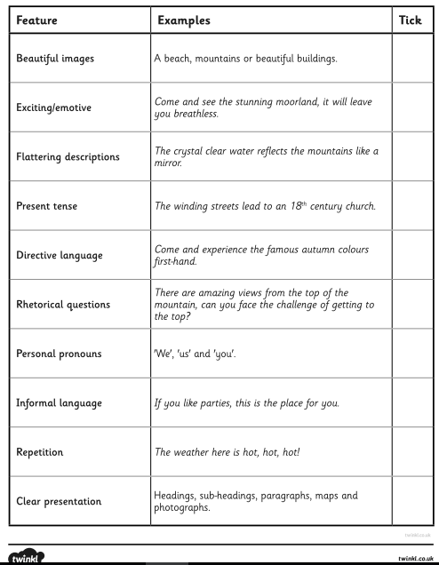 | Daily reading  TTRockstars

Learning Activities
Year 6 2019-20

Self-isolation learning Week 6
 | Lessons set | Additional comments
Monday | Maths  Get your brain in gear – play a game to reinforce your knowledge about angles  https://www.topmarks.co.uk/Flash.aspx?a=activity16  White Rose Maths  Summer Term Week 2 Lesson 1 Angles in special quadrilaterals – watch video, complete activity and check answers  https://whiterosemaths.com/homelearning/year-6/  Puzzle of the day - Feel like a teacher marking Maths homework  https://www.transum.org/software/SW/Starter_of_the_day/starter_April17.asp  Reading  Read the non-fiction extract ‘Circulation’ and answer questions Set A – answers at the end of the document.  Writing  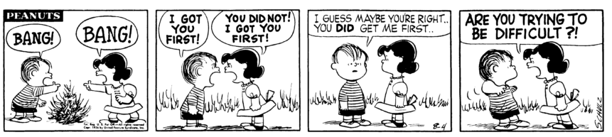  Look at the comic strip. Write the dialogue between the characters showing (not telling) what kind of person they are. Remember to use the correct punctuation for your direct speech. Here is a link to remind you:  https://youtu.be/uoE9ET6CtaI  GPaS  Spelling Rule 48 - Homophones and other words that are often confused (1 of 5) – Choose Practise/Test  https://spellingframe.co.uk/spelling-rule/41/48-Homophones-and-other-words-that-are-often-confused-1-of-5  Science  Experiment – Objectives: to observe how the light affects the pupil.  Prediction: What will happen to your pupils in the dark/dim lit environment?  Method: Sit in front of a mirror in a lit room and cover your eyes well. Count slowly up to 60. Now remove the cover from your eyes and look at your pupils (the black dot on your eye) in the mirror. What did you notice? Does this happen every time? Can you guess why?  Watch the clip - https://www.youtube.com/watch?v=axpCN6Vj9p0  Draw the diagram of the human eye and label it.  Conclusion: Do you remember why your pupils were dilated (wider than normal)? Write your answer down. | Daily reading  TTRockstars
Tuesday | Maths  Get your brain in gear – play a games of finding a missing angle in triangles and quadrilaterals  https://eng.mathgames.com/skill/6.108-find-missing-angles-in-triangles-and-quadrilaterals  White Rose Maths  Summer Term Week 2 Lesson 2 Angles in regular polygons – watch video, complete activity and check answers  https://whiterosemaths.com/homelearning/year-6/  Puzzle of the day - Can you find all possibilities?  https://www.transum.org/software/SW/Starter_of_the_day/starter_April23.asp  Reading  Read the non-fiction extract ‘Circulation’ and answer questions Set B – answers at the end of the document.  Writing  Choose a well-known fairy tale (Little Red Riding Hood) and write a dialogue between the main characters (the girl and the wolf) showing their personalities through speech. This is called to convey character through dialogue (speech). In your dialogue, you must include:  - What they say  - How they say it - through verbs (eg. bellowed, whispered, snag, sneered, muttered)  - How they say it - though adverbs (eg. angrily, timidly, confidently)  - Voice description - adjectives (eg. cold, bitter, warm, gentle)  - Actions as they talk (eg. pushed, wept, raised a sward)  Make sure to punctuate your speech correctly.  GPaS  Spelling Rule 48 - Homophones and other words that are often confused (2 of 5) – Choose Practise/Test  https://spellingframe.co.uk/spelling-rule/52/49-Homophones-and-other-words-that-are-often-confused-2-of-5  Art – Collage  Use newspaper and/or magazines advertisement pages, old catalogues or food packaging to create an eye collage.  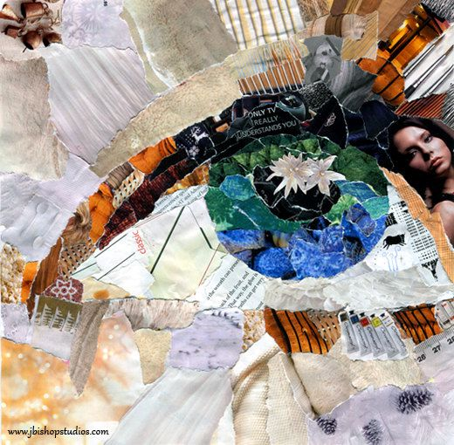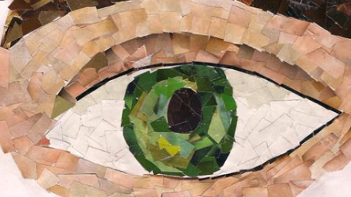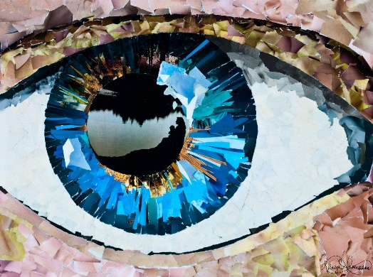 | Daily reading  TTRockstars
Wednesday | Maths  Get your brain in gear – play a game of shapes and co-ordinates  https://mathsframe.co.uk/en/resources/resource/153/coordinates--reasoning-about-position-and-shapes  White Rose Maths  Summer Term Week 2 Lesson 3 Problem solving – watch video, complete activity and check answers  https://whiterosemaths.com/homelearning/year-6/  Puzzle of the day  https://www.transum.org/software/SW/Starter_of_the_day/starter_April24.asp  Reading  Read the non-fiction extract ‘Trappers Hill’ and answer questions Set A – answers at the end of the document.  Writing – to create a comic strip  ‘Ruckus’ - Frank and Jason are Wanted, but they are still carrying out daring robberies, this time it seems is the great train robbery, however, will their greed be the end of them?  https://www.youtube.com/watch?v=Ji1KM1BbAyY  Watch the clip twice and create a comic strip. Include speech bubbles, thoughts clouds to show what the brothers would say.  GPaS  Spelling Rule 48 - Homophones and other words that are often confused (3 of 5) – Choose Practise/Test  https://spellingframe.co.uk/spelling-rule/53/50-Homophones-and-other-words-that-are-often-confused-3-of-5  Computing and PE  Create a dance party to the song of your choice. You need to choose your age from the list (this is for the music options).  https://studio.code.org/s/dance-2019/stage/1/puzzle/1  Then practise the moves though the whole song. Remember to stick to the beat (1 2 3 4). Was it easy to move from one dance move to the other? What would you change? | Daily reading  TTRockstars
Thursday | Maths  Get your brain in gear – play a couple of games of possible outfits for Bobbie Bear  https://www.nctm.org/Classroom-Resources/Illuminations/Interactives/Bobbie-Bear/  White Rose Maths  Summer Term Week 2 Lesson 4 Problem solving – watch video, complete activity and check answers  https://whiterosemaths.com/homelearning/year-6/  Puzzle of the day  https://www.transum.org/software/SW/Starter_of_the_day/starter_April26.asp  Reading  Read the non-fiction extract ‘Trappers Hill’ and answer questions Set B – answers at the end of the document.  Writing - ‘Ruckus’ – to plan the dialogue  https://www.youtube.com/watch?v=Ji1KM1BbAyY  Watch the clip again/ look at your comic strip and choose two different parts where you could introduce dialogue between the brothers, to show their personalities (to convey characters). Create a plan:  - what they would say,  - what characters they are,  - which verbs, adverbs and adjectives you need to use to show it.  Find in the thesaurus the necessary vocabulary.  GPaS  Spelling Rule 48 - Homophones and other words that are often confused (4 of 5) – Choose Practise/Test  https://spellingframe.co.uk/spelling-rule/66/51-Homophones-and-other-words-that-are-often-confused-4-of-5  French – Body parts  Draw a picture of a person to be ready to label the body parts in French. Then listen, listen again, repeat and write it down:  https://www.french-games.net/frenchlessons?topic=Body%20-%20parts%20of%20the%20body&level=primary | Daily reading  TTRockstars
Friday | Maths  Get your brain in gear – play a couple of games problem solving addition  https://www.topmarks.co.uk/Flash.aspx?f=MagicSquares  White Rose Maths  Summer Term Week 2 Lesson 5 Maths Challenge with BBC Bitesize – complete activity and check answers  https://whiterosemaths.com/homelearning/year-6/  Puzzle of the day  https://www.transum.org/software/SW/Starter_of_the_day/starter_April27.asp  Reading  Read a book of your choice for 20 minutes. Which book did you choose? Why? What did you find interesting? Summarise the information in three sentences? Can you predict what will happen next? Which clues did you use to help you form the prediction?  Writing – ‘Ruckus’ – To convey characters through dialogue  https://www.youtube.com/watch?v=Ji1KM1BbAyY  Use your plan to create the two dialogues between the brothers. Remember you are showing (not telling) what kind of characters they are. You must include:  - What they say  - How they say it - through verbs (eg. bellowed, whispered, snag, sneered, muttered)  - How they say it - though adverbs (eg. angrily, timidly, confidently)  - Voice description - adjectives (eg. cold, bitter, warm, gentle)  - Actions as they talk (eg. pushed, wept, raised a sward)  Make sure to punctuate your speech correctly.  GPaS  Spelling Rule 48 - Homophones and other words that are often confused (5 of 5) – Choose Practise/Test  https://spellingframe.co.uk/spelling-rule/67/52-Homophones-and-other-words-that-are-often-confused-5-of-5  Jigsaw  Listen to the story, discuss it and follow the activity. Finish it with Calm Me Time.  https://families.jigsawpshe.com/stuck-at-home-1/#1584978048407-c19cbbeb-8c8d | Daily reading  TTRockstars

Creative curriculum

In addition to these tasks, we would like you to produce something creative! Choose one thing, two things... all the things from the list below if you fancy:

- Try cooking or baking something. Write the recipe for it afterwards.
- Create your Joe Wicks style work out video. Which exercises would you get people to do?
- Create a picture to represent the Spring season, using whatever art resources you like and have available to you.
- Research an Olympic sport. Who are successful athletes from that sport? What are the rules? Create a poster for the sport, ready for next year.
- Give your grown-ups a break- learn a new household skill. Vacuuming, dusting, using the washing machine.

