
Learning Activities
Year 6 2019-20

Hello Year 6,
We hope everyone is well and enjoying their new school experience.
Please follow the links to complete the assigned work below.
If there are any issues, or you would like to send us any of your fantastic learning, just email us using the email address on the website.

Self-isolation learning Week 3
 | Lessons set | Additional comments
Monday | Maths  Get your brain in gear – play a couple of games of hit the button.  https://www.topmarks.co.uk/maths-games/hit-the-button  Data Handling activity - https://cdn.oxfordowl.co.uk/2019/01/02/14/13/11/673/Bond_10Minute_Maths_NonVerbal_Data_9_10.pdf  Answers are on the final page  Data Handling activity 2 –  https://cdn.oxfordowl.co.uk/2019/01/02/14/26/59/523/Bond_10Minute_Maths_NonVerbal_Data_10_11.pdf  Answers are on the final page  Puzzle of the day –  https://cdn.oxfordowl.co.uk/2019/04/23/14/28/45/591/Bond_MathsPuzzles_Tricky_HowOldIsHector.pdf  Answers are on the final page  Writing  Write a letter or email to a family member or friend that you can’t visit at the moment. You could tell them about what you have been up to, any exciting news that you might have. I am sure they will love to hear from you!  Reading  https://cdn.oxfordowl.co.uk/2020/03/13/08/49/58/68816f2c-c1e7-4020-af21-afdfd7f27819/BondSATsSkills_Comprehension10-11_Unit2.pdf  Answers are on the final page  GPaS  https://cdn.oxfordowl.co.uk/2020/03/13/08/58/36/abe3e746-66a5-4d06-bce8-0c7a674a8b45/BondSATsSkills_Grammar10-11_Unit1.pdf  Answers are on the final page  PE  Design your own PE circuit. You could include press ups, lunges, sit ups, squats etc.  Time yourself completing your circuit. Can you beat your time each day? | Daily reading  TTRockstars
Tuesday | Maths  Get your brain in gear – play a couple of games of countdown  http://happysoft.org.uk/countdown/numgame.php  Properties of 2D and 3D shapes -  https://cdn.oxfordowl.co.uk/2020/03/13/09/01/53/f540ac3e-2d51-43b6-8433-3539f02a783d/BondSATsSkills_MathsMeasGeoStats10-11_Unit1.pdf  Answers are on the final page  Puzzle of the day –  https://cdn.oxfordowl.co.uk/2019/04/23/14/26/48/268/Bond_WordPuzzles_WarmUp_PicturePuzzle.pdf  Answers on the second page  Reading  https://cdn.oxfordowl.co.uk/2020/03/13/08/51/03/310c5cb6-60d9-4a7d-a47b-9465fb234ecf/BondSATsSkills_Comprehension10-11_Unit10.pdf  Answers are on the final page  Writing  Use this story mountain plan to help you create your own adventure story. Use the steps to help you plan out your story and then write it. You might want to use the second link as an example of a plan.  https://cdn.oxfordowl.co.uk/2019/01/28/16/21/36/786/2019_500Words_StoryMountain.pdf  https://cdn.oxfordowl.co.uk/2018/11/01/14/27/04/131/NightZookeerper_WriteaStory.pdf  Your characters and storyline can be whatever you want them to be – be creative!  Art  Turn your story into a comic strip. What do your characters look like? What would they say in a comic strip? Which onomatopoeia words could you use for effect? How will you show the key events in the story?  GPaS  https://cdn.oxfordowl.co.uk/2020/03/13/10/54/07/84be020e-3908-4d3b-b261-87071c294b1c/BondSATsSkills_SpellingAndVocabulary10-11_Unit1.pdf  Answers are on the final page | Daily reading  TTRockstars
Wednesday | Maths  Get your brain in gear – play a couple of games  http://www.math-play.com/Place-Value-Millionaire/place-value-millionaire-game_html5.html  Calculating with fractions  https://cdn.oxfordowl.co.uk/2020/03/13/08/47/31/13f39590-b36b-44e5-8473-a5f9d7a13a08/BondSATsSkills_Arithmetic10-11_Unit6.pdf  Answers are on the final page  Puzzle of the day –  https://cdn.oxfordowl.co.uk/2019/04/23/14/28/05/744/Bond_MathsPuzzles_WarmUp_NumberTrain.pdf  Answers are on the second page  Reading  https://cdn.oxfordowl.co.uk/2019/01/02/12/53/43/17/Bond_10Minute_English_Comprehension_9_10.pdf  Answers are on the final page  https://cdn.oxfordowl.co.uk/2019/01/02/12/55/13/330/Bond_10Minute_English_Comprehension_10_11.pdf  Answers are on the final page  Writing    Choose one of these settings (or think of your own) and create a setting description.  Try to include:  - Similes  - Metaphors  - Personification  - A range of senses, e.g. what could be seen, heard etc.  Art  Create your own piece of artwork to go with your setting description. You could use whatever style of art you like.  GPaS  https://cdn.oxfordowl.co.uk/2020/03/13/08/59/39/97d237bf-2257-4ac6-82b7-fc554147d6d1/BondSATsSkills_Grammar10-11_Unit6.pdf  Answers are on the final page | Daily reading  TTRockstars
Thursday | Maths  Get your brain in gear – play a couple of games of hit the button.  https://www.topmarks.co.uk/maths-games/hit-the-button  Number and place value -  https://cdn.oxfordowl.co.uk/2020/03/13/08/46/50/8e55fe44-c6dd-47a9-bcdc-401bf2bdb7ac/BondSATsSkills_Arithmetic10-11_Unit1.pdf  Answers are on the final page  Number and place value 2 -  https://cdn.oxfordowl.co.uk/2020/03/13/09/05/21/525d1a83-b2cd-400c-a12f-b9a84fa04f16/BondSATsSkills_MathsNumbers10-11_Unit7.pdf  Answers are on the final page  Puzzle of the day –  https://cdn.oxfordowl.co.uk/2019/04/23/14/30/18/647/Bond_LogicPuzzles_Intermediate_ProductionLine.pdf  Answers are on the second page  Reading  https://cdn.oxfordowl.co.uk/2020/03/13/08/49/07/41ba3a3d-d6de-47c6-98c2-e0a85cc13b04/BondSATsSkills_Comprehension9-10_Unit9.pdf  Answers are on the final page  Writing  Write a diary entry about your home schooling journey so far. What have you enjoyed? What are you missing?  GPaS  https://cdn.oxfordowl.co.uk/2020/03/13/08/54/58/7cde3a57-6363-43a1-90db-34a0befb5b56/BondSATsSkills_Grammar9-10_Unit10.pdf  Answers are on the final page | Daily reading  TTRockstars
Friday | Maths  Get your brain in gear – play a couple of games of countdown  http://happysoft.org.uk/countdown/numgame.php  Number patterns and algebra –  https://cdn.oxfordowl.co.uk/2020/03/13/09/04/17/d552b4b1-794e-49fe-aa16-8e6ea57f2446/BondSATsSkills_MathsNumbers10-11_Unit2.pdf  Puzzle of the day –  https://cdn.oxfordowl.co.uk/2019/04/23/14/29/54/710/Bond_LogicPuzzles_Tricky_SailingClub.pdf  Answers are on the second page  Reading  https://cdn.oxfordowl.co.uk/2020/03/13/08/48/24/fb03cb45-922f-477f-94db-f0c9a18980df/BondSATsSkills_Comprehension9-10_Unit1.pdf  Answers are on the final page  DT/Writing  Design a new fairground ride. What would it be called? What would it look like? Who is it suited to? What does it do? How does it work? Create a labelled diagram of your new ride and an information fact file about what it.  GPaS  https://cdn.oxfordowl.co.uk/2020/03/13/08/53/49/9ac76b1b-8eec-4680-b64d-c50ef64847fd/BondSATsSkills_Grammar9-10_Unit3.pdf  Answers are on the final page | Daily reading  TTRockstars

Learning Activities
Year 6 2019-20

Self-isolation learning Week 4
 | Lessons set | Additional comments
Monday | Maths  Get your brain in gear with Countdown Numbers  http://happysoft.org.uk/countdown/numgame.php  White Rose Maths  Week 1 Lesson 1 Using Ratio Language – watch video, complete activity and check answers  https://whiterosemaths.com/homelearning/year-6/  GPaS  Play Trapped https://www.topmarks.co.uk/Flash.aspx?e=spelling-grammar01  Reading  Read ‘The Secrets of the Classroom’ and answer questions Set A – answers at the end of the document  Writing  Watch https://www.youtube.com/watch?v=irbFBgI0jhM and create a story ‘s’ of the events – add conjunctions and high level vocabulary to use throughout the week. Split it into three sections so you have a beginning, middle and ending.(if you don’t like the ending you can create an alternative one)  Science  Visit each website and watch the video, make notes and complete the activity  https://www.bbc.co.uk/bitesize/topics/zwdr6yc/articles/zs8f8mn  https://www.bbc.co.uk/bitesize/topics/zwdr6yc/articles/zqv4cwx  https://www.bbc.co.uk/bitesize/topics/zwdr6yc/articles/zw8xb82  https://www.bbc.co.uk/bitesize/topics/zwdr6yc/articles/ztg6gdm  Conduct your own research about the heart in order to make a double spread non chronological report  Here are some good website  https://www.theschoolrun.com/homework-help/human-circulatory-system  http://www.stanleyroad.oldham.sch.uk/uploads/4/0/2/8/40289551/y6_t2_-_the_circulatory_system.pdf  https://kidshealth.org/en/kids/heart.html | Daily reading  TTRockstars
Tuesday | Maths  Get your brain in gear with Countdown Numbers  http://happysoft.org.uk/countdown/numgame.php  White Rose Maths  Week 1 Lesson 2 Ratio and Fractions (scroll down) – watch video, complete activity and check answers  https://whiterosemaths.com/homelearning/year-6/  GPaS  Play Comma Castle https://gridclub.com/activities/comma-castle  Reading  Read ‘The Secrets of the Classroom’ and answer questions Set B – answers at the end of the document  Writing  https://www.youtube.com/watch?v=irbFBgI0jhM  Write the beginning to your story. You can write it from first or third person. Create suspense through high level vocabulary, fronted adverbials and punctuations.  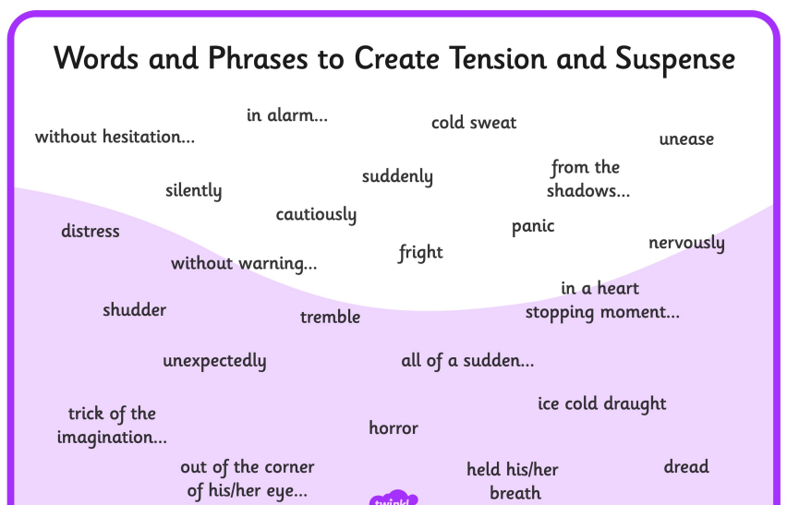  Science  Use your notes from yesterday to create a non-chronological report about the Circulatory System. Imagine you are writing it for a child, so keep it light hearted and use humour where possible. Possible sub headings could be:  - How the heart works?  - What is in our blood?  - The journey blood takes  - What do our lungs do?  Example below  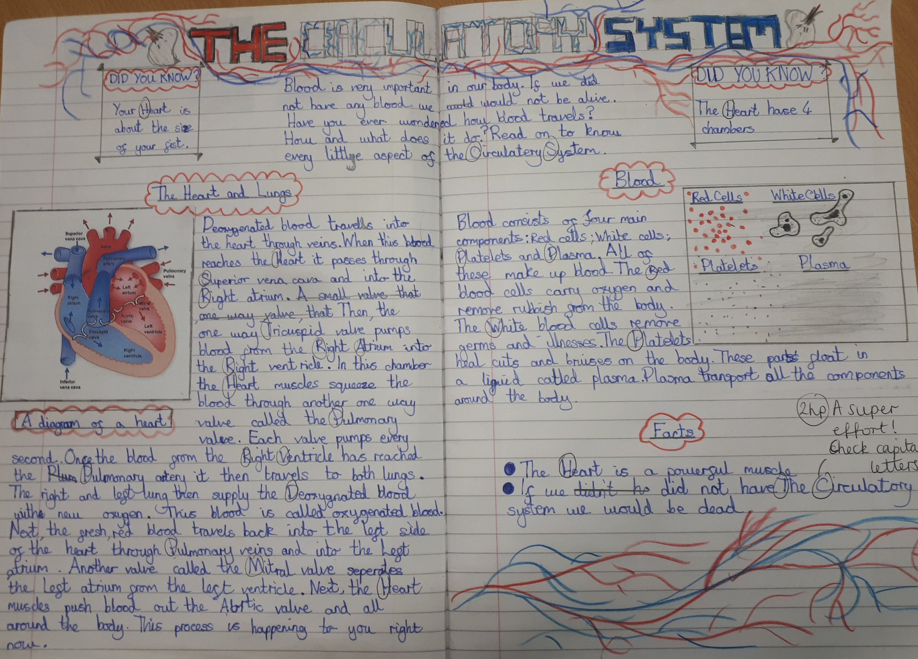 | Daily reading  TTRockstars
Wednesday | Maths  Get your brain in gear with Countdown Numbers  http://happysoft.org.uk/countdown/numgame.php  White Rose Maths  Week 1 Lesson 3 Including Ratio Symbol (scroll down) – watch video, complete activity and check answers  https://whiterosemaths.com/homelearning/year-6/  GPaS  Play https://resources.hwb.wales.gov.uk/VTC/2011-12/english/reading-games/antonym-splat/index.html  Reading  Read ‘Treasure Island’ and answer questions Set A – answers at the end of the document  Writing  https://www.youtube.com/watch?v=irbFBgI0jhM  Write the middle to your story. Create suspense through high level vocabulary, fronted adverbials and punctuations.  Science  Continue with the non-chronological report on the Circulatory system | Daily reading  TTRockstars
Thursday | Maths  Get your brain in gear with Countdown Numbers  http://happysoft.org.uk/countdown/numgame.php  White Rose Maths  Week 1 Lesson 4 Calculating Ratio (scroll down) – watch video, complete activity and check answers  https://whiterosemaths.com/homelearning/year-6/  GPaS  Play http://www.funenglishgames.com/grammargames/prefixsuffix.html  Reading  Read ‘Treasure Island’ and answer questions Set B – answers at the end of the document  Writing  https://www.youtube.com/watch?v=irbFBgI0jhM  Write the ending to your story – are you going to leave it on a cliff-hanger?  Science – Heart rate investigation  Watch https://www.bbc.co.uk/bitesize/clips/z274d2p  Why is exercise important? What is the definition of exercise?  We are going to be conduction an investigation where you measure your pulse. Here is how to do it:  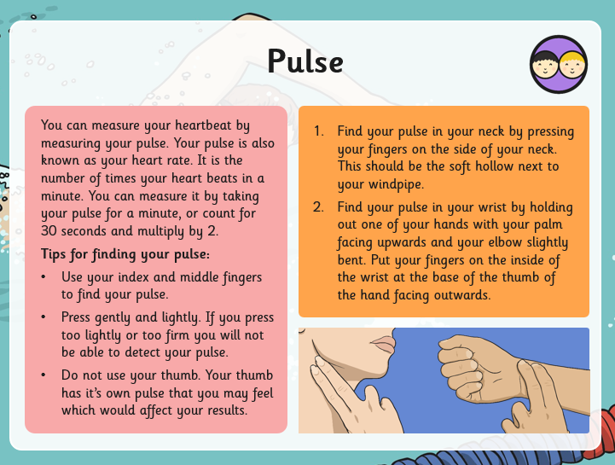  You will need to measure your pulse during several activities. Record your findings on a table like this: As scientists it’s important to take several recordings in order to make sure it is reliable. Calculate the mean at the end of each exercise (add the three attempts together and divide by 3) Repeat with other members of the family | Daily reading  TTRockstars
  Activity | Beat per minute  Attempt 1 | Beat per minute  Attempt 2 | Beat per minute  Attempt 3 | Mean  Beat per minute
  Sitting
  Slow breathing
  Walking
  Jogging
  Jumping
  Sprinting
Friday | Maths  Get your brain in gear with Countdown Numbers  http://happysoft.org.uk/countdown/numgame.php  White Rose Maths  Week 1 Lesson 5 Using Scale Factors (scroll down) – watch video, complete activity and check answers  https://whiterosemaths.com/homelearning/year-6/  GPaS  Play https://learnenglishkids.britishcouncil.org/grammar-practice/present-simple-and-present-continuous  Reading  Write a book review for Amazon for a book you have read over the past 2 weeks. Email to us and we will post it on the Amazon Website and display it in our classrooms  Writing  Edit your story using CUPS  C- Capitalisation  U – Understanding – does it makes sense?  P – punctuation  S – Spelling  Can you improve your work in any way? Up-levelling vocabulary, change sentence starters, mixture of short and long sentences, extend sentences using conjunctions? Feel free to type them up and send them to us!  Science  Present your findings from yesterday’s information on a graph (see below for ideas) You could even input the data onto an Excel spreadsheet (if you can) and create a graph on there. Can you find a way to put all of your family’s data on one graph?  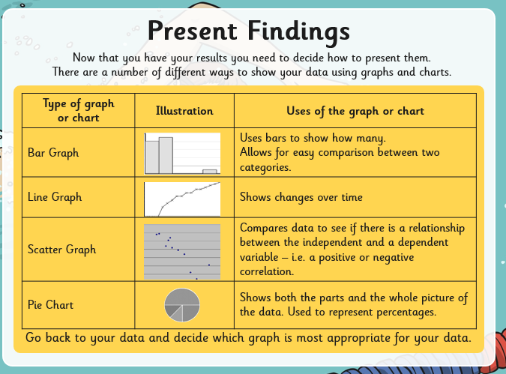 | Daily reading  TTRockstars

Creative curriculum

In addition to these tasks, we would like you to produce something creative! Choose one thing, two things... all the things from the list below if you fancy:

- Design and create your own card or board game. Test it out and then write a set of instructions on how to play it.
- Create your own dance routine to your favourite song. You could always video yourself performing it and post on twitter or email it to us.
- Research an artist of your choice and create a piece of your own artwork inspired by them.
- Create a quiz on a particular topic (e.g. animals/countries/sports et.) that you could give to your family members. Make sure you have researched and found the correct answers.

