Monday
Healthy eating

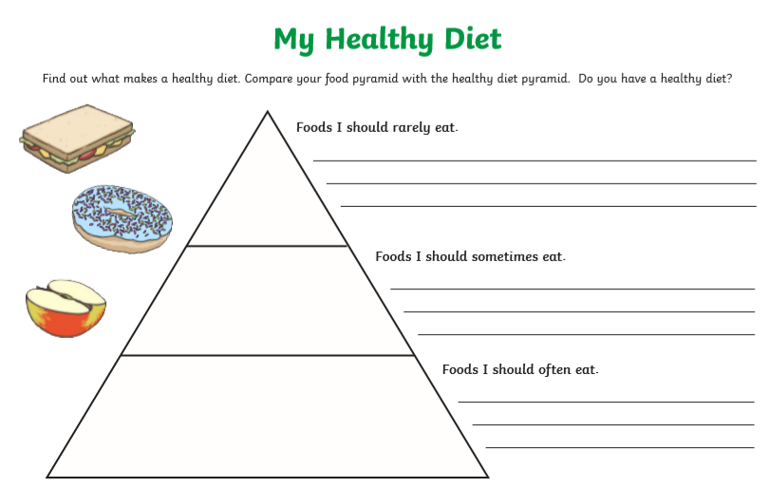

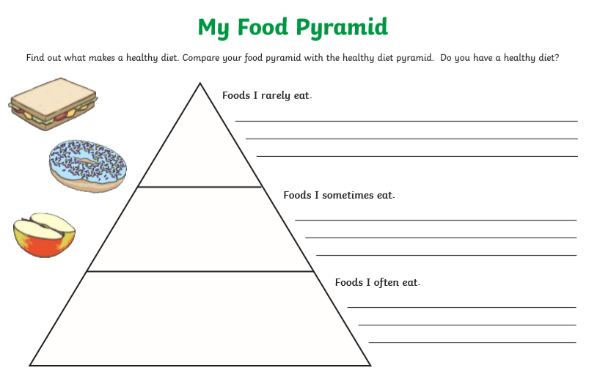

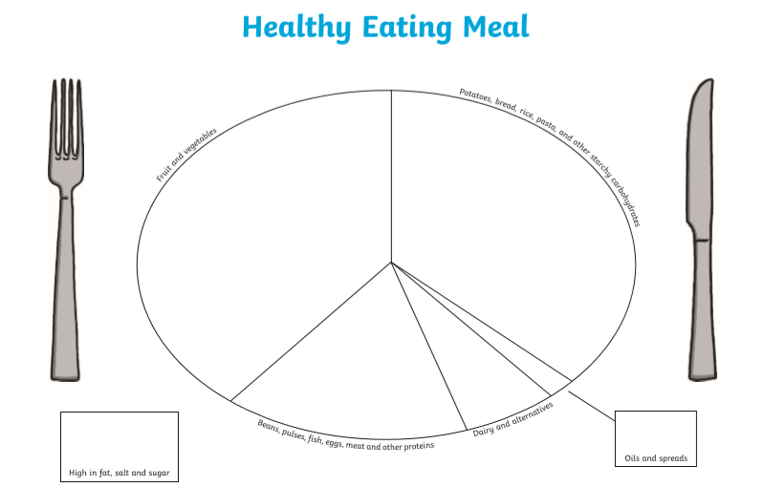

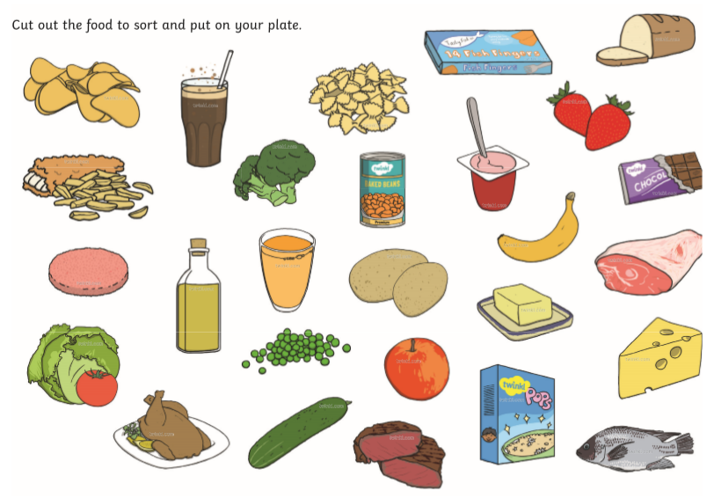

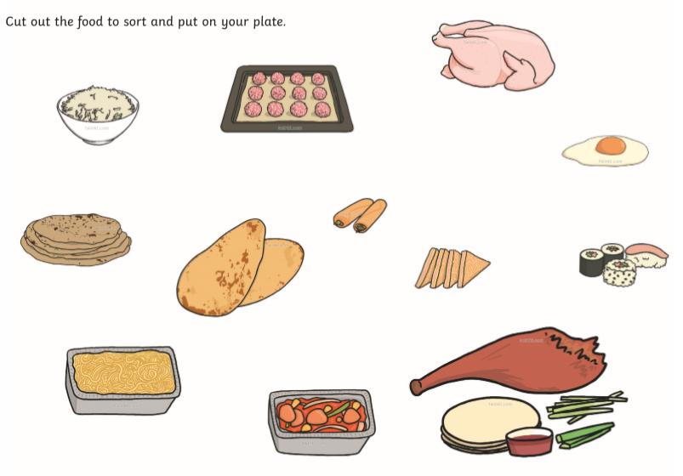

Bonus Activity
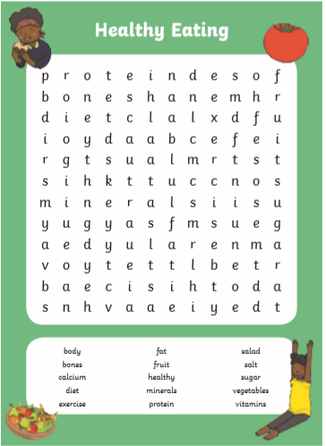

Tuesday
The Dangers of Smoking
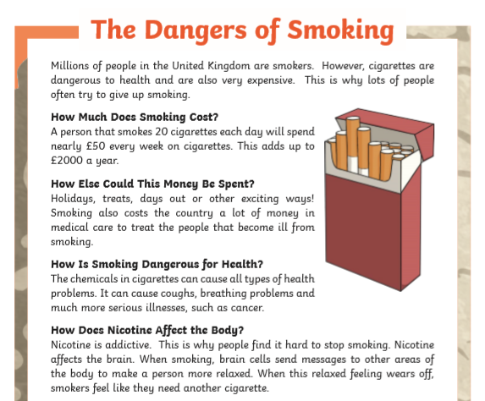
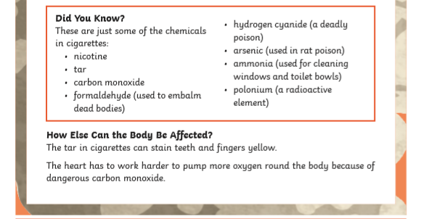
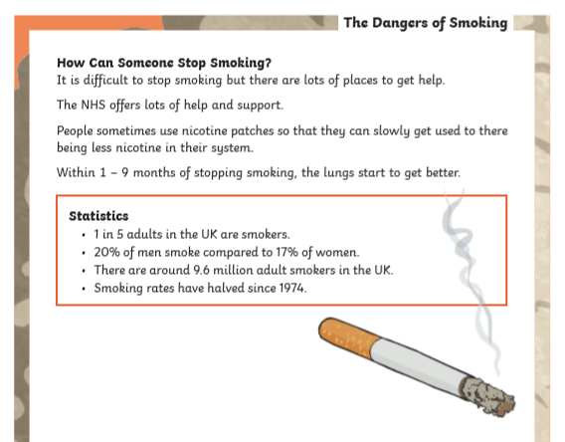

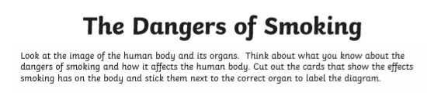

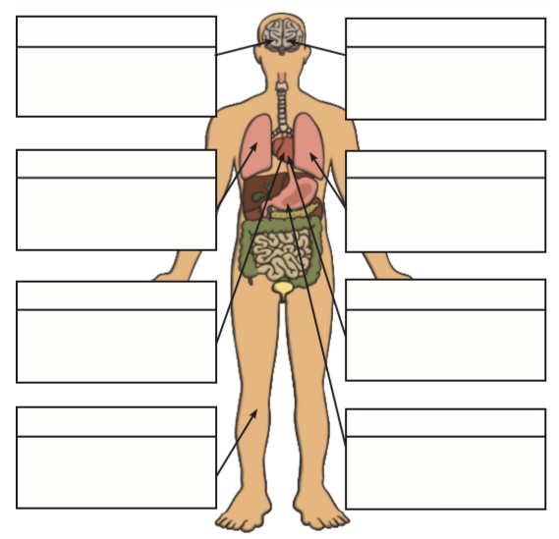
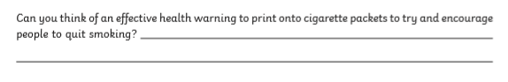

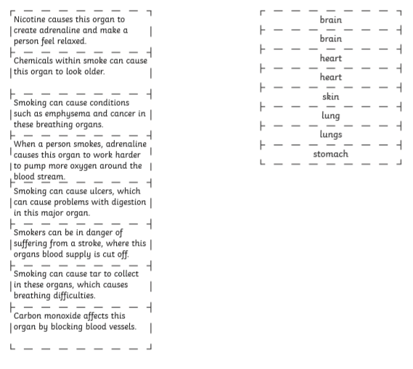

Bonus Activity!
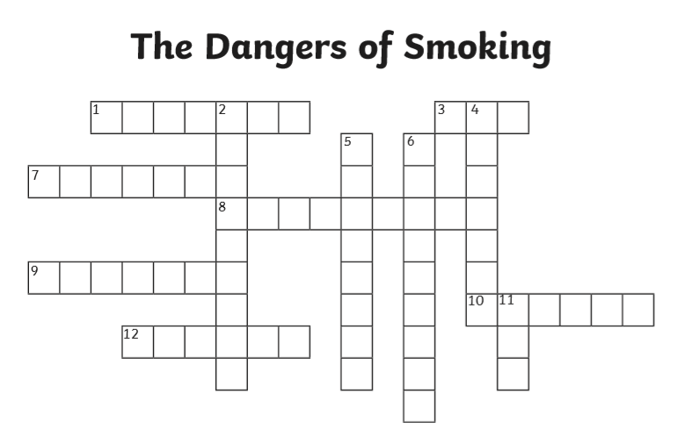

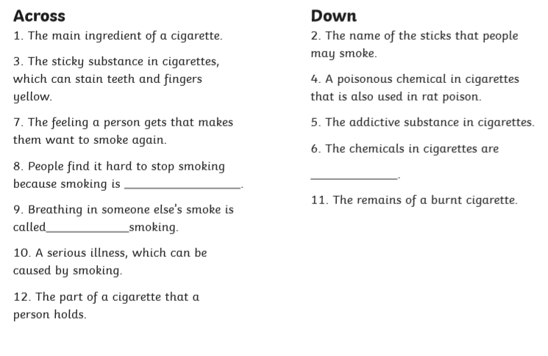

Wednesday
Why exercise is important
Information sheet
You exercise all the time without even thinking of it. When you run around outside or play kickball at school, you are exercising. What else counts as exercise? Playing sports, dancing, and doing push-ups. Even reaching down to touch your toes!
When you exercise, you make your body stronger. So be active every day. Your body will thank you!

Make Your Heart Happy!
Your heart is a muscle. It works hard, pumping blood every day. Help your heart get stronger by doing aerobic (say: air-OH-bik) exercise.
Aerobic means "with air." When you do aerobic exercise, you breathe faster so you take in more air. Your heart beats harder too. This gives your heart a workout. It will get even better at its main job — taking oxygen from the air you breathe in and giving it to all your body parts.

What Type of Exercise Is Good for Me?
Lots of exercises can get your heart pumping. Try these:
- swimming
- basketball
- hockey
- running or walking
- skating
- soccer
- cross-country skiing
- riding your bike
- jumping rope

How Can I Get Stronger Muscles?
Did you ever swing across the monkey bars at the playground or play a game of tag? They can make your leg and arm muscles stronger. Here are other ways to build strong muscles:
- push-ups
- pull-ups
- tug-of-war
- rowing
- running
- jumping
- bike riding

How Can I Be More Flexible?
Being flexible means you can stretch your body easily. Exercises that build flexibility feel really good, like when you take a big stretch in the morning after waking up. It's easy to find things that help you stretch:
- gymnastics
- yoga
- dancing
- karate
- bending, twisting, and reaching

Exercise Feels Good
It feels good to have a strong, flexible body that can do all the things you enjoy — like running, jumping, and playing with your friends. It's also fun to be good at something, like making a basket, hitting a home run, or dancing.
Exercising can also put you in a better mood. When you exercise, your brain releases chemicals that make you feel happier. It's just another reason why exercise is a good idea!

Science / Maths
You are going to investigate how exercise effects your heart rate
Your heart rate is how many times your heart beat in a certain amount of time (usually in a minute).
Your heart beats the blood around your body. The blood moves in aves and these waves can be felt on your arteries. We call this your pulse. There are a few places in the body that you can feel your pulse which is how you can measure your heart rate. This is measured in beats per minute. Can you find your pulse? The 2 main places you can feel it are in your wrist and neck.
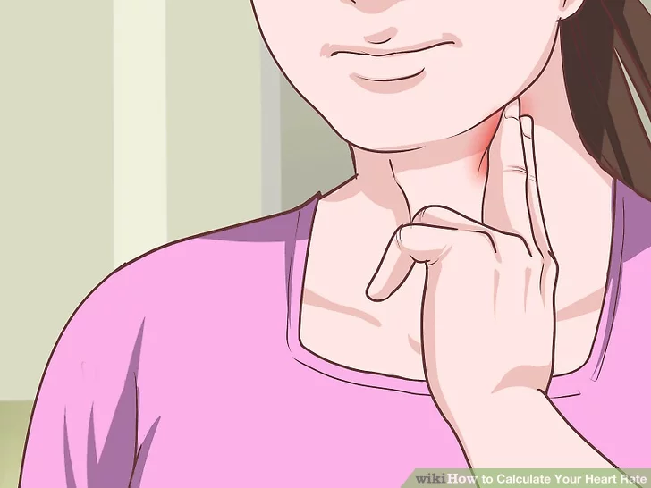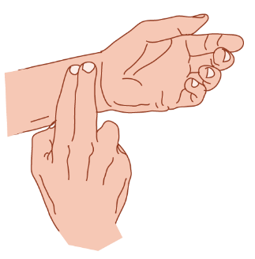
Your task:
Sit quietly for a minute or 2 and then measure your heart rate. Once you have sat still for 2 minutes, and your pulse and count the number of beats you feel in 30 seconds. Double your number and that’s how many beats there would be in a minute. This is your resting heart rate.
Record this on the table (next page)
Next, you are going to walk for 30 seconds. Measure your pulse rate again – count it for 30 seconds and then double it. Record it on your table. Are there any other changes you can feel?
Now do a gentle jog on the spot or round your garden for 30 seconds. Measure your pulse the same as before and record it! How do you feel now?
What other exercises will you choose to do? Star jumps? Press ups? Running as fast as you can?
Things to remember:
- Exercise for the same time every time
- Count your pulse rate straight away carefully and record it each time
- Think about the other changes you can feel in your body as you do each exercise

Exercise | Pulse rate | Other changes I can feel in my body
Walk
Jog

What other changes did you notice in your body?
____________________________________________________________
Why do you think your heart needs to beat faster?
__________________________________________________________________________________________________________________________________________

The answers are here! Highlight and change the font colour to read it.
One of the functions of your blood is to carry oxygen round your body. Your muscles need oxygen to work. So, the harder your muscles work, the more oxygen they need. This means that you have to breathe harder and faster and your heart needs to beat more quickly to get the oxygen to where it needs to be. Exercise is important for a healthy heart, lungs and muscles. It also helps you sleep and improves your mental health.
This extra activity and movement releases heat so you probably felt hotter.
Your body knows that when your skin is wet, it feels cooler. Your body’s natural cooling system is sweating. This is why it is important to drink water to replace what our body has lost.
Bonus Maths task
Draw your results in a bar graph


Thursday
Hygeine
A part of keeping healthy is to keep clean. You should have a routine cleaning your teeth, washing your face, body daily and your hair 3 or 4 times a week. At this stage in your life, and especially this time of year, you are probably finding that you are sweating more and as you get older, this can start to get a bit smelly! Another part of your routine now may be washing more regularly and wearing deodorant.
It is important to wash your clothes regularly too to keep them clean and fresh.
Today you are going to do an investiagtion to see how soap works. All you need to do is follow the instructions on the following sheets. First, look at the record sheet you will be filling in.

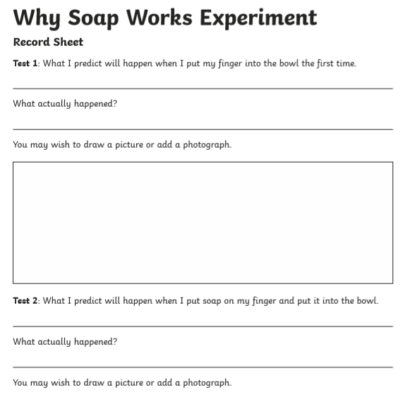

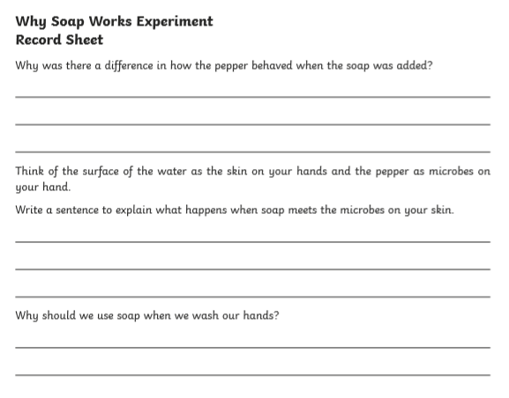

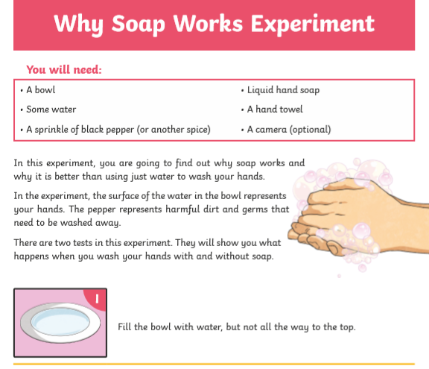

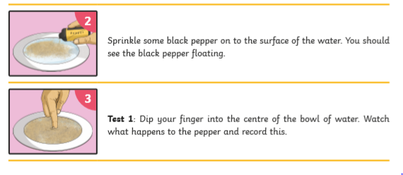

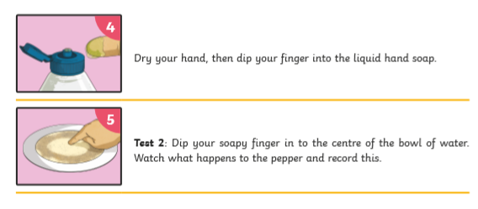

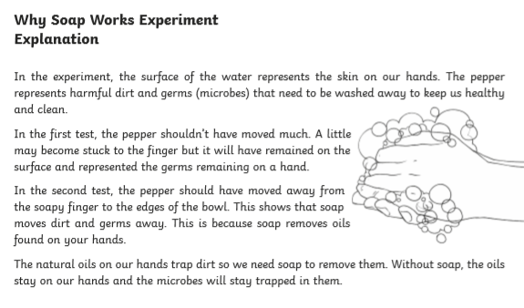

Friday
Sleep
A really important part (and an often forgotten or overlooked part) of stayng healthy is getting enough sleep. Your brain never stops working, but it is working really hard when you are awake. Throughout the day, a chemical builds up in your brain as it works and you need to sleep to allow your brain to clean this chemical away. Sleep also gives your body time to relax and repair.
Yoga is a great way to relax your body to promote better sleep. It is especially good for athletic people as it strengthens and lengthens muscles which help avoid injury. You might be interested to read this:
https://sportsnaut.com/2016/03/xx-pro-athletes-teams-that-practice-yoga/
Have a go at these yoga poses below!



