UK Sporting Stars Pack Week 14

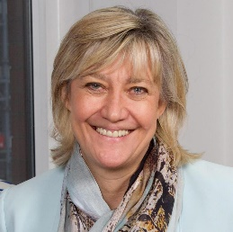
Monday

Debbie Jevans, CEO, England Rugby 2015

Our leading lady of British sport, Jevans is the first female chief executive to organise a Rugby World Cup, and the first woman to be appointed director of sport for an Olympic Games when she led the double triumph of an Olympic and Paralympic Games at London 2012. There, managing 20,000 staff and a budget in excess of £160m, Jevans cemented a name for herself as an extraordinary individual in sport, having already played a key part in winning the bid for London in 2005. With so few women seated alongside her at sport's top tables, Jevans has been unequivocal in speaking out against gender imbalance in sport - most recently calling for quotas to be considered, despite a lifelong aversion to the concept. Formerly a professional tennis player – she once beat Judy Murray (Andy Murray’s mum) Jevans is also a member of the All England Lawn Tennis Club's committee of management and championships committee, as well as a Sport England board member, and sits on the UK Sport major events panel.
Finding synonyms
- What word has been used that means the same as ‘secured’?
- What word has been used that means the same as ‘indisputable’?
- What word has been used that means the same as ‘loathing’?
True or false?
- Jevans was formerly a professional netball player.
- She was the first female chief executive to organise a Rugby World Cup.
- She was the second woman to be appointed director of sport for an Olympic Games when she led the double triumph of an Olympic and Paralympic Games at London 2012.
- She had a budget of more than £160m when she was director of sport for the Olympic Games in 2012.

Monday Answers:
Finding synonyms
- Secured – cemented
- Indisputable – unequivocal
- Loathing – aversion
True or False?
- False (she was a former professional tennis player)
- True
- False (she was the first woman to be appointed director of sport for an Olympic Games when she led the double triumph of an Olympic and Paralympic Games at London 2012).
- True

Tuesday
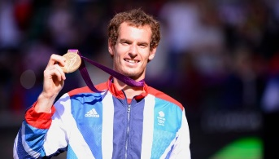

Sir Andy Murray

Any Brit thinking of tennis will automatically think of the name Andy Murray, and the Scotsman has certainly earned his popularity. Unfortunately, throughout 2018, Murray has been plagued with recurring injuries leaving him unable to play in the Wimbledon Championships, but there are plenty of hopes that he will be well enough to participate again in 2019. Murray has won Wimbledon not just once, but twice, and has also won the Grand Slam three times. At his peak, Murray was the world No. 1 in men’s tennis, making all of us Brits proud. He’s smashed many records out of the park including being the first British man since Fred Perry over 80 years ago to win more than one Wimbledon singles title. Even more spectacularly, he also won the singles Olympic gold medal for men in both 2012 and 2016 making him the only tennis player (both female or male) to win two Olympic medals in the singles category. If anyone has earned the right to be called Sir, it’s this guy.

Finding Synonyms:
- What word has been used that means the same as instinctively?
- What word has been used that means the same as tormented?
- What word has been used that means the same as outstandingly?
True or false?
- Andy Murray has won Wimbledon three times.
- Andy Murray won gold in the singles Olympics in 2012 and 2016.
- Andy Murray has never won the Grand Slam.
- At his peak, Andy Murray was the world No. 1 in men’s tennis.

Tuesday Answers:
Find the synonym:
- Instinctively – automatically
- Tormented – plagued
- Outstandingly – spectacularly
True or False:
- False – Murray has won Wimbledon twice.
- True
- False – Murray has won the Grand Slam three times.
- True

Wednesday
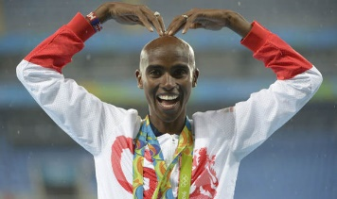

Sir Mo Farah

Sir Mohamed Muktar Jama Farah, a British track athlete, is the most popular and successful runner in the history of the Olympic Games. Farah was knighted in 2017 for his spectacular efforts in both the 2012 and 2016 Olympic Games, winning gold medals in not only the 5000-metre race, but also the 10,000 metres. Sir Mo Farah has become a name that every British citizen knows and loves, with his unique ‘Mobot’ celebration after winning his races – this is one cool guy. After smashing his track career earning a total of six World titles, four Olympic golds and four European golds, Farah has now set himself another challenge; marathons. He placed third in the London Marathon at the start of 2018 and we doubt he will stop anytime soon.

Find the synonym:
- What word has been used that means the same as well liked?
- What word has been used that means the same as amazing?
- What word has been used that means the same as individual?

True or False?
- Mo Farah became Sir Mo Farah in 2017.
- Mo Farah won the London Marathon in 2018.
- In the 2012 and 2016 Olympic Games, he won gold medals in the 5000-metre race and the 10,000 metres.
- Mo Farah has never won a World title.

Wednesday Answers:
Find the synonym:
- Well liked – popular
- Amazing – spectacular
- Individual – unique

True or False?
- True
- False – He came third in the London Marathon in 2018
- True
- False – Mo Farah has won six World Titles

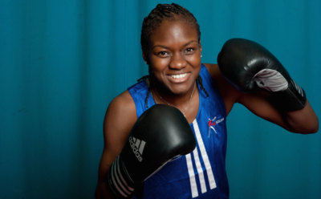
Thursday

Nicola Adams - Double Olympic Boxing Champion

The hugely popular 37-year-old is from Leeds and has a Yorkshire accent as broad as her famous smile. Adams’ parents separated when she was just 14. Her mother Dee first sent her to a boxing gym when she needed help with some form of childcare while she worked. But it was with her father that she first watched videos of Muhammad Ali and sparked an interest that would take her to the very top. Adams has two Olympic golds, from London and Rio. She became the first British boxer to retain an Olympic title for 92 years by winning gold in the women's flyweight final in 2016. Adams also has a gold medal from the 2014 Commonwealth Games in Glasgow. She has picked up first-place finishes in World Championships, European Championships and European Games. She also picked up three silver medals in the World Championships and one in the European Championships in a glittering career. Since turning professional, Nicola has won her first five fights. She beat Virginia Noemi Carcamo on points in Manchester in her professional debut, and followed that up by knocking out Mexican Maryan Salazar in Leeds.

Find the Synonym:
1. What word has been used that means the same as wide?
2. What word has been used that means the same as parted?
3. What word has been used that means the same as keep?

True or False?
- Nicola Adams was born in London and has a cockney accent.
- Nicola Adams watched videos of Muhammad Ali with her mother.
- Nicola Adams became the first British boxer to retain an Olympic title for 92 years by winning gold in the women's flyweight final in 2016.
- Since turning professional, Nicola has won her first five fights.

Thursday Answers
Find the synonym:
- Wide – broad
- Parted – separated
- Keep – retain
True or False?
- False – She was born in Leeds and has a Yorkshire accent.
- False – She watch videos of Muhammad Ali with her father.
- True
- True

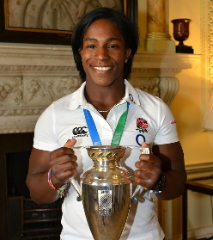
Friday

Margaret Alphonsi MBE, England Rugby World Cup Winner.

Before announcing her international retirement in 2014, she represented her country an impressive 74 times, scored 28 tries, and helped England win a record breaking seven consecutive Six Nations crowns. She was also a crucial member of the team that won the 2014 Rugby World Cup for the first time in 20 years and was part of the team that was crowned the BBC’s Sports Personality Team of the Year.
Through her England rugby career she has become a household name but also a media professional, and since retiring she has commentated on live rugby matches for SKY Sports, BT Sport and the BBC. In 2015 she became the first ever former female player to commentate on men’s international rugby when she was signed up by ITV for the Rugby World Cup, and she continues to work with ITV Sport across their rugby coverage. Maggie is also the first ever former female player to become a columnist for a national newspaper, and you can regularly read her thoughts and opinions in The Telegraph. In 2016, Maggie made history by becoming the first England Women’s player to be elected as a National Member of the Rugby Football Union’s Council. She is one of just six females on the 56-strong Council and her role is to be a person of experience and influence in the Game, which includes a leading role in the Diversity & Inclusion steering Group.
Find the synonym:
1. What word has been used that means the same as one after the other?
2. What word has been used that means the same as key?
3. What word has been used that means the same as usually?
True or False?
- Margaret Alphonsi was part of the team that won BBC’s Sports Personality of the Year.
- Margaret Alphonsi represented her country an impressive 54 times.
- In 2015 she became the first ever former female player to commentate on men’s international rugby when she was signed up by ITV for the Rugby World Cup.
- In 2016, Maggie made history by becoming the first England Women’s player to be elected as a National Member of the Cricket Council.
Friday Answers:
Find the synonym:
- One after the other – consecutive
- Key – crucial
- Usually – regularly
True or False?
- True
- False – She represented her country an impressive 74 times.
- True
- False – she was elected as a National Member of the Rugby Football Union’s Council.

