You have a text, questions and the answers.
Read the text, answer the questions and then check your answers!
The Boy from Far Away
Joe’s mum sent him to wash his hands before dinner. Joe stomped out of the tent and ran across the muddy site. It was still raining, as it had been for the past four days. Camping holiday weather, Dad called it.
There was nobody else in the shower block. Joe turned the tap on. Then he heard a noise.
‘Pssst!’ said a voice.
Joe turned round. He couldn’t see anybody.
The noise came again. ‘Pssst!’
Then Joe noticed a pair of eyes looking at him from above one of the shower curtains.
‘Help me! I’m stuck!’ said the voice.
Joe pulled open the curtain and blinked. Hard.
The person – it was impossible to say whether it was a boy or a man – was standing on the wall. His feet, encased in butter-yellow boots, were planted firmly on the tiles.
‘Wow! How did you get up there?’ asked Joe.
‘I thought it was the ground,’ said the person.
Joe frowned. ‘But what’s holding you up there? Why aren’t you falling down?’
‘It’s my boots,’ whispered the person.
‘Your boots!’ exclaimed Joe.

‘Sssshh!’ The person peered round the edge of the cubicle to make sure nobody was listening. ‘Please do not speak about the boots.  They are secret.’  Slowly, the person lifted one foot and began to walk down the wall. When he reached the ground he righted himself and grinned up at Joe. He was very short – at least six inches shorter than Joe – and he had a young-looking face. But his hair was sparse and wispy and his hand was wrinkly like an old man’s hand.  ‘Thank you. You are my best friend! I am Oran,’ said the person. | 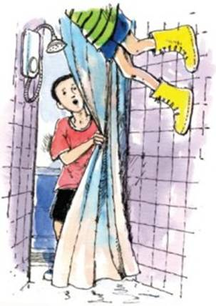
‘That’s okay. I’m Joe. But how ... ?’
‘Is this Holiday?’ whispered Oran, looking round the shower block.
‘No!’ laughed Joe. ‘A holiday isn’t a room! It’s like ... a break.’
Oran frowned. ‘A break? Snap?’
‘Not that sort of break. A rest sort of break. When you go somewhere to enjoy yourself.’
Oran nodded. ‘Rest sort of break. Enjoy yourself.’ He dipped his thin wrinkly hand into the pocket of his shorts and pulled out a notebook and pencil. He wrote something down.
‘Only it’s better when it’s not raining,’ said Joe.
‘Good! So now I am in the right place. And the right way up! I will have Holiday with you!’
‘Hmmm, maybe,’ said Joe, cautiously. ‘How come you haven’t heard of a holiday before?’
‘We don’t have them where I come from,’ said Oran.
‘Where’s that?’ asked Joe. He thought everybody had heard of holidays.
‘Oh – far away,’ said Oran, waving his skinny arm.
Joe had never heard of Faraway.
‘Where’s that?’
Oran suddenly looked sad. ‘It is a very long way and I do not want to talk about it.’
Joe thought Oran must be homesick. He would have to try to be friendly and not mention Faraway again.
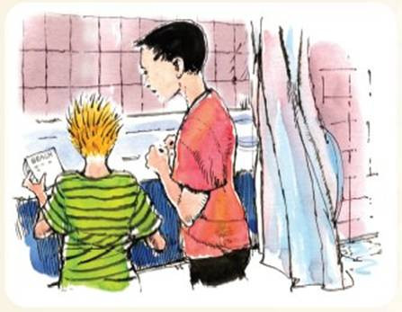
‘Why do you want to know about holidays?’ asked Joe.
‘It is my homework,’ said Oran. ‘Tell me more.’
Joe tried to explain. ‘Holiday is when you have fun and games and you don’t have to go to school or work. You can go on the beach. The beach is brilliant – sun and sea and tons of sand to play on.’
‘I would like to see Beach,’ said Oran. He stood up and put the notebook away. ‘I must go now. There is much work to do. It will be sunny tomorrow and we will go to Beach.’
Joe didn’t believe him.
But it was sunny the next day. Suddenly the camp site came to life. Bags full of grass mats and beach balls appeared outside each tent. Picnics were packed and swimsuits put on.
Joe was hardly surprised at all when he tripped over a small figure bending down to tie his bootlaces. It was Oran, of course.
‘Hello, friend!’ said Oran. ‘Is this to Beach?’
‘Yes,’ said Joe. ‘Look! There it is!’
He pointed down at the bright sand and dazzling sea.
‘Oh!’ gasped Oran. ‘But the sea is wet? You didn’t like the wet!’
‘I didn’t like the wet when it was coming down as rain. It’s different when it’s the sea.’
Oran didn’t look convinced.
Oran stood on the sand and made notes while his friend swam. This water was interesting. It wasn’t flat. It had hills and ridges, and it moved.
Oran noticed that every so often the water came nearer, and he kept having to walk a bit further up the beach. The water was growing!
As they walked back up the beach, Oran confided, ‘I don’t wish to alarm you, Joe, but the sea is growing. I think it may overflow.’  ‘The sea can’t overflow,’ said Joe. ‘It just moves up and down a bit – it’s called the tide. It’s something to do with the moon’s gravity.’  ‘Ah! I know about gravity,’ said Oran, jumping with both feet and landing – THUMP! – on the sand. | 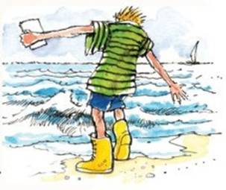
Joe looked down at Oran’s boots. They might be great for walking up walls, but were they any good for playing football in? Oran had never heard of football, so Joe fetched his ball and showed Oran how to kick.
‘Now you try,’ said Joe. Oran pulled back his butter-yellow boot and then he kicked – hard. The ball flew into the air, growing smaller and smaller until it was just a tiny speck in the sky.
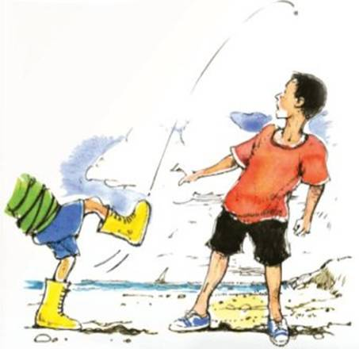
‘Wow!’ said Joe. Maybe Oran’s boots were all-round magic boots. It was a stunning kick for somebody who hadn’t even heard of football. And where on Earth had nobody heard of football?
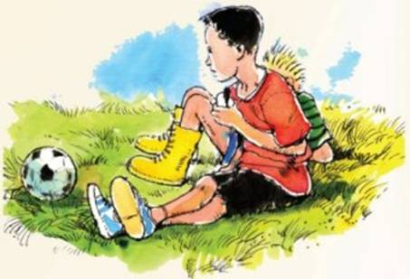
The sun shone the rest of the week.
Soon it was the last evening of the holiday. Then Oran told Joe his news.
‘I have finished my homework. Tonight, I have to go back.’
Joe fiddled with a few blades of grass. He didn’t want Oran to go home. His holiday had been much more fun with him around. And much sunnier.
‘Perhaps we could write to each other,’ said Joe.
‘I’m afraid we don’t have a very good postal service where I come from,’ said Oran. ‘But please give me your address. You have been a good friend to me. I would like to send you a present. What would you like?’
‘What I would like most of all is – a special pair of boots like yours,’ said Joe.
Oran looked down and wriggled his toes. ‘This is difficult,’ he said.
‘These boots were specially made for me and my ... circumstances.
They might not suit you. But I will send you some boots specially made for you and your ... circumstances.’
‘Thanks!’ said Joe.
‘Now I must go,’ said Oran. He shook Joe’s hand and stood up.
‘Goodbye, friend.’
When Joe woke up the next day it was raining again.
It rained all the way home. When they got back there was a parcel waiting on the doorstep. There was an envelope taped on top.
He opened the letter.
‘Dear Joe,’ it said.
‘Thank you for helping me with my homework. I have explained to my fellows about holidays, and fun and games, and the sea and beach.
Here are the special boots I promised you. They aren’t exactly like mine.
Now that I am not there with you, there may be rather a lot of rain for a while so I have made your boots waterproof. Also, you said that you didn’t like yellow very much, so yours are a different colour. I hope you will like these. Remember to be sensible with them. Wall-walking can be very dangerous.
Your friend,
Oran.’
Joe ripped open the box. Inside was ... a very special pair of boots.
Joe lifted them out. They were glossy navy-blue and lined with some kind of short black fur and they had a pattern of stars on the soles. So these were Joe’s special boots – made for him and his circumstances. Glossy blue, fur-lined, star-soled, wall-walking ... wellington boots!
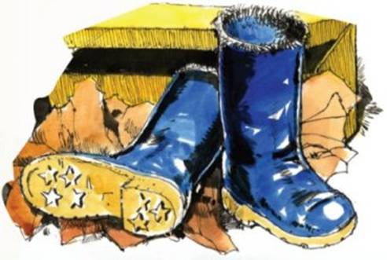

1. Circle the correct option to complete each sentence below.
(a) This story is about two boys who

1 mark
(b) Joe thinks that Oran is a bit strange but we realise that he

1 mark
(c) The boys have fun together although Oran has really come to

1 mark
2. What did Joe’s Dad mean when he said:
Camping holiday weather?
___________________________________________________________________
2 marks
3. On page 2, Oran introduces himself to Joe in the following way:
‘Thank you. You are my best friend! I am Oran.’
Why might Joe have found this introduction surprising?
___________________________________________________________________
___________________________________________________________________
___________________________________________________________________
2 marks
4. What clues are there in the story that Oran was not an ordinary boy?
Find three.
• _________________________________________________________________
• _________________________________________________________________
• _________________________________________________________________
• _________________________________________________________________
2 marks
5. Look at page 2. Oran asks ‘A break? Snap?’
Explain why Oran asks this.
___________________________________________________________________
___________________________________________________________________
2 marks
6. “Hmmm, maybe,” said Joe, cautiously... (page 2)
Which word most closely matches the meaning of the word cautiously?

 | Tick one.
happily | 
slowly
quietly
carefully
1 mark
7. Why is Oran surprised that Joe likes swimming?
___________________________________________________________________
___________________________________________________________________
___________________________________________________________________
1 mark
8. Look at the fourth page of The Boy from Far Away. It says
This water was interesting. It wasn’t flat. It had hills and ridges, and it moved.
Why do you think the sea is described in this way?
___________________________________________________________________
___________________________________________________________________
___________________________________________________________________
2 marks
9. At the end of the holiday, Joe was sad about Oran leaving. Does this surprise you?
Explain fully, referring to the text in your answer.

3 marks

ANSWERS

1. Award 1 mark for each correctly identified option.
(a)

(b)

(c)

Up to 3 marks
2. Award 2 marks for answers that show some understanding of the irony / sarcasm of the comment in relation to the weather, eg:
• he meant that it always seems to rain / usually rains when you go on a camping holiday.
Also accept for 2 marks:
• it always rains.
Award 1 mark for answers that give only a simple description of the weather derived from the text or give a simple explanation of the comment, eg:
• the weather was bad;
• he meant it was raining and muddy.
up to 2 marks
3. Award 2 marks for answers that identify the unconventional nature of Oran’s remark and / or explain why Oran’s statement was inconsistent / not normal, eg:
• because people usually get to know each other before they become best friends – Oran and Joe didn’t know each other;
• you wouldn’t have to tell your best friend your name;
• he had never met him before and yet he said he was his best friend.
Award 1 mark for answers that recognise that Oran’s introduction was odd but do not explain it, eg:
• they had only just met / they hardly knew each other;
• because he had suddenly said ‘You are my best friend’.
up to 2 marks
4. Award 2 marks for reference to any three of the following:
Award 1 mark for reference to any two of the following:
Each point may be made only once. Do not credit rephrasing of a point already given.
• unusual abilities: standing on the wall, body horizontal, ability to influence the weather, could kick a ball high;
• unusual boots (with special powers), funny / yellow / weird;
• unusual appearance: young face and old man’s hands, sparse wispy hair;
• unfamiliarity with ordinary things (holiday / sea / football / intro);
• reluctance to reveal where he is from / had no address.
Do not accept:
• he came from far away.
up to 2 marks
5. Award 2 marks for answers that show implicity or explicity, recognition of the fact that the word ‘break’ can have another meaning of which Oran was not aware, eg:
• because Oran thought that break meant something was broken;
• because ‘break’ can mean two things – a holiday or a snap;
• because he didn’t realise that we call a holiday a break.
Award 1 mark for answers that simply refer to Oran’s ignorance of the term ‘holiday’, eg:
• because he didn’t know what a holiday was;
• because he didn’t understand what Joe meant / the language.
Up to 2 marks
6. Award 1 mark for
carefully
1 mark
7. Award 1 mark for answers that explain why Oran thought Joe hated water, eg:
• he thought that Joe hated water because he said he didn’t like the rain;
• because he didn’t like the rain.
Also accept answers that refer to Oran’s assumption that Joe did not like water but do not provide an explanation, eg:
• because he thought that Joe hated (didn’t like) water / getting wet.
Do not accept:
• Oran didn’t understand about swimming.
1 mark
8. Award 2 marks for answers that recognise Oran’s viewpoint (explicity or implicity) by referring either to the fact that Oran did not have the appropriate knowledge / vocabulary to describe what he was seeing, or to the fact that the sea is described through Oran’s eyes, eg:
• he hadn’t seen the sea before and didn’t know that the hills and ridges were waves;
• because Oran is a stranger here and can’t say what waves really are;
• to show that Oran didn’t know what waves were;
• because he is writing about what Oran thinks / from Oran’s point of view.
Award 1 mark for simple reference to the visual appearance of the sea, eg:
• because it had ripples / waves;
• because it looks like it has hills.
Up to 2 marks
9. Answers may refer to:
• friendship / attachment – they had become friends / liked each other, he didn’t want him to go / would miss him / might never see him again;
• fun / shared activities – time they spent together, sharing, things they did / finding out about each other (or not knowing each other long);
• Oran’s unique character (including influence on the weather) – how interesting / unusual he was, how Oran made it sunny (or Oran was strange).
Award 3 marks for developed answers that refer to at least two of the above which are either supported by references to the text or indicate fuller recognition of the underlying theme / concept of friendship in the story, eg:
• Joe was sad about Oran leaving because they had become good friends and he wished he could stay. His holiday was much more fun after he came and the weather was better too;
• it was surprising in a way because, at first, Joe thought Oran was strange. But he got used to him and made friends. When you get close to someone you don’t want them to leave.
Award 2 marks for answers that refer to one or more of the above and make some limited reference(s) to the text, eg:
• they were good friends, and Joe taught Oran to play football;
• Joe was sad because he would miss Oran and because he thought it would start raining again;
• because they had spent so much time together and Joe had made a new best friend. Joe taught Oran about football and beaches and holidays;
• he would miss Oran when he left. During the holiday they had done lots of fun things together and really did become best friends;
• because they had such a lovely time together and now he will never see him again so he’s sad. The weather was lovely too which meant they were able to spend more time with each other;
• I am surprised because they didn’t really know each other that well and Oran was very odd.
Award 1 mark for simple answers that refer to one or more of the above, in general terms, but are not developed, eg:
• because they had fun together;
• because he was his friend;
• they had so much fun together he didn’t want him to go;
• yes because Oran was weird.

