3 in 3!!

3 questions in 3 minutes!!!

Read the text and then time yourself answering the questions – your aim is to answer all 3 questions in 3 minutes!

Maths frequently uses words in its own special way. Take, for example, the words ‘proper’ and ‘improper’. When used in everyday language, they can feel like being criticised, especially when talking about behaviour. If someone told you that your actions were improper, you might feel a bit awkward or that you were being told off. But when it comes to fractions, it only indicates that the top number is greater than the lower one. That means it’s worth more than one whole. But that’s easily solved by converting it into a mixed number. All you need to do is find out how.

1. Find and copy the word in the first sentence that is closest in meaning to often.

______________________________________________

2. According to the text, what do the words proper and improper sometimes feel like?
______________________________________________

3. … you might feel a bit awkward …
In this context, which word is closest in meaning to awkward? Circle one.

proper uncomfortable actions told

You have a text, questions and the answers.
Read the text answer the questions and then check your answers!

Feet First
The Running Shoe
A running shoe is a special type of trainer. It is designed to protect your feet from injuries and help to improve your performance. Running shoes support the foot in the typical running position when the toes are down and the heels  are raised.  A good running shoe has four important parts, each with its own job to do: | 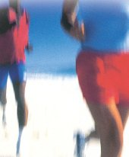
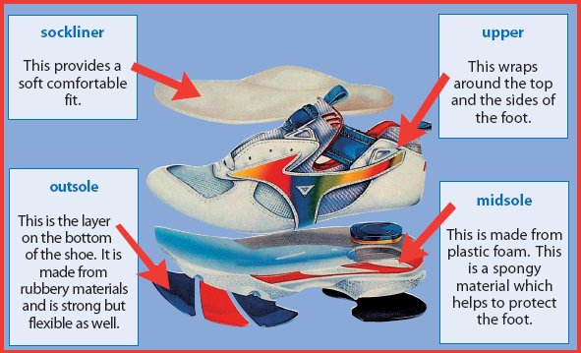
As well as wearing the correct footwear, a runner has to train regularly in order to improve performance.
Training for a race
Warming up and cooling down
It is important to warm-up and cool down every time you exercise. A warm-up gets your body ready for exercise. It helps your blood carry oxygen to your muscles so they are ready to work harder. When muscles are warm, they are more stretchy and tear less easily. | 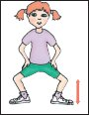
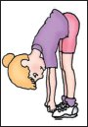 | You can warm-up by marching or jogging on the spot and doing stretching exercises. A balanced routine should be developed which covers all the muscles used. You should warm-up for about five to ten minutes until you feel warm and are breathing a bit faster than normal.
To cool down after exercising, do some slower movements until you are breathing normally again.  Cooling down helps stop your muscles getting sore. Stretching after exercise can help you to become more supple. | 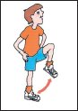
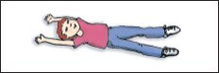

Training
If you are in good shape and have no injuries, you will be able to race short distances often. It is very important to listen to your body and if you are over-racing – slow down. The English Schools’ Athletic Association Award Scheme sets realistic targets for pupils of all abilities. Only short distances should be sprinted at maximum speed.

Year | Distance
3 | 40 m
4 and 5 | 60 m
6 | 80 m
Only Year 5 and 6 children should attempt racing longer distances.
The recommended distance is 800 metres, which should be run and not sprinted.
It is important to keep your body safe and comfortable when you are training. Do not train just after a meal or if you are unwell. Do not train so hard that your muscles hurt or you feel dizzy, sick or tired. Always drink plenty of water before and during exercise, especially in hot weather. This is to replace water you lose when you sweat. | 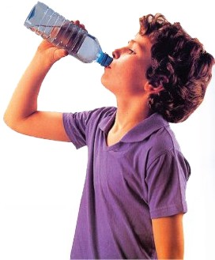

The benefits of exercise
Running is only one way of exercising. Exercise keeps your body strong and fit. Fitness means you have enough energy to do all the things you want to do easily. Your body cannot store fitness so you need to exercise regularly to stay fit.
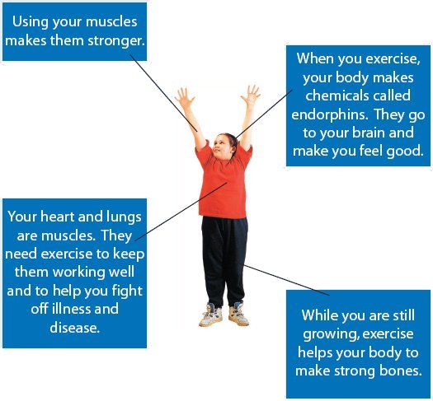

1. Circle the correct option to complete the sentence below.
The bottom layer of a running shoe is called the

1 mark
2. What makes the outsole strong and flexible?
___________________________________________________________________
1 mark
3. Look at the paragraph beginning: A running shoe is a special...
Find and copy one word meaning made like that on purpose.
___________________________________________________________________
1 mark
4. How can you tell from your breathing if you are warming up and cooling down properly?
___________________________________________________________________
___________________________________________________________________
___________________________________________________________________
2 marks
5. How many metres should a year 4 child sprint at maximum speed?
___________________________________________________________________
1 mark
6. How does the text try to make sure the reader will drink water before and during exercise?
___________________________________________________________________
___________________________________________________________________
1 mark
7. Give one of the bad effects of training too hard.
___________________________________________________________________
1 mark
8. How does exercise make you feel good?
___________________________________________________________________
___________________________________________________________________
1 mark
9. What does Feet First say happens to your muscles when you exercise?
Write two things.
1. _________________________________________________________________
2. _________________________________________________________________
2 marks
10. Why should you exercise?
Find and copy three reasons given in Feet First.
1. _________________________________________________________________
2. _________________________________________________________________
3. _________________________________________________________________
3 marks

ANSWERS

1.

1 mark
2. Award 1 mark for answers referring to the rubbery materials.
1 mark
3. Designed.
1 mark
4. Award 1 mark for each of the following (up to a maximum of 2 marks):
• you should be breathing faster when you have finished warming up;
• you should be breathing normally when you have finished cooling down / breathing slows down again.
Do not accept:
• references to the heart beating faster and slower.
up to 2 marks
5. Award 1 mark for 60.
1 mark
6. Award 1 mark for referring to one of the following with an indication of authorial intent:
• it tells you why you should do it;
• it says it’s important;
• the author says that you should replace the water when you sweat;
• it emphasises that it is important to drink / to replace sweat;
• it says to do it to keep your body safe / comfortable;
• by using the word ‘always’;
• he has put a big picture.
Accept references to ‘dehydration’ if used to mean ‘lose water when you sweat’ and the rest of the answer is acceptable.
Do not accept:
any of the above reasons given without an indication of authorial intent, eg:
• you should replace water when you sweat.
any answers, with or without an indication of authorial intent, unrelated to the effect of drinking water or answers not evident in the text, eg:
• by warning you that you’ll get dizzy;
• you will get dizzy, sick or tired;
• it says what will happen if you don’t drink water.
1 mark
7. Award 1 mark for any of the following:
• your muscles will hurt / you will injure yourself;
• you will feel dizzy / sick / tired.
Do not accept:
• you will pull a muscle;
• don’t train when you’re sick.
1 mark
8. Award 1 mark for answers that refer to the body making chemicals (endorphins) which go to your brain and make you feel good.
1 mark
9. Award 1 mark for each of the following facts from the leaflet (up to a maximum of 2 marks):
• warms your muscles up;
• makes them stretchy / they tear less easily;
• blood carries oxygen to the muscles;
• they hurt if you exercise too much;
• makes them stronger;
• keeps them working well;
• helps you fight off illness and disease;
• they work harder;
• your heart and muscles work well.
Do not accept:
• so they get healthy / fit / flexible / supple;
• you will get bigger muscles;
• it makes bones strong / helps your bones grow;
• it makes you stronger;
• they hurt (without clarification).
up to 2 marks
10. Award 1 mark for each of the following reasons from the leaflet (up to a maximum of 3 marks):
• it helps you stay fit / the body cannot store fitness;
• to give you energy to do all the things you want to easily;
• to keep your body strong and fit;
• to make your muscles stronger;
• to help your body to make strong bones;
• to keep your muscles / heart and lungs working well;
• to help you fight off illness and disease;
• to make you feel good;
• to help you become a better runner.
Do not accept:
any answers that can be drawn from general knowledge or paraphrases of the text, eg:
• makes you healthy / stay strong / to keep well;
• to keep fit / get fitter / to keep you fit.
up to 3 marks

