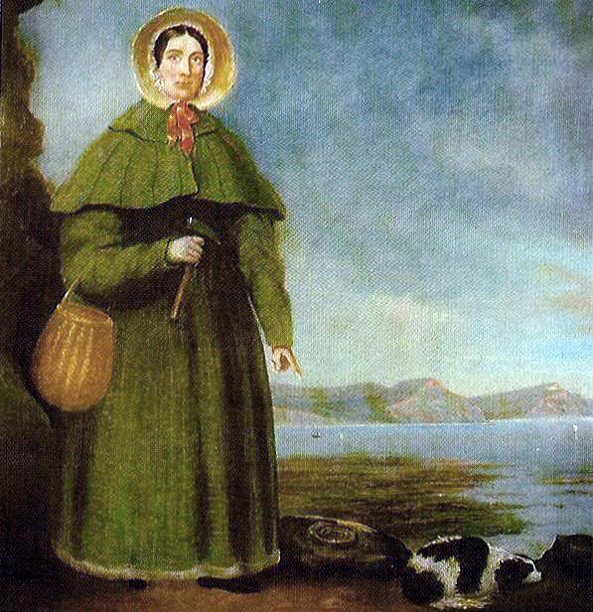

Mary Anning was a famous fossil hunter and collector (Palaeontologist). She found and identified many pre-historic fossils from the time of the dinosaurs and sold them to make money for her family.
Anning was one of the earliest fossil hunters to identify these pre-historic fossils, and she shared her specimens and impressive knowledge about them with scientists at the time.
Anning was born and grew up in Lyme Regis, on the south coast of England. This is an area with lots of fossils. 10 facts
- Although recognised by the science community, Anning was not admitted to The Geological Society – women were not allowed to join it until 1904. However, The Geological Society did record her death in 1847, demonstrating her importance.
- There is a memorial stained glass window to Anning in St Michael’s Parish Church in Lyme Regis.
- When a woman holding Anning at 15 months old was struck by lightning and killed, Anning survived.
- Anning was the first person to uncover a full Ichthyosaurus skeleton.
- Lyme Regis, where Mary lived, was once under water, 200 million years ago. This is why there are so many pre-historic fossils from underwater creatures found there.
- Anning often went fossil hunting after a storm because this usually caused bits of cliff to fall and for rocks to break open which made fossil hunting easier.
- Anning inspired the tongue twister ‘she sells sea shells on the seashore’.
- Anning’s Ichthyosaurus has been on display at the Natural History Museum in London.
- Anning discovered that if you grind up belemnites (squid-like creatures), the mixture can be turned into an ink for writing and drawing.
- Anning only ever left Lyme Regis once in her lifetime, to take a trip to London.

Time line:

1799 Mary Anning is born
1810 Anning’s father dies
1810-1811 Discovery of the first complete Ichthyosaur
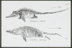
1823 Discovery of Plesiosaurus

T
1828 Discovery of Pterodactylus
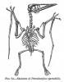

1837 Queen Victoria comes to the throne
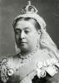

1847 Mary dies of breast cancer, age 47

