Monday Week 12 Answers
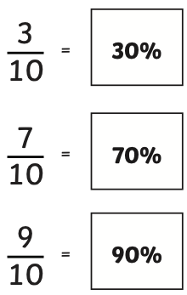
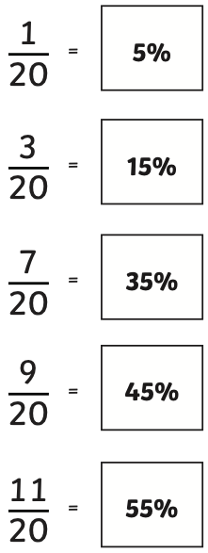
Mild/Hot
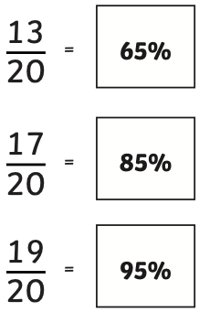
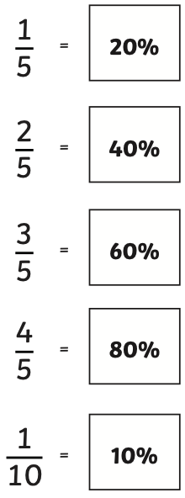
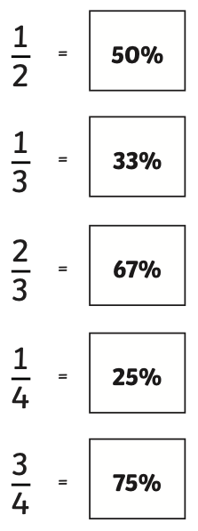

Hot challenge:
$\frac{1}{20}$, $\frac{1}{10}$, $\frac{3}{20}$, $\frac{1}{5}$, $\frac{1}{4}$, $\frac{3}{10}$, $\frac{1}{3}$, $\frac{7}{20}$, $\frac{2}{5}$, $\frac{9}{20}$, $\frac{1}{2}$, $\frac{11}{20}$, $\frac{3}{5}$, $\frac{13}{20}$, $\frac{2}{3}$, $\frac{7}{10}$, $\frac{3}{4}$, $\frac{4}{5}$, $\frac{17}{20}$, $\frac{19}{20}$

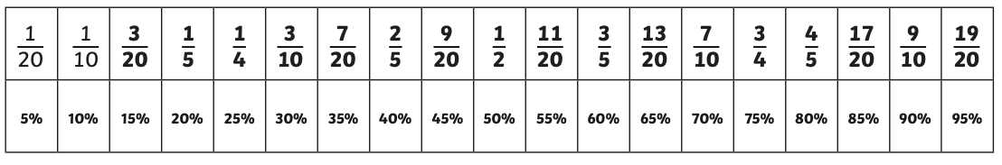
Spicy

Tuesday Week 12 Answers
Mild
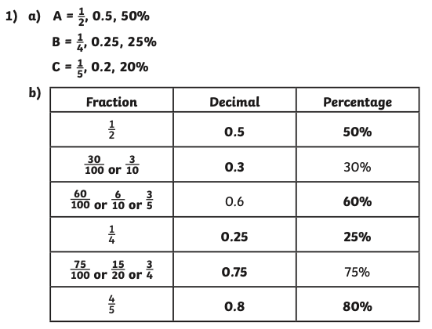

Hot
Charmaine is incorrect.
There is already 40% shaded.

$\frac{6}{25}$ = $\frac{24}{100}$ = 24% (to work out hundredths, you should have multiplied the denominator and numerator by 4)

40% + 24% = 64% = 0.64

0.64 has been shaded, which is less than 0.75

Spicy
- a) False.
Petra:
40% = £20 10% = £20 ÷ 4 = £5
60% = £5 x 6 = £30 (cost of present)

Jake:
£18 = 0.3 0.1 = £18 ÷3 = £6
0.7 = £6 x 7 = £42 (cost of present)

b) True.
Petra: 10% = £5 100% = £5 x 10 = £50 (amount taken shopping)
Jake: 0.1 = 6 100% = £6 x 10 = £60 (amount taken shopping)
Total = £50 + £60 = £110
  - of £150 = £150 ÷ 10 = £15
0.8 of £150 = £15 x 8 = £120

- Day 1:
25% = $\frac{1}{4}$

$\frac{1}{4}$ of 6000m = 1500m

Day 2:
$\frac{4}{5}$ of 1500m = 1500m ÷ 5 = 300m x 4 = 1200m

Day 3:
0.9km = 900m

1500m + 1200m + 900m = 3600m = 3.6km (amount run so far)
Left to complete: 6000m – 3600m = 2400m

10% of 6000m = 600m
30% of 6000m = 1800m (600m x 3)

Toni has more than 30% of her target left to complete because 2400m is more than 1800m.

Wednesday Week 12 Answers
Mild
- 50% = $\frac{1}{2}$.
Half of 60kg = 30kg.
The farmer sells 30kg of potatoes.

- 25% = $\frac{1}{4}$.

To find $\frac{1}{4}$ of a number you need to divide by 4.
24 ÷ 4 = 6.
There are 6 litres of paint left.

- To find 20%, it is easier to find 10% first then multiply by 2.
To find 10%, you need to divide by 10.
£60 ÷ 10 = 6.
Then, multiply by 2 because you want to find 20%.
6 x 2 = 12.
The children’s charity received £12.

- To find 10%, you need to divide by 10.
250 ÷ 10 = 25.
Amit reads 25 pages per day.

- To find 40%, it is easier to find 10% first then multiply by 4.
To find 10%, you need to divide by 10.
30 ÷ 10 = 3.
Then, multiply by 4 because you want to find 40%.
3 x 4 = 12.
The athlete runs 12 miles on one day.

Hot
- 25% = $\frac{1}{4}$.

To find $\frac{1}{4}$ you need to divide by 4.

300 ÷ 4 = 75.
75kg of potatoes are sold in 5kg bags.
The rest are sold in 1.5kg bags.
300 – 75 = 225.

225kg of potatoes are sold in 1.5kg bags.

- First, you need to find 10% of £90. To do this, you need to divide by 10.
90 ÷ 10 = 9. £9 comes from selling biscuits.
50% of the remaining money comes from selling chocolate cakes.
The remaining money is £90 – £9 = £81.
50% = $\frac{1}{2}$. Half of £81 = £40.50.

£40.50 came from selling chocolate cakes.

- 50% of the bricks are used on the first day.
50% of 600kg = 600kg ÷ 2 = 300kg.
25% of 600kg = 600kg ÷ 4 = 150kg.

After the second day, 450kg of bricks have been used because 300kg + 150kg = 45kg.
To find out what mass we have left, we need to do 600 – 450 = 150.

There are 150kg of bricks left after the second day.

- 10% of 500 words = 50 words.
500 – 50 = 450.
Niamh has 450 words left to write.

- 50% of 800m = 400m.
To find 25% of the remaining distance, you need to d0 400 ÷ 4 = 100.
The swimmer swims 100m on their back.

Spicy
- It is easier to find 50% of 850kg first as this is half.
Half of 850kg = 425kg. 425kg of parsnips go to the local supermarket.

To find 30%, it is easier to find 10% and then multiply by 3.
10% of 850 = 850 ÷ 10 = 85.
85 x 3 = 255. 255kg of parsnips go to the local market.

To find out the mass of parsnips the farmer has left, we first need to find out how much has gone.
425 + 255 = 680.
680kg of parsnips have gone to both the market and supermarket.

To find out the mass that is left, we do 850 – 680 = 170.
The farmer has 170kg of parsnips left.

- To find 20%, first you need to find 10% and multiply it by 2.
10% of 150m = 15m.
15 x 2 = 30. The plumber uses 30m for the central heating system.

The plumber uses 25% of what is left.
To find out how much is left, you must do 150m – 30m = 120m.

25% of 120 = 120 ÷ 4 = 30.
The plumber uses 30m to fit the bathroom.

- To find 40%, first you need to find 10% then multiply by 4.
2500 ÷ 10 = 250.
250 x 4 = 1000.
1000 books are fiction.

2500 – 1000 = 1500.
1500 books are not fiction.

- To find 30%, first find 10% and then multiply by 3.
460 ÷ 10 = 46.
46 x 3 = 138. She covers 138 miles in one ride.

Then we need to find out what is left.
460 – 138 = 322.
The cyclist has 322 miles still to cover after 1 ride.

- To find 20%, find 10% and multiply by 2.
£1740 ÷ 10 = £174.
£174 x 2 = £348.

To find out how much the rest of the auction raised, you must do £1740 - £348 = £1392.
The rest of the auction raised £1392.

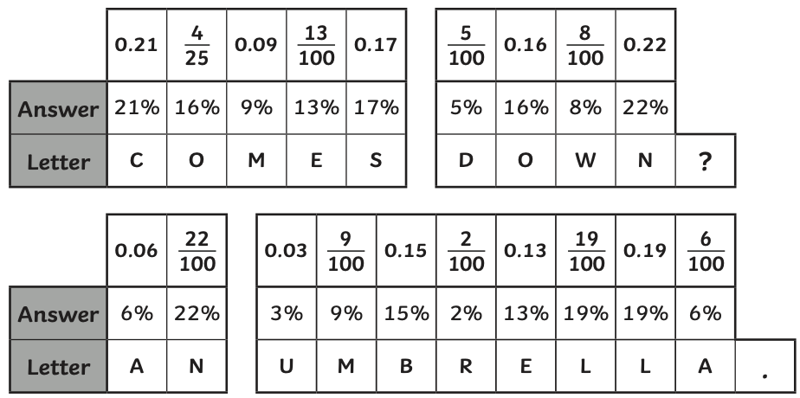
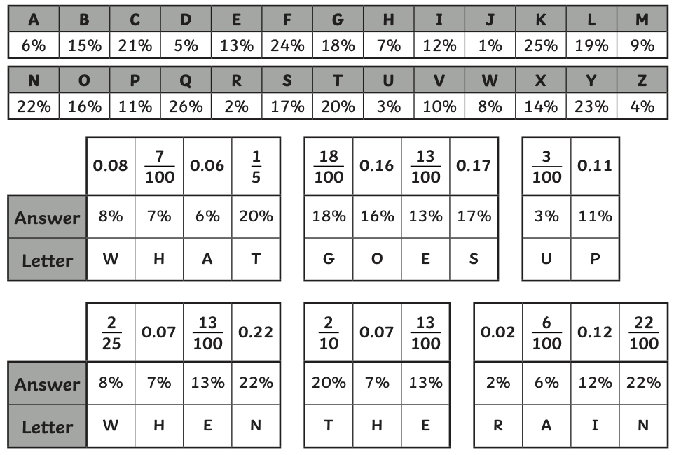
Thursday Week 12 Answers

Friday Week 12 Arithmetic Answers
- 37 – 30 = 7

- $\frac{7}{10}$ + $\frac{3}{10}$ = 1

- 2 + 1796 = 1798

- 3 x 8 x 4
(3 x 8) = 24
24 x 4 = 96

- 498 x 7 = 3486

- $\frac{7}{8}$ of 88 = 77

88 ÷ 8 = 11
11 x 7 = 77

- 57,226 + 4879 = 62,105

- 90,000 – 500 = 89,500

- 1210 ÷ 11 = 110

- 7.3 x 12 = 87.6

- $\frac{11}{12}$ - $\frac{3}{4}$ = $\frac{1}{6}$

$\frac{11}{12}$ - $\frac{9}{12}$ (multiply denominator and numerator by 3) = $\frac{2}{12}$ = $\frac{1}{6}$ (divide the denominator and numerator by 2)

- $\frac{3}{10}$ x 12 = 3$\frac{3}{5}$

3 x 12 = 36

$$\frac{36}{10}$$

36 ÷ 10 = 3r6

Whole number: 3
Fraction: $\frac{6}{10}$ = $\frac{3}{5}$

Friday Week 13 Arithmetic Answers (10/07/20)
- 187 – 100 – 87

- 91 x 7 = 637

- $\frac{1}{6}$ + $\frac{1}{6}$ = $\frac{2}{6}$ = $\frac{1}{3}$

- 3006 – 563 = 2443

- 5 x 12 = 60

- 3.5 + 0.6 = 4.1

- 29 ÷ 10 = 2.9

- 555,431 + 24,532 = 579,963

- 6³ = 6 x 6 x 6 = 216

- 9 x 40 = 360

- $\frac{7}{8}$ + $\frac{3}{4}$ = $\frac{11}{8}$ or 1$\frac{3}{8}$

$\frac{7}{8}$ + $\frac{6}{8}$ = $\frac{11}{8}$

11 ÷ 8 = 1r3
Whole number: 1
Fraction: $\frac{3}{8}$

- 3.97 + 2.6 = 6.57

