Monday Week 12
Mild/Hot
Cut out the ‘Fraction and Percentage Matching Cards’ (separate document). Alternatively, make your own cards.
Match the fractions with the percentages correctly and record your answers below.
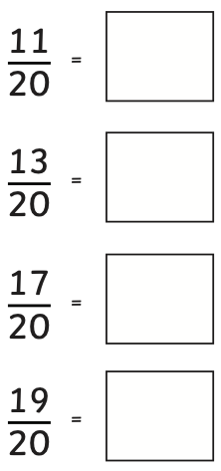
Use your fraction, decimal and percentage bookmark from the previous weeks to help you with this.
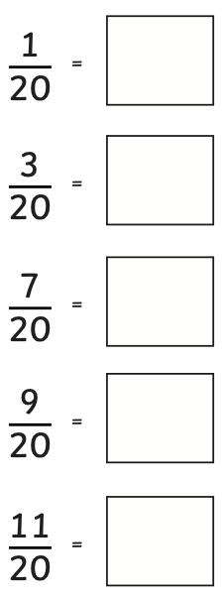
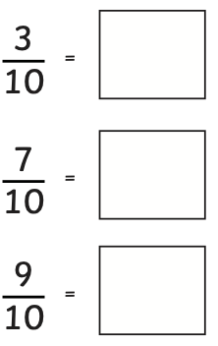
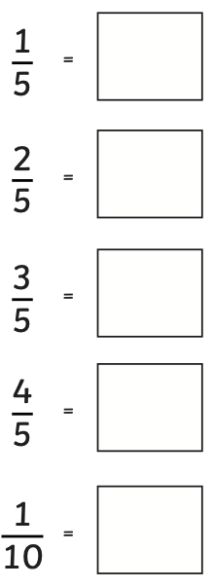
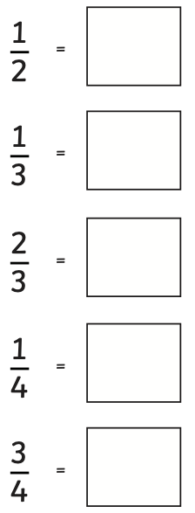

Hot challenge:
Write the fractions in order from smallest to largest. Look at the percentages to help you order the fractions.

Spicy
Write all the fractions for $\frac{1}{20}$ to $\frac{19}{20}$, writing the fraction in its smallest form. Below each, write the equivalent percentage.

$$\frac{1}{20}$$ | $$\frac{1}{10}$$

Tuesday Week 12
Mild
- a) Look at the bar models below. Use the first bar model to help you write A, B and C as a fraction,
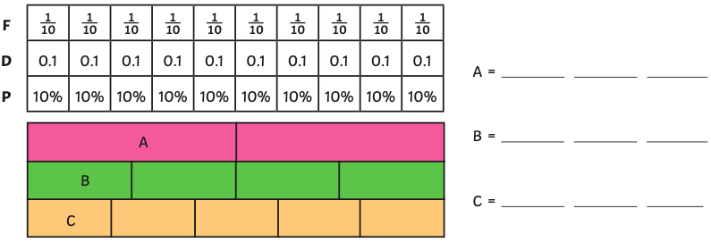
decimal and percentage.

b) Use part a) to help you complete the table.
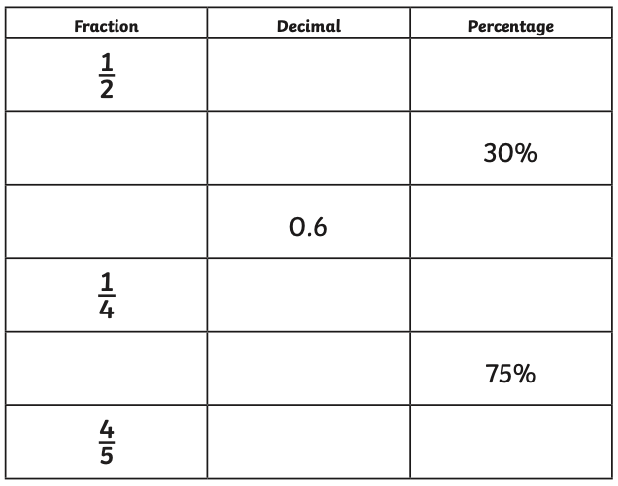
Hot
- Charmaine is playing the game, ‘Race to 100%’. This is how far she has got with colouring the grid.
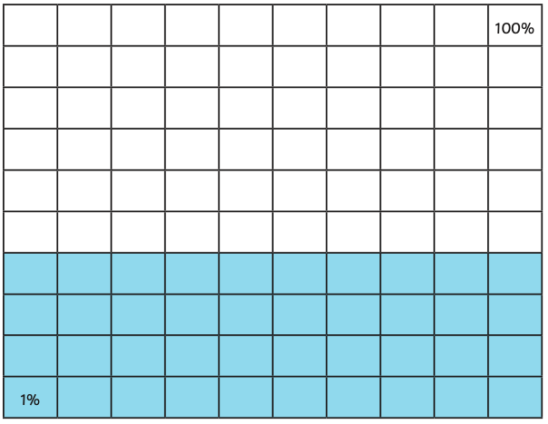
The next card that Charmaine turns over is $\frac{6}{25}$.
Charmaine says, “After shading $\frac{6}{25}$, I will have shaded more than 0.75 in total.”
Is Charmaine correct? Explain how you know.

Tip: Think about what $\frac{6}{25}$ would be in hundredths.
Think also about what 0.75 is as a fraction.

Spicy
- 2 friends had some money to buy a present for their friend, Carlos.
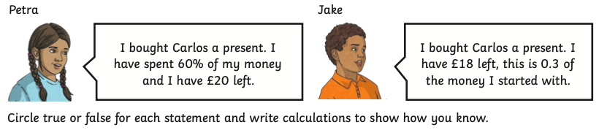

Write down ‘true’ or ‘false’ for each statements and write calculations to show how you know.

- Petra’s present cost more than Jake’s present.
- The total amount of money Petra and Jake started with was less than 0.8 (80%) of £150.

- Toni has set herself a target of running at least 6km over 4 days. This is how much she has run so far:

Day 1: 25% of the target
Day 2: $\frac{4}{5}$ of the distance covered on Day 1
Day 3: 0.9km

Has Toni got more or less than 30% of her target to complete? Show how you know.

Wednesday Week 12
Mild
- A grocer has 60kg of potatoes. In one day, he sells 50% of the potatoes. What mass of potatoes does he sell?

- A decorator buys 24 litres of paint. When he finishes painting, there is 25% of the paint left. How much paint is left?

- A collection is made for local charities, which raises £60. 20% of the money is given to a children’s charity. How much does the children’s charity receive?

- Amit reads a book with 250 pages. He reads 10% of the book each day. How many pages does he read each day?

- An athlete runs 30 miles a week in 3 runs. On one day, the athlete runs 40% of the mileage. How long does the athlete run on this day?

Hot
- A supermarket stocks 300kg of potatoes. 25% of the potatoes are sold in 5kg bags. The rest are sold in 1.5kg bags. What mass of potatoes are sold in 1.5kg bags?

- Some children hold a bake sale for a local charity and raise £90.
10% comes from selling biscuits. 50% of the remaining money comes from selling chocolate cakes. How much is made from selling chocolate cakes?

- A builder has 600kg of bricks delivered to build an extension to a house. 50% are used on the first day and 25% are used on the second day. What mass of bricks are left after the second day?

- Niamh enters the 500 words story competition. She writes 10% of the required words on the first day. How many words has she got left to write?

- A swimmer swims 800m every morning. She swims the first 50% of the distance on her front and then 25% of the remaining distance on her back, before finishing on her front. How far does she swim on her back?

Spicy
- A farmer harvests 850kg of parsnips. 30% go to the local market and 50% go to a local supermarket. What mass of parsnips are left?

- A plumber has 150m of pipes. The plumber uses 20% fitting a central heating system and then 25% of what is left to fit a bathroom. How much pipe does the plumber use to fit the bathroom?

- A library has 2500 books. 40% of the books are fiction. How many books are not fiction?

- A cyclist rides 460 miles each week in training. She covers 30% of the miles in one ride. How many miles are left after 1 ride?

- A charity raises £1740 at an auction. 20% of the money was raised by auctioning one item. How much did the rest of the auction raise?

Thursday Week 12
Calculations Code Breaker
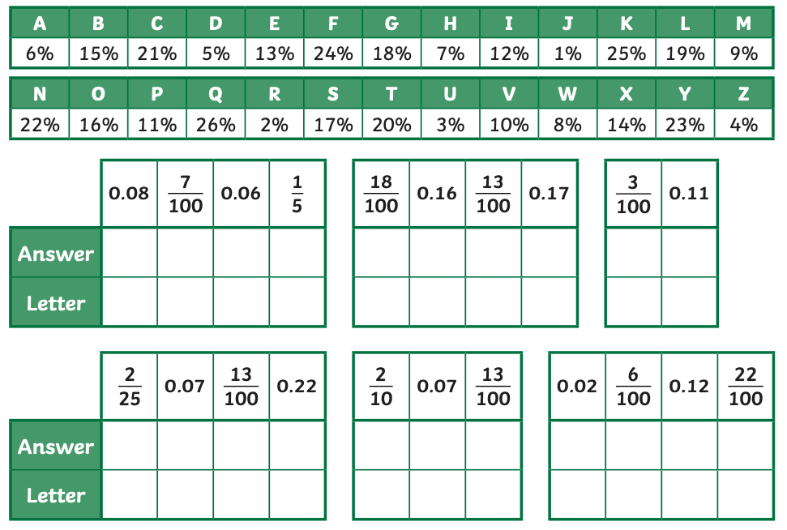
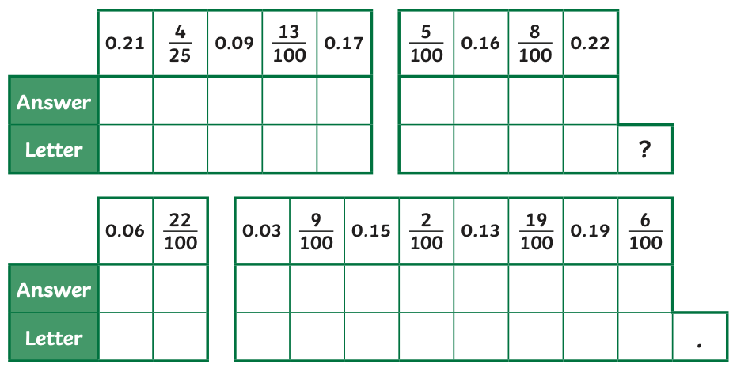
Reveal a riddle by writing the percentage equivalent to the following fractions and decimal fractions. Use the grid to locate the letter that matches each answer. The riddle will read across the tables.

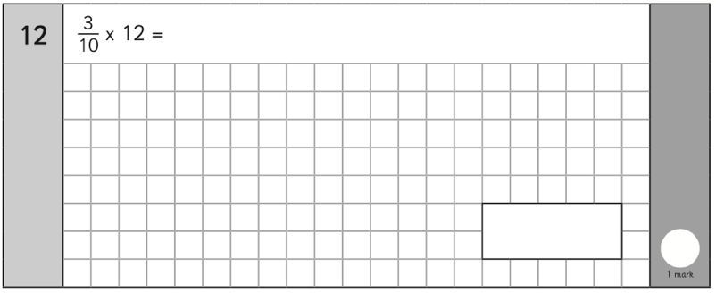
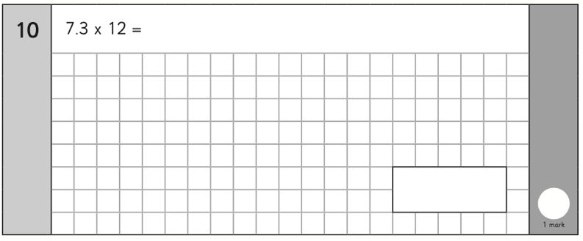
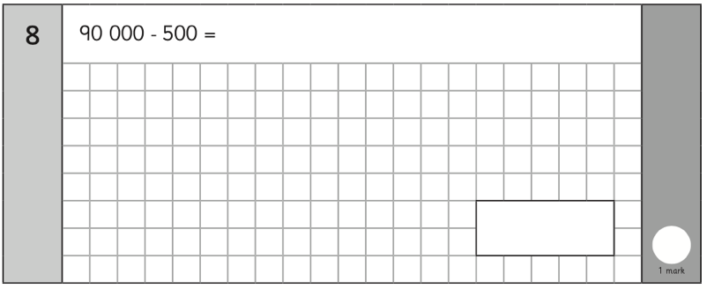
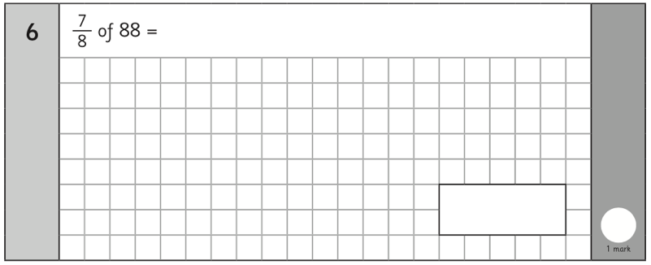
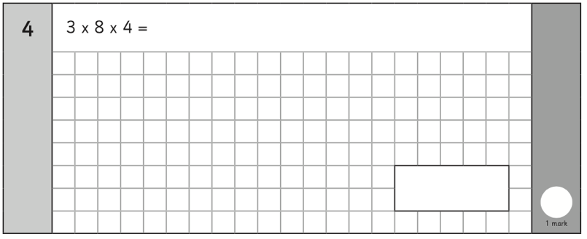
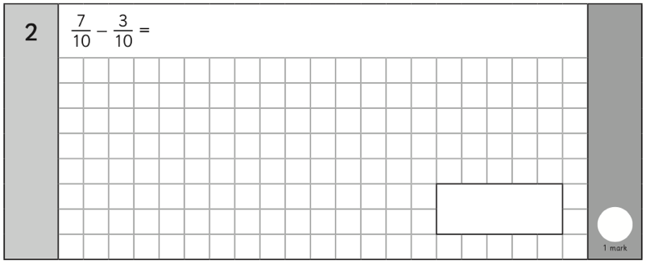
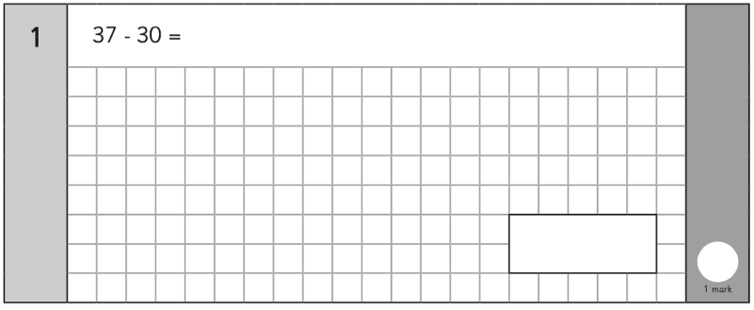
Friday Week 12 Arithmetic
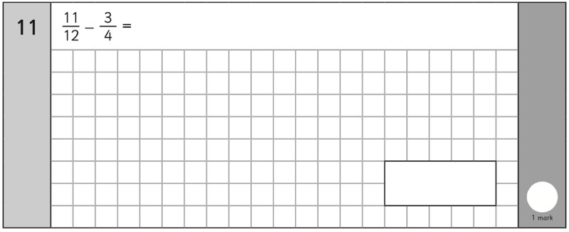
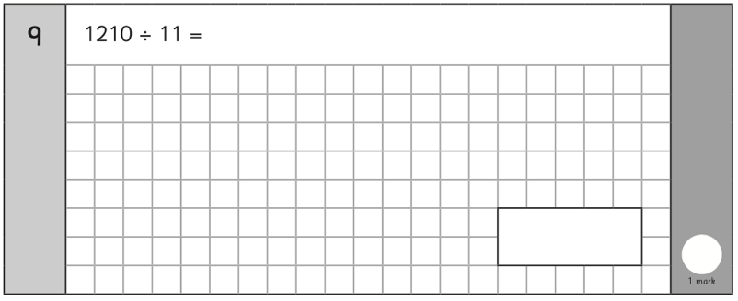
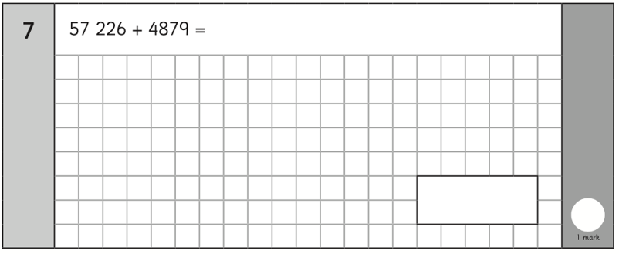
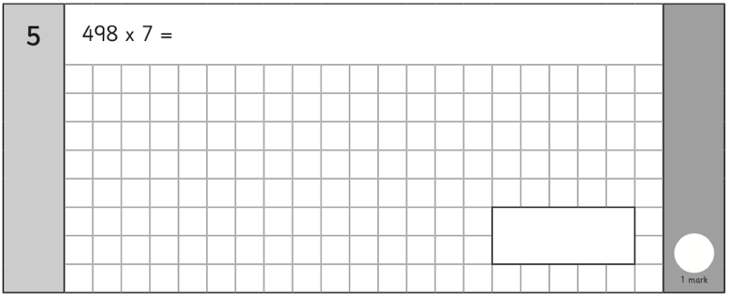
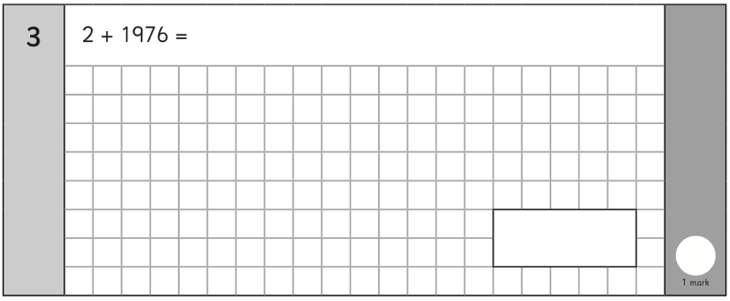

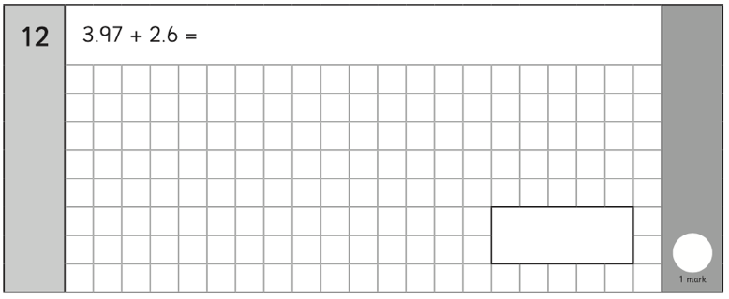
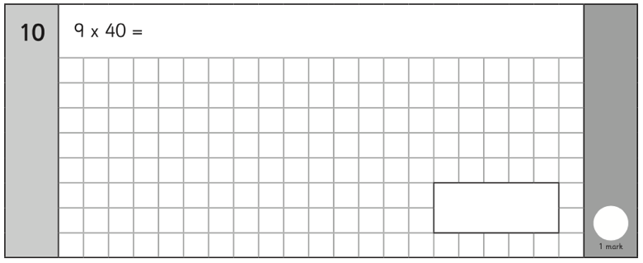
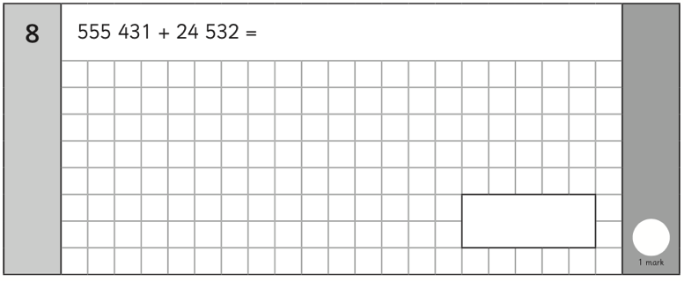
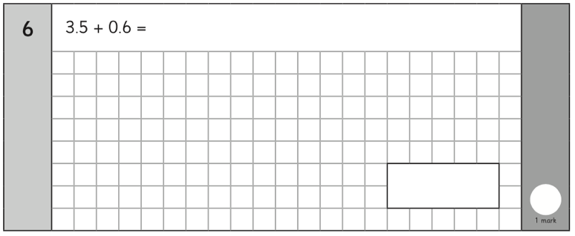
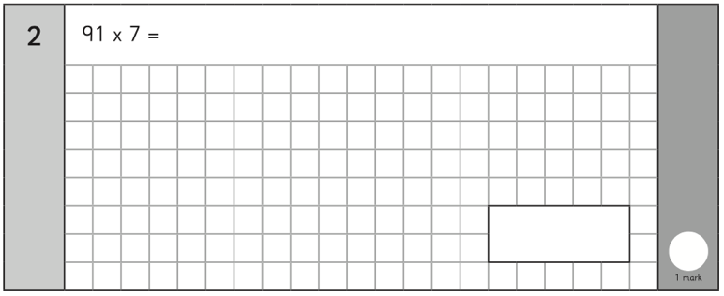
Friday Week 13 Arithmetic (for 10/07/20)


