Week 13 Work pack
Monday Topic
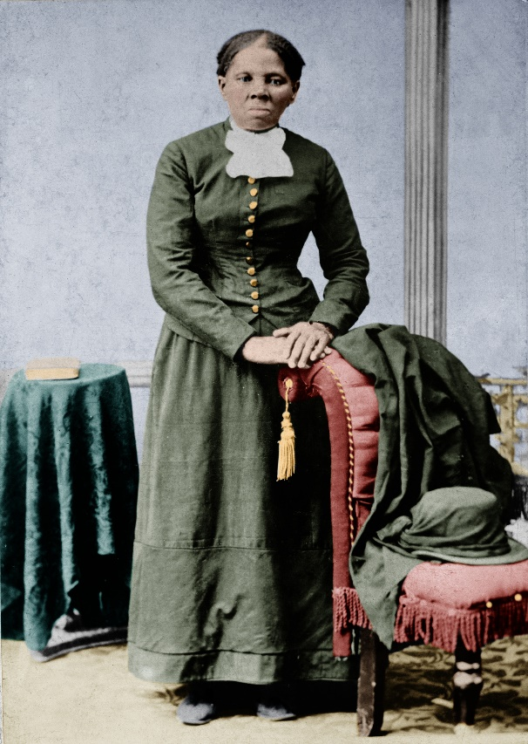

This is Harriet Tubman
Your task today is to research who she is!
What is she known for?
What was her name when she was a child?
When did she live?
Where did she live?
What was her childhood like?
What was her nickname in later life?
What job did she do in the army?
What war did she serve in?
What else did she fight for?

Useful videos
https://www.youtube.com/watch?v=b3OehwRHIlo
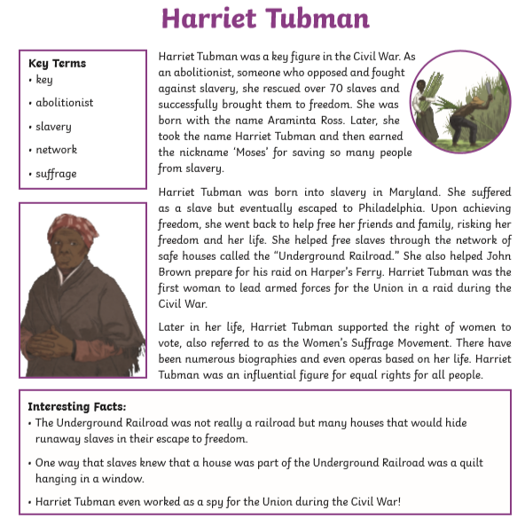

Tuesday – Quiz

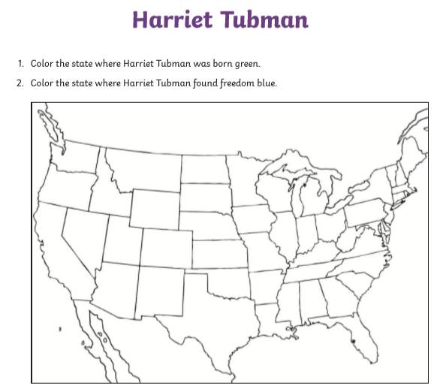

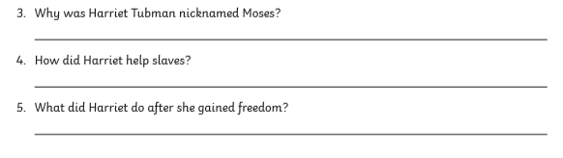

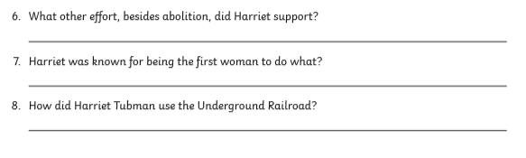

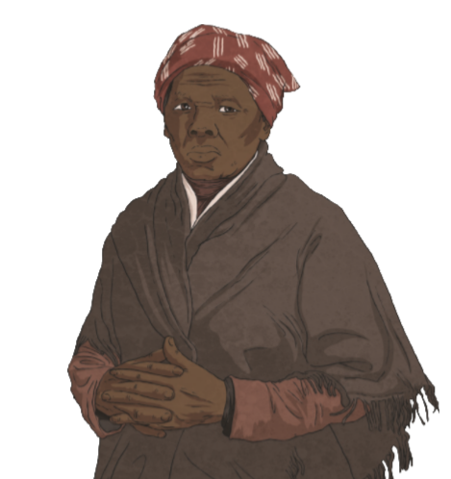

Wednesday – information booklet
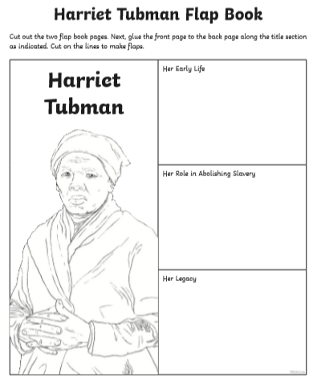

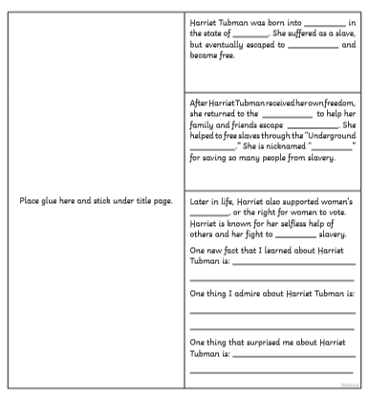

Thursday – Jigsaw
Freedom.

How would you feel if this freedom was taken away from you?
Did slaves have this freedom?
Why is this freddom important to you?

What freedoms do you have and enjoy that Harriet Tubman and other slaves never knew?

Friday -Art

Cretae your own freedom lettering
Use these ideas to inspire your own. Think about the shape and sizw of the letters and the colours you will use

You could watch this video for ideas on how to create your own lettering

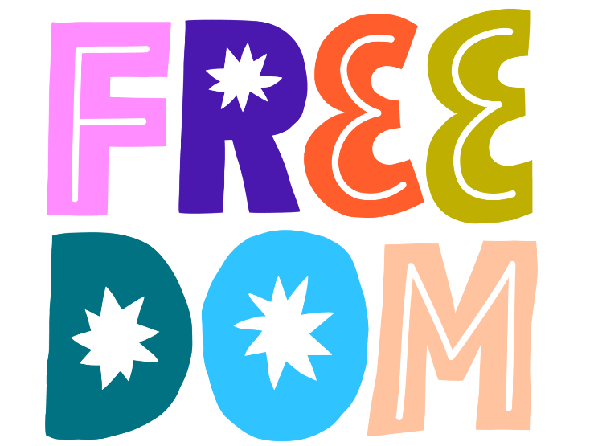

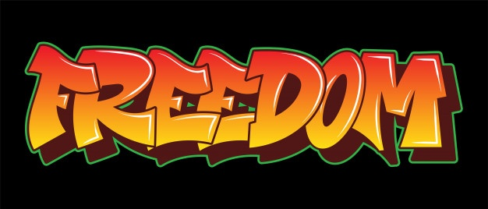

Bonus Activity!



