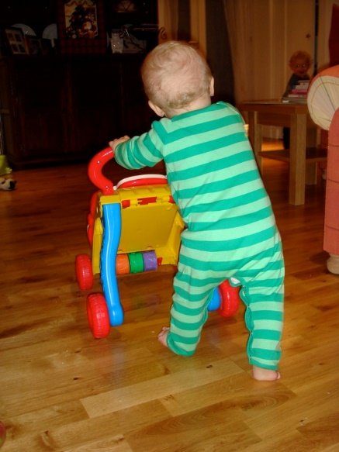
Science – Cut out the pictures and place them in chronological order.





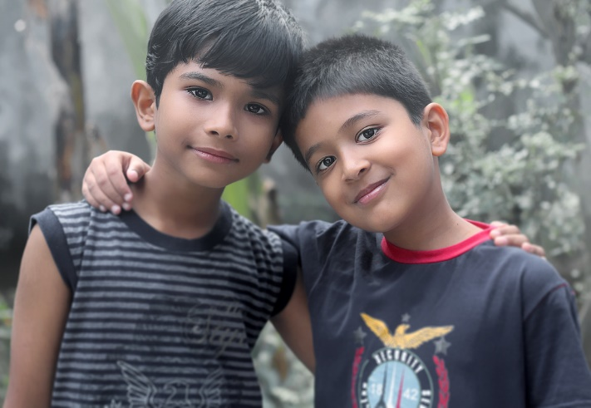
Geography

Information about tourists

Tourism and Mountains
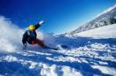
Mountains can aid tourism and bring in money for the people who live there.
More than 50 million people visit mountains each year.
Many mountain towns around the world depend on tourists to support them. People in the town provide food and lodging for tourists who come to enjoy the nearby mountains.
Did you know?
About 13 million people live in the Alps.
About 100 million visitors visit the Alps each year.
Mountains can be places for leisure activities. Many people like to ski on mountains. Other people like to climb mountains. Some people like to just visit mountains to take photos and admire their beauty.
Tourists are attracted to mountains for many reasons:
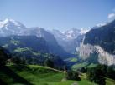
- the climate and clean air,
- varied topography,
- beautiful scenery,
- local traditions,
- simple life styles,
- sports that require steep slopes or winter snow
Sport-based tourism has boomed over the past 30 years
Typical mountain activities
- Mountaineering,
- Paragliding,
Summer Activities
- walking,
- hiking,
- bird watching
- rafting,
- Mountain Biking
Winter Activities
- skiing,
- snow boarding,
- Sledging / Tobboganing
- Icefall climbing
- Snow-Shoe Trekking
- Winter walking
- Ice skating
Impact of Tourism on the Environment
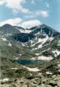
Although tourism has it advantages it can have serious impact on the environment, the people who live there and the local economy. As more and more people visit the mountains, whether to climb or simply to trek through the valleys, the chances of the environment being permanently damaged become ever greater.
Advantages of Tourism
- Creates jobs
- Encourages local crafts
- Improved living standards
Disadvantages of Tourism
- Higher prices of land and food
- Pollution from traffic
- Erosion
- Litter
- More crowded
- Trees felled to supply timber and fuel wood
- Lost of cultural identity among the mountain people

Mount Everest is the highest mountain in the world and many people dream of climbing to the top. From a distance, the mountain looks magestic and serene.

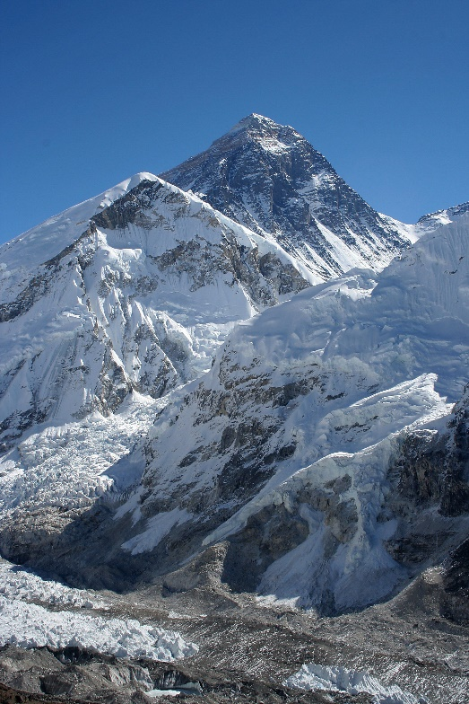

It takes many days to climb to the top after years of training and when people get to the top, they often want to leave something to prove that they were there, to mark the occasion and achievement. This is what the top of Mount Everest looks like now.

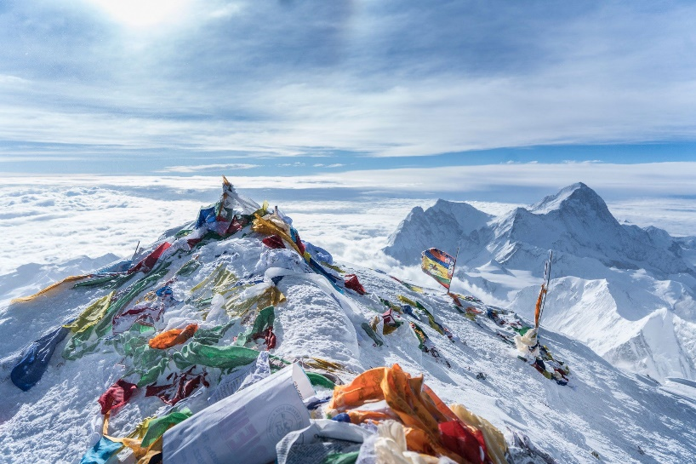
Art
Your activity to day is to upscale a picture using a grid. ‘Upscale’ means to make larger.
You can watch this video to see a demonstration:
https://www.youtube.com/watch?v=kx2zhcNZ2sQ
Here is an example.

You need to look at what part of the picture is in each square of the grid and copy it into a larger scale.
Now you can either do the sheet below and enlarge the picture of Tigger OR you could find your own picture, draw a grid over it and then enarge.
If you choose your own picture things to think about are:
- Make sure that your grid drawing is accurate. Measure carefully using a ruler and make sure that all the squares are the same size.
- On the larger picture you will need the same number of squares – they just need to be larger.
You could complete the picture on here:
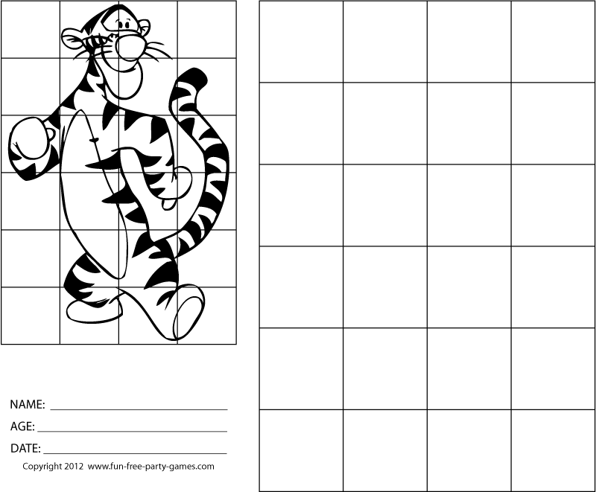

Or youou could complete the picture on here so it’s even bigger!

