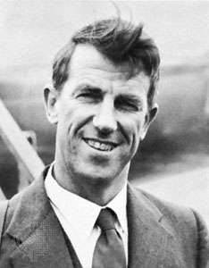
Edmund Hillary
This is a picture of Edmund Hillary. This week, you are going to do a mini project based him. There are some questions to help you with your research but you may have your own questions that you want to research the answers to to extend your knowledge.
What is Hillary most famous for?
What country is it in?
Where is he from?
When was he born?
When did he complete his greatest achievement?
Where did he complete his greatest achievement?
How was his experience different to people who do it today?
What can be seen there today? How does this make you feel?

Geography

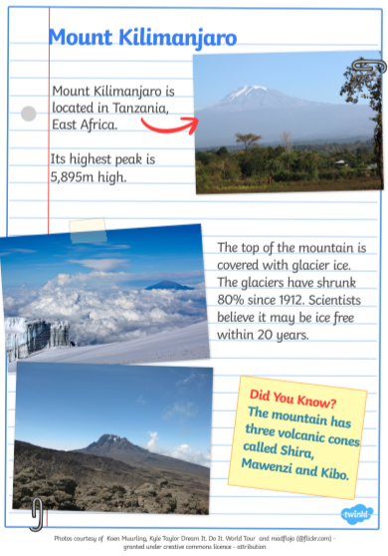

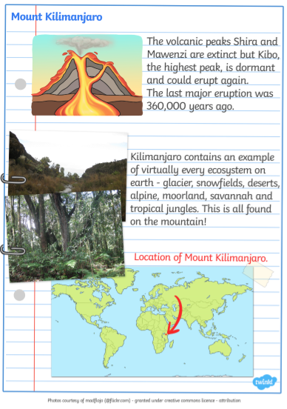

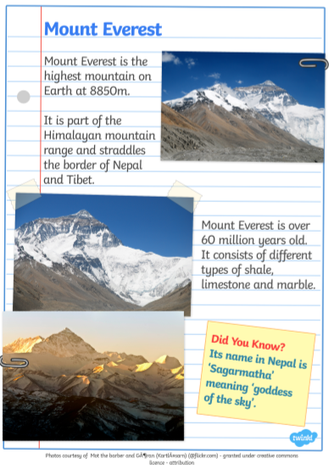
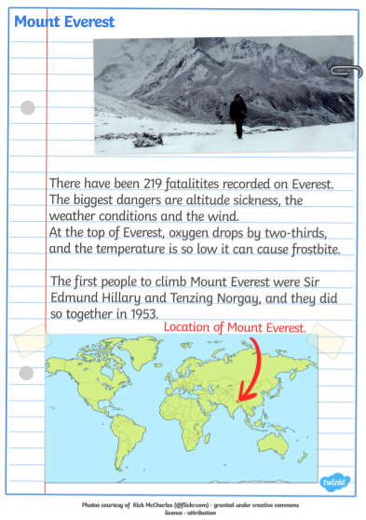

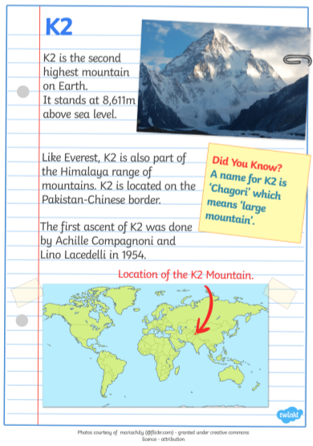

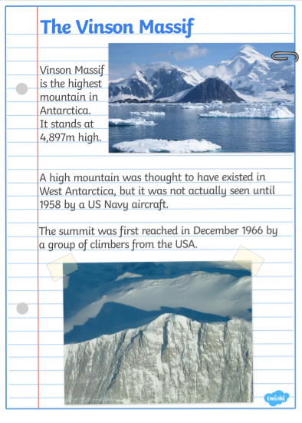

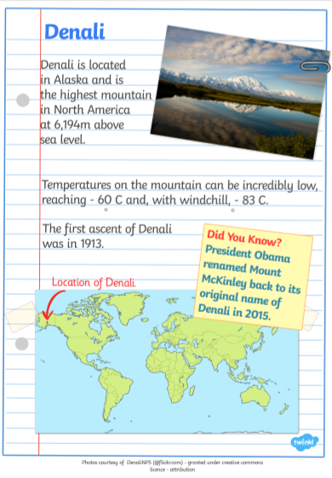

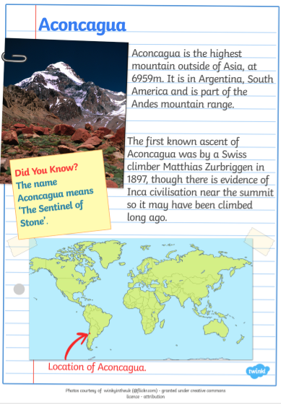


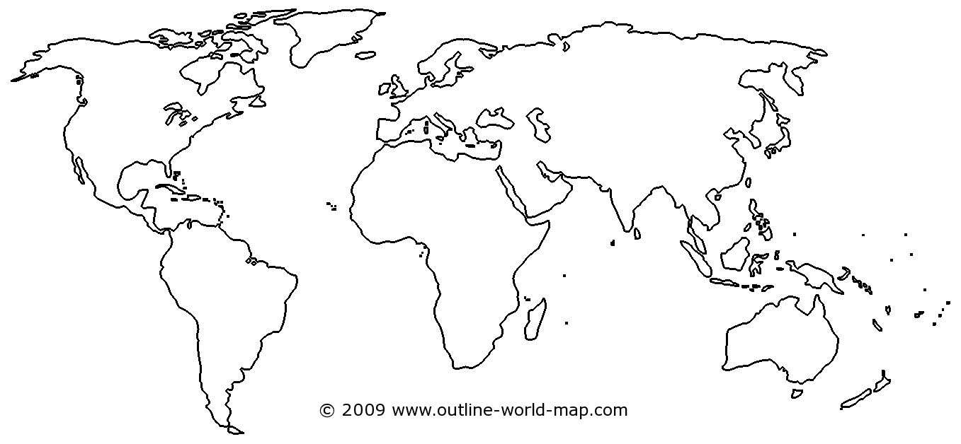
Geography

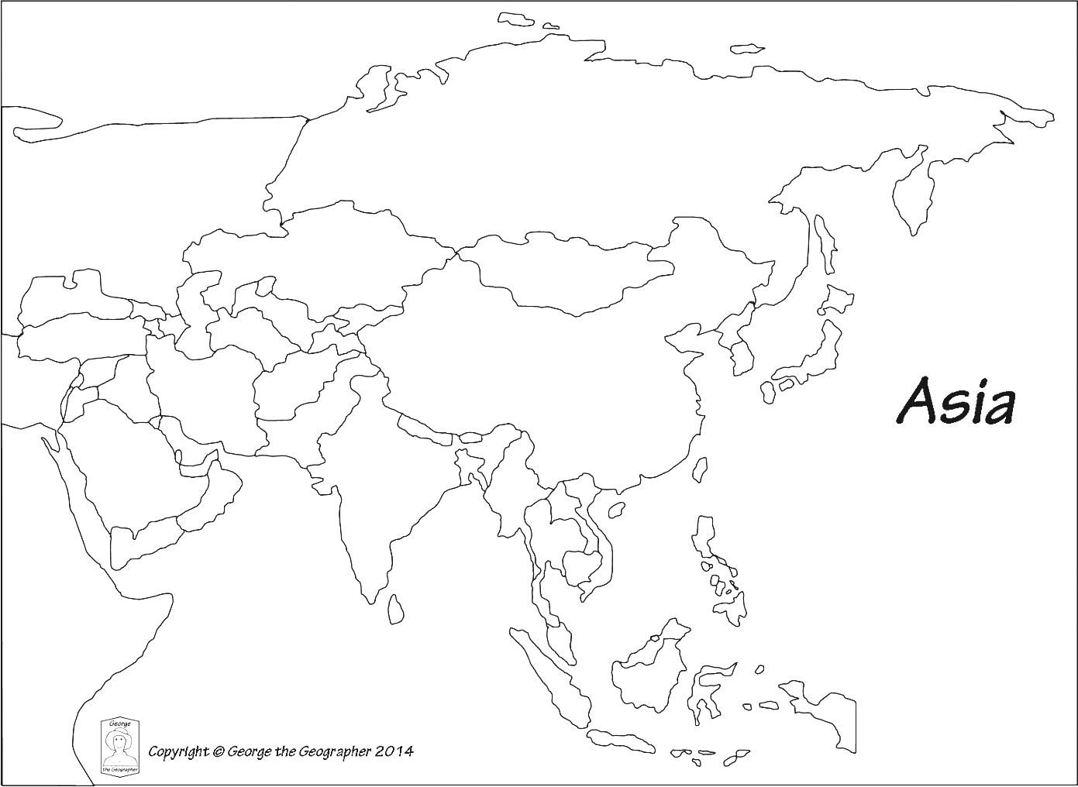

Science

Mrs Gren stands for:
Movement,
Respiration, (breathing)
Sensitivity, (feeling or moving towards light (plants))
Growth,
Reproduction, (making new ones of themselves – babies or seeds)
Excretion (going to the toilet)
Nutrition. (needing to eat or drink)

Make a poster to explain these living functions

Jigsaw information sheet
How we learn
The brain is an amazing organ that Scientists are learning more about all the time. It is the organ in our body that controls everything we do and everything we think. So how does it work?
If we looked inside your brain with a very powerful microscope then we would see you brain cells. They look like this:
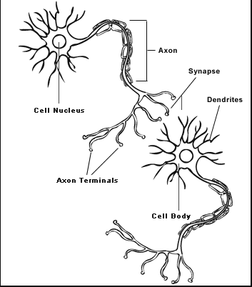
Interesting facts
- You have more brain cells in your head than there are stars in the universe.
- A healthy brain smells like cheese
- You brain is a grey colour – you might have heard people refer to ‘grey matter’ when they talk about intelligence – ‘I wish I had her grey matter.’
Every time you learn something new, a dendrite grows. The more you do something, the stronger the dendrite gets and more of them grow making it easier to remember. So, that’s why practising your timetables or spellings is so helpful – the stronger the dendrites, the more you will remember! As these dendrites grow, they attach onto other brain cells which ‘switches them on’ meaning that you can remember more things. The more you use your brain, the stronger these brain cells become.
The brain is also key in how you feel about yourself. So, if you are a person who is constantly thinking, “I can’t do it” or “I’m rubbish at that” then these are the dendrites that are getting stronger. Thinking positive things is really good for your mental health and your growth mindset. The word ‘yet’ is really helpful here. Change “I can’t do this!” to “I can’t do this yet”

Jigsaw activity

You could draw and label brain cells by copying the picture on the information sheet.
Change these negative thoughts into positive thoughts. There might be more than one positive thought you could have as the opposite of the negative thought.

Negative thought | Positive thought
I can’t do this

I’m rubbish at this

I will never get this

I am useless

No one likes me

It’s too hard

I can’t learn anything

How will you change your thinking to help you achieve a more positive mindset?

_______________________________________________________________________________________________________________________________________________________________________________________________________________

