Week 11 Maths
Monday
You might find it helpful to look back on Wednesday and Thursday’s learning from last week to help you answer these questions. Your bookmark will also help you.

Mild
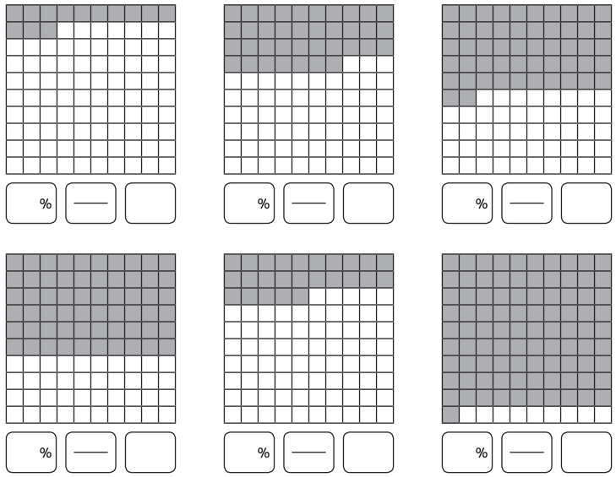
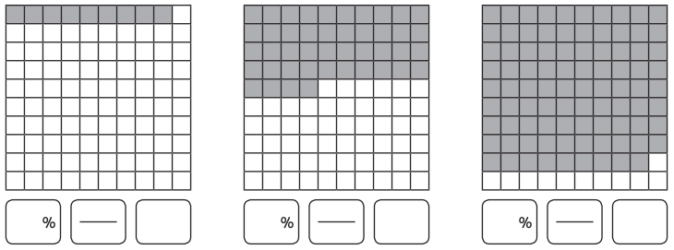
Write the percentage, fraction and decimal represented by the following diagrams:

Hot/Spicy
Write the percentage, fraction and decimal represented by the following diagrams:
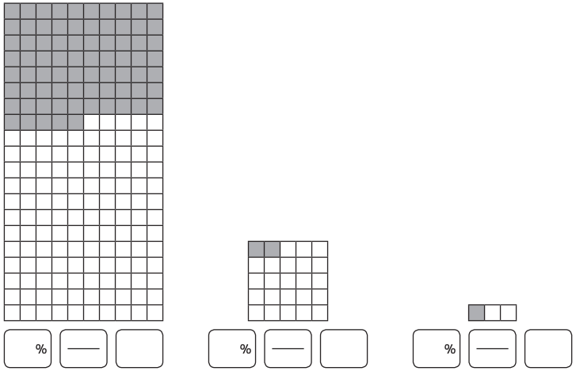
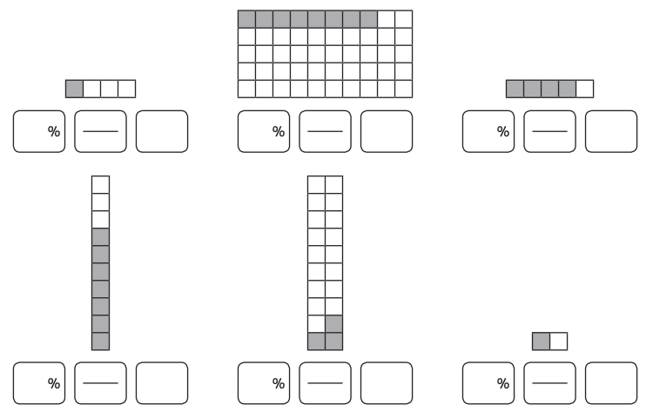

Tuesday
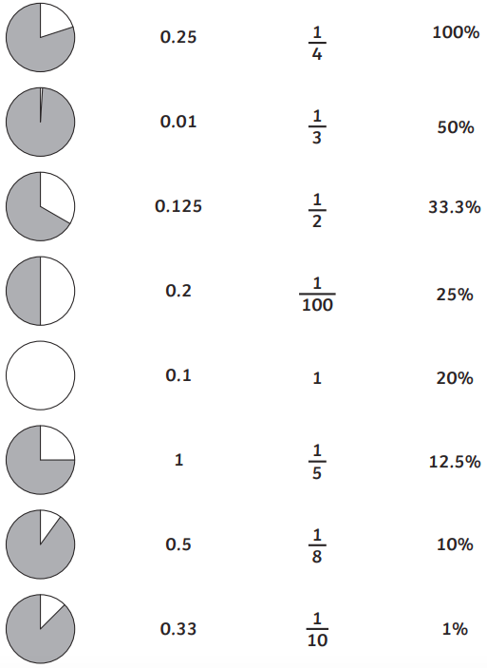
Match the equal fractions, decimals and percentages. The white spaces in the circles represent the amounts.

Wednesday
Ultimate Equivalent Fractions, Decimals and Percentages Challenge

Match the following decimal numbers, percentages and fractions.
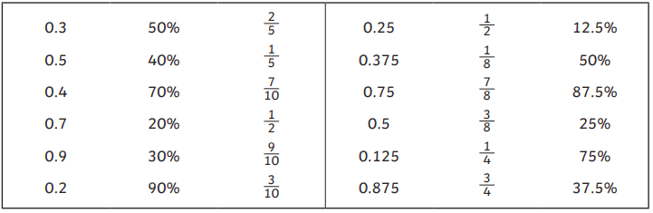

Write the equivalent fraction (in its simplest form) to the following:
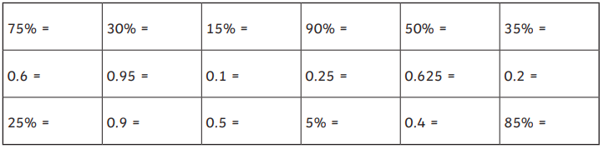

Write the equivalent decimal and percentage to the following:
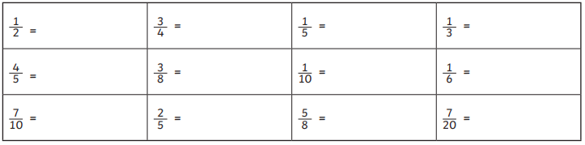

Write the missing equivalent fraction (in its simplest form), decimal or percentage as needed.
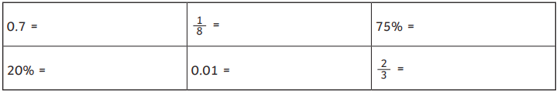

Thursday
Mild
Twinkl Department Store Sale!
For one day only, all our items are 50% off their full price with a Twinkl Loyalty card! Work out the sale price for each item in the shop.

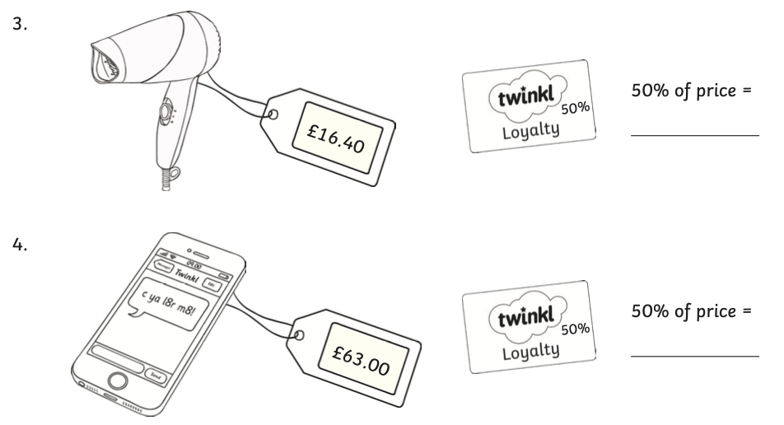
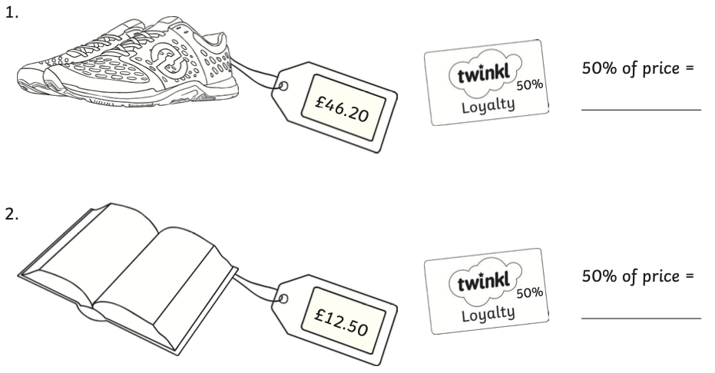
Top tip: Remember that 50% is the same as taking away half the price.

Challenge: Next week, all the full prices will increase by 10%. Work out the new price for each item. (Hint: find one tenth and add it to the full price.)

Hot
Twinkl Department Store Sale!
For one day only, all our items are only 75% of their full price (25% off) with a Twinkl Loyalty card! Work out the sale price for each item in the shop.

Top tip: To find 75% of a number, you can find one half, then one quarter, then add the two numbers together.

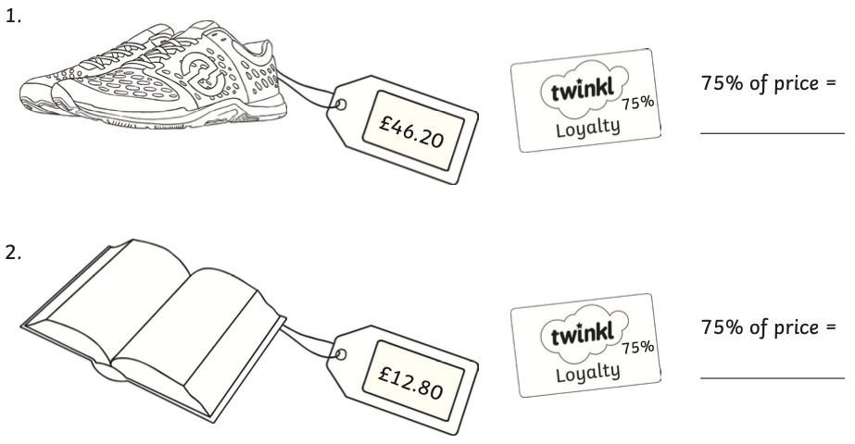
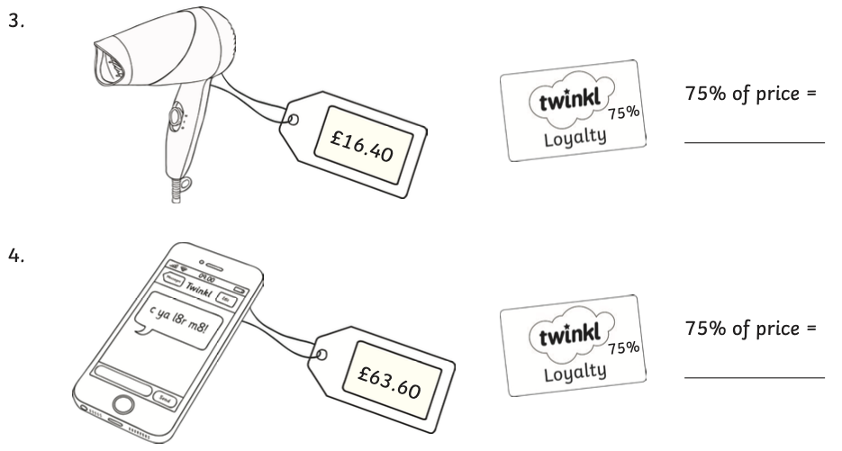

Challenge: Next week, all the full prices will increase by 25%. Work out the new price for each item.
(Hint: Find one quarter and add it to the full price.)

Spicy
Twinkl Department Store Sale!
For one day only, we’ve cut the prices of all our stock for Twinkl Loyalty Card owners! Each item is now only a percentage of its full price. The loyalty card next to each item shows the percentage of the full price that the item costs in the sale.
Work out the sale price for each item in the shop.

Top tip: To find a given percentage of a number, divide the number by 100 then multiply the answer by the given percentage.

E.g. 55% of £12.40
12.40 ÷ 100 = 0.124
0.124 x 55 = 6.82
55% of £12.40 = £6.82

If you are faced with an overall answer with three decimal places, round up or down as appropriate.
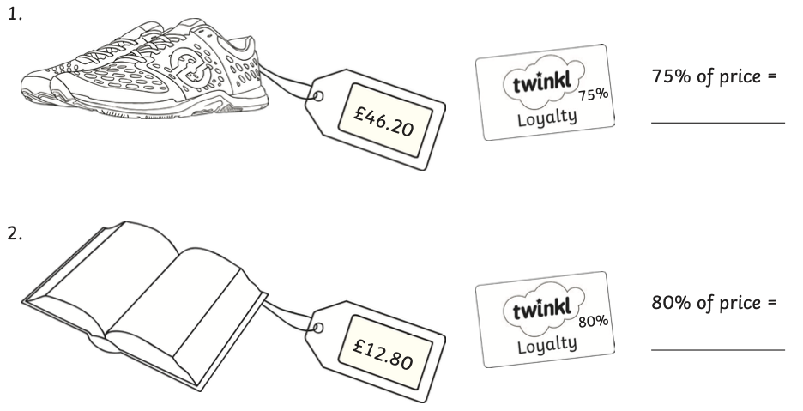

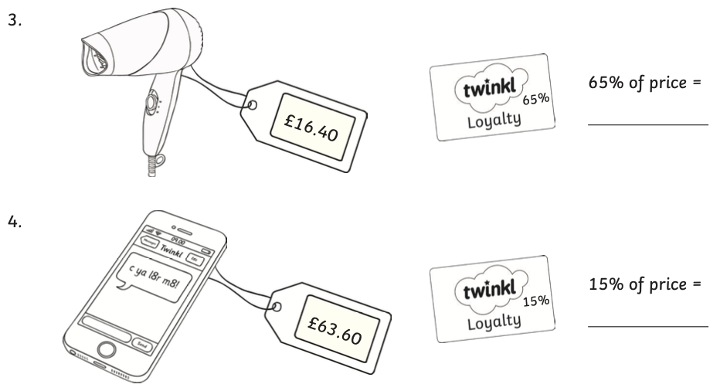

Challenge: Next week, all the full prices will increase by 5%. Work out the new price for each item. (Hint: Find one tenth, halve it and add this number to the full price.)

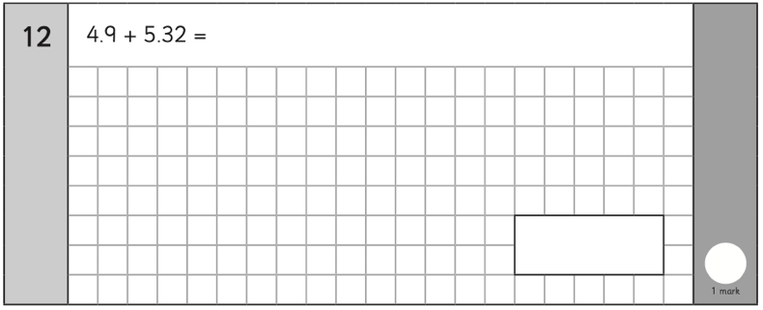
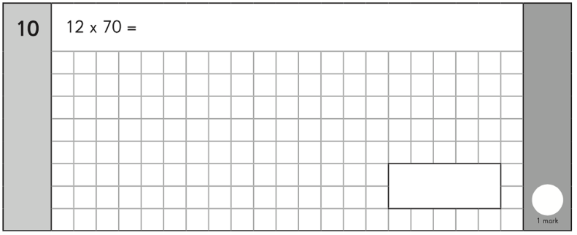
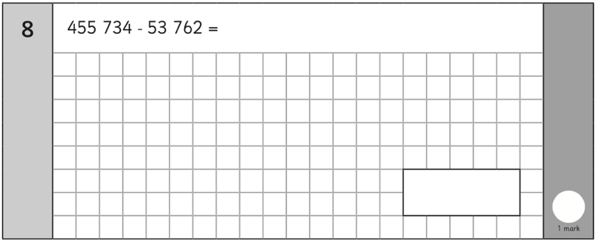
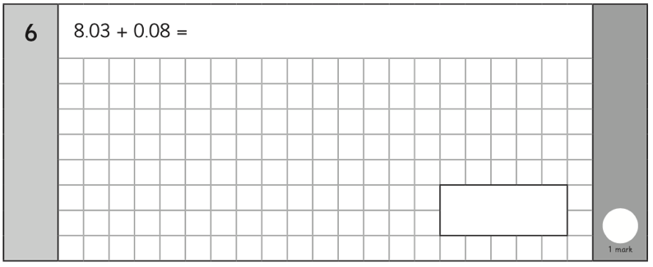
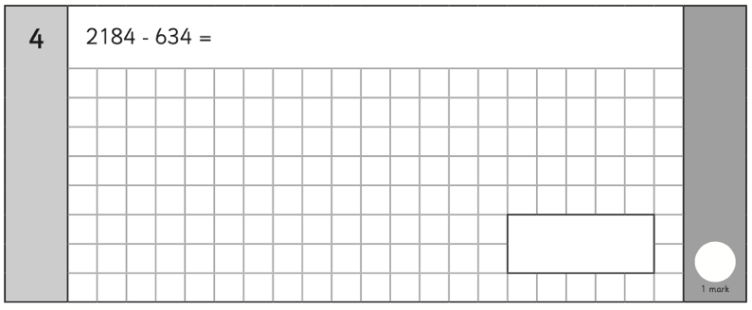
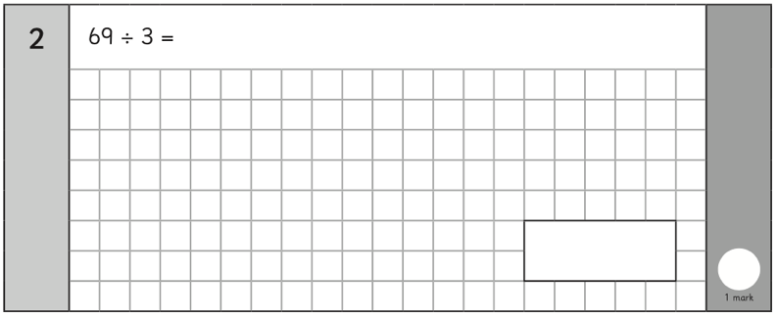
Friday Arithmetic


