Week 11 Answers
Monday
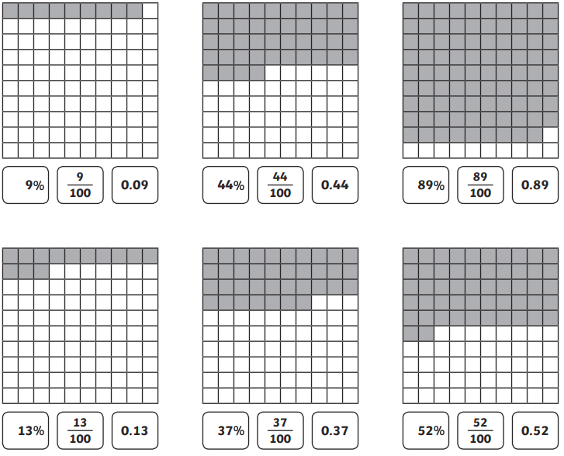
Mild
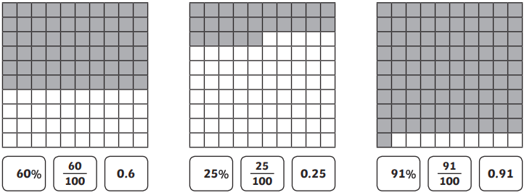

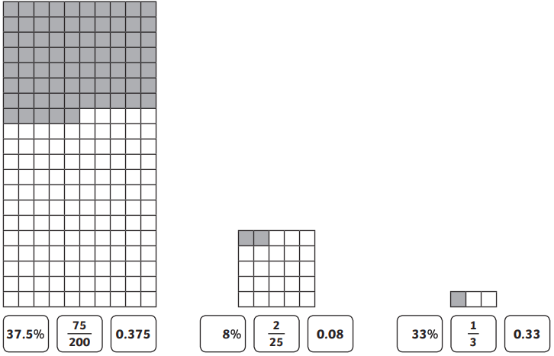
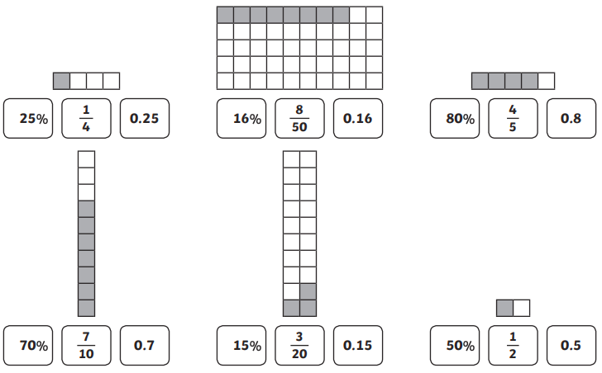
Hot/Spicy

Tuesday
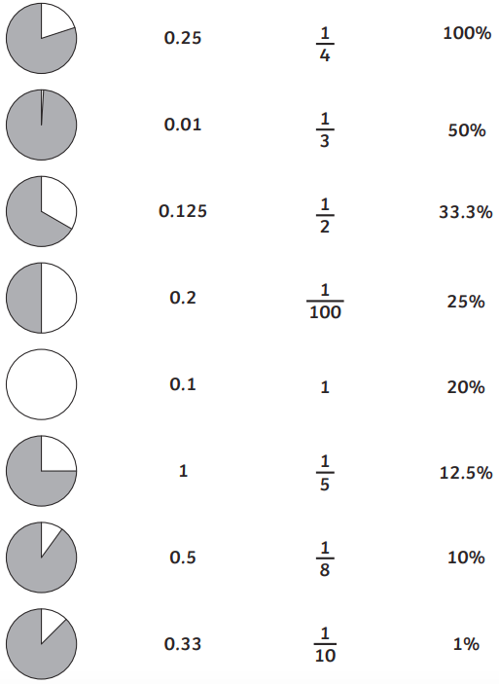

Wednesday

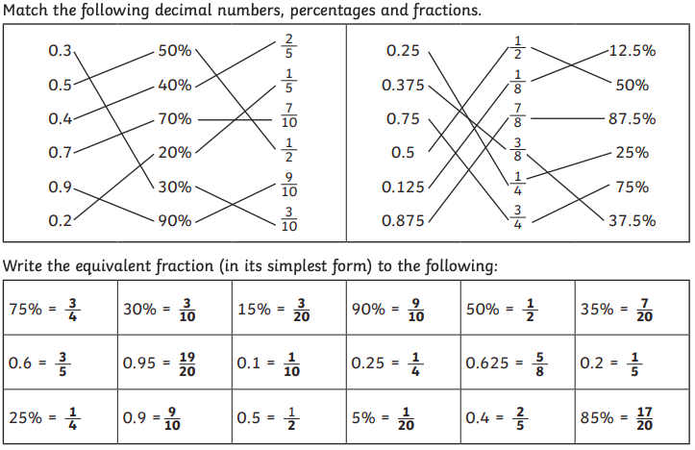

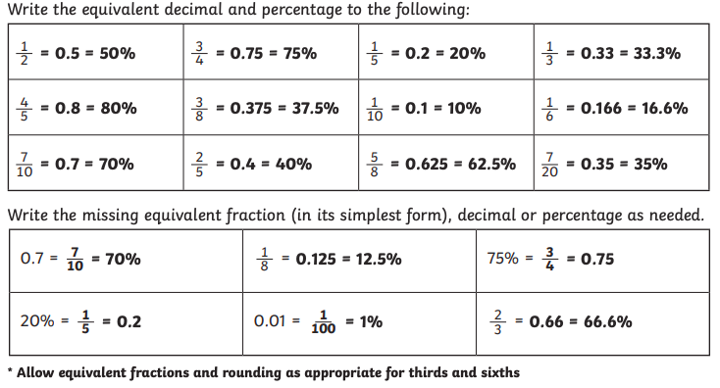

Thursday
Mild

 | Item | Full Price | Sale Price | Challenge  (+10% Price)
1 | Trainers | £46.20 | 50% = £23.10 | £50.82
2 | Book | £12.50 | 50% = £6.25 | £13.75
3 | Hairdryer | £16.40 | 50% = £8.20 | £18.04
4 | Mobile phone | £63.00 | 50% = £31.50 | £69.30

Hot

 | Item | Full Price | Sale Price | Challenge  (+25% Price)
1 | Trainers | £46.20 | 75% = £34.65 | £57.75
2 | Book | £12.80 | 75% = £9.60 | £16.00
3 | Hairdryer | £16.40 | 75% = £12.30 | £20.50
4 | Mobile phone | £63.60 | 75% = £47.70 | £79.50

Spicy

 | Item | Full Price | Sale Price | Challenge  (+5% Price)
1 | Trainers | £46.20 | 75% = £34.65 | £48.51
2 | Book | £12.80 | 80% = £10.24 | £13.44
3 | Hairdryer | £16.40 | 65% = £10.66 | £17.22
4 | Mobile phone | £63.60 | 15% = £9.54 | £66.78

Friday Arithmetic

- 717 + 100 = 817

- 69 ÷ 3 = 23

- $\frac{4}{11}$ + $\frac{6}{11}$ = $\frac{10}{11}$

- 2184 – 634 = 1550

- 7 x 7 = 49

- 8.03 + 0.08 = 8.11

- 77 ÷ 100 = 0.77

- 455,734 – 53,762 = 401,972

- 11² = 121

- 12 x 70 = 840

- $\frac{2}{3}$ + $\frac{7}{12}$ = $\frac{15}{12}$ or 1$\frac{3}{12}$ or 1$\frac{1}{4}$

- 4.9 + 5.32 = 10.22

