Week 10 Maths
Monday

Mild
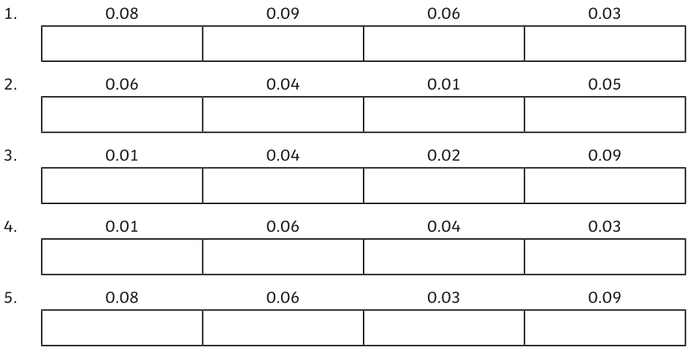
Order the following decimals from smallest to largest:
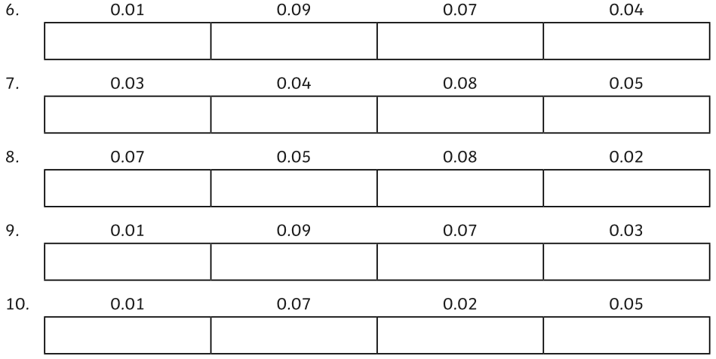

Hot
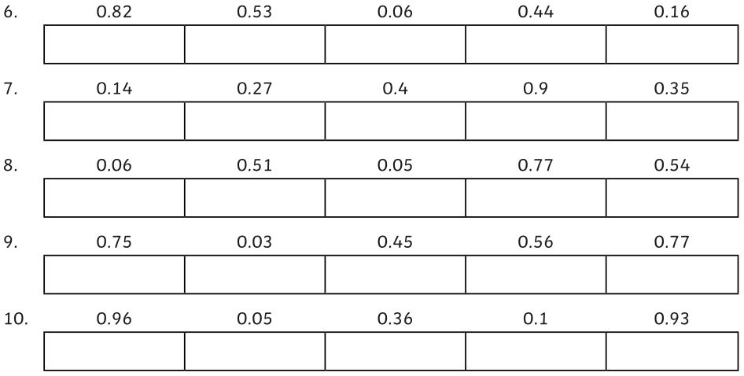
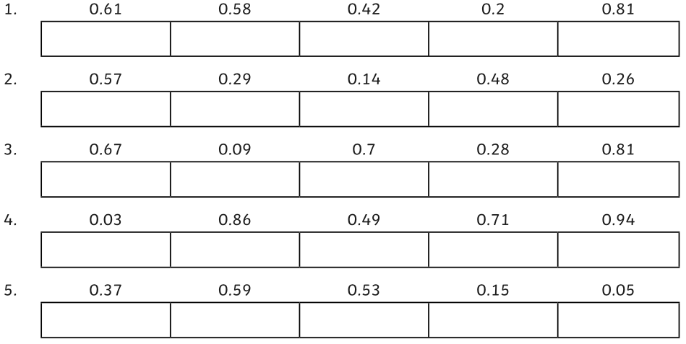
Order the following decimal numbers from smallest to largest.

Spicy
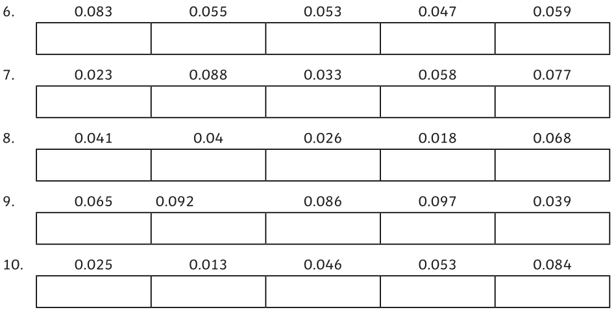
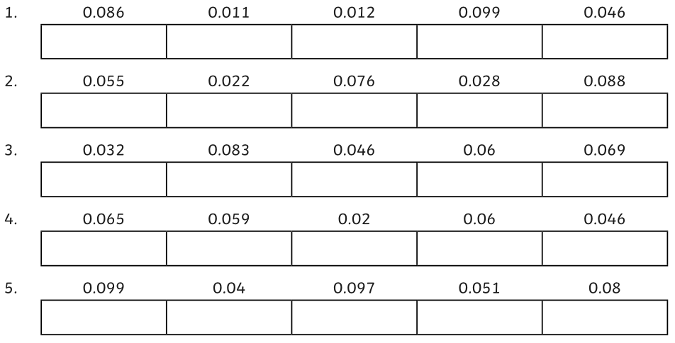
Order the following decimal numbers from smallest to largest.

Tuesday
Mild
- Complete these calculations.
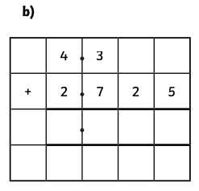
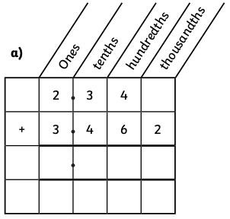

c) 3.142 + 4.468 =

d) 2.03 + 6.109 =

- Looking at these calculations, use your estimating knowledge to identify which have the wrong answer without doing any written methods. Tick or cross to show which are correct and incorrect. What would you estimate the totals to be?
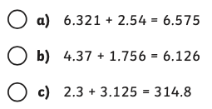

- Jody walked 2.406km on Monday and another 3.84km on Tuesday. How far has she walked in total?

Hot
- Philip and Holly are adding 2.356 and 3.47 together. Here are their adding methods:
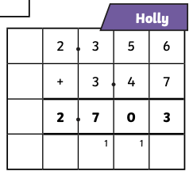
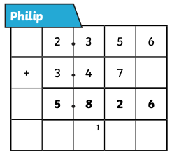

Who has used the correct method? Prove it and explain the mistake that the other person has made.

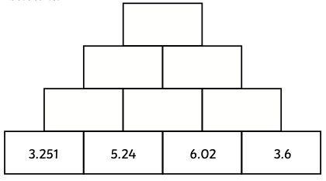
- Complete the addition pyramid. The block above each pair of blocks is the total of the numbers below it.

- Can you work out the missing digits in these calculations?
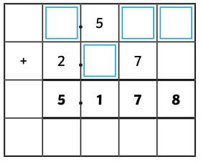
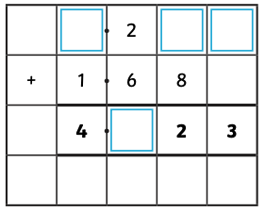

Spicy
- Use these digit cards to make 2 numbers with a total between 6 and 7. Find 4 possible solutions. You can only use the digits 1-7 once.
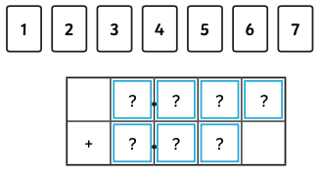

- The calculation has a total that when rounded to the nearest whole number is 10. Again, you can only use the digits 1-7 once. Find 4 possible solutions.
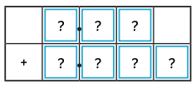

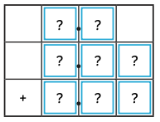
- Each digit is different. These three numbers have a total of 10. What could they be? Find 3 possible solutions.

What do you notice about the digits you have used in your different solutions?

Wednesday
Today, we are going to look at percentages.

The word ‘per cent’ relates to ‘number of parts per hundred’. The percent symbol looks like this: %
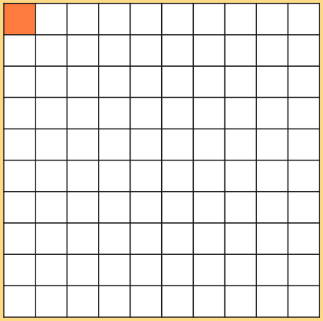
This grid contains 100 squares. There is 1 part shaded out of 100.
This represents 1%
As a fraction, this would be $\frac{1}{100}$

As a decimal, it would be 0.01

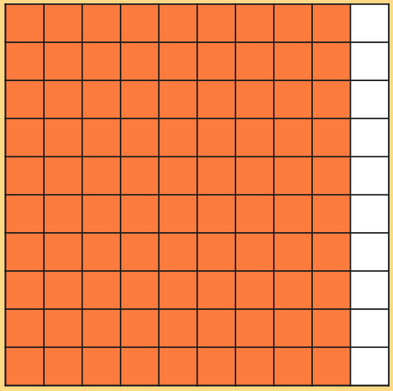
This grid has 90 parts shaded out of 100.
This represents 90%

As a fraction, this would be $\frac{90}{100}$ or $\frac{9}{10}$

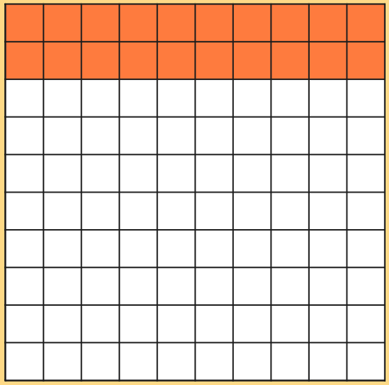
As a decimal, it would be 0.9

This grid has 20 parts shaded out of 100.
This represents 20%

As a fraction, this would be $\frac{20}{100}$ or $\frac{2}{10}$

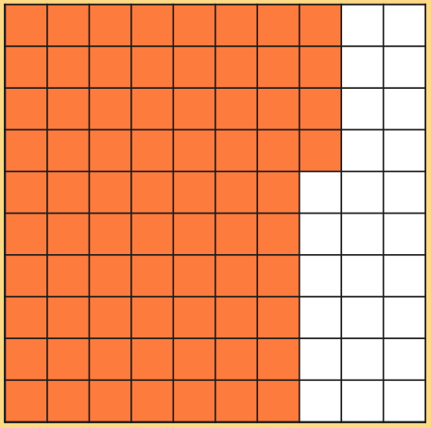
As a decimal, it would be 0.2

This grid has 74 parts shaded out of 100.
This represents 74%.

As a fraction, this would be $\frac{74}{100}$

As a decimal, it would be 0.74

Activity
Use these hundred squares to shade in the following percentage amounts:
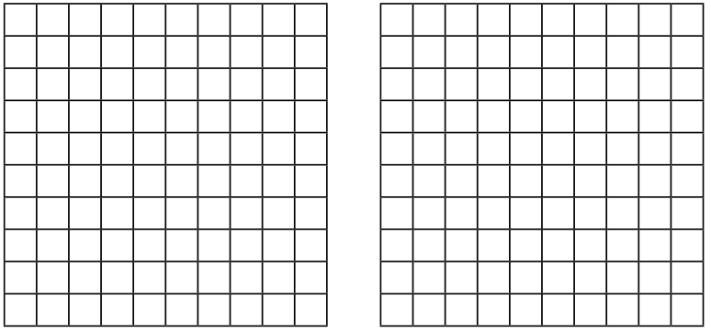
70%
3%
22%
55%

48%
17%

Thursday
Mild
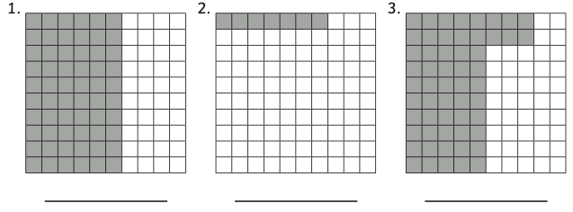
What percentage of each grid is coloured in?

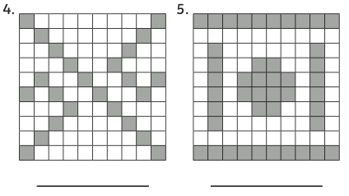

Hot
What percentage of each shape is coloured in?
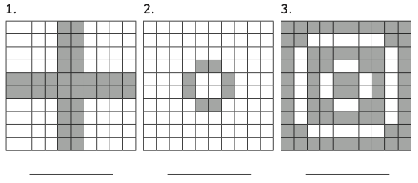

In order to work the next 3 questions, you will need to count the number of equal parts each shape has, then divide 100 by this number.
Whatever your answer is, you will then need to multiply this by the number of parts shaded.

E.g. This shape is has 5 equal parts.

100 ÷ 5 = 20.
There are 3 parts shaded.
3 x 20 = 60.
60% of the shape is shaded.
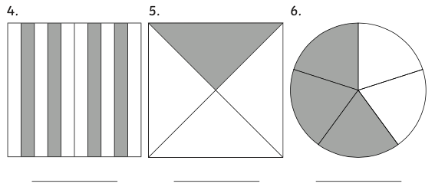

Spicy
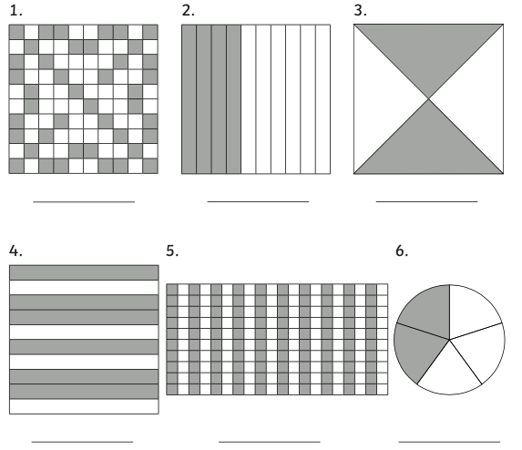

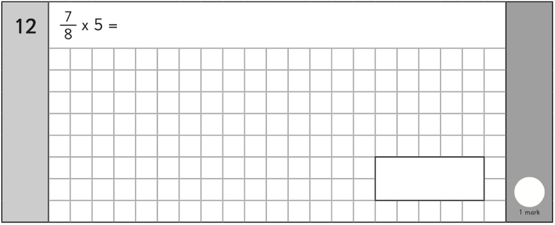
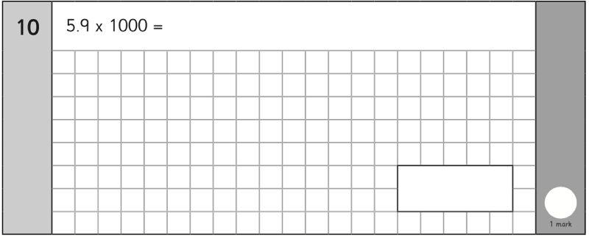
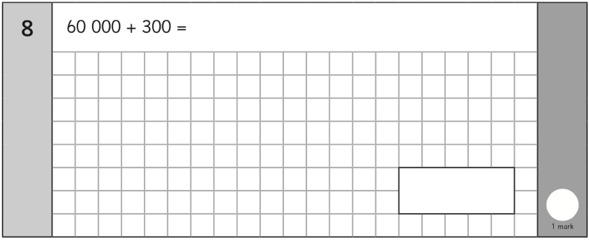
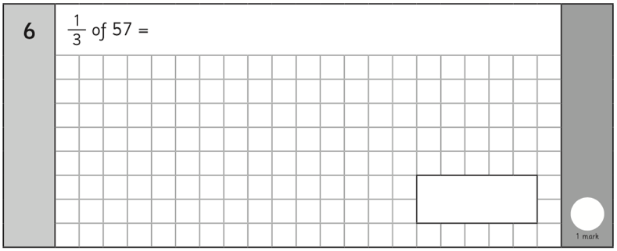
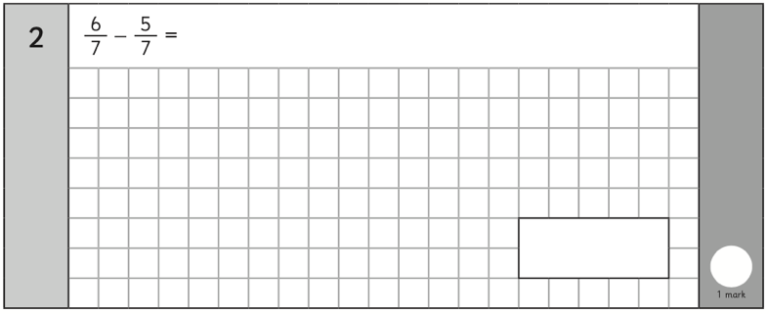
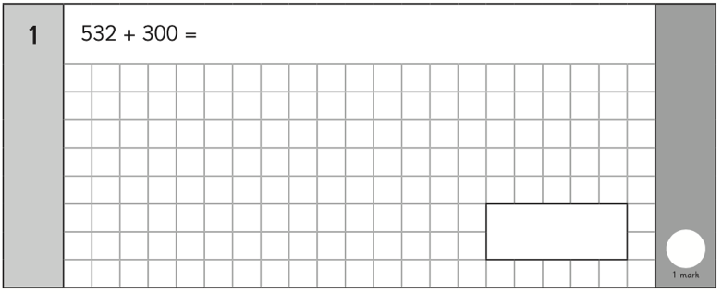
Friday arithmetic


