Week 10 answers
Monday
Mild
- 0.03 0.06 0.08 0.09
- 0.01 0.04 0.05 0.06
- 0.01 0.02 0.04 0.09
- 0.01 0.03 0.04 0.06
- 0.03 0.06 0.08 0.09
- 0.01 0.04 0.07 0.09
- 0.03 0.04 0.05 0.08
- 0.02 0.05 0.07 0.08
- 0.01 0.03 0.07 0.09
- 0.01 0.02 0.05 0.07

Hot
- 0.2 0.42 0.58 0.61 0.81
- 0.14 0.26 0.29 0.48 0.57
- 0.09 0.28 0.67 0.7 0.81
- 0.03 0.49 0.71 0.86 0.94
- 0.05 0.15 0.37 0.53 0.59
- 0.06 0.16 0.44 0.53 0.82
- 0.14 0.27 0.35 0.4 0.9
- 0.05 0.06 0.51 0.54 0.77
- 0.03 0.45 0.56 0.75 0.77
- 0.05 0.1 0.36 0.93 0.96

Spicy
- 0.011 0.012 0.046 0.086 0.099
- 0.022 0.028 0.055 0.076 0.088
- 0.032 0.046 0.06 0.069 0.083
- 0.02 0.046 0.059 0.06 0.065
- 0.04 0.051 0.08 0.097 0.099
- 0.047 0.053 0.055 0.059 0.083
- 0.023 0.033 0.058 0.077 0.088
- 0.018 0.026 0.04 0.041 0.068
- 0.039 0.065 0.086 0.092 0.097
- 0.013 0.025 0.046 0.053 0.084

Tuesday
Mild
- a) 5.802
b) 7.025
c) 7.822
8.139

- a) and c) are correct.
A sensible estimate for a) would be 9. The correct answer is 8.861
A sensible estimate for b) would be 5. The correct answer is 5.425

- 6.246km

Hot
- Philip is correct. Holly has made the mistake of not lining up the digits according to their place value. Lining up the decimal point can help with this, as can be seen with Philip’s method.
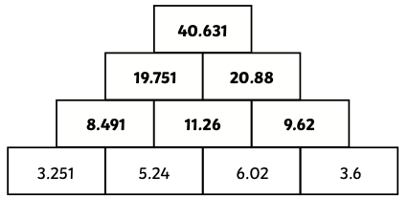

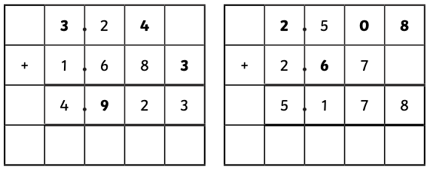

Spicy
- Possible solutions include:
3. Possible solutions include:
3.7 + 5.24 + 1.06
3.2 + 1.76 + 5.04
3.2 + 1.06 + 5.74

Answers will vary. For example, the tenths, hundredths and thousandths have a total of 1 and therefore as long as they keep that value, the digits can be moved around in the calculation.
  - + 2.71 = 6.166
5.267 + 1.34 = 6.607
2.765 + 4.413 = 6.895
2.765 + 2.54 = 6.301

- Possible solutions include:
3.26 + 7.145 = 1.06
2.35 + 7.614 = 9.964
2.13 + 7.546 = 9.676
7.14 + 3.256 = 10.396

Wednesday
70% = 70 squares should be coloured in.

3% = 3 squares should be coloured in.

48% = 48 squares should be coloured in.

17% = 17 squares should be coloured in.

22% = 22 squares should be coloured in.

55% = 55 squares should be coloured in.

Thursday
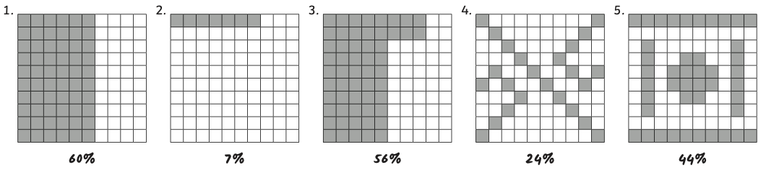
Mild
Hot
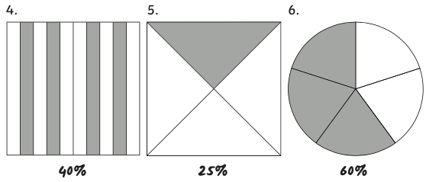
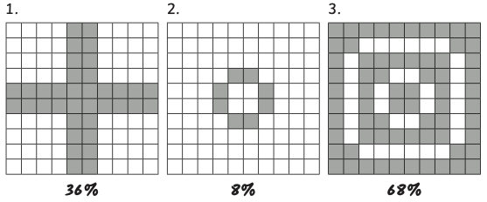

Spicy
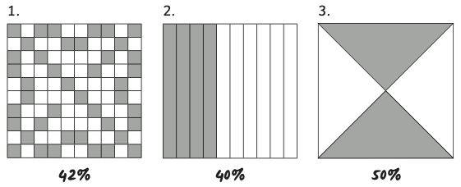

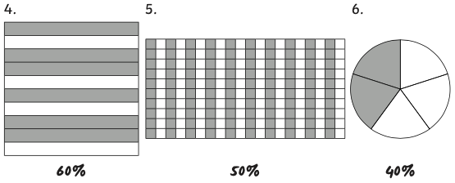

Friday arithmetic
- 532 + 300 = 832

- $\frac{6}{7}$ - $\frac{5}{7}$ = $\frac{1}{7}$

- 5628 + 4744 = 10,372

- 45 ÷ 1 = 45

- 572 x 8 = 4576

- $\frac{1}{3}$ of 57 = 19

- 86,724 – 4773 = 81,951

- 60,000 + 300 = 60,300

- 810 ÷ 9 = 90

- 5.9 x 1000 = 5900

- $\frac{9}{10}$ - $\frac{1}{5}$ = $\frac{7}{10}$

- $\frac{7}{8}$ x 5 = $\frac{35}{8}$ or 4$\frac{3}{8}$

