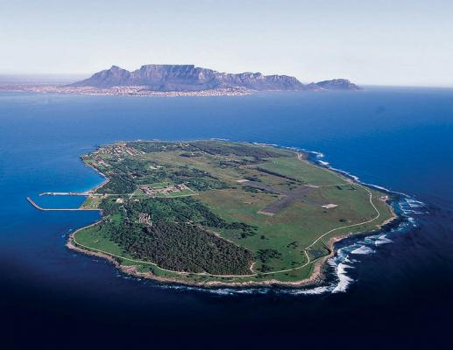
Which famous person stayed on this island? Why and for how long?

What is this island best known for?
What land mark can be seen in the background of this picture?
How has the use of this island changed in the last 30 years?
Where is Robben Island located in the World?
This is a picture of Robben Island. You are going to do a mini project based on this picture. There are some questions to help you with your research but you may have your own questions that you want to research the answers to extend your knowledge.
Robben Island

Geography

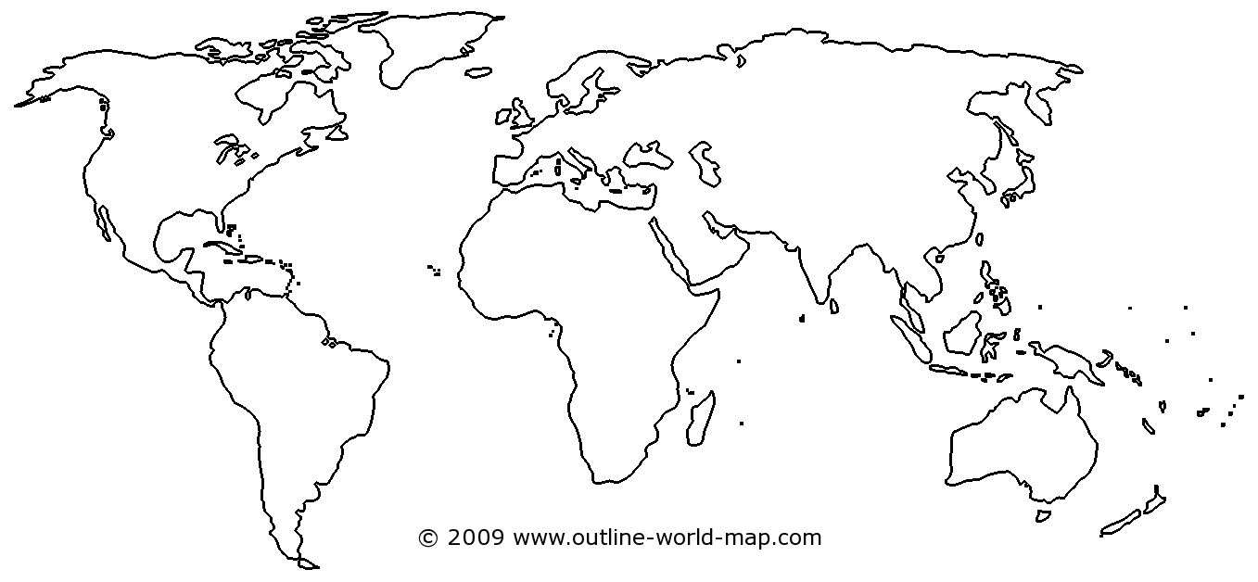

Geography

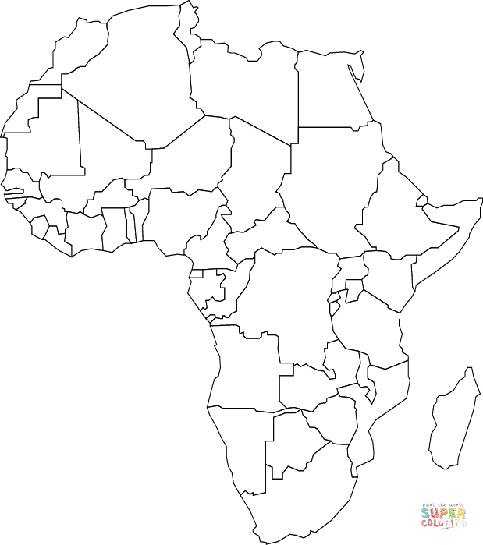

Art
Your task is to create your own design inspired by the Ndebele people. Below are some examples.
Top tips –
- use a ruler
- using squared or dotted paper might be helpful to make it symmetrical,
- use bright and bold colours
- outline your shapes in black.



