Monday Week 9
Mild
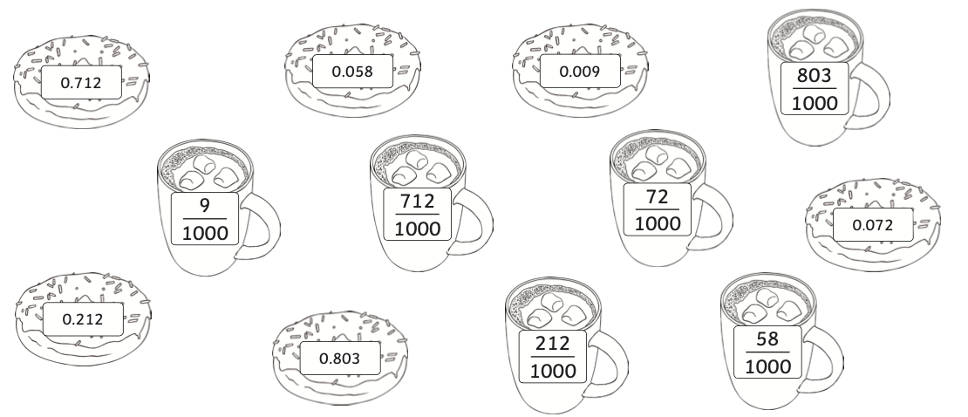
Match the decimal numbers on the doughnuts to the equivalent fraction on a mug of hot chocolate.
Hot
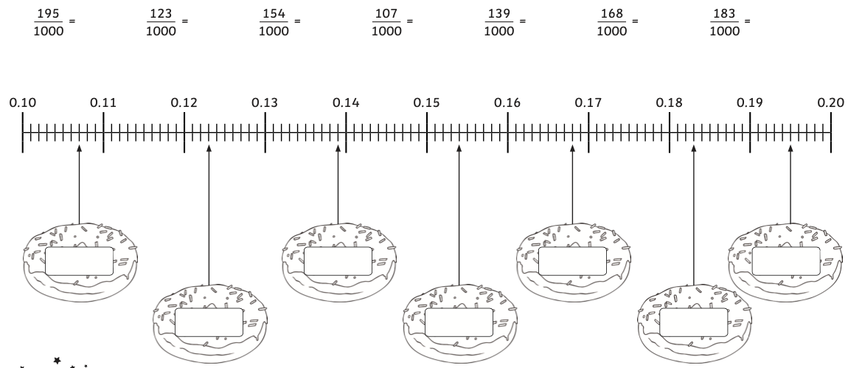
Convert the fractions into decimals and then place them on the correct doughnut on the number line.

Spicy
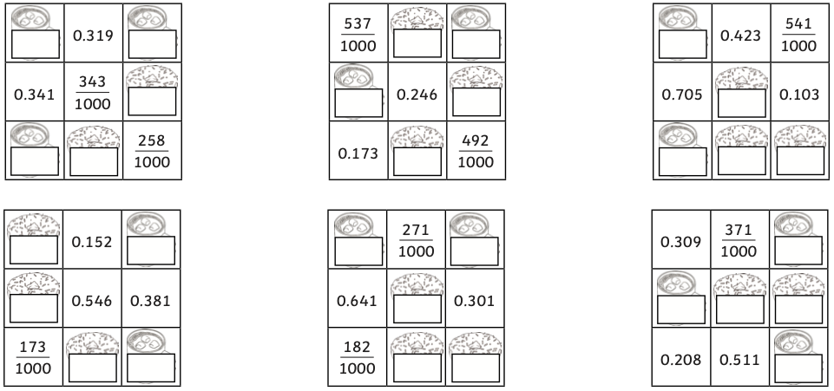
When added together, each row and column totals 1 which is equivalent to $\frac{1000}{1000}$. Write the missing decimals on the doughnuts and the missing fractions on the hot chocolates to complete each grid.

Tuesday Week 9
Mild
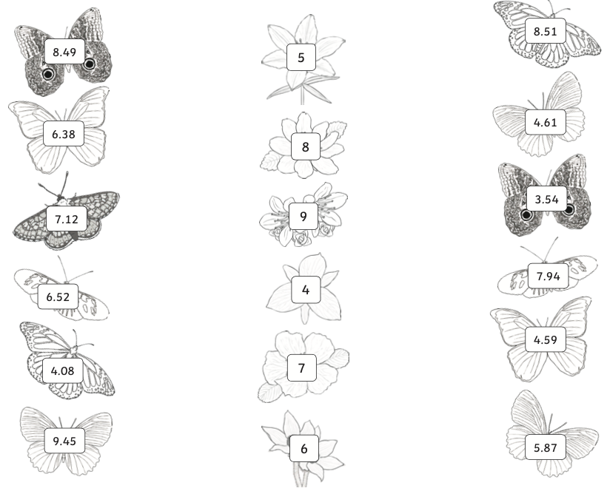
Round the decimal numbers on the butterflies to the nearest whole number. Draw a line to join the butterflies to the flowers that they round to.

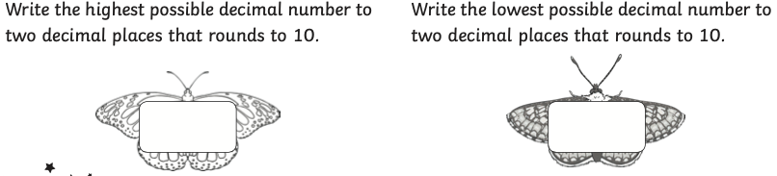

Hot
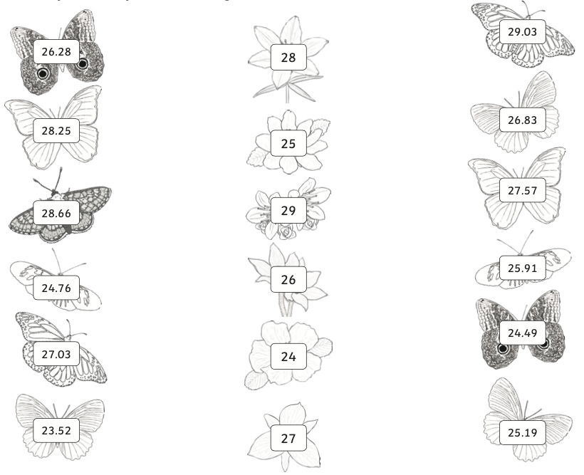
Round the decimal numbers on the butterflies to the nearest whole number. Draw a line to join the butterflies to the flowers that they round to.

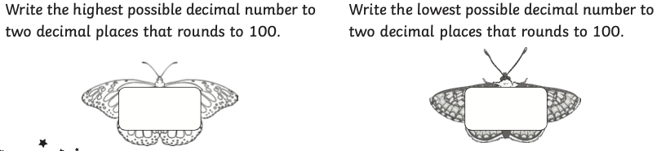

Spicy
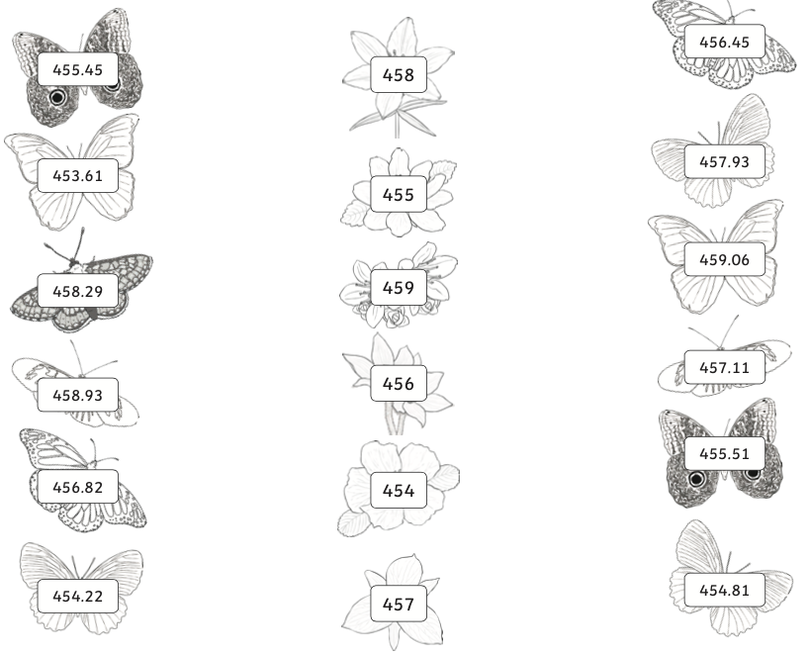
Round the decimal numbers on the butterflies to the nearest whole number. Draw a line to join the butterflies to the flowers that they round to.

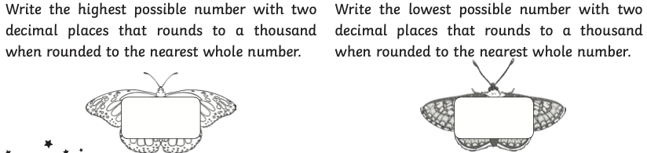

Wednesday Week 9
Mild
Round the decimal numbers to one decimal place:

- 4.76 =
- 5.82 =
- 9.65 =
- 2.53 =
- 3.49 =
- 1.21 =
- 6.17 =
- 7.34 =
- 8.85 =
- 5.46 =

Hot
Round the decimal numbers to one decimal place:

- 25.92 =
- 34.85 =
- 58.29 =
- 62.67 =
- 83.23 =
- 37.74 =
- 51.21 =
- 76.09 =
- 15.46 =
- 25.75 =

Spicy
Round the decimal numbers to one decimal place:

- 135.74 =
- 598.56 =
- 726.32 =
- 247.87 =
- 951.21 =
- 369.66 =
- 839.12 =
- 495.85 =
- 625.34 =
- 273.59 =

Thursday Week 9
Mild
Use your decimal place value skills to solve the riddles.
Four
- It is less than 10 but greater than 1 with two digits.
- The digits add up to 12.
- Both digits are odd.
- The tenths digit equals the ones digit multiplied by three.
Three
- It is less than 10 but greater than 1 with two digits.
- The digits add up to 14.
- Both digits are even.
- The tenths digit is the smallest digit.
Two
- It is less than 10 but greater than 1 with two digits.
- The digits add up to 11.
- Only the ones digit is even.
- The ones digit is seven less than the tenths digit.
One
- It is less than 10 but greater than 1 with two digits.
- The digits add up to 12.
- Both digits are odd.
- The ones digit is two greater than the tenths digit.

Challenge: Can you write your own decimal place value riddle for someone else to solve?

Hot
Use your decimal place value skills to solve these riddles:
One
- It is less than 10 but greater than 1 with three digits.
- The digits add up to 13.
- Only the tenths digit is odd.
- The ones digits and the hundredths digit are the same.
- The ones digit is less than five.
Two
- It is less than 10 but greater than 1 with three digits.
- The digits add up to 14.
- Only the tenths and hundredths digits are odd.
- The sum of the tenths and hundredths digits is 8.
- The tenths digit is six more than the hundredths digit.
Three
- It is less than 10 but greater than 1 with three digits.
- The digits add up to 11.
- The tenths digit is a quarter of the ones digit.
- The product of the ones and tenths digit is 16.
- The sum of the tenths and hundredths digits is 3.
Four
- It is less than 20 but greater than 10, with four digits.
- The digits add up to 16.
- Both the tenths and hundredths digits are even; the product of these digits is 12.
- The sum of the tens and ones digits is 8.
Hot challenge: Can you write your own decimal place value riddle for someone else to solve?

Spicy
Four
- It is less than 40 but greater than 30, with five digits.
- The digits add up to 25.
- The product of the tens and ones digits is 24.
- The tenths digit is half of the ones digit.
- The hundredths digit is one less than the tenths digit.
- The product of the hundredths and thousandths digits is 21.
Three
- It is less than 20 but greater than 10, with five digits.
- The digits add up to 23.
- The product of the tens and ones digits is 4.
- The tenths digit is five greater than the ones digit.
- The product of the tenths and hundredths digits is 72.
- The sum of the hundredths and thousandths digits is 9.
Two
- It is less than 10 but greater than 1, with four digits.
- The digits add up to 15.
- Only the tenths digit is even.
- The product of the ones and tenths digits is 28.
- The hundredths digit is three less than the tenths digit.
- The product of the hundredths and thousandths digits is 3.
- The thousandths digit is two more than the hundredths digit.
One
- It is less than 10 but greater than 1, with four digits.
- The digits add up to 20.
- The ones and tenths digits are odd.
- The sum of the ones and tenths digits is 10.
- The tenths digit is seven less than the hundredths digit.
- The sum of the hundredths and thousandths digit is 10.

Challenge: Can you write your own decimal place value riddle for someone else to solve?

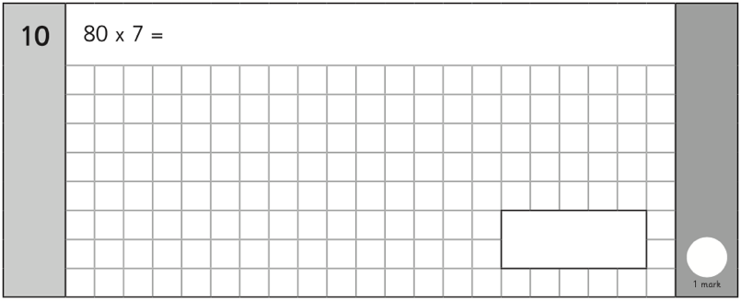
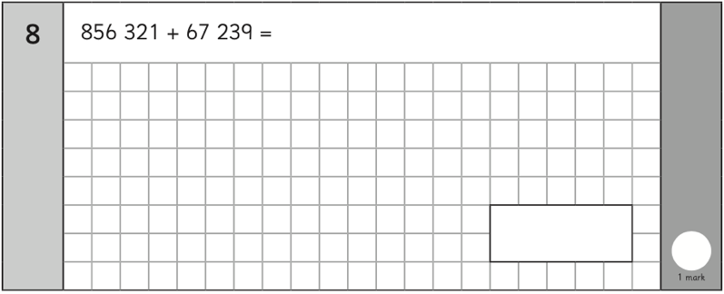
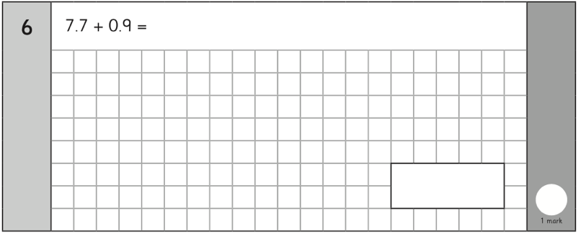
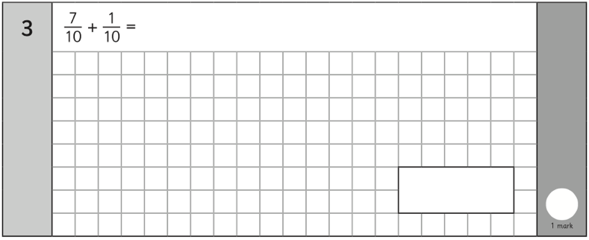
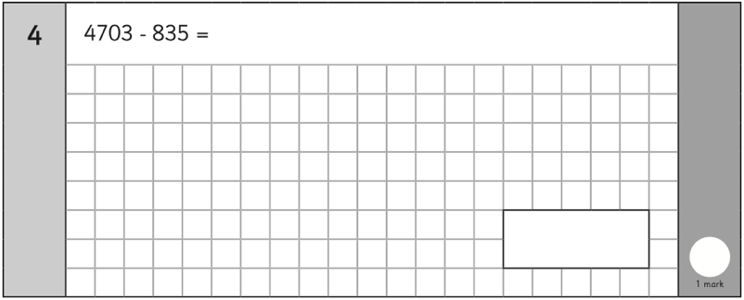
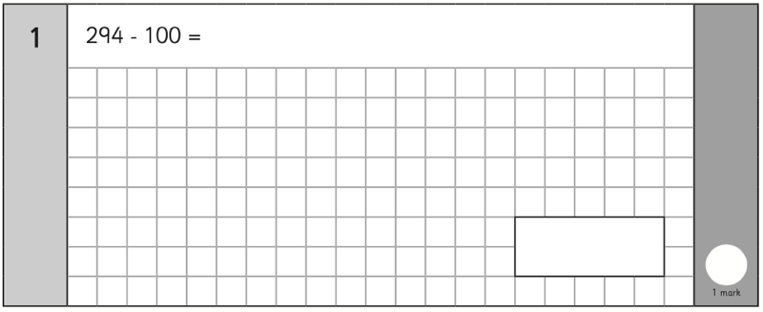
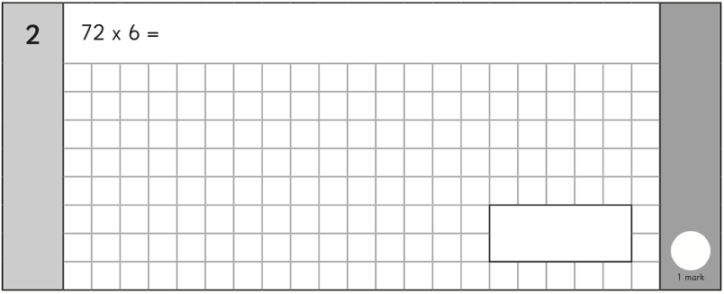
Friday Week 9


