Monday Week 8
Mild
Colour the diagrams to multiply the proper fractions by whole numbers.
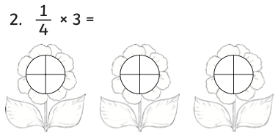
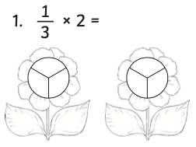
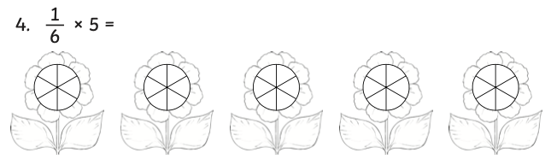
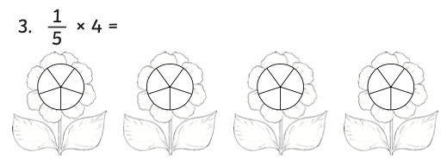

Hot
Colour the fraction diagrams to multiply the proper fractions by whole numbers. Write your answer as a mixed number.
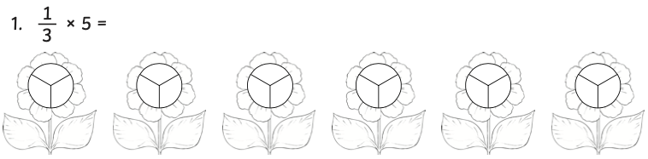

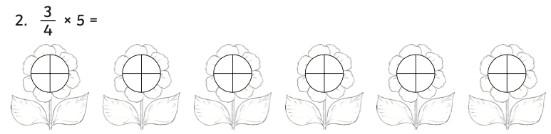

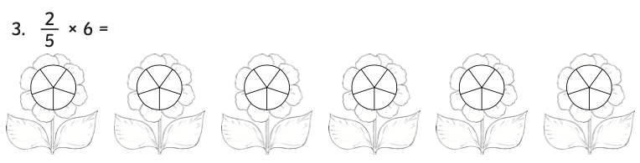

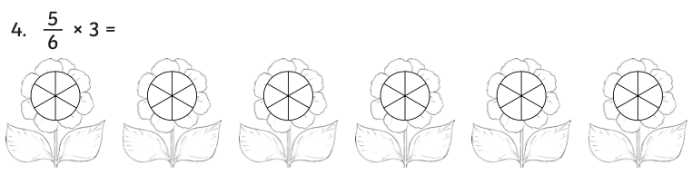

Spicy
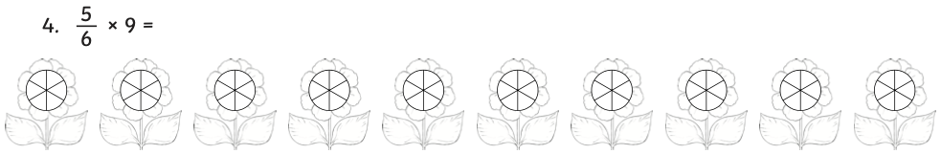
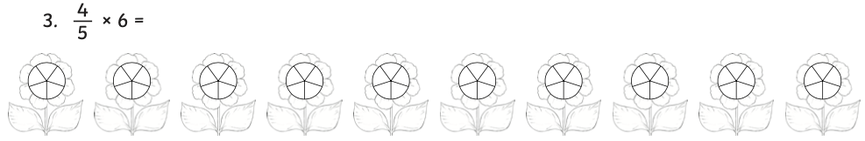
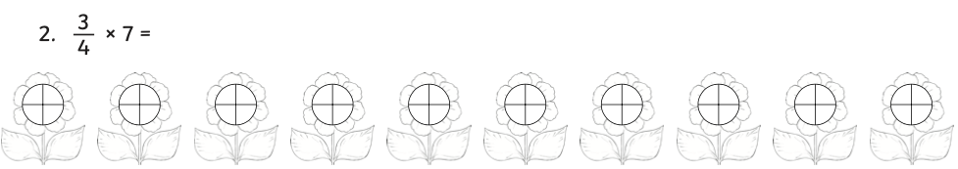
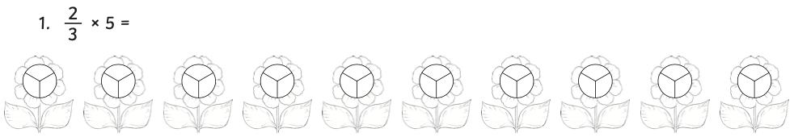
Colour the fraction diagrams to multiply the proper fractions by whole numbers. Write your answer as a mixed number.

Tuesday Week 8
Mild
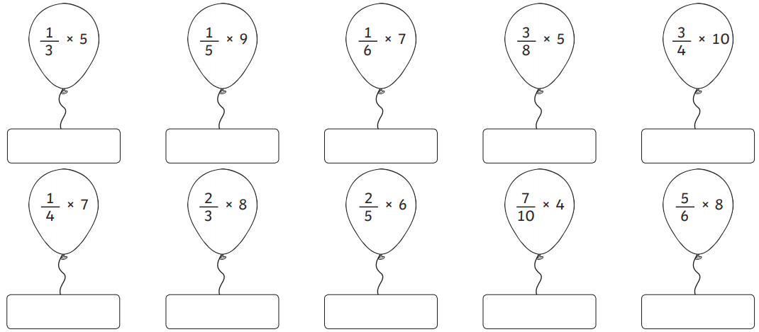
Calculate the answers to the balloons. Write your answer as a mixed number.

Hot
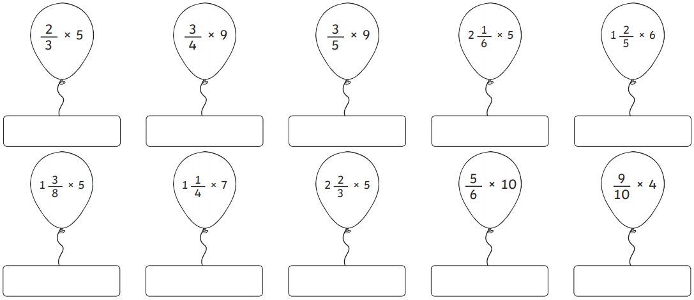
Calculate the answers to the balloons. Write your answer as a mixed number.

Spicy
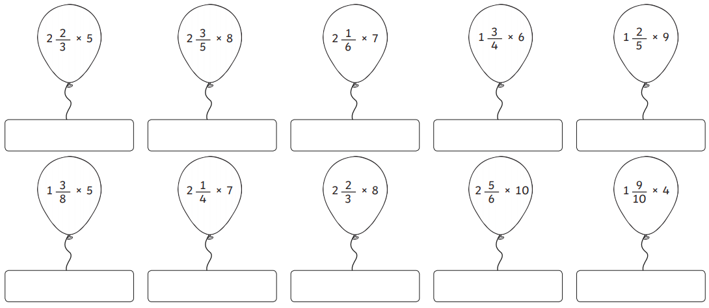
Calculate the answers to the balloons. Write your answer as a mixed number.

Wednesday Week 8
Mild
Write each fraction as a decimal and then sort the decimals into the correct place on the Venn diagram:
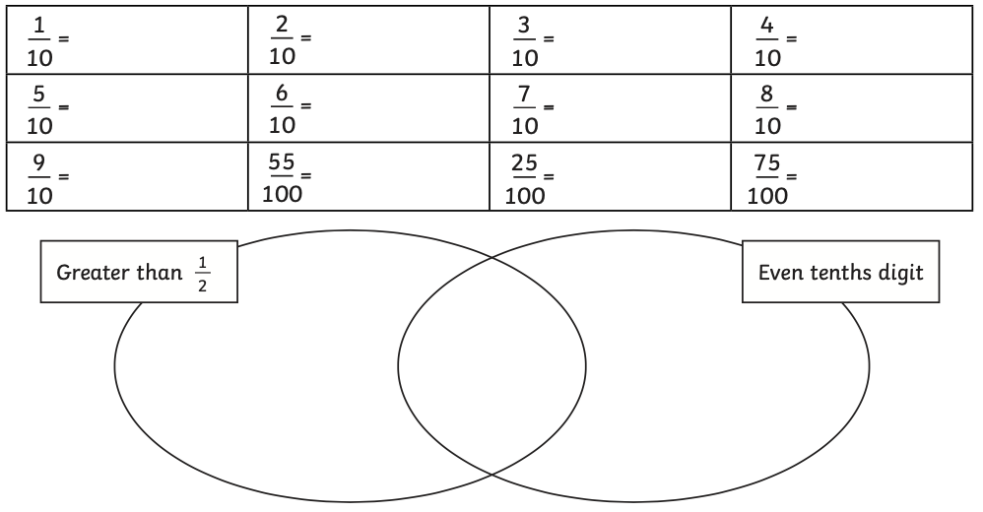

Hot
Write each fraction as a decimal and then sort the decimals into the correct place on the Venn diagram:
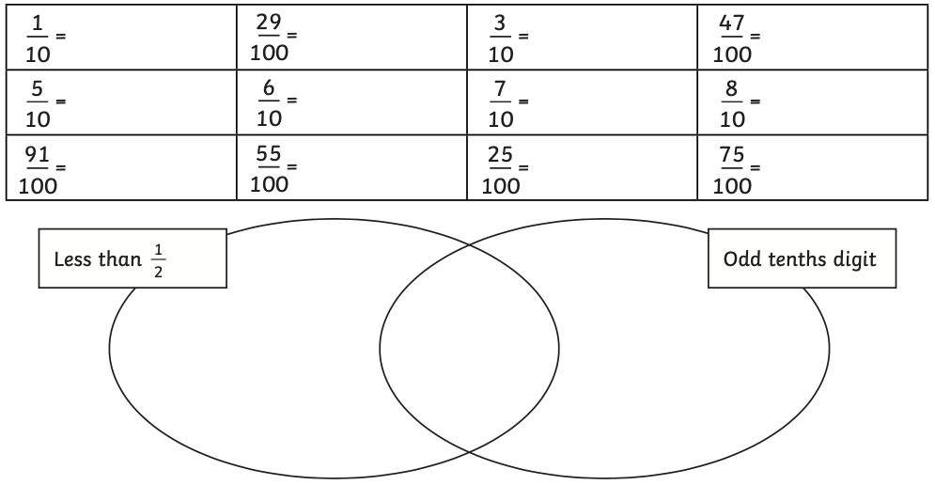

Spicy
Write each fraction as a decimal and then sort the decimals into the correct place on the Venn diagram:
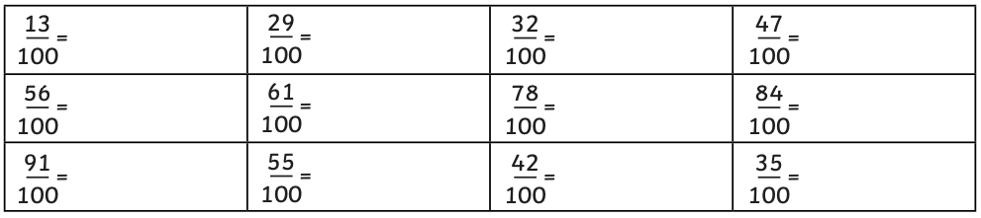

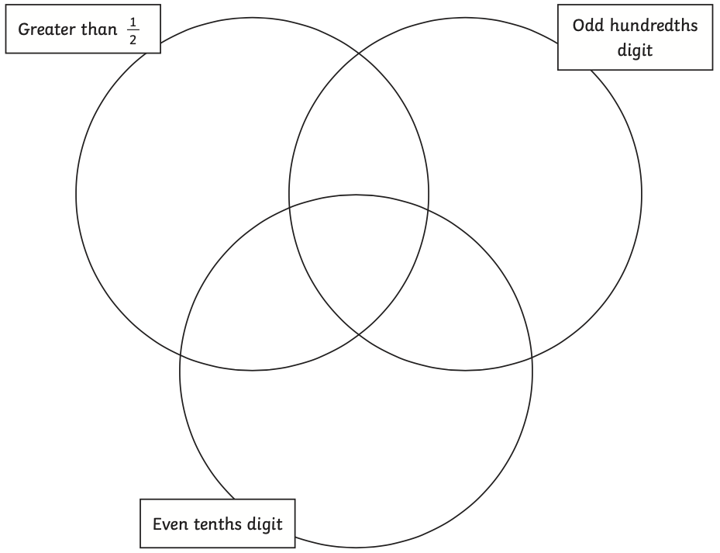

Thursday Week 8
Mild
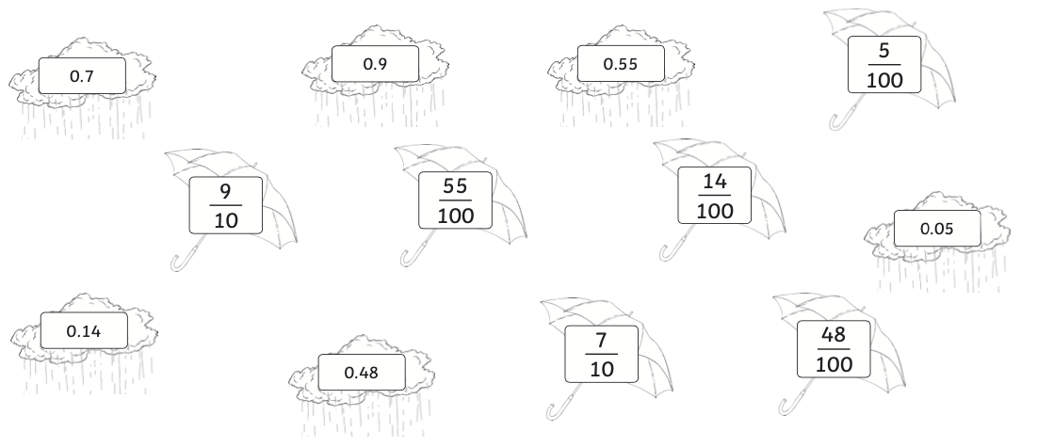
Match the decimals on the rain clouds to the equivalent fraction on the umbrella.

Hot
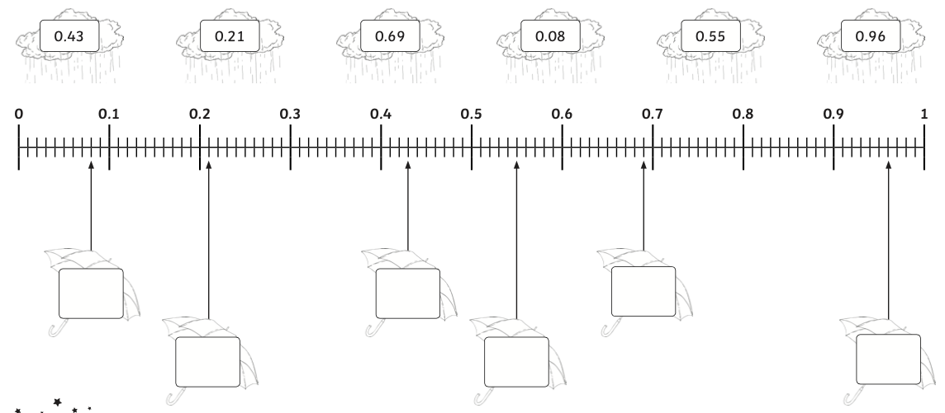
Convert the decimal numbers on the rain clouds to fractions and then place them on the correct umbrella on the number line.

Spicy
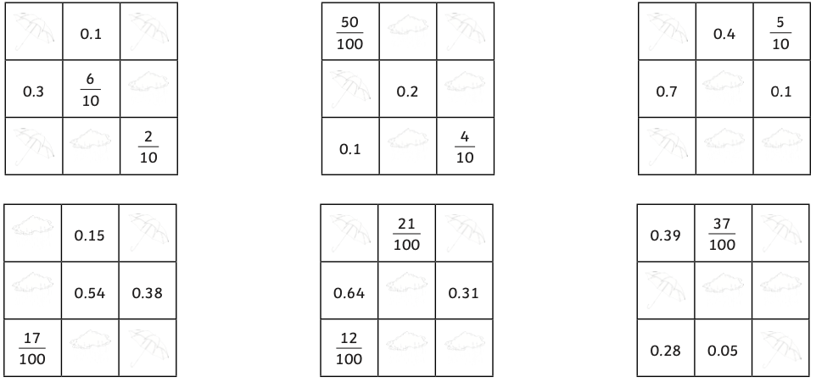
When added together, each row and column totals 1 which is equivalent to $\frac{1}{10}$ or $\frac{1}{100}$. Write the missing decimals on the rain clouds and add the missing fractions on the umbrella to complete each grid.

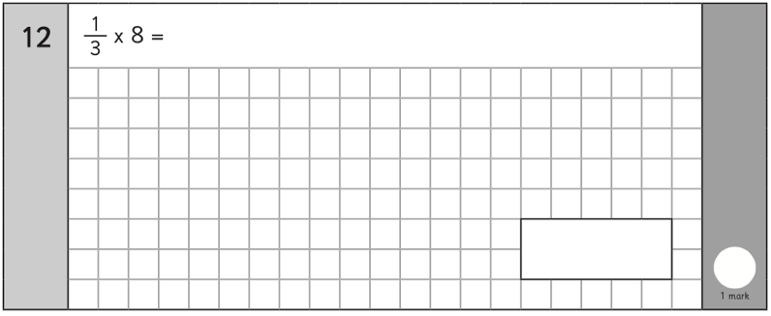
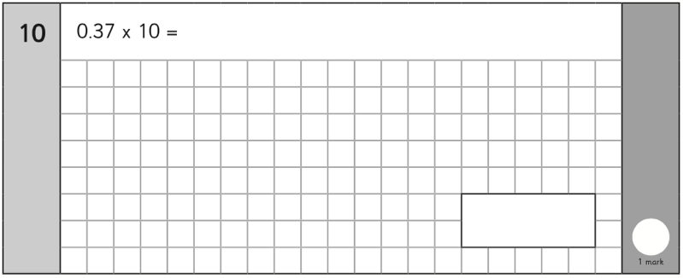
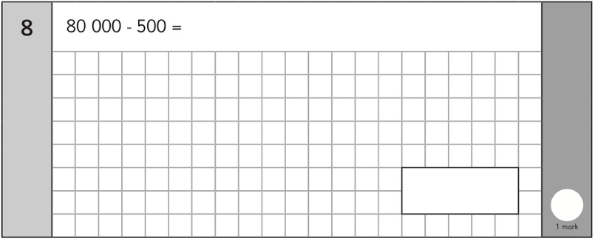
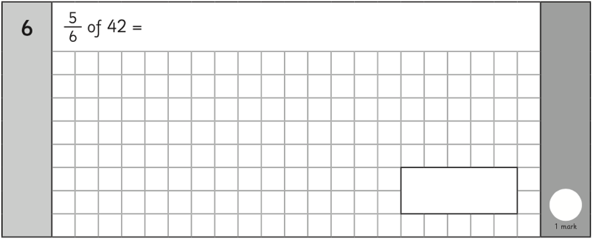
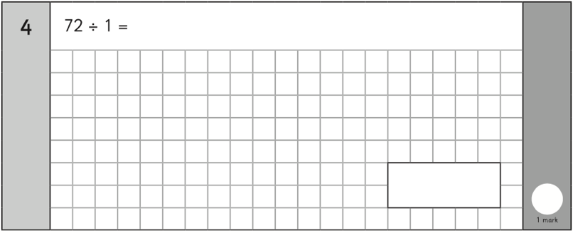
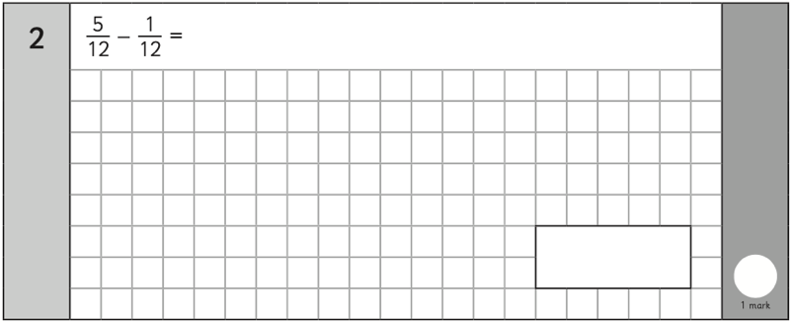
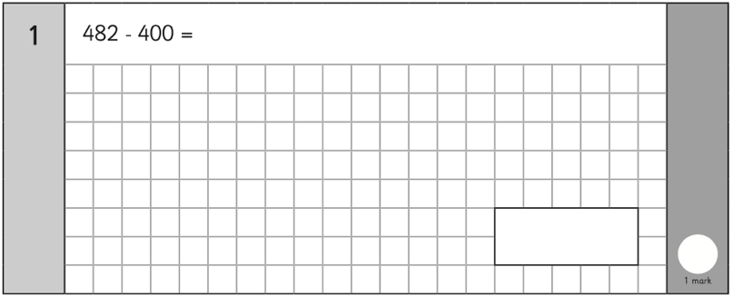
Friday Week 8


