Jigsaw lesson – week 7
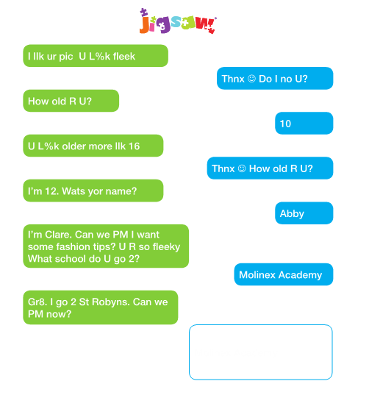
Abby put a photo of herself on social media. She didn’t use any privacy settings.
Shen then got into this conversation.

She agreed to private message Clare. After a few weeks they swapped information and then agreed to meet up.

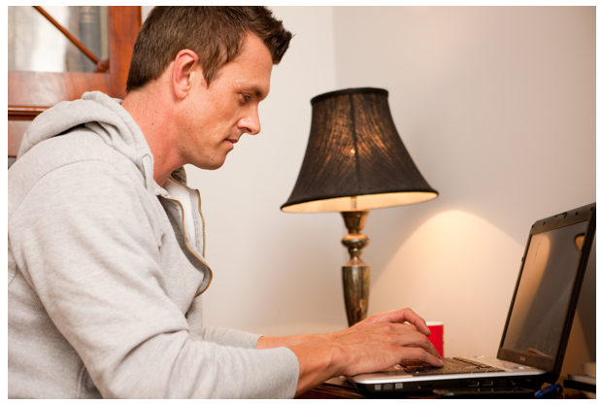
When Abby got to the meeting point, she found out that this was actually Clare. Luckily, Abby was able to run away and stay safe.

What did Abby do wrong?
Look at the messages again – were there any clues?
What should she have done differently?

It is really important to stay safe online. Make sure you know who you are speaking to. When you make new friends, you can never be sure of who they are and you should NEVER give out your personal information.
Stay safe online!
Extension – make a poster to explain to children how to stay safe online. What rules should be followed?

