3 in 3!!

3 questions in 3 minutes!!!

Read the text and then time yourself answering the questions – your aim is to answer all 3 questions in 3 minutes!

Dora felt sick to the pit of her stomach. She had been saving for that bicycle for a whole year, but now she found that she was forty pounds short. How could that have occurred? Through all her saving, sacrifice and jobs for Grannie, it had remained the same price for eleven months. Why did they have to increase it now, in the twelfth month, just as she had thought she had achieved her dream? According to the shop assistant, they had only put it up the previous day. He tried to recommend a different, cheaper one, but Dora wasn’t interested.

1. How long had Dora been saving money?

______________________________________________

2. How much more money did Dora still need to buy the bicycle?

______________________________________________
3. … how could that have occurred? …
In this context, which word is closest in meaning to occurred? Circle one.

happened increased paid realised

You have a text, questions and the answers.
Read the text answer the questions and then check your answers!

The New Explorers
Throughout history, we have been fascinated by the unknown. Hundreds of years ago sea-faring explorers set off in their ships to discover unknown lands across the seas. They discovered ‘new worlds’ and different ways of life. In more recent times, our need to explore has taken us on new voyages of discovery...
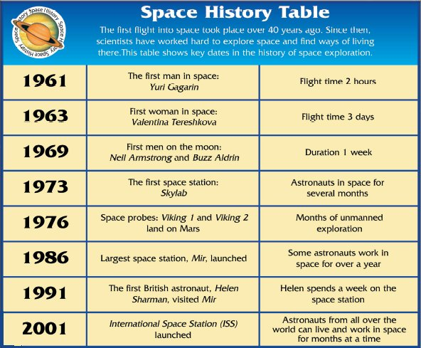

Helen Sharman
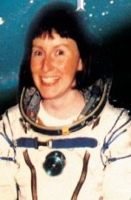
Helen Sharman is the first British astronaut. Here are some of the things she said about the time she spent on Mir performing scientific experiments and experiencing the unique feeling of being in a ‘new world’.
“Inside an orbiting spacecraft you feel weightless. Because you’re travelling so fast, you’re pulled towards the Earth as it curves away below you. It’s as though you’re constantly falling round the Earth. Wonderful!
We go into space because of the useful things we can find out there, but no astronaut ever tires of just looking out of the window. If you look towards the Earth you see vast oceans of rich blue, sprinkled with snow white clouds that are so bright with reflected sunlight that it hurts your eyes to look at them for long.
Deserts are brick-red, crossed with sandy coloured roads that seem to have neither beginnings nor ends. If you look away from Earth into space, you see millions and millions of stars that seem to go on forever.” | 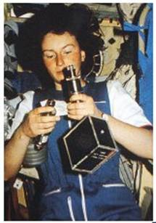

1. Circle the correct option to answer the question below.
Who are New Explorers?
1 mark
2. Look at the table called Space History.
Tick one box on each row to show whether each statement is true or false.
 | True | False
The first man landed on the moon in 1961.
Skylab was the name of a space station launched in the seventies.
Two astronauts landed on Mars in 1976.
People can stay in space for longer nowadays than they could at first.
2 marks
3. The Space History Table has no column headings.
Use the information in the table to think of helpful headings for each column.
One has been done for you.
Write your headings here.
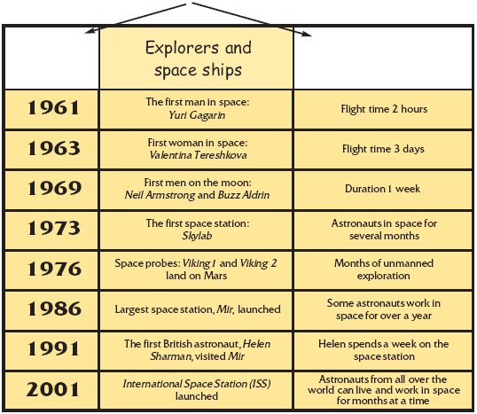
2 marks
4. What makes Helen Sharman special in this country?
___________________________________________________________________
___________________________________________________________________
1 mark
5. What does Helen say is the main reason for going into space?
___________________________________________________________________
___________________________________________________________________
1 mark
6. What were the two things that Helen most enjoyed on board the space station?
1. _________________________________________________________________
2. _________________________________________________________________
2 marks
7. Look at the paragraph beginning: Helen Sharman is…
Find and copy one word meaning like nothing else.
_________________________________
1 mark

ANSWERS

1. Award 1 mark for the correctly identified option.
Do not award a mark if a child has circled more than one option.


1 mark
2. Award 2 marks for all four correct ticks.
Award 1 mark for 2 or 3 correct ticks.
Note – crosses in the ‘false’ column are acceptable.

 | True | False
False |  | ✔
True | ✔
False |  | ✔
True | ✔
up to 2 marks
3. Award 1 mark for each acceptable suggestion.
First column: Award 1 mark for answers referring to the date of the flight, eg:
• date / year;
• when (it happened).
Third column: Award 1 mark for answers referring to duration of space flight, eg:
• time taken / how long;
• length of flight / flight time.
Do not accept:
• (flight) information.
up to 2 marks
4. Award 1 mark for reference to the fact that Helen was the first British astronaut, eg:
• first British person in space / to go on Mir.
Do not accept:
• first British person to go to the moon.
1 mark
5. Award 1 mark for answers that refer to the usefulness of research.
• to find out useful things / the useful things we can find out there.
Do not accept:
• because of the useful things / to find useful things.
1 mark
6. Award 1 mark up to a maximum of 2 for answers that refer to each of the following:
• the feeling of weightlessness (constantly falling around the earth, or any reference to gravitational differences);
• the wonderful sights to be seen (no astronaut ever tires of just looking out of the window, the amazing views).
Each point should be made only once. Do not credit rephrasing of a previously given point.
up to 2 marks
7. Award 1 mark for
Unique.

1 mark

Week 7. Friday

Reading Together
Learning focus: Understanding poetry
Share the poem ‘My Best Friend’. Read each line and ask children to read/say it back to you. Identify key features such as rhyme, verses, repetition etc. Explore the hidden meaning of the poem (the friend is actually very unkind). What makes a good friend? Sort the actions from the poem into ‘kind/unkind’ and add your own ideas.

Questions you could ask as you read:
• Do you think this ‘friend’ is really a good friend?
• What does she do that shows this?
• Who/what do you think the last verse is referring to?
• How do you know this?
What do the following words mean: loyal, adore, menace?

My Best Friend
My best friend’s an angel,
My best friend’s a queen.
My best friend’s a menace;
She’s really rather mean.
My best friend adores me,
My best friend can share.
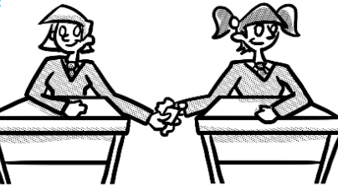
My best friend ignores me;
She loves to pull my hair.
My best friend’s a wonder,
My best friend’s not shy.
My best friend tells secrets;
She always seems to lie.
So
I guess
She’s not really
My real best friend
At all
Because…
My real best friend is loyal,
My real best friend can’t talk.
My real best friend just barks and wags
When we go out for walks.

