Monday 11th May 2020

Read the following – what errors can you spot?
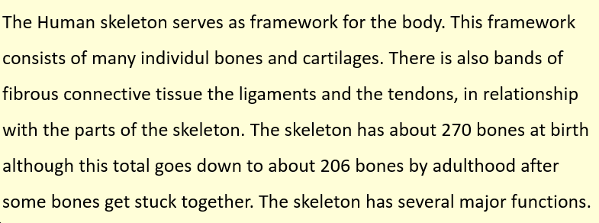

See below – How did you do?

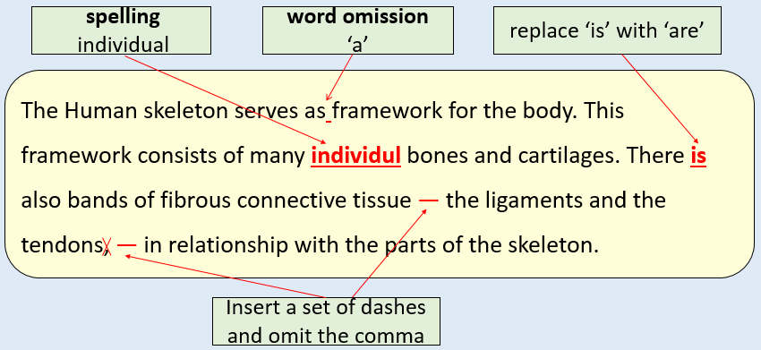

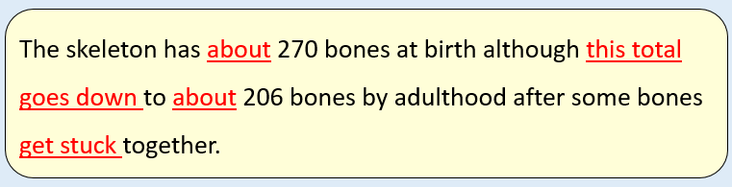
We can improve the language we use -
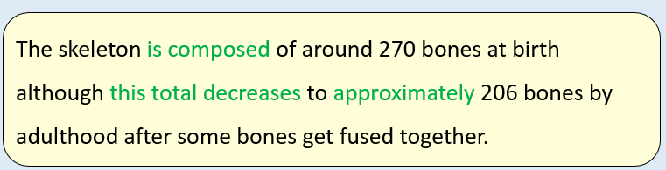

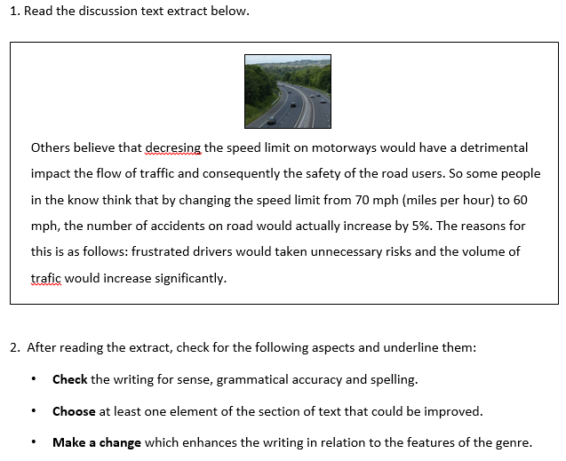

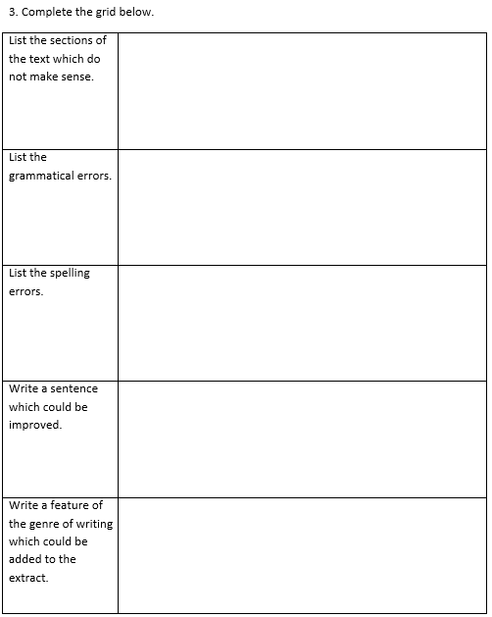

4. Rewrite the extract, making the amendments which you have identified in the grid above.



