Nets of 3D Shapes are available at the end of this document if you would like to print them out and make them to get a better understanding of what 3D shapes look like.

Monday Week 6
Mild
- Write the number of faces for each shape in the table below:
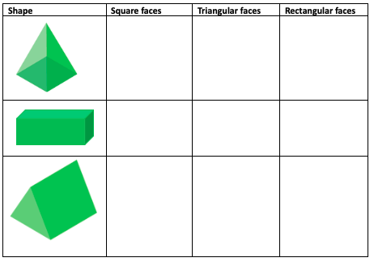

- What 3D shape will this net make?
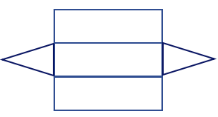

Hot
- Compete the table below with the number of each type of face needed to create a net for each 3D shape:
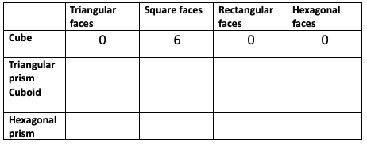

- List the different faces needed to create this 3D shape:
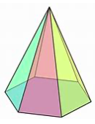

Spicy
- These nets will not make a cube. Explain why.
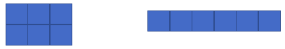

- PRACTICAL ACTIVITY: Design and make a net for a box of your choice. Label the faces on your net and then create the box. Can you make more than one net for your box?

Tuesday Week 6

- Name three different 3D shapes that have at least one rectangular face.

- Name two different 3D shapes that have a curved surface.

- Thinking about these 3D shapes, which could be the odd one out and why? Can you think of more than one example?
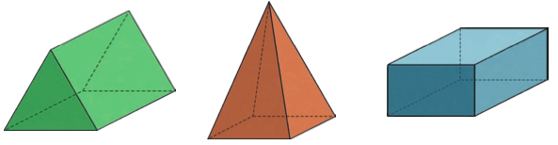

- True or false?
- a cylinder is a type of prism.
- A cuboid is the only 3D shape to have rectangular faces.
- A triangular prism has six vertices.

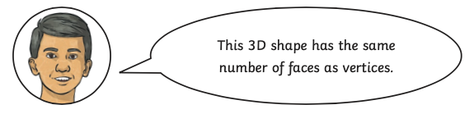
- Arnold is looking carefully at a square-based pyramid. He says:

Investigate to find out if this is true for all pyramids.

What have you learnt from your investigation? What are your findings?

Wednesday Week 6
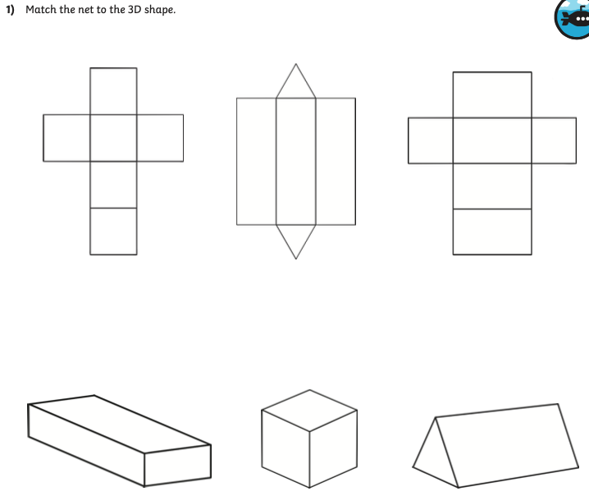

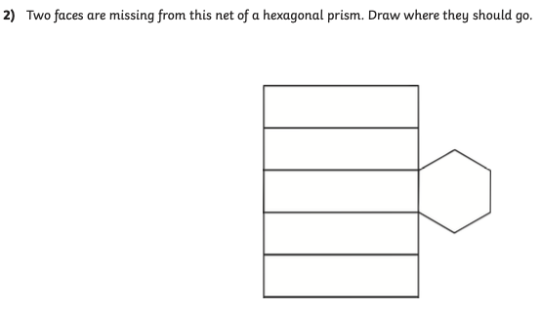

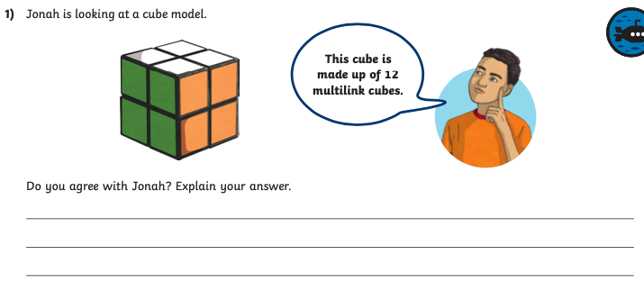

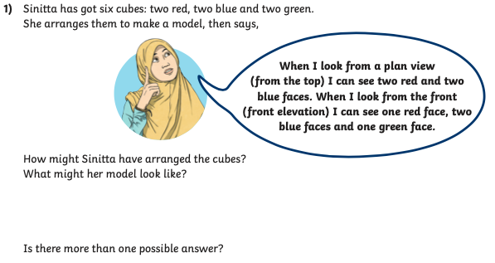

Thursday Week 6
Mild
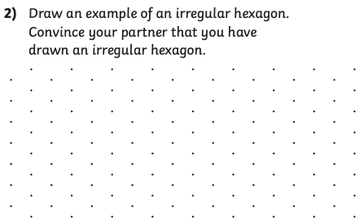
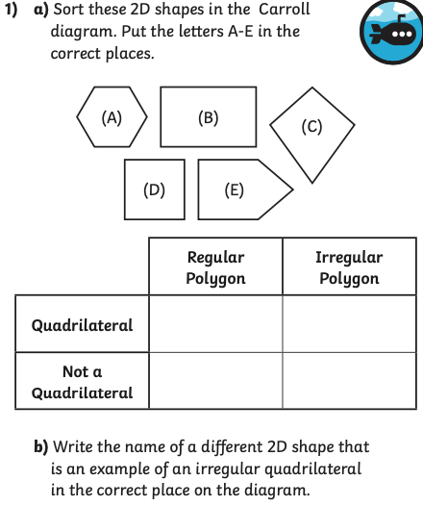

Hot
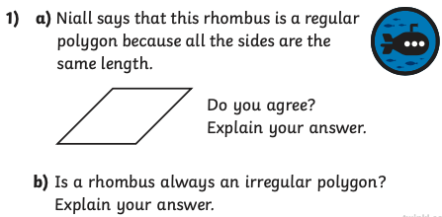

Spicy
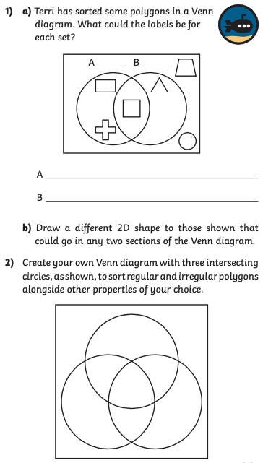

Friday Week 6
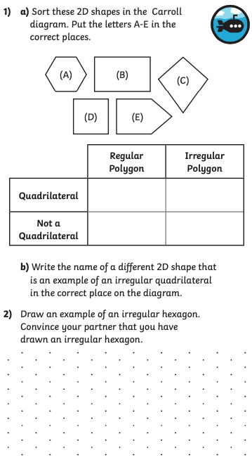
Mild

Hot
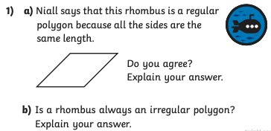

Spicy


