Please note: none of the shapes used are to scale.
Monday Week 5
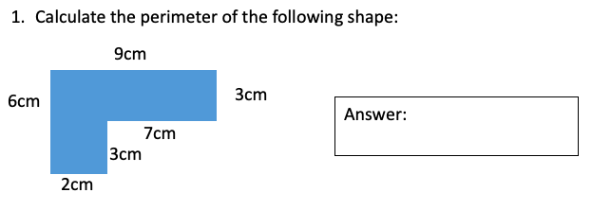
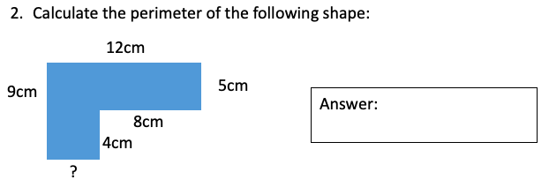
Mild

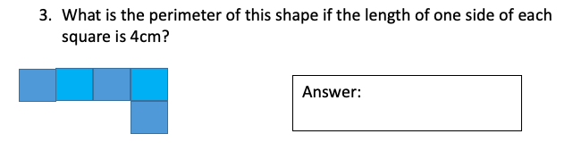

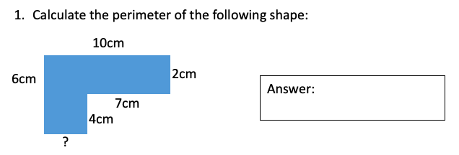
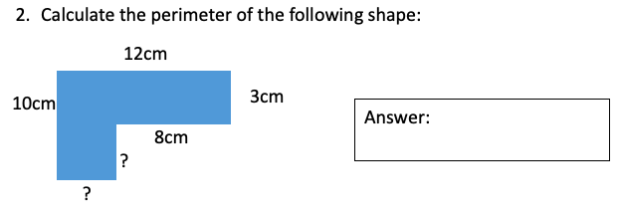
Hot

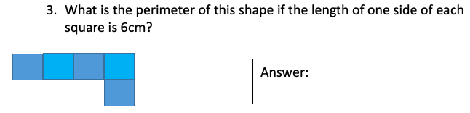

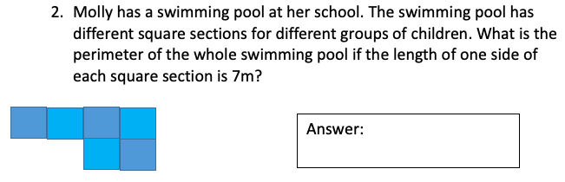
Spicy
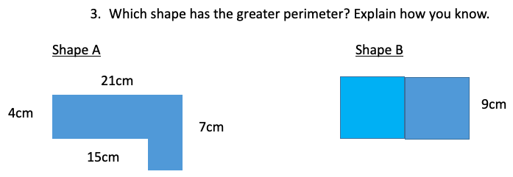
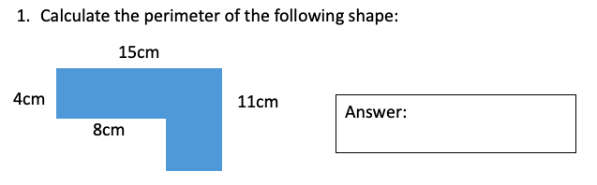

Tuesday Week 5
Shapes are not to scale.
Mild
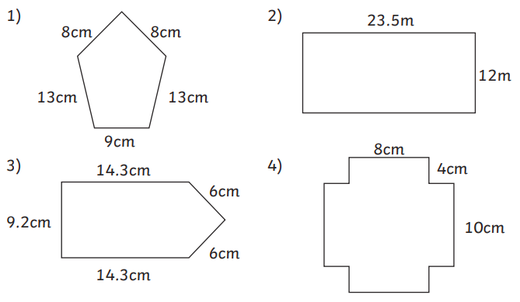

Hot
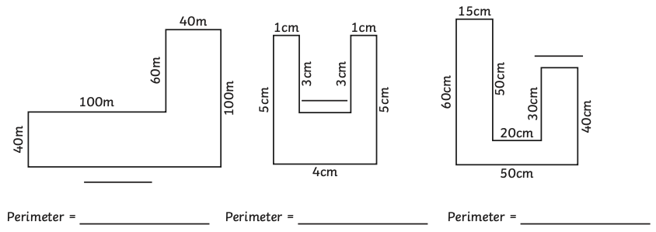
Use the labelled sides to find the length of the unlabeled side on each of these shapes. Then, calculate the perimeter of each shape.

Spicy
- Toby says, “This shape has a perimeter of 4000m.”
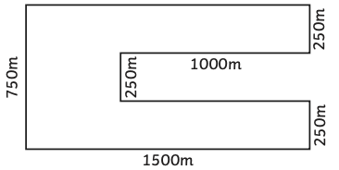

Explain his mistake, then calculate the correct perimeter of the shape.

- Are these statements true or false? Explain how you know.
- A rectangle with sides 2cm and 8cm will have the same perimeter as a square with 5cm sides.
- A long, thin rectangle will always have a longer perimeter than a shorter, wider rectangle.
- If you put a square with sides of 4cm and a square with sides of 6cm side by side on a straight line, they make a rectilinear shape with a perimeter of 40cm.

Wednesday Week 5
Mild
- Jamie ran around the perimeter of the local park. He used his smartphone to draw a map and measure the distance he ran. From the map, work out the total distance he ran all the way around the perimeter of the park.
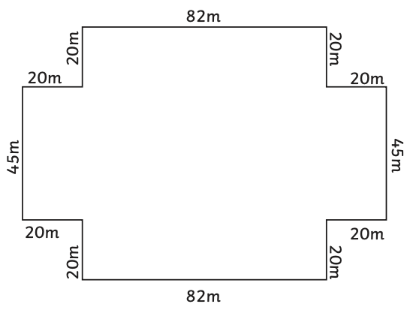

- Farmer Green wants to put up a fence for his ferret enclosure. What is the length of the chicken wire he needs to go around the whole perimeter of the enclosure?
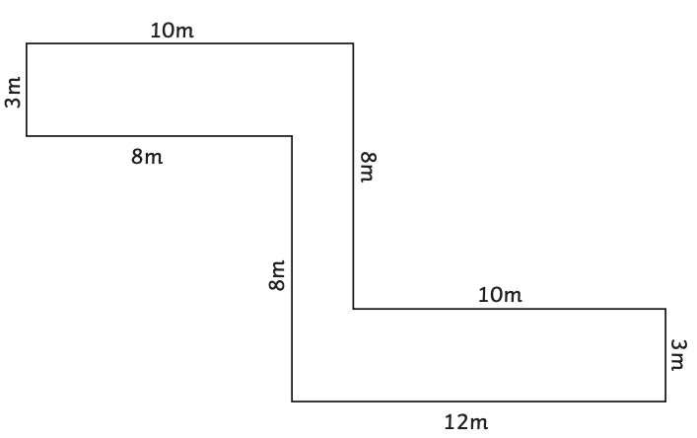

- Harry designed a t-shirt with his initial on it. He wants to go around the edge of the letter in shiny black fabric paint to make it stand out. Work out the perimeter of the shape so that Harry can work out how much paint he needs.
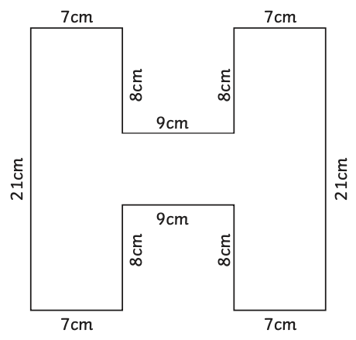

Hot
- The school caretaker needs to price up some new guttering for the whole way around the school building. Work out the total perimeter of the school building from this plan so that she will know how much guttering to buy.
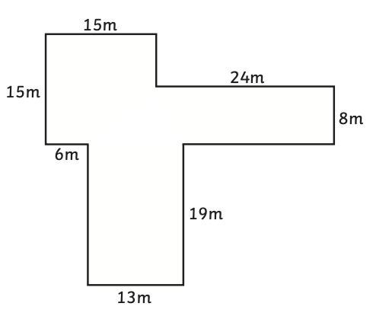

- Andy is planning a campsite for a music festival. He has a few fields for the campsite but needs to put fencing around the perimeter of the whole site. Work out how many meters of fencing he will need.
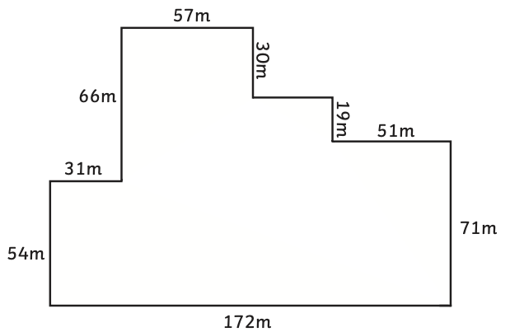

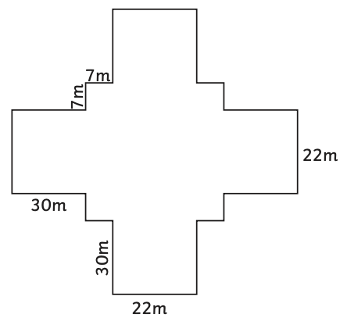
- Emma wants to run 2km. She is going to run five times around the perimeter of her local park. What is the total distance she will run around the park and will she have reached her 2km target? (The park is symmetrical on both sides.)

Spicy
- Miss Taylor is creating a bullying display with the word TELL in the middle. Work out the perimeter of the whole word so that she can work out how much luminous tape to use around the edge of the letters to make them stand out. (All the letters are the same height and width.)
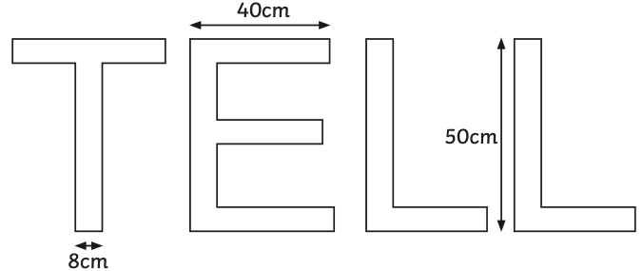

- Joe is a forklift truck driver. Every day, he has to go three times around the perimeter of the warehouse where he works. How far does he travel in one day?
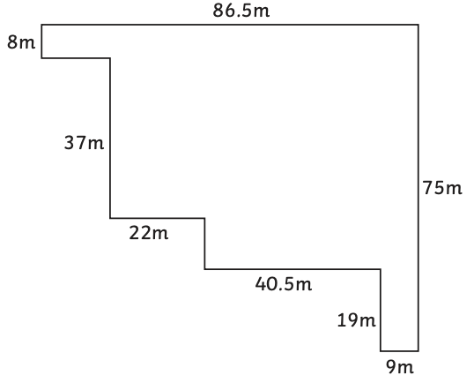

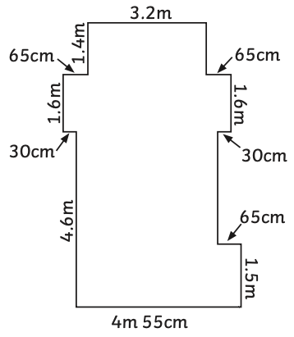
- A Year 5 teacher wants to decorate their classroom for Diwali by putting up a series of fairy lights around the classroom. Work out the perimeter of the classroom and how many strings of 6m fairy lights she will need.

Thursday Week 5
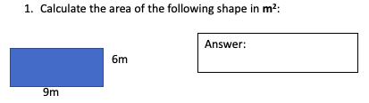
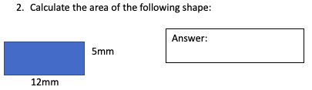
Mild
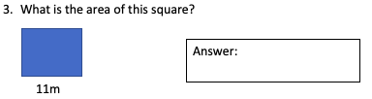

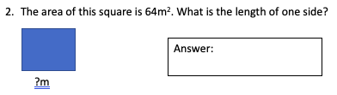
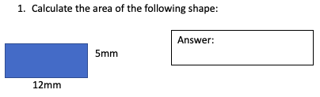
Hot
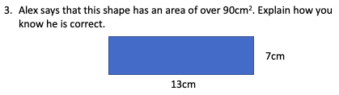

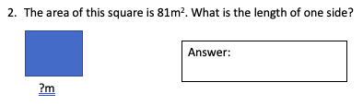
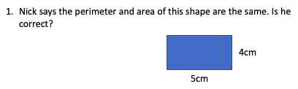
Spicy
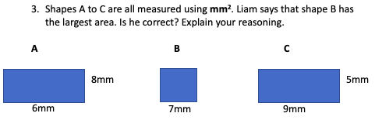

Friday Week 5
Mild
Calculate the area of each rectangle (remember – a square is a type of rectangle), then calculate the area of the whole compound shape.
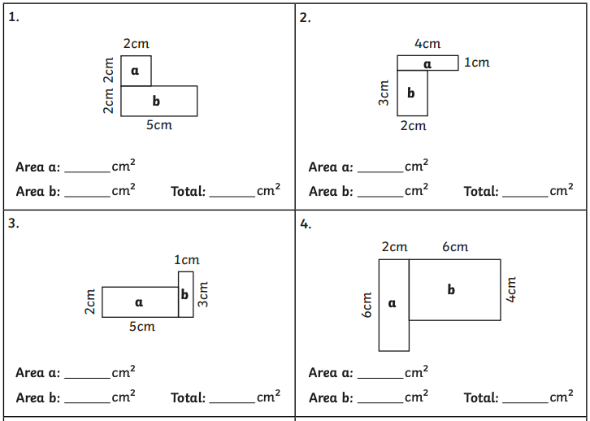

Hot
Calculate the area of each rectangle (remember – a square is a type of rectangle), then calculate the area of the whole compound shape.
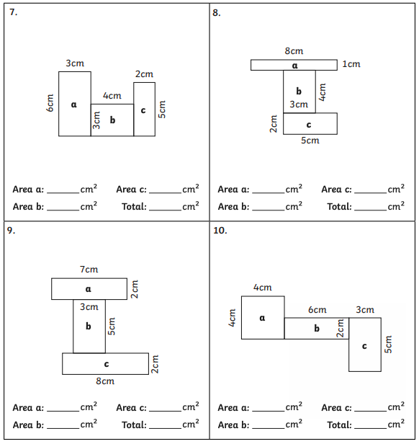

Spicy
Identify the shapes where the area can be calculated. Calculate the area of each compound shape.


