3 in 3!!

3 questions in 3 minutes!!!

Read the text and then time yourself answering the questions – your aim is to answer all 3 questions in 3 minutes!

By the third day, Tomaz was beginning to get concerned. Every day he would walk past the front door and windows of their neighbour, Mrs Watson, and every day she would wave cheerfully from her chair. But he hadn’t seen her all week and it was now Wednesday. At first, his mother said that she didn’t want to interfere – she was probably visiting relatives or something. Finally, Tomaz managed to persuade her to have a look, if only to stop him bothering her. When she peered through the window, Mum gasped and reached for her mobile – there was Mrs Watson, slumped on the sofa and she didn’t appear conscious.

1. … she was probably visiting relatives, or something …
What impression does this give you of how Tomaz’s mum feels?

____________________________________________________________________________

2. … if only to stop him bothering her …
How does this help you to understand Tomaz’s mum’s character?

___________________________________________________________________________

3. What do you think Tomaz and his mum will do next? Use evidence from the text to support your prediction.
_______________________________________________________________________________
_______________________________________________________________________________

You have a text, questions and the answers.
Read the text answer the questions and then check your answers!

This is quite a long activity, so you may want to split in over a 2 or 3 days.

The Battle for the Beaches
Turtle numbers are falling fast.
This article looks at the problem and what we can do to help.
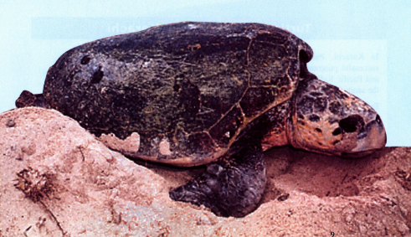

Threatened Sea Turtles
Turtle numbers are falling fast. In order to protect turtles, marine nature reserves have been set up and protection plans put in place. Sadly, many of these do not work as turtles swim freely from country to country. Turtles may be safe in some areas but not in others as different countries have different protection laws.

Turtle Conservation In Karachi
In Karachi, Pakistan, there is a very successful programme to protect the Green and Pacific Ridley turtles which nest along the sandy beaches near the city.  Every night, the beach is patrolled by turtle guards. Whenever they find a female digging a nest they wait patiently nearby and, once she has finished laying, collect her eggs. These are taken to enclosures, which are guarded 24 hours a day.  When the tiny turtles hatch, several weeks later, they are carefully placed in a | bucket and taken to the sea to be released.  Another of the major aims of Pakistan’s turtle programme is to teach people about the value of sea turtles. Guided tours are arranged for visitors to the beaches and parties of school children are taken for exciting night-time visits to watch the animals.  The project is extremely successful: the turtles and their eggs are now well protected, and local people take a real interest in the animals’ welfare.
Turtle species

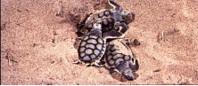 | 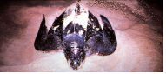
Flatback - still common | Leatherback - extremely rare
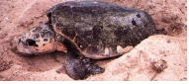 | 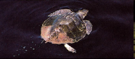
Loggerhead - seriously threatened | Pacific Ridley - extremely rare

Turtles or Tourists in Saltos?
Every summer thousands of Loggerhead turtles travel across the oceans to lay their eggs on the soft, sandy beaches of Saltos.
In recent years their numbers have been falling.
Saltos - a safe haven?  The Mediterranean island of Saltos is beautiful. Its rolling hills are crowned with cypress trees and olive groves. Vineyards snuggle in the valleys. Saltos’ golden beaches are the nesting grounds for the Loggerhead turtle.  Fifteen years ago tourists were almost unknown in Saltos. Now, holiday-makers swarm everywhere, driving cars on to the beaches and playing loud music. This is bad news for the turtles. They do not like noise, they are confused by bright lights (which cause them to crawl inland instead of towards the sea) and they hate crowds.  Although the females usually wait until dark before coming ashore to lay their eggs, they often come face-to-face with dozens of eager | tourists, each armed with a torch and a camera. If they do lay their eggs, there is every chance that, next morning, clumsy sunbathers will stamp on them.  Keeping turtles and tourists apart  Some of the turtles’ favourite beaches are now protected by strict laws, but these are largely ignored by hotel owners. As they depend on tourism for their living, they do not seem to care that turtles’ nesting sites are destroyed by the building of new hotels. The bulldozers, used to remove the rubbish left by lazy tourists, continue to destroy nests every day.  The Prime Minister of Saltos and the Chief of Police are on the side of the turtles. Let us hope that they can persuade people to obey the law. Otherwise, there will soon be nowhere left for the animals to go.

1. Look at the information on Turtle Species.
Which type of turtle is not in danger of dying out?
___________________________________________________________________
1 mark
2. In the passage Threatened Sea Turtles, find and copy the words or phrases which are nearest in meaning to the following.
decreasing ____________________________________________________
established ____________________________________________________
unfortunately ___________________________________________________
function _______________________________________________________
2 marks
Look at the information on turtles conservation in Karachi to help you answer questions 3 and 4.
3. Name two kinds of turtles which nest along the beaches of Karachi.
1. _________________________________________________________________
2. _________________________________________________________________
1 mark
4. (a) Apart from the beach patrol guards, name two other things that the organisers of the turtle programme have started doing.
1. ____________________________________________________________
2. ____________________________________________________________
2 marks
(b) What are the two main results of the turtle protection programme?
1. ____________________________________________________________
2. ____________________________________________________________
2 marks
Look at the information on Saltos.
5. What kind of turtles nest in Saltos?
1 mark
6. Name two things that make Saltos an attractive place for tourists.
1. _________________________________________________________________
2. _________________________________________________________________
1 mark
7. What makes the turtles crawl inland?
___________________________________________________________________
___________________________________________________________________
1 mark
8. List four different things that holiday-makers do which cause problems for the turtles.
1. _________________________________________________________________
2. _________________________________________________________________
3. _________________________________________________________________
4. _________________________________________________________________
2 marks
9. In the information about Saltos, it is written that
holiday-makers swarm everywhere.
Why is this an effective way of describing how the holiday-makers behave?
___________________________________________________________________
___________________________________________________________________
___________________________________________________________________
2 marks
Use all the information to help you answer these questions.
10. Laws have been passed to protect turtles.
Write down two reasons why these have not been very successful.
1. _________________________________________________________________
2. _________________________________________________________________
2 marks
11. Do you think the writer of Turtles or Tourists in Saltos is mainly on the side of the turtles or tourism?

Turtles |  | Tourism
Find and copy two phrases which make you think this.
1. _________________________________________________________________
2. _________________________________________________________________
2 marks
12. Different views are expressed in the article: The Battle for the Beaches.
This is what turtle supporters have said:
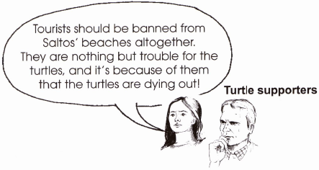
What do you think hotel owners would say in answer to the turtle supporters?
Write your answer in the speech bubble.
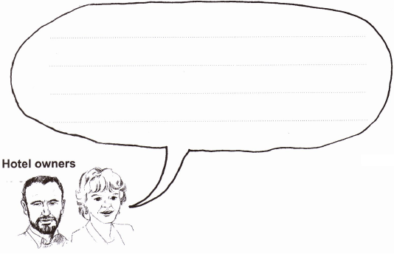
3 marks

ANSWERS

1. • Flatback
1 mark
2. Award 2 marks for all four correct.
Award 1 mark for two or three correct.
decreasing - falling
established - set up
unfortunately - sadly
function - work
2 marks
3. • Green Turtle,
• Pacific Ridley Turtle
1 mark
4. (a) Award 1 mark for any of the following up to a maximum of 2 marks:
• guided tours
• school/night-time visits
• teach people the value of turtles
up to 2 marks
(b) Award 1 mark for each of the following ideas:
• eggs are protected
• people are interested/aware
up to 2 marks
5. • Loggerhead
1 mark
6. Award 1 mark for any two of the following:
• trees, hills,
• beaches,
• valleys, sea
Also accept:
• its beauty, olive groves, Mediterranean Sea,
• vineyards
Not acceptable:
• turtles, nesting sites, hotels
1 mark
7. Award 1 mark for answers such as:
• bright lights or confusion
1 mark
8. Award 2 marks for four of the following:
Award 1 mark for two or three of the following:
• crush eggs, drive cars, play loud music, use cameras, shine bright lights, make noise, swarm everywhere, leave rubbish
(0 if only one correct)
up to 2 marks
9. Award 2 marks for answers which explain the effect of the image or which compare tourists/holiday-makers to insects with supporting reference to text (movement or noise or number of holiday-makers ‘taking over’).
• because the tourists swarm around the beaches like bees, driving cars on the beach, playing loud music destroying their habitat
• because the holiday-makers swarm round like bees round a lolly, there are lots of them in a small space
• the writer wanted to give the image of people huddled together on a crowded beach with no room for anyone else.
Award 1 mark for answers which explain the meaning of swarm but without fully explaining the image.
• holiday-makers are all over the beaches and there is no room for the turtles.
up to 2 marks
10. Award 1 mark for each answer which shows reasoned deduction from text, up to a maximum of 2 marks.
• different laws in different countries (turtles don’t know the laws)
• tourist industry has different priorities / hotel owners ignore the rules
• tourists don’t understand the damage they do
Not acceptable:
answers which simply describe the turtles’ problems,
• bulldozers
• lazy tourists leave rubbish
up to 2 marks
11. The ‘Turtles’ box should be ticked.
Award 1 mark for each different answer which identifies use of biased language, up to a maximum of 2:
• holiday-makers swarm
• clumsy sunbathers
• lazy tourists
• Let us hope ...
• This is bad news...
• do not seem to care
up to 2 marks
12. Award 3 marks for answers which explain the business argument in detail or make counter suggestions/arguments in response to the turtle supporters’ suggestions.
• You can’t ban tourists from Saltos because lots of people’s lives depend on the money the tourists bring into the country. The government should reach a solution where we can both have a section of the beaches.
• Turtles may be nice but they are worthless. Tourists love it here and I’ve got a business to run. We could live without turtles, but not without tourists.
• I rely on my tourists for my living. I cannot be held responsible for the danger against turtles. As soon as the government takes action and seal an area off for turtles, then we can stick to our own sides. I am just making a living and so are the other hotel owners. Tourists must come.
Award 2 marks for answers which focus only on the hotel owner’s central argument: that tourism is a source of income for Saltos.
• if no tourists come then I will be out of business
• Rubbish! I need to make a living and no one would come to my hotel if they were banned from the beach
• I agree with you, but people need employment and we need money. You will have to think of something else. I’m sorry.
• If we had no tourists Saltos would be poor. We need tourists more than we need turtles.
Award 1 mark for answers which deal with the issues in a simplistic, general or superficial way.
• Saltos has many beaches, why can’t the turtles go to other beaches
• we can build hotels if we want because the land belongs to us
• turtles are a thing of the past
up to 3 marks

