3 in 3!!

3 questions in 3 minutes!!!

Read the text and then time yourself answering the questions – your aim is to answer all 3 questions in 3 minutes!

Can you guess what was the first recorded sporting competition between two countries? Although it is not always easy to be certain, there is one individual event that lays claim to that title. If you assume that the original Olympics only involved the people from one country, ancient Greece, you have to skip forward to 1844. Believe it or not, this was when a team from the United States played a team from Canada in the centre of what is now New York. And what was the sport? You might be very surprised to learn that it was cricket.

1. How does the text suggest that you probably don’t know what was the first recorded sporting competition between two countries?
_________________________________________________________________________
2. Find and copy the word in the second sentence that is closest in meaning to single.

_________________________________________________________________

3. According to the text, what only involved people from one country?

_________________________________________________________________

You have a text, questions and the answers.
Read the text answer the questions and then check your answers!

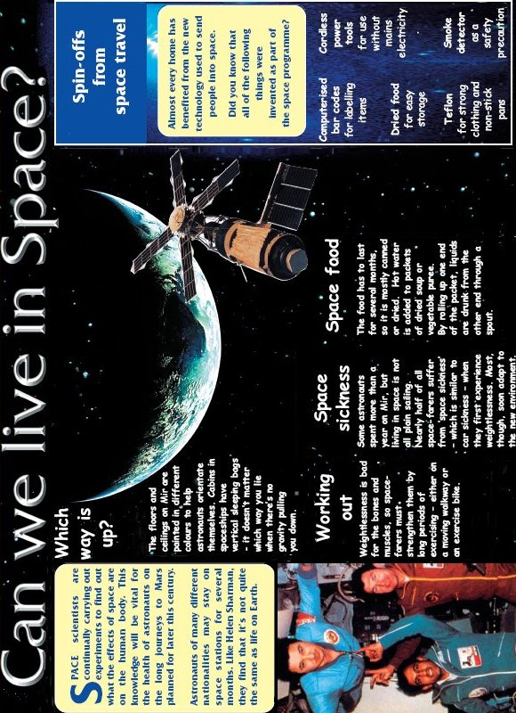

1. This knowledge will be vital for the health….
Which word most closely matches the meaning of the word vital?

 | Tick one.
energetic | 
light
active
necessary
1 mark
2. Much of the food taken on a spaceship is dried food.
Find two reasons why dried food is used.
1. _________________________________________________________________
2. _________________________________________________________________
1 mark
3. Look at the paragraph beginning: Almost every home has…
Find and copy one word meaning been helped by.
_________________________________

1 mark

ANSWERS

1. Award 1 mark if the correct word has been ticked.

energetic
light
active
necessary
1 mark
2. Award 1 mark if both responses are correct:
1. because it has to last a long time / so it won’t go off;
2. for easy storage.
1 mark
3. Award 1 mark for benefited.
1 mark

