Monday Week 4
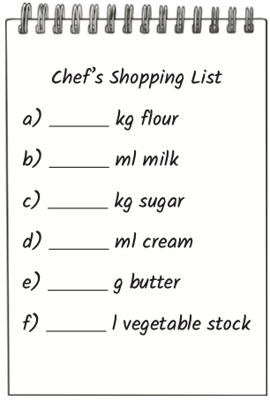
Mild
- The chef wants to make a delicious meal for his guests but he has run out of some important ingredients.
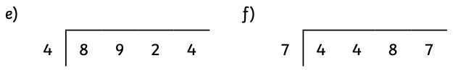
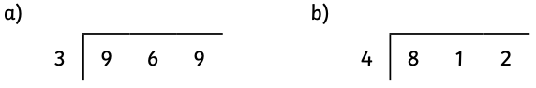
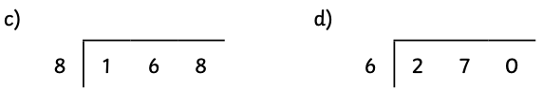
Solve the division problems to find the missing numbers and save the day!

- How much chocolate sauce is left over if…
- 268ml is shared between 4 guests?
- 546ml is shared between 9 guests?
- 657ml is shared between 8 guests?
- 892ml is shared between 7 guests?
Hot
- The chef wants to make a delicious meal for his guests but he has run out of some important ingredients.
Solve the division problems to find the missing numbers and save the day!

- 1377 ÷ 3
- 2484 ÷ 4
- 7544 ÷ 8
- 3676 ÷ 6
- 1276 ÷ 4
- 6601 ÷ 7

- How much chocolate sauce is left over if…
- 3427ml is shared between 4 guests?
- 7820ml is shared between 9 guests?
- 9592 is shared between 6 guests?
- 8632ml is shared between 7 guests?

Spicy
- How much chocolate sauce is left over if…
- 9256ml is shared between 4 guests?
- 8749ml is shared between 8 guests?
- 6832ml is shared between 7 guests?
- 1082ml is shared between 7 guests?

- How many delicious roast potatoes can each table have if the chef shares them out equally? Will there be any left over for his dinner?
- 1092 roasties shared between 8 tables
How many per table? How many are left over?

- 6736 roasties shared between 4 tables
How many per table? How many are left over?

- 5242 roasties shared between 7 tables
How many per table? How many are left over?

- 8234 roasties shared between 9 tables
How many per table? How many are left over?

- 8432 roasties shared between 6 tables
How many per table? How many are left over?

Tuesday Week 4
Mild
- Calculate these answers using short division.
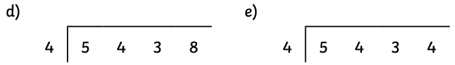

- Calculate the answer to this question:
- 4413 ÷ 3 =

Now, use your answer above to predict which answer will be correct for the questions below. Then do the calculations. Were you correct? Put a tick next to each one you got correct.
- 4410 ÷ 3 = 1475 1470r2 1470
- 4416 ÷ 3 = 1471r2 1473 1472
- 4418 ÷ 3 = 1473 1474 1472r2
- 4420 ÷ 3 = 1473r1 1473 1472r3

Hot
- Use the first calculation to predict the answers for the next four calculations. Calculate the answers using short division then tick the predictions that were correct.

- 8984 ÷ 8 =
- 8976 ÷ 8 prediction:
- 8992 ÷ 8 prediction:
- 8991 ÷ 8 prediction:
- 8983 ÷ 8 prediction:

- Predict which of these calculations will not have a remainder:

7832 ÷ 5 = 7835 ÷ 5 = 7839 ÷ 5 =

Why did you choose this one?

Now, do the short division calculations. Were you correct?

Spicy
- Use the first calculation to predict the answers for the next four calculations. Calculate the answers using short division then tick the predictions that were correct.

- 8984 ÷ 9 =
- 8982 ÷ 9 prediction:
- 8973 ÷ 9 prediction:
- 8974 ÷ 9 prediction:
- 8993 ÷ 9 prediction:

- Predict which of these calculations will not have a remainder:

8532 ÷ 5 = 8810 ÷ 5 = 8832 ÷ 5 =

Why did you choose this one?

Now, do the short division calculations. Were you correct?

Wednesday Week 4
Mild
- Calculate the answers to the division questions, expressing any remainders as whole numbers.
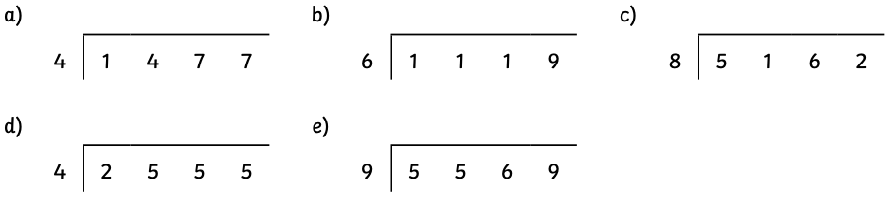
e.g. 6452 ÷ 5 = 1290r2

- Now, use the same calculations but express the remainders as fractions. Remember that the remainder tells you how many parts of a group you have.
e.g. 1435 ÷ 4 = 358r3. There are 3 out of the 4 we need to make another group of 4, so the remainder as a fraction is ¾. 1435 ÷ 4 = 358¾

- 1477 ÷ 4 =
- 1119 ÷ 6 =
- 5162 ÷ 8=
- 2555 ÷ 4 =
- 5569 ÷ 9 =

- Express the remainders in these new calculations as decimals.
Remember: Work out what the remainder would be as a fraction and then use what you know about equivalents to convert it to a decimal.
- 2170 ÷ 4 =
- 4761 ÷ 6 =
- 3402 ÷ 8 =

Hot
Complete this table. Calculate the answers and write the remainder as a whole number remainder, fraction and decimal.

Calculation | Remainder as a whole number | Remainder as a fraction | Remainder as a decimal
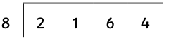
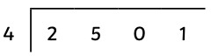
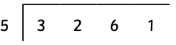
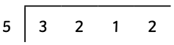

Spicy
Complete this table. Calculate the answers and write the remainder as a whole number remainder, fraction and decimal.

Calculation | Remainder as a whole number | Remainder as a fraction | Remainder as a decimal
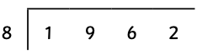
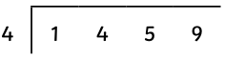
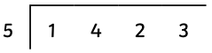
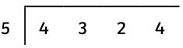

Thursday Week 4
Mild
- How many can I afford?
- I go to the buffet car to get some drinks. I have 153p to spend. Orange squash costs 5p a cup. How many cups can I buy?
- Train tickets are £8 each. I have a budget of £125. Can I afford 16 tickets?

- How much does each item cost?
- I can pay extra to reserve my seats on the train. To reserve four seats, I pay £15. How much does it cost to reserve a seat?
- My lunch bill comes to £18. We decide to share it equally between 6 of us. How much should each of us pay?

- How many do I need?
- The seats on the train are in rows of three. If there are 55 of us in my group, how many rows do we need to reserve?
- What if the seats were in rows of four? How many rows would we need then?

Hot
- How many can I afford?
- I go to the buffet car to get some meals. I buy 6 lunch boxes and it costs me 3696p. Can I afford to buy 10 lunch boxes with 6160p?
- Train tickets are £8 each. I have a budget of £258. Can I afford to buy 35 tickets for the school trip?

- How much does each item cost?
- I can pay extra to reserve my seats on the train. To reserve 7 seats, I pay £22.75. How much does it cost to reserve a seat?
- The lunch bill comes to £35.80. We decide to share it equally between the 4 of us. How much should each of us pay?

- How many do I need?
- Today, there are 154 passengers on the train. How many rows of 3 seats are needed to make sure that all of the passengers can sit down?
- The train company decides to give a free piece of fruit to every passenger. If apples come in packs of 8, how many packs will they need to buy for the 276 passengers travelling today?

Spicy
- How many can I afford?
- I go to the buffet car to get some drinks for my group. Lemonade costs £2 per cup. If I have 4066p, how many cups can I buy?
- Train tickets are £7 each. I have a budget of £332. Can I afford to buy 48 tickets?

- How much does each item cost?
- I can pay extra to reserve my seats on the train. To reserve 6 seats, I pay £16.80. How much does it cost to reserve a seat?
- My lunch bill comes to £111.60. We decide to share it equally between the 9 of us. How much should each of us pay?

- How many do I need?
- Today, there are 247 passengers on the train. How many rows of three seats are needed to make sure that all of the passengers can sit down?
- The train company decides to give a free piece of fruit to every passenger. If apples come in packs of 8, how many packs will they need to buy for the 2764 passengers travelling today?

Friday Week 4
Use a written method of division to work out how many egg boxes are needed on each day. You may have an egg box that isn’t full, but you can’t have loose eggs!

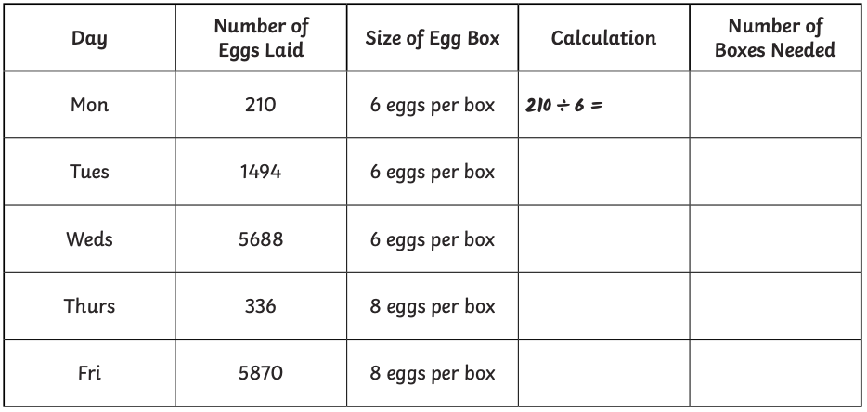
Mild

Hot
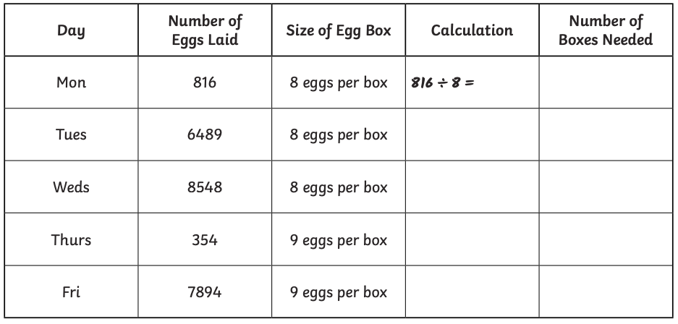

Spicy


