Monday Week 3
Mild
- Tom and Bill are twins. Their mum has to buy double the amount of everything for them! Help her out by doubling each of the items on her shopping list:

224g rice
355ml lemonade
1288ml milk
293g chicken
1053 soup
5421g bread

- Tom and Bill are great at sharing things! Work out how many of these things they will get if they share them equally.

5520 sweets
£26 pocket money
4½ mini pizzas
524 crisps
6248 rice pops
11 slices of bread

Hot
- Tom and Bill are twins. Their mum has to buy double the amount of everything for them! Help her out by doubling each of the items on her shopping list:

224.4g of rice
355.6ml lemonade
290.3g chicken
105.3ml soup
542.1g bread

- Tom and Bill are great at sharing things! Work out how many of these things they will get if they share them equally.

552 sweets
£25.50 pocket money
4½ mini pizzas
59 crisps
625 rice pops
11 slices of bread

Spicy
- Tom and Bill are twins. Their mum has to buy double the amount of everything for them! Help her out by doubling each of the items on her shopping list:

224.42g of rice
355.62ml lemonade
128.81ml milk
290.37g chicken
105.33ml soup
542.13g bread

- Tom and Bill are great at sharing things! Work out how many of these things they will get if they share them equally.

552 sweets
£25.56 pocket money
4¼ mini pizzas
593 crisps
6258 rice pops
11½ slices of bread

Tuesday Week 3
Mild
Divide these numbers using PCR (Partition, Calculate, Recombine). The first one has been done for you as an example.

- 484 ÷ 4 = 121
P: 484 = 400 + 80 + 4
C: 400 ÷ 4 = 100, 80 ÷ 4 = 20, 4 ÷ 4 = 1
R: 100 + 20 + 1 = 121

- 6936 ÷ 3 =
- 2846 ÷ 2 =
- 8428 ÷ 4 =
- 5500 ÷ 5 =
- 7070 ÷ 7 =
- 9660 ÷ 3 =
- 8084 ÷ 4 =

Hot
Divide these numbers using PCR (Partition, Calculate, Recombine). The first one has been done for you as an example.

- 48.4 ÷ 4 = 12.1
P: 48.4 = 40 + 8 + 0.4
C: 40 ÷ 4 = 10, 8 ÷ 4 = 2, 0.4 ÷ 4 = 0.1
R: 10 + 2 + 0.1 = 12.1

- 69.3 ÷ 3 =
- 28.6 ÷ 2 =
- 84.8 ÷ 4 =
- 5.5 ÷ 5 =
- 770.7 ÷ 7 =
- 906.3 ÷ 3 =
- 884.8 ÷ 4 =

Spicy
Divide these numbers using PCR (Partition, Calculate, Recombine). The first one has been done for you as an example.

- £62.19 ÷ 3 = £20.73
P: £62.19 = £60 + £2.10 + 9p
C: £60 ÷ 3 = £20, £2.10 ÷ 3 = 70p, 9p ÷ 3 = 3p
R: £20.00 + £0.70 + £0.03 = £20.73

- £82.44 ÷ 4 =
- £154.55 ÷ 5 =
- £497.70 ÷ 7 =
- £459.09 ÷ 9 =
- £864.24 ÷ 8 =
- £420.36 ÷ 6 =
- £155.45 ÷ 5 =

Wednesday Week 3

Choose whether you are going to use Mild, Hot or Spicy cards.
If you have a printer, print out your cards and cut them out. If not, create your own using a piece of paper and the calculations.
Then, follow the instructions underneath.

Mild

104 ÷ 4 | 63 x 4 | 53 x 9 | 73 x 50 | 11 x 52 | 848 ÷ 4
16 x 6 | 65 x 50 | 9 x 85 | 75 x 11 | 842 x 5 | 74 x 4

Hot

484 ÷ 4 | 635 x 4 | 538 x 9 | 77 x 50 | 11 x 528 | 648 ÷ 4
165 x 6 | 67 x 50 | 9 x 88 | 753 x 11 | 852 x 5 | 744 x 4

Spicy

484 ÷ 4 | 6305 x 4 | 5038 x 9 | 777 x 50 | 11 x 5280 | 6488 ÷ 4
167 x 6 | 674 x 50 | 9 x 889 | 753 x 11 | 852 x 5 | 748 x 4

- Sort the cards into four piles according to the strategy you would use to solve the calculations:
Pile 1: Multiplying by 10 and adding or subtracting groups
Pile 2: Multiplying by 10 and halving
Pile 3: Multiplying by 100 and halving
Pile 4: Using factors, e.g. multiply by 4 by multiplying by 2 x 2

- Use the strategies to work out the answers and write them on the cards.

- Use a written method or calculator to check your answers. If you made a mistake, find out where you went wrong and put it right.

Thursday Week 3
Mild
- Match these calculations with their answers:
2) Solve these calculations. Look for the facts you know!

0.7 x 4

0.2 x 9

3 x 0.9

0.3 x 6

5 x 0.7

8 x 0.2
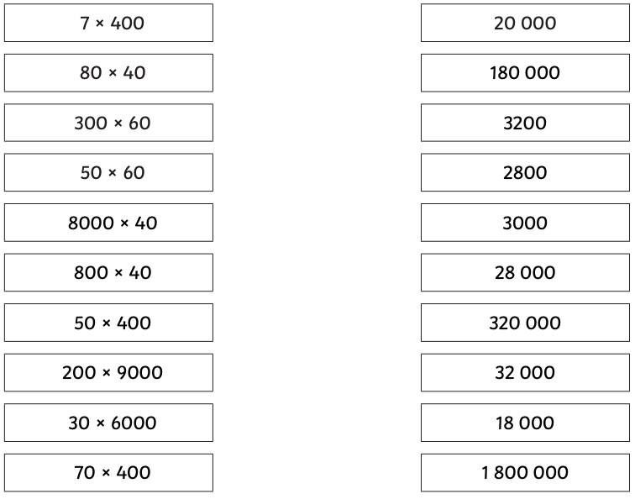

Hot
- There are 3 possible answers for the following calculations:

2.8 2,800 28,000

Use what you know to choose the correct answer for each calculation.

70 x 40
0.7 x 4
4,000 x 7
700 x 40
4 x 700
7 x 0.4
70 x 400

- Can you think of 2 multiplication questions for each of these answers? The first one has been done as an example.
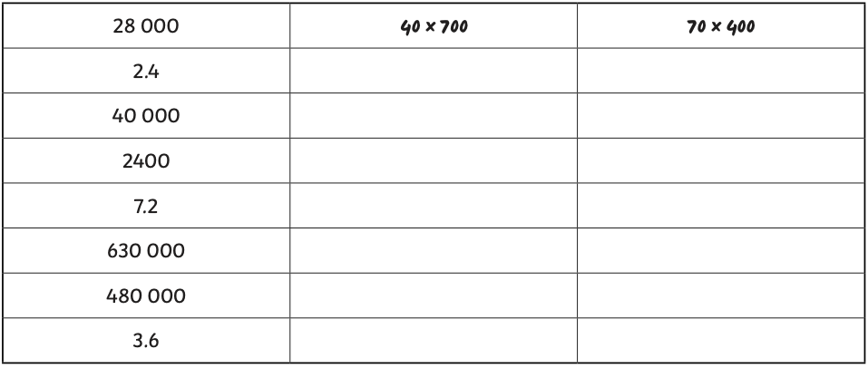

Spicy
- There are 5 possible answers for the following calculations:

5.6 5,600 56,000 560,000 56,000,000

Use what you know to choose the correct answer for each calculation. Are there any calculations that should not be in this list?

7 x 0.8
8 x 7,000
7,000 x 80
8,000 x 7,000
70 x 800,000
800 x 7
8 x 0.7
70 x 80
800 x 70
7 x 8
7 x 8,000
- 70,000

- Can you think of 2 multiplication questions for each of these answers? The first one has been done as an example.
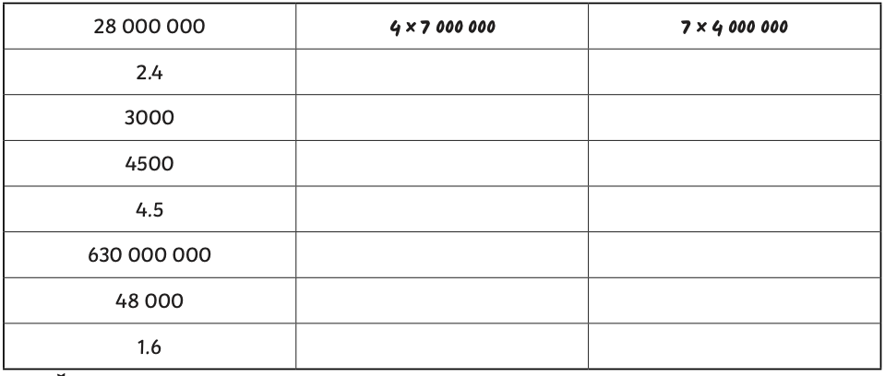

Friday Week 3

Play this game with a family member.
Take it in turns to roll a dice and get your number.
Then, roll again to find out the calculation you need to do (you can work these out mentally using the strategies you’ve practiced!)
Finally, roll again to find your action.


