Maths Week beginning 13/07/20
14/07/20 – Maths Scavenger Hunt
Using your estimating skills, can you find items in the house/outside that approximately weigh or measure the amounts in the table below.
You will need:
- A tape measure
- weighing scales

Capacity | Object found and actual weight | Length | Object found and actual length
35g |  | 30cm
300g |  | 5cm
120g |  | 1m
8g |  | 75cm
550g |  | 1.5m
50g |  | 15cm

Once you have estimated, don’t forget to go back and measure to see how close you were!

15/07/20 – Who am I? – A classic Christmas game that you can play to develop questioning (this is a two player game).
Create some cards (or you could use post-it notes) with anything maths related on each one. It could be a number, a shape or an angle (if you want to make it even trickier). Without looking choose a card from the pile and hold it above your head. Ask your partner questions about what could be on your card. They can only answer yes or no.
Examples of questions include:
Is it a multiple of 7?
Is it and odd number?
Is it more than 1000?
Does it have 4 sides?
Does it have more than 4 vertices?
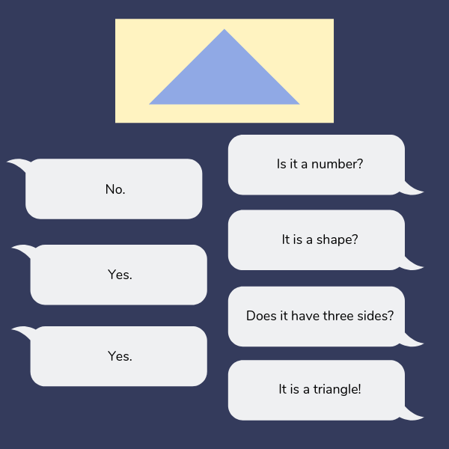

16/07/20 – Battle ships – Remember: Along the corridor, up the stairs!
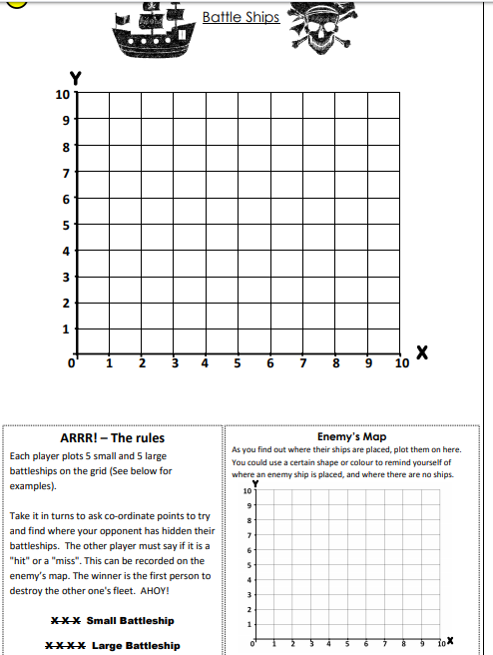

17/07/20 – The 24 Game
This is a very simple game that will help your child practice their arithmetic skills (This is a 2+ player game).
What you need to play:
- A pack of playing cards – just the numbered ones (or you can make your own number cards)
How to play:
Step 1: Each player picks 4 number cards at random from the pile.
Step 2: They then need to find a way to manipulate the 4 digits using any of the 4 operations (+, -, x, ÷) so the end result is 24 For example, if they chose 4, 7, 8, 8, they could do
8÷8= 1
7 – 1 = 6
6 x 4 = 24
Step 3: If nobody is able to reach 24, you can make it closest wins!
Here’s an example of someone playing it: https://youtu.be/HeO0q0cSvx0

You can play as many rounds as you wish or, you could even change the number!

