
Learning Activities
Year 4 2019-20

self-isolation learning Week 14
 | Lessons set | Additional comments
Monday  13/07/20 | Maths: Please find all maths sheets in the document named ‘Maths week 14-15’. Extra arithmetic tests have been included if you wanted a bit more practice!  Complete at least 5 sessions of TT Rockstars.  Create your own Times table game to help you practice your times tables. It could be a (lifesize) board game where you are a character, playing cards – anything!  SLOR: All reading extracts can be found in the document named ‘SLoR WEEK 14-15’. Read the text. Answer questions 1-3 labelled vocabulary. Use the answer page at the bottom of the document to mark your answers. If your answer is incorrect think about what went wrong and make your corrections  English: English week 14 document contains resources needed for the next week.  This year was meant to be the year of the Tokyo 2020 Olympics. The Olympics have unfortunately been cancelled this year. However, we would like you to carry out research about the Olympic Games. Create a leaflet about the games and some of the sports that should have been happening this summer. Today’s activity is to research the history of the games. You can carry out your own research alternatively information is available in the English Week 14 document.  Science: See Science weeks 14 for instructions. | MATHS: Videos uploaded weekly to our year group YouTube channel: https://www.youtube.com/channel/UCwrDzSuycugd5WfI9kO5-2A  PE- Complete a yoga session from the link below:  https://www.youtube.com/user/CosmicKidsYoga  Art for Kids Hub on You Tube has some good tutorials for different drawings.  Reading Challenge  Read for at least 10 minutes each day and then choose a challenge to complete from the document labelled ‘Reading Challenge’.
Tuesday | Maths: Complete at least 5 sessions of TT Rockstars.  Maths Scavenger Hunt  SLOR: Re-Read the text. Answer questions 4-6 labelled retrieval. Use the answer page at the bottom of the document to mark your answers. If your answer is incorrect think about what went wrong and make your corrections.  English: Research 2 sports that feature in the Olympics and write a paragraph about each of them. Information about some of the sports can be found in the English documeny For further information about each sport or if you would like to write about a sport without information below please feel free to carry out your own research using book or the internet.  PSHE/ Jigsaw: Memories: Think back to the things we’ve done while you were at school (Topics – volcanoes and earthquakes, Ancient Greece, Deserts) (other events – science week, Harvest Festival, celebration assemblies, TT Rockstars). Create a picture of your favourite memories. You could use this idea below.  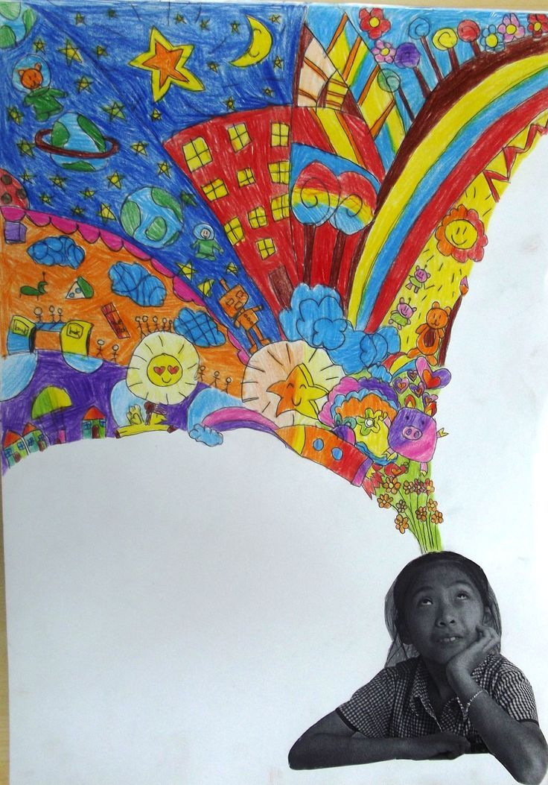 | PE – Just dance  https://www.youtube.com/results?search_query=just+dance+kids  Dance for at least 30 minutes!  Maths  Please find all maths sheets in the document named ‘Maths week 14-15’.  SLOR  All reading extracts can be found in the document named ‘SLoR WEEK 14-15’.  English  Please find all English sheets in the document named ‘English week 14-15’.  Reading Challenge  Read for at least 10 minutes each day and then choose a challenge to complete from the document labelled ‘Reading Challenge’.
Wednesday | Maths: Complete at least 5 sessions of TT Rockstars.  Maths game: Who am I?  SLOR: Re-Read the text. Answer questions 7-9 labelled inference. Use the answer page at the bottom of the document to mark your answers. If your answer is incorrect think about what went wrong and make your corrections.  English: Continue your leaflet but researching another 2 sports that feature in the Olympics and write a paragraph about each of them. Some information is available in the English document. Alternatively carry out your own research.  Art: Create a piece of art based on your favourite topic we have covered this year. We have covered:  Volcanoes and Earthquakes, Ancient Greece, Deserts, Anglo-Saxons and Vikings, The Normans and Our local area. What you create us completely up to you. | PE- Complete a yoga session from the link below:  https://www.youtube.com/user/CosmicKidsYoga  Maths  Please find all maths sheets in the document named ‘Maths week 14-15’.  SLOR  All reading extracts can be found in the document named ‘SLoR WEEK 14-15’.  English  Please find all English sheets in the document named ‘English week 14-15’.  Reading Challenge  Read for at least 10 minutes each day and then choose a challenge to complete from the document labelled ‘Reading Challenge’.
Thursday | Maths: Complete at least 5 sessions of TT Rockstars.  Maths game: Battle Ships.  SLOR: Re-Read the text. Answer questions 10 - 12. Use the answer page at the bottom of the document to mark your answers. If your answer is incorrect think about what went wrong and make your corrections.  English: Continue your leaflet by researching another 2 sports that feature in the Olympics and write a paragraph about each of them. information  Topic: Create a scrapbook/collage of your time in lockdown. You can include learning you have created, fun activities you experienced and even photos. These will be great to share with your new teachers to show them what you have been up to! | PE – Just dance  https://www.youtube.com/results?search_query=just+dance+kids  Dance for at least 30 minutes!  Maths  Please find all maths sheets in the document named ‘Maths week 14-15’.  SLOR  All reading extracts can be found in the document named ‘SLoR WEEK 14-15’.  English  Please find all English sheets in the document named ‘English week 14-15’.  Reading Challenge  Read for at least 10 minutes each day and then choose a challenge to complete from the document labelled ‘Reading Challenge’.
Friday | Maths: Complete at least 5 sessions of TT Rockstars.  Complete the week 14 arithmetic.  Maths game: The 24 Game.  SLOR: https://www.bbc.co.uk/bitesize/articles/zs7tjsg look at the lesson on BBC bitesize. Complete one of the comprehension activities.  English: Write the information you have found out up into a leaflet form by folding a piece of A4 paper into three. You may wish to draw lines on each page using a ruler to improve your presentation. Remember to include illustrations where appropriate. Please send your teacher a photo of your finished leaflet we would love to see them.  Topic: Design and create your own end of the year award certificate. If you could reward yourself for something you did really well during lockdown, what would it be? For example; always completing my tt rockstars sessions, working really hard to complete my learning at home, always staying positive etc. You can always ask your parents/guardians what they think you deserve an award for! | PE- Complete a yoga session from the link below:  https://www.youtube.com/user/CosmicKidsYoga  Maths  Please find all maths sheets in the document named ‘Maths week 14-15’.  SLOR  English  Please find all English sheets in the document named ‘English week 14-15’.  Reading Challenge  Read for at least 10 minutes each day and then choose a challenge to complete from the document labelled ‘Reading Challenge’.

Learning Activities
Year 4 2019-20

Holiday activities.

Here is a list of activities you could do during the holidays if you wish.

English:

- Why not complete the all about me sheet attached below then use this to help you write a letter to your new teacher introducing yourself?

- Play some of the English games on top marks: https://www.topmarks.co.uk/english-games/7-11-years/spelling-and-grammar

- Write a diary about each day of your summer holidays.

- Use Pobble 365 images and write short stories or descriptions based on the pictures.
- https://www.pobble365.com

- Use BBC bitesize to revise any areas of English you have found particularly challenging
https://www.bbc.co.uk/bitesize/subjects/zv48q6f

- Vocabulary challenge: Think of at least 1 adjective for each letter of the alphabet, find the definition of each word. You could use this to create your own vocabulary book.
- Name alphabet challenge: Can you write a name for each letter of the alphabet.

SLOR:
- https://www.bbc.co.uk/bitesize/articles/zqpx8hv look at the lesson on BBC bitesize. Complete the activities.
- Reading challenge: How many books can you read during the holidays? You could also look at this summer reading challenge: https://summerreadingchallenge.org.uk/
- Write a book review of each book you read. What did you like about the book? What didn’t you like? Which was your favourite part? Would you recommend the book? Who would you recommend it to?
- Create a book recommendation list full of your favourite reads with a short paragraph to explain why you like them. These would be great to share with your classmates in September
- Create a question and answer quiz about the book you are reading for someone else to complete when they have read the book.

Maths:
- TT Rockstar challenge: How many TT Rockstars sessions can you play today? What’s the highest score you can achieve? Keep playing until you beat your score by at least 5 points! Then complete a TT Rockstars sheet attached (below) to see if you are still as quick on paper!

- Complete a soundcheck. Have you improved? Then play the times table game you made last week. (You could facetime a friend and play with them)

- Play the times table game you created weekly so that you don’t forget your times tables.

- Play Hit the Button to practice your number bonds to 10, 20, 50 and 100: https://www.topmarks.co.uk/maths-games/hit-the-button

- Use BBC Bitesize to revise any of the maths topics you have found a bit challenging:
https://www.bbc.co.uk/bitesize/subjects/z826n39

- Play ‘Simon Says’ to practice any mathematical concepts – for example: angles. Simon Says, make an acute angle using your arms.

- Make your own analogue clock with moving hands and ask someone to give you different times to make (you could also test your adult on their knowledge). Challenge: then write the times in 24 hour digital.

Other:
- Create an all about me fact file – include a self-portrait!
- Practice your sketching skills by sketching a place you visit during the holidays
- Create a poster for your new teacher showing all the things you love – you could lay it out like the poster below.

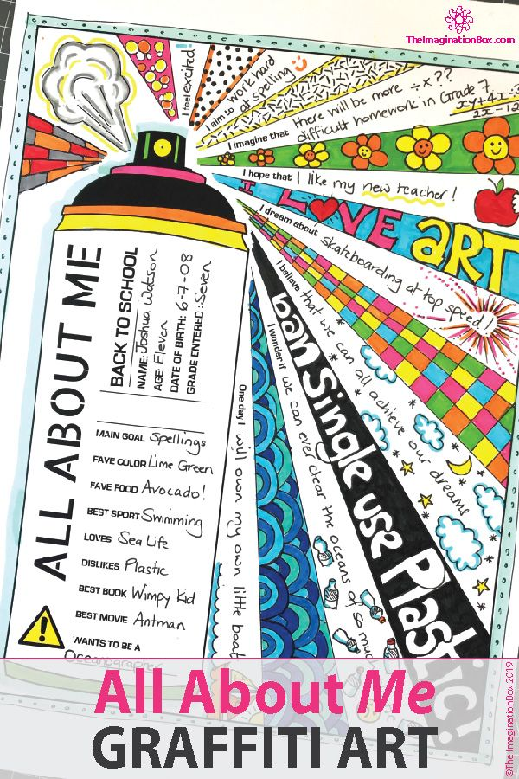

All About Me
The facts:
________________________________________________________________________________________________________________________________________________________________________________________________________________________________________________________________________________________________________________________________________________________________________________________________________________________
This is me!
________________________________________________________________________________________________________________________________________________________________________________________________________________________________________________________________________________________________________________________________________________________________________________________________________________________
The things I love most.
________________________________________________________________________________________________________________________________________________________________________________________________________________________________________________________________________________________________________________________________________________________________________________________________________________________
When I grow up I want to be:
____________________________________________________________________________________________________________________________________________________________________________________________________________
Something interesting I have learnt this year:
__________________________________________________________________________________________________________________________________________________________________________________________________________________________________________________________________________________________________________________
Three awesome things to know about me.
1.__________________________________________________________________
2._________________________________________________________________
3. _______________________________________________________________


