PSHE – 07/07/20 - Mixed – A Colourful Story
Watch and listen to the story on the link below:
https://youtu.be/SIbGioTNs4M
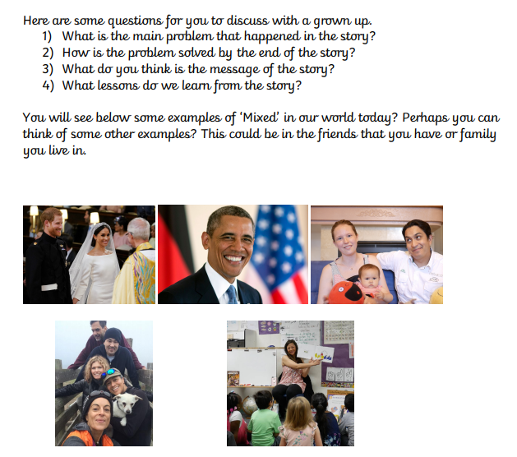
Task
Rewrite the story to create your own version. Your title is still ‘Mixed – A Colourful Story’.
Think about how you could change the plot so that the colours mixed from the beginning. How would their lives be different? Maybe your story could involve two colours working together to solve problems or convince other colours why mixing is positive. It’s up to you!

